**table of contents**

|  |  |  |  |
| --- | --- | --- | --- |
| **1** | **ABSTRACT** | | **1** |
| **2** | **INTRODUCTION** | | **2** |
| **3** | **OBJECTIVE OF THE PROJECT** | | **3** |
| **4** | **TECHNOLOGY STACK USED** | | **4-5** |
| **5** | **KEY FEATURES IMPLEMENTED** | | **6-10** |
| **6** | **SCREENSHOTS AND LINK TO DEPLOYED PROJECT** | | **11-17** |
|  | **6.1** | **Screenshots** | **11-16** |
|  | **6.2** | **Link to Deployed Project** | **17** |
| **7** | **CHALLENGES FACED AND LEARNINGS** | | **18-23** |
|  | **7.1** | **Challenges Faced** | **18-21** |
|  | **7.2** | **Learnings** | **22-23** |
| **8** | **CONCLUSION** | | **24** |

#### ABSTRACT

The Carpooling Web Application is a comprehensive full-stack project developed using the PERN stack (PostgreSQL, Express.js, React.js, Node.js). This platform facilitates ride-sharing by connecting drivers who want to offer rides with passengers seeking transportation. The application features a robust authentication system, dynamic role switching between driver and rider modes, intelligent ride filtering, secure booking mechanisms, and advanced features including AI-powered natural language search and multi-language support. The project emphasizes user experience through a clean, responsive interface built with Tailwind CSS and React.js, while maintaining security through JWT-based authentication and bcrypt password hashing. The backend API, developed with Express.js and Node.js, provides RESTful endpoints for all application functionality, with data persistence managed through PostgreSQL database integration. Key distinguishing features include the ability for users to seamlessly switch between driver and rider roles, manual route entry with GPS dependency, AI-enhanced search capabilities that understand natural language queries, and comprehensive multi-language support using i18next. The application operates on an offline, cash-based transaction model, making it accessible in various geographical and technological contexts. The platform successfully demonstrates modern web development practices, including responsive design, secure authentication flows, database normalization, API development, and cloud deployment strategies. This project serves as a practical solution for community-based ride-sharing while showcasing advanced full-stack development capabilities.

1. **INTRODUCTION**

In today's rapidly evolving urban landscape, transportation challenges have become increasingly complex, with rising fuel costs, environmental concerns, and traffic congestion affecting millions of commuters daily. The traditional model of individual car ownership is being challenged by the growing need for sustainable, cost-effective, and community-driven transportation solutions. Carpooling emerges as a compelling answer to these challenges, offering environmental benefits through reduced carbon emissions, economic advantages through shared travel costs, and social benefits through community building.

The digital transformation of transportation services has created unprecedented opportunities to connect drivers and passengers through intelligent, user-friendly platforms. However, many existing solutions are either overly complex, geographically limited, or focused primarily on commercial ride-hailing rather than genuine peer-to-peer carpooling. There exists a significant gap in the market for a platform that prioritizes community collaboration, flexibility, and accessibility while maintaining the security and reliability that users demand.

Our Carpooling Web Application addresses these challenges by creating an innovative, comprehensive platform that reimagines how people share rides. Unlike traditional ride-sharing services that focus on professional drivers and commercial transactions, our solution emphasizes community-based sharing where any user can seamlessly switch between being a driver offering rides and a passenger seeking transportation. This dual-role approach reflects the real-world nature of carpooling, where today's driver becomes tomorrow's passenger, fostering a true sharing economy.

The application is built on the robust PERN stack (PostgreSQL, Express.js, React.js, Node.js), ensuring scalability, maintainability, and performance. What sets this platform apart is its unique combination of simplicity and sophistication – offering an intuitive user experience while incorporating advanced features such as AI-powered natural language search, comprehensive multi-language support, and intelligent ride matching algorithms.

Key innovations include a flexible role-switching system that eliminates the need for separate driver and passenger accounts, manual route entry that does depend on GPS integration, and an offline-first approach that assumes cash-based transactions, removing barriers related to digital payment integration. The platform also features advanced search capabilities that understand natural language queries, allowing users to search for rides using phrases like " Show me rides to Bangalore under ₹1000 " rather than complex form-based inputs.

#### 3. OBJECTIVE OF THE PROJECT

#### The primary objective of this Carpooling Web Application is to create a user-friendly, scalable, and secure platform that addresses the growing need for efficient ride-sharing solutions. The project aims to achieve several key goals:

**Primary Goals:**

* Develop a comprehensive ride-sharing platform that enables users to offer and find rides seamlessly
* Implement a flexible user role system allowing dynamic switching between driver and rider modes
* Create an intuitive interface for manual route entry and ride management without requiring GPS integration
* Establish a secure authentication and authorization system protecting user data and transactions

**Secondary Goals:**

* Integrate advanced search capabilities with AI-powered natural language processing
* Implement multi-language support to cater to diverse user bases
* Design a scalable database architecture that can handle growing user and ride data
* Create a deployment-ready application with proper CI/CD practices
* Demonstrate proficiency in modern full-stack development using the PERN stack

#### User Experience Objectives:

#### Provide an intuitive dashboard for managing rides and bookings

#### Enable efficient ride discovery through multiple filtering options

#### Implement real-time feedback through toast notifications and status updates

#### Ensure smooth navigation between different application features

#### Technical Objectives:

* Build a RESTful API following industry best practices
* Implement proper error handling and validation throughout the application
* Establish secure data transmission and storage protocols
* Deploy the application using modern cloud platforms and services

#### TECHNOLOGY STACK USED

The Carpooling Web Application leverages the PERN stack, a powerful combination of technologies that enables full-stack JavaScript development. Each component was carefully selected to ensure optimal performance, scalability, and maintainability.

**Frontend Technologies:**

**React.js (v18.2.0)**:

* Primary framework for building the user interface
* Utilizes functional components with React Hooks for state management
* Implements React Router for client-side navigation
* Uses React Context API for global state management and authentication

**Tailwind CSS (v3.3.0):**

* Utility-first CSS framework for rapid UI development
* Provides responsive design capabilities out of the box
* Enables consistent design system implementation
* Reduces custom CSS requirements through pre-built utility classes

**Backend Technologies Node.js (v18.16.0):**

* JavaScript runtime environment for server-side development
* Provides non-blocking, event-driven architecture
* Enables full-stack JavaScript development
* Supports modern ES6+ features and modules.

**JSON Web Tokens (JWT):**

* Token-based authentication system
* Enables stateless authentication across requests
* Supports token expiration and refresh mechanisms

**Database Technology PostgreSQL (v15.4)**:

* Relational database management system
* Provides ACID compliance for data integrity
* Supports complex queries and joins

**Database ORM/Query Builder: pg (node-postgres):**

* Direct PostgreSQL client for Node.js
* Connection pooling for efficient database connections
* Parameterized queries for SQL injection prevention
* Transaction support for data consistency

**Development and Deployment Tools Development Environment:**

* Prettier: Code formatting and style consistency
* Git: Version control and collaboration

**Deployment Platforms:**

* + **Frontend:** Vercel for static site hosting
  + **Backend:** Render for server deployment
  + **Database:** Render for PostgreSQL hosting
  + **CI/CD:** GitHub Actions for automated deployment

#### Additional Tools and Middleware CORS (Cross-Origin Resource Sharing):

#### Enables frontend-backend communication across different origins

#### Configures allowed origins, methods, and headers

#### Provides security for cross-origin requests.

**Express Middleware:**

* express.json(): JSON request body parsing
* express.urlencoded(): URL-encoded form data parsing
* helmet: Security headers for Express applications
* morgan: HTTP request logging

#### 5. KEY FEATURES IMPLEMENTED

The Carpooling Web Application incorporates a comprehensive set of features designed to provide a complete ride-sharing experience. These features demonstrate advanced full-stack development capabilities while addressing real-world user needs.

**Core Authentication and Security Features:**

* Secure user registration with email validation and password strength requirements
* JWT-based authentication with access and refresh token implementation
* Password hashing using bcrypt with configurable salt rounds
* Protected routes that require authentication for access
* Automatic token refresh to maintain user sessions

**User Profile Management**

* Comprehensive user profile creation and editing capabilities
* Profile picture upload and management (with file validation)
* Personal information management including contact details and preferences
* Account settings and privacy controls
* Password change functionality with current password verification

**Role-Based Functionality**:

**Dynamic Role Switching**

* Seamless switching between Driver and Rider roles within the same account
* Role-specific dashboard and navigation elements
* Contextual features based on selected user role
* Permission-based access to different application sections

**Driver-Specific Features**

* Ride offering interface with comprehensive route details input
* Vehicle information management (car model, capacity, amenities)
* Ride pricing and payment preference settings
* Driver ratings and review system
* Ride history and earnings tracking

**Rider-Specific Features**

* Advanced ride search with multiple filter criteria
* Ride booking and cancellation capabilities
* Passenger preferences and requirements specification
* Booking history and expense tracking
* Rider rating system for drivers

**Ride Management System:**

**Ride Creation and Publishing**

* Manual route entry with origin and destination specification
* Date and time scheduling for rides
* Passenger capacity and availability management
* Ride pricing with flexible payment options
* Ride description and special instructions
* Recurring ride setup for regular commutes

**AI-Powered Natural Language Search**

* Natural language query processing (e.g., "Ride from Downtown to Airport tomorrow morning")
* Intelligent parsing of location, time, and preference information
* Machine learning-enhanced search result ranking
* Context-aware search suggestions and auto-completion

**Booking and Reservation System:**

**Ride Booking Process**

* One-click booking for available rides
* Booking confirmation with automatic notifications
* Waitlist functionality for fully booked rides
* Booking modification and cancellation options
* Group booking capabilities for multiple passengers

**Booking Management**

* Real-time booking status updates
* Automated reminder notifications
* Check-in and check-out functionality
* No-show reporting and handling
* Booking history with detailed records

**User Interface and Experience Features:**

**Responsive Design Implementation**

* Mobile-first design approach with Tailwind 3.4.7
* Cross-device compatibility (desktop, tablet, mobile)
* Touch-friendly interface elements
* Optimized loading times and performance
* Progressive web app (PWA) capabilities

**Multi-Language Support**

* Complete internationalization using i18next
* Dynamic language switching without page reload
* Support for multiple languages (English, Kannada) Localized date, time, and currency formatting

**Communication and Notification System**:

**In-App Messaging**

* Direct messaging between drivers and riders
* Automated system notifications for booking updates
* Email notifications for important events
* SMS integration for critical updates (when configured)

**Toast Notification System**

* Real-time feedback for user actions
* Success, error, and informational messages
* Non-intrusive notification display

**Technical Features:**

**API Development**

* RESTful API design with proper HTTP methods and status codes
* Comprehensive error handling and validation
* API documentation with endpoint specifications
* Rate limiting and security measures
* Versioning support for future updates

**Database Optimization**

* Efficient database schema with proper normalization
* Indexing for improved query performance
* Database connection pooling
* Backup and recovery procedures
* Data migration and seeding scripts

**Security Implementation**

* Input validation and sanitization
* SQL injection prevention through parameterized queries
* Cross-site scripting (XSS) protection
* Secure HTTP headers and CORS configuration

**Map Integration & Location Services**

* Real-time map interface for pickup/drop-off selection
* Interactive route planning with drag-and-drop
* GPS tracking and geolocation services
* Offline map caching

**Environmental Impact Features**

* Carbon emission reduction calculator
* Environmental impact dashboard
* Sustainability badges and achievements
* Green route suggestions

**Enhanced User Experience**

* Dark/Light mode toggle with system detection
* Advanced profile picture updating with real-time preview
* English and Kannada language support with regional localization
* Enhanced performance using motion UI

**Smart Cost Management**

* AI-powered cost suggestion algorithm
* Real-time fuel price integration
* Market demand-based pricing
* Cost breakdown transparency

**Comprehensive Email System**

* Booking confirmation emails
* Driver seat confirmation notifications
* Ride reminders and completion emails
* Review request automation

**Advanced Rating & Review System**

* Multi-category rating system (punctuality, cleanliness, communication)
* Post-ride review prompts via email
* Reputation scoring and trust indicators
* Review moderation and response capabilities

#### 6. SCREENSHOTS AND LINK TO DEPLOYED PROJECT

**6.1 SCREENSHOTS**

The following screenshots demonstrate the key interfaces and functionality of the Carpooling Web Application across different user scenarios and device types.

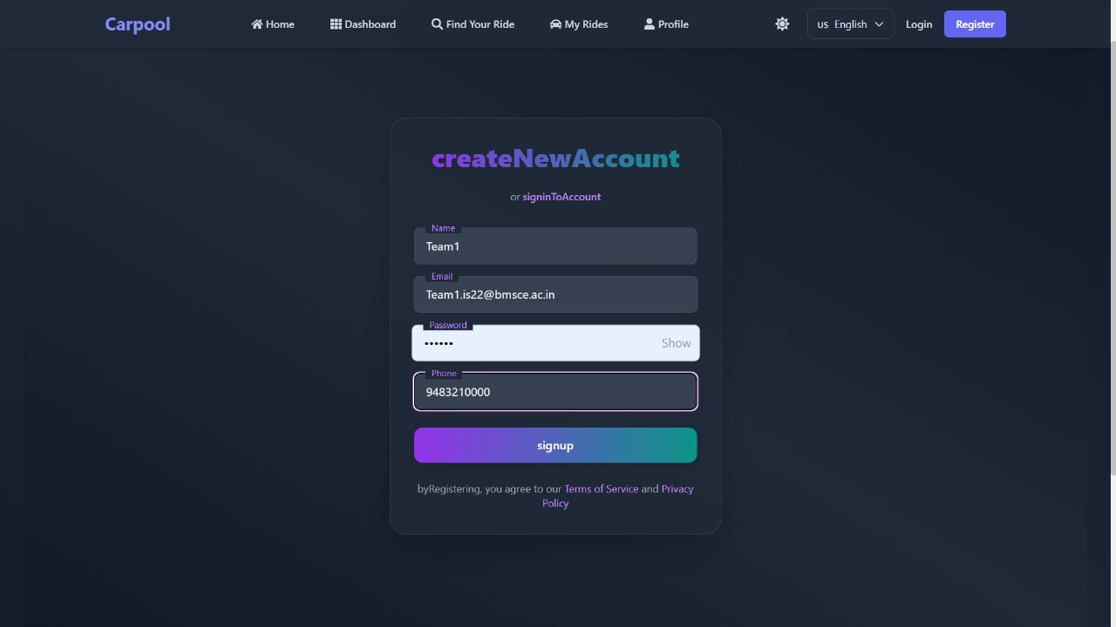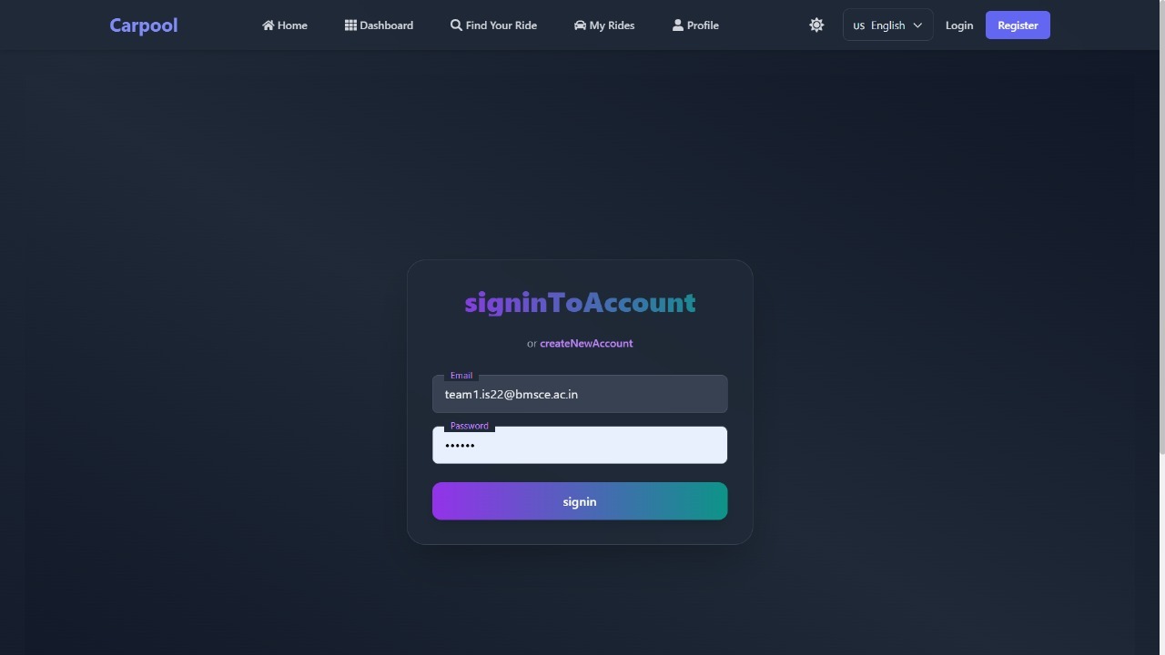**Login & Signup Module with Secure Authentication**

**Figure 1:** Login and Signup Page

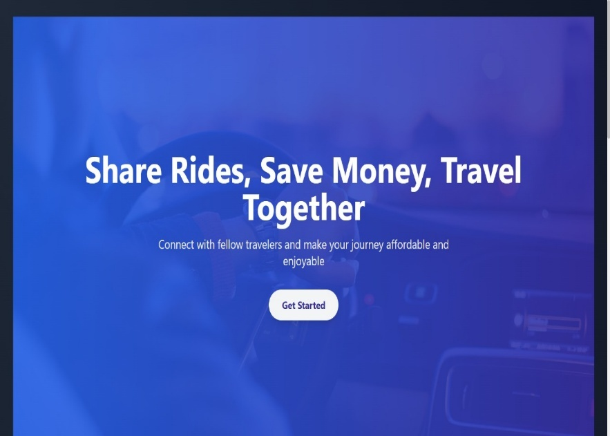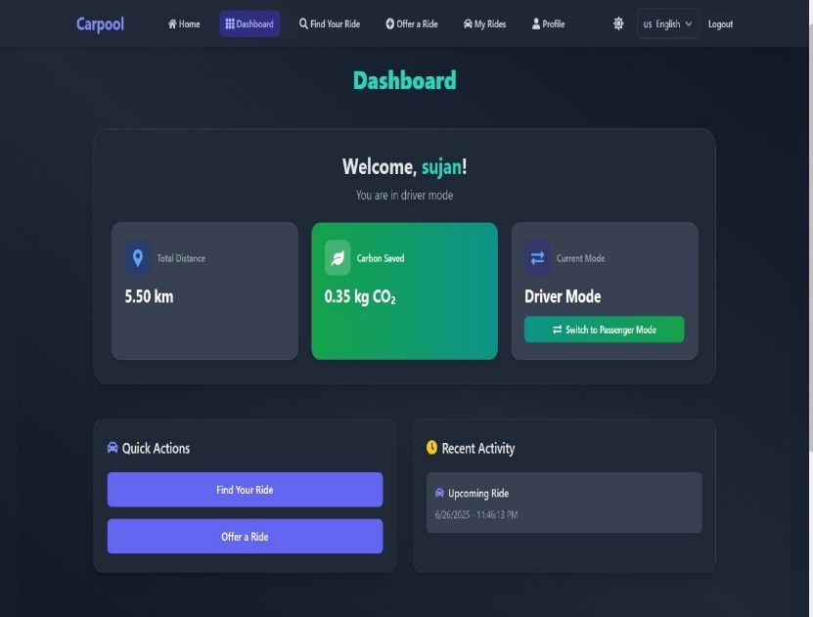**Home Page:** Clean, modern landing page with clear call-to-action buttons for registration

**Figure 2:** Home Page and Dashboard

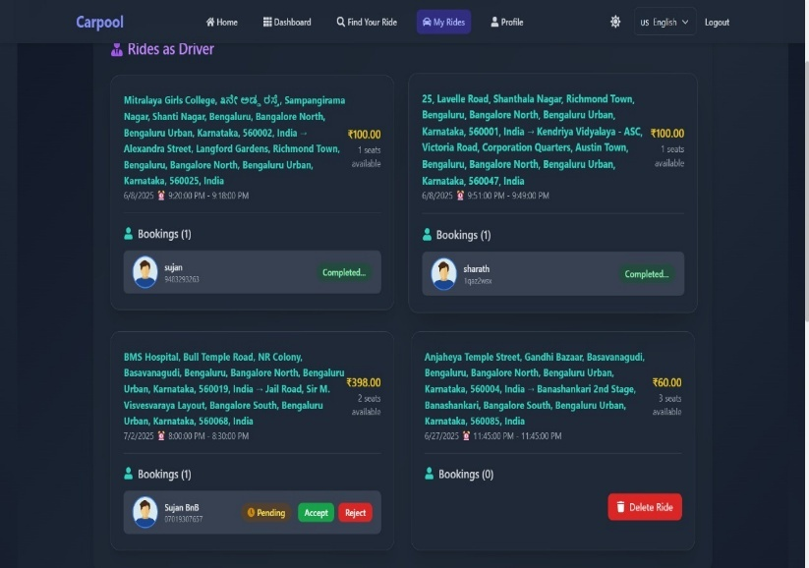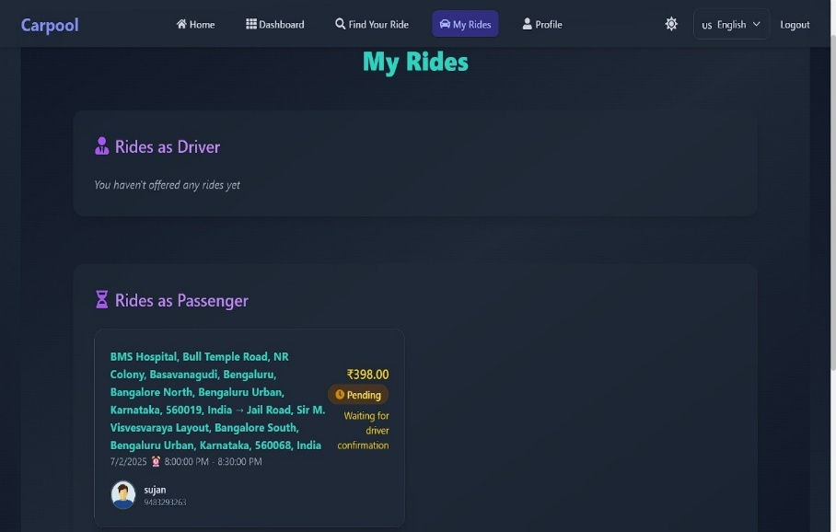**My Rides Page:** This section of the application provides users with a consolidated view of all their ride activities.

**Figure 3:** My Ride Section – Rides as Passenger and Driver

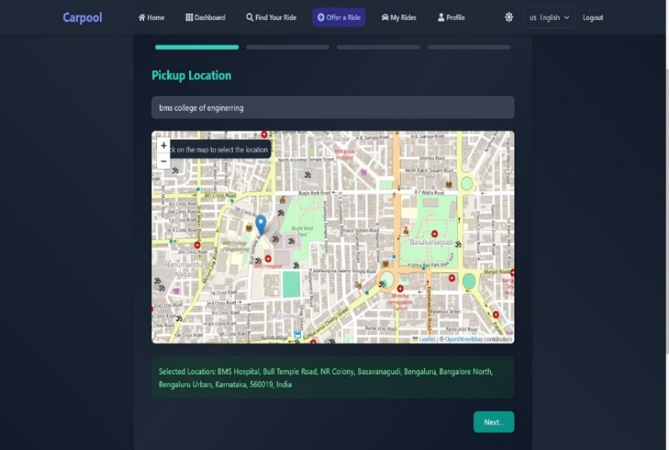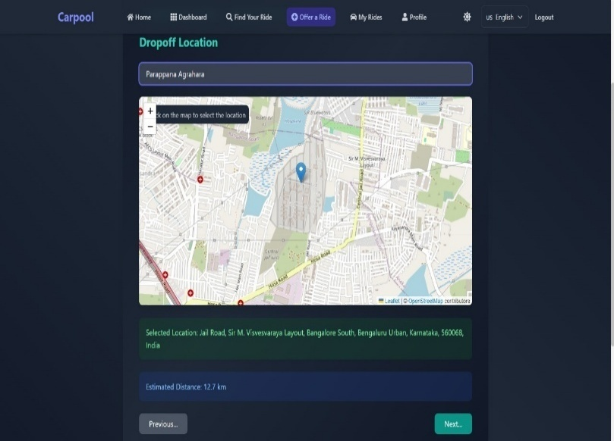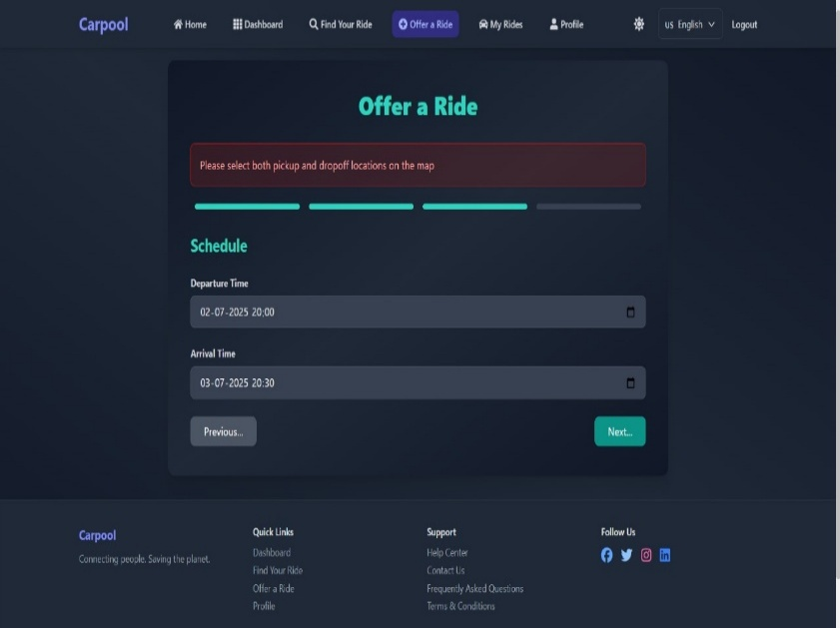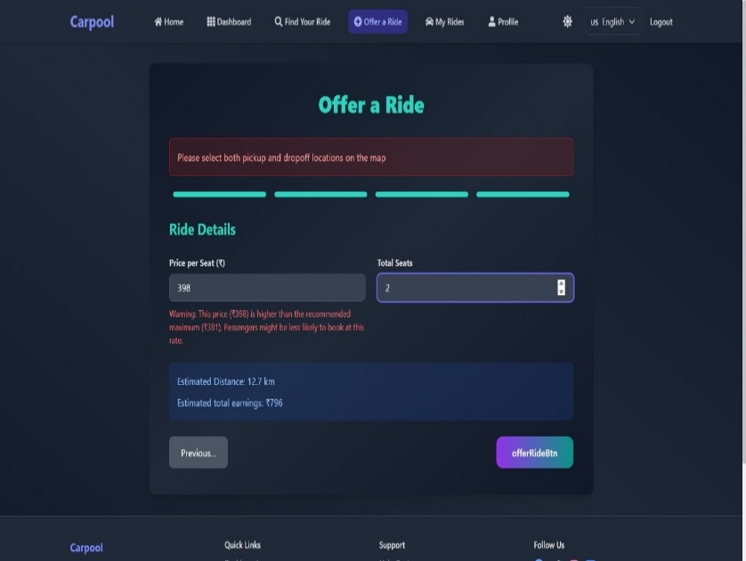**Offer Rides Page**: Drivers can offer rides by submitting a ride details form.

**Figure 4:** Levels of Offering a Ride as a Driver

**Profile Page**: Displays the user’s personal details and reviews received from other users.

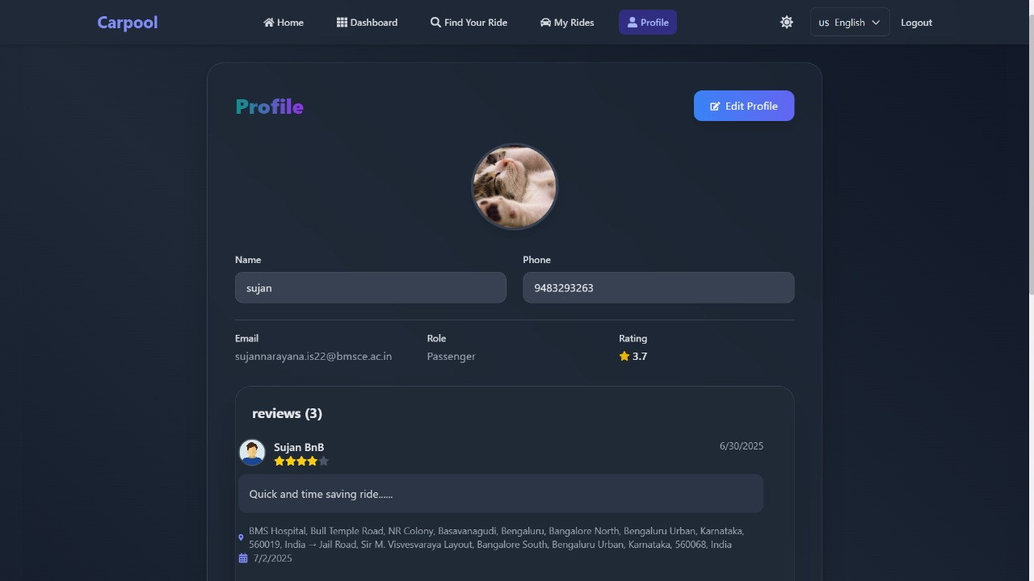

**Figure 5:** User (both passenger and driver) Profile Status

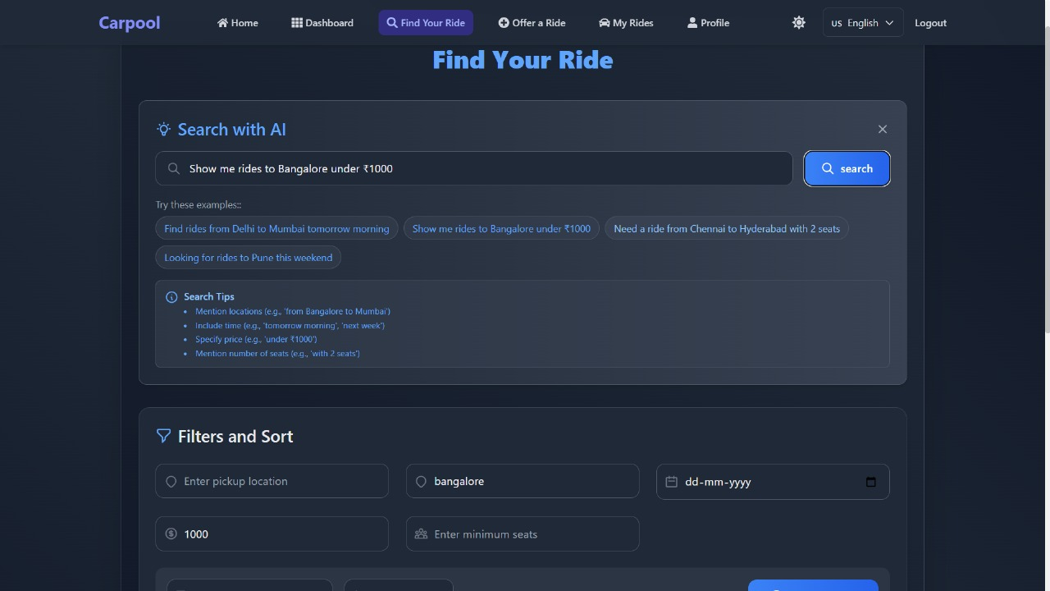**Find Ride Page**: Page allows users to search and book available rides based on source, destination, and date.

**Figure 6:** AI Powered Search Feature

**Filter and Sort**: The Find Ride page includes filter and sort options to help users narrow down rides by fare, time, seats, and driver ratings.

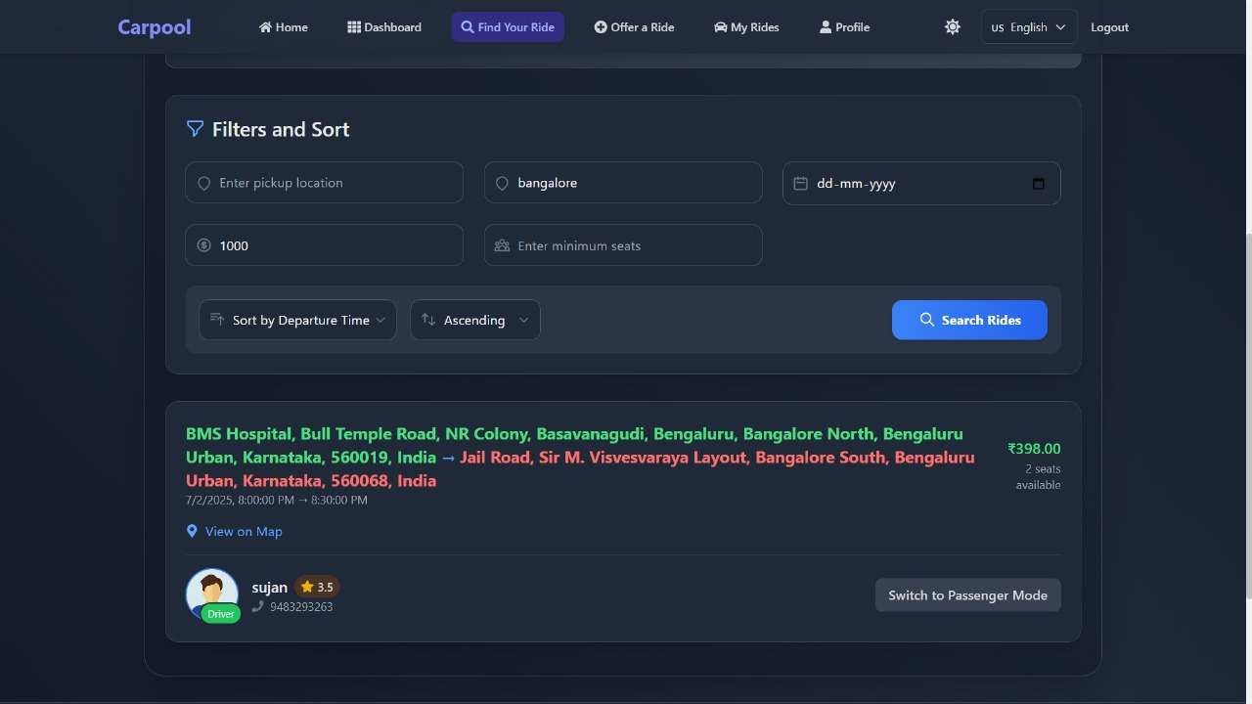

**Figure 7:** Filtering and Sorting out Rides

**Multi-lingual Property:**

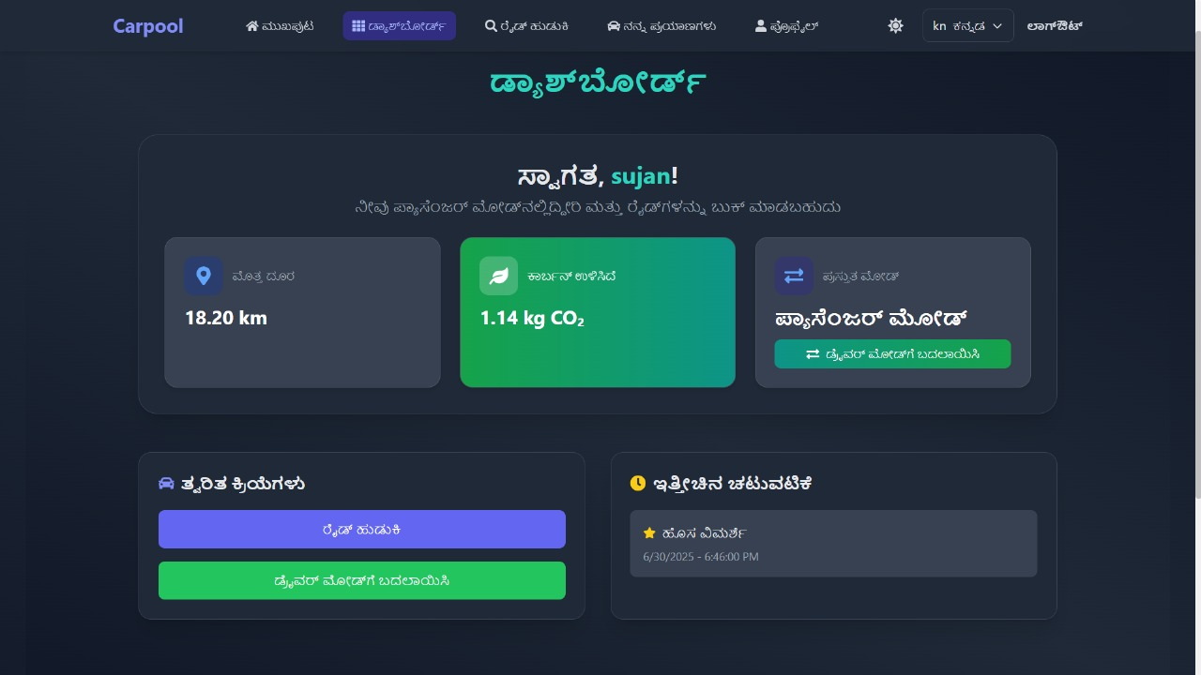

**Figure 8:** Dual-Language Integration

**Email System:** Provides users with booking status updates and feedback received from co-riders about their ride experiences.

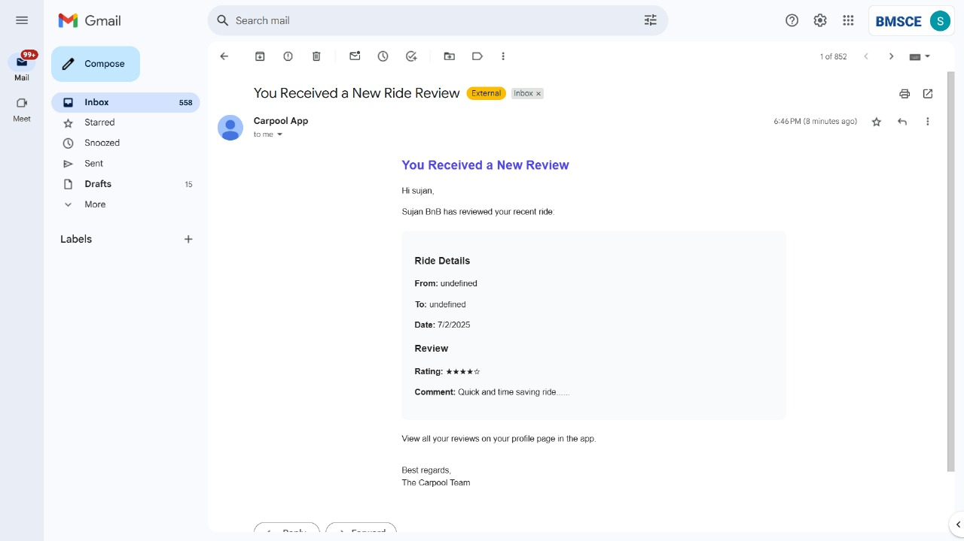

**Figure 9:** Updation of Reviews via Email

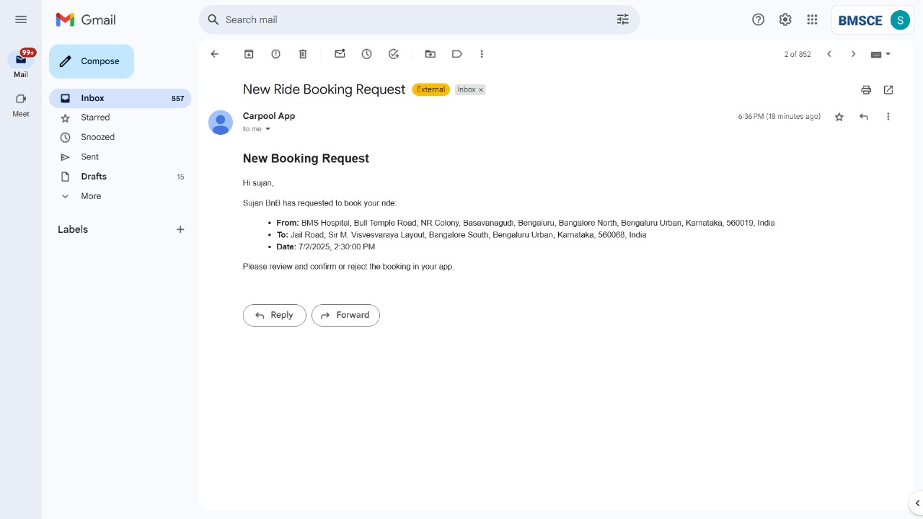

**Figure 10:** Ride and Booking Status alerts via Email

**User Dashboard and Navigation Driver Dashboard:** Personalized dashboard showing offered rides, pending bookings, and quick action buttons Rider Dashboard: Customized interface displaying booked rides, search shortcuts, and ride recommendations Navigation Menu: Responsive navigation with role-based menu items and user profile dropdown Profile Settings: Comprehensive profile management with photo upload and information editing.

**Ride Management Interfaces Offer Ride Form:** Detailed ride creation interface with route input, scheduling, and pricing options Ride Listing: Grid and list view of available rides with filtering sidebar and sorting options Ride Details: Comprehensive ride information page with booking button and driver profile My Rides Page: Organized view of user's rides separated by offered and booked categories.

**Search and Filtering Advanced Search:** Sophisticated filtering interface with location, time, price, and preference options AI Search Bar: Natural language search input with intelligent suggestions and auto-completion Search Results: Well-organized results with ride cards showing key information and booking status Map Integration: Optional map view showing ride routes and pickup/drop-off points.

**Booking and Communication Booking Confirmation:** Clear booking interface with ride details, terms, and confirmation button Booking Status: Real-time booking status with driver information and contact options Message Interface: In-app messaging system for driver-rider communication Notification Center: Centralized notifications for bookings, updates, and system messages.

**Mobile Responsive Design**

Mobile Dashboard: Touch-optimized dashboard with easy navigation and quick actions

Mobile Search: Streamlined search interface optimized for mobile interaction

Mobile Booking: Simple, one-touch booking process with clear confirmation steps

Mobile Menu: Collapsible navigation menu with gesture-friendly interface

**Multi-Language Support Language Switcher:** Dropdown language selector with flag icons and language names Localized Interface: Screenshots showing the application in different languages (English, Kannada) Currency, date, and time format adjustments for different regions.

#### 6.2 LINK TO DEPLOYED PROJECT

The Carpooling Web Application has been successfully deployed using modern cloud platforms, ensuring high availability, scalability, and performance.

**Frontend Application (React.js):**

Development URL: <https://carpoolingapp-iota.vercel.app/>

**Backend API (Express.js)**

Development URL: <https://carpoolingapp.onrender.com>

Health Check Endpoint: <https://carpoolingapp.onrender.com/api/health>

#### 7. CHALLENGES FACED AND LEARNINGS

**7.1 CHALLENGES FACED**

The development of the Carpooling Web Application presented numerous technical and architectural challenges that required innovative solutions and deep problem-solving skills. Each challenge provided valuable learning opportunities and contributed to the overall robustness of the application

**1. Backend and API Development Challenges:** Database Schema Design and Optimization Challenge: Designing an efficient relational database schema that could handle complex relationships between users, rides, bookings, and reviews while maintaining data integrity and query performance.

Solution Implemented: Created a normalized database structure with proper foreign key relationships Implemented composite indexes for frequently queried combinations (location + date + time) Used database transactions for operations involving multiple tables Added database constraints to ensure data consistency Implemented connection pooling to handle concurrent database requests efficiently.

CORS (Cross-Origin Resource Sharing) Configuration Challenge: Frontend and backend were deployed on different domains, causing CORS errors that blocked API requests from the React application.

**Solution Implemented:**

* Configured Express.js CORS middleware with specific origin whitelisting
* Set up proper preflight request handling for complex HTTP methods
* Implemented credential sharing for authenticated requests
* Created environment-specific CORS configurations for development, staging, and production Added proper error handling for CORS-related issues

**2. JWT Authentication and Token Management Challenge:** Implementing secure, stateless authentication while handling token expiration, refresh, and security concerns across different user sessions.

**Solution Implemented:**

* Designed a dual-token system with access tokens (short-lived) and refresh tokens (long-lived)
* Implemented automatic token renewal on the frontend
* Created secure token storage using httpOnly cookies for refresh tokens
* Added token blacklisting for logout functionality
* API Rate Limiting and Security Challenge: Protecting the API from abuse, spam, and potential security attacks while maintaining good user experience.
* Implemented rate limiting using express-rate-limit middleware
* Created different rate limits for different endpoints based on their sensitivity
* Added IP-based and user-based rate limiting strategies
* Implemented proper error responses for rate limit violations
* Added request logging and monitoring for security analysis

**3. Frontend Development Challenges:** State Management Complexity Challenge: Managing complex application state across multiple components, including user authentication, ride data, booking status, and UI preferences.

Solution Implemented:

* Utilized React Context API for global state management
* Created separate contexts for authentication, rides, and user preferences
* Implemented custom hooks for state logic encapsulation
* Used localStorage for persistent state where appropriate
* Added state synchronization between different browser tabs

Responsive Design and Cross-Browser Compatibility Challenge: Ensuring the application works seamlessly across different devices, screen sizes, and browsers while maintaining design consistency.

**Solution Implemented:**

* Adopted mobile-first design approach using Tailwind CSS
* Implemented comprehensive responsive breakpoints for all components
* Tested and optimized for major browsers (Chrome, Firefox, Safari, Edge)
* Used CSS Grid and Flexbox for layout consistency
* Added polyfills for older browser support where necessary

**4. Integration and Communication Challenges**: AI Natural Language Processing Integration Challenge: Implementing intelligent search functionality that could understand and parse natural language queries like "Ride from downtown to airport tomorrow morning."

**Solution Implemented:**

* Created custom JavaScript parsing logic using regular expressions
* Implemented keyword extraction and location matching algorithms
* Added date/time parsing for relative time expressions

**5. Database Migration Challenge**

* Initially, a basic database schema was created with core tables like users, rides, and bookings
* As the project developed, new requirements emerged—such as adding columns, changing data types, or renaming fields.
* Making these changes manually could lead to data loss, errors, and inconsistencies between local and deployed versions.

**Solution Implemented:**

* Used a **migration-based approach** to handle schema updates without affecting existing data.
* Maintained schema consistency across development and deployment environments.
* Improved tracking and collaboration by keeping all migrations in the project repository.

**6. Map Integration Challenge**

* Integration of an interactive map for selecting ride routes and displaying driver/passenger locations.
* Real-time GPS tracking and route visualization
* Drag-and-drop location selection functionality
* Geofencing and offline map caching capabilities

**Solution Implemented:**

**Map Integration with Leaflet API:**

* Used **Leaflet.js**, an open-source JavaScript library, to embed interactive maps on the frontend
* Enabled **marker placement and drag-and-drop** functionality for selecting source and destination.

**7. Feedback and Review System Challenge**

* Bidirectional rating system for drivers and riders
* Review validation, moderation, and authenticity verification
* Aggregate rating calculations and analytics
* Review response and reporting functionality

**Solution Implemented:**

**Optimistic UI Updates**:

* Show UI changes **before server confirms** (optimistic update).
* Revert on failure with user-friendly error messages.

**8. Real-Time State Synchronization Challenge**

* WebSocket implementation for instant ride status updates
* Event-driven architecture for driver-rider communication
* Optimistic UI updates with fallback mechanisms
* Conflict resolution for simultaneous updates

**Solution Implemented:**

**Data Consistency & Transactions**:

* Wrap multi-step DB updates in **atomic transactions**.
* Use **ACID-compliant databases** (PostgreSQL, MySQL) and **ORMs** with transaction support (e.g., Sequelize, SQLAlchemy)

**9. Additional Performance Challenges**

* Concurrent user management with database locking
* Data consistency and transaction management
* Search optimization and performance enhancements

#### 6.2. LEARNINGS

The development of this Carpooling Web Application provided extensive learning opportunities across multiple domains of full-stack web development. These learnings represent both technical skills acquired and practical insights gained through hands-on development experience.

**Technical Skills and Competencies Developed**

**Full-Stack JavaScript Mastery**

* Gained comprehensive understanding of the PERN stack architecture and component interactions
* Developed proficiency in modern JavaScript (ES6+) features including async/await, destructuring, and modules
* Learned to effectively manage JavaScript across both frontend and backend environments
* Understood the benefits and challenges of using JavaScript throughout the entire application stack

**React.js Advanced Concepts**

* Mastered React Hooks (useState, useEffect, useContext, useReducer) for functional component development
* Learned React Context API for global state management without external libraries
* Implemented custom hooks for reusable logic and state management
* Gained expertise in React Router for single-page application navigation
* Understood React component lifecycle and optimization techniques

**Backend API Development**

* Learned to design and implement RESTful APIs following industry best practices
* Gained proficiency in Express.js middleware development and routing
* Understood proper HTTP status codes, request/response patterns, and API versioning
* Learned to implement authentication and authorization mechanisms

**Database Design and Management**

* Acquired deep understanding of relational database design principles
* Learned PostgreSQL-specific features including indexing, constraints, and performance optimization
* Gained experience in database normalization and relationship modeling
* Understood transaction management and data consistency principles

**Security and Authentication**

**JWT-Based Authentication Systems**

* Learned to implement secure, stateless authentication using JSON Web Tokens
* Understood token lifecycle management including generation, validation, and revocation
* Gained experience in implementing token refresh mechanisms
* Learned security best practices for token storage and transmission

**Application Security Principles**

* Developed understanding of common web vulnerabilities (OWASP Top 10)
* Learned to implement input validation and sanitization
* Gained experience in preventing SQL injection, XSS, and CSRF attacks
* Understood proper password hashing and security practices
* Learned secure HTTP headers and CORS configuration

**Frontend Development and User Experience**

**Modern CSS and Responsive Design**

* Mastered Tailwind CSS utility-first approach for rapid UI development
* Learned advanced CSS techniques including Grid, Flexbox, and custom properties
* Gained expertise in responsive design principles and mobile-first development
* Understood design systems and component-based styling approaches.

**8. CONCLUSION**

The Carpooling Web Application stands as a testament to the successful application of modern web development technologies and practices in solving real-world transportation challenges. Through the comprehensive implementation of the PERN stack, the project has created a robust, scalable, and user-friendly platform that not only meets current carpooling needs but also provides a foundation for future innovation in the mobility sector. The technical achievements demonstrated throughout this project—from secure authentication systems and real-time communication to advanced mapping integration and multilingual support—showcase the depth of modern web development capabilities. The application successfully bridges the gap between drivers and riders while addressing critical concerns such as security, privacy, environmental impact, and user experience.

The extensive feature set, including dynamic role switching, intelligent search capabilities, comprehensive review systems, and environmental impact tracking, positions this application as a competitive solution in the ride-sharing market. The implementation of advanced technologies such as AI-powered matching, real-time tracking, and smart pricing algorithms demonstrates the project's forward-thinking approach and technical sophistication. Looking toward the future, the outlined enhancement roadmap provides a clear path for continued innovation and growth. From immediate improvements in AI integration and mobile experience to long-term visions of autonomous vehicle support and blockchain integration, the application is positioned to evolve with emerging technologies and changing user needs.

The success of this project extends beyond technical implementation to demonstrate the practical application of theoretical knowledge in creating solutions that address real societal needs. By reducing transportation costs, minimizing environmental impact, and fostering community connections through carpooling, the application contributes positively to sustainable urban mobility.

This comprehensive full-stack development project serves as both a practical solution to transportation challenges and a showcase of modern web development excellence. The combination of technical proficiency, user-centered design, and forward-thinking architecture creates a solid foundation for continued success and innovation in the rapidly evolving mobility technology landscape.