A
Project Report on

Online Mentorship Platform
Submitted to
Savitribai Phule Pune University
In the partial fulfillment of the requirement of the award of the degree of Bachelor of Computer Application,
TY BCA Science, Sem VI Academic Year 2025-26 By
Mr. H Shiv Kumar
Under the guidance of
Dr. Vikas Mahandule
Through



Alandi (D)- Pune 412105



Alandi (D) - Pune 412105

CERTIFICATE

Department of Computer Application

This is to certify that Mr. H Shiv Kumar of TY BCA (Science), Sem VI, Exam Seat No. [TE1103], has successfully completed project work entitled Online Mentorship Platform in the partial fulfillment of the requirement of the degree of Bachelor of Computer Application (Science) for the Academic Year 2025-26

Dr. Vikas Mahandule Prof. Amit Tale
Project Guide Head of the Department

Internal Examiner External Examiner

Acknowledgement

The words are not enough to express my thanks to Dr. B. B. Waphare, Principal, MIT Arts Commerce and Science College Alandi (D) for providing me with the opportunity to avail the excellent facilities and infrastructure of the institute.
It is my proud privilege to express my profound gratitude to Prof. Amit Tale, HOD, Computer Application Department, for his astute guidance, constant encouragement and sincere support throughout my academic course.
I thanks to my honest gratitude to Dr. Vikas Mahandule for his inspiration, constructive suggestions and affectionate guidance in my project work completion.
Last but not the least, I express my sincere thanks to all my dear friends and family members for their constant motivation, moral support and invariable direction throughout my life.

DECLARATION

I, Mr. H Shiv Kumar, hereby declare that this project work entitled Online Mentorship Platform submitted at MIT, Arts Commerce and Science College, Alandi(D), (Affiliated to Savitribai Phule Pune University) is a record of original work done by me under the supervision and guidance of Dr. Vikas Mahandule, Department of Computer Application.

Signature :
- Name of Student: H Shiv Kumar Exam Seat No:

Place : Alandi (D), Pune
Date :

Index

Chapter No. | Chapter Title | Page No.
CHAPTER 1 | INTRODUCTION | 2
1.1 | Problem Statement | 2-3
1.2 | Objective and goals | 3-4
1.3 | Project scope and limitations | 4-5
CHAPTER 2 | SYSTEM ANALYSIS | 6
2.1 | Existing systems | 6
2.2 | Project Perspective and Features | 7-8
2.3 | Functional Requirement | 8-9
2.4 | Hardware & Software Requirement | 9-10
CHAPTER 3 | SYSTEM DESIGN | 11
3.1 | System Architecture | 12
3.2 | System Model: DFD, ERD, Data Dictionary | 13-18
3.3 | User interfaces | 19-28
CHAPTER 4 | IMPLEMENTATION DETAILS | 29-30
CHAPTER 5 | FEATURES OF THE APPLICATION | 31
CHAPTER 6 | RESULTS / OUTPUT | 32
CHAPTER 7 | LIMITATIONS | 33
CHAPTER 8 | CONCLUSION & FUTURE SCOPE | 34
8.1 | Conclusion | 34
8.2 | Future Scope | 35
CHAPTER 9. | REFERENCES | 36

CHAPTER 1. INTRODUCTION

In today’s highly competitive academic and professional environment, mentorship plays a crucial role in guiding individuals toward achieving their career and personal development goals; however, traditional mentorship methods are often unstructured, limited by geographical barriers, and dependent on informal networks, making it difficult for learners to find suitable mentors. To address these challenges, the Online Mentorship Platform is developed as a web-based solution that enables seamless and structured interaction between mentors and mentees within a secure digital environment. The system aims to improve accessibility to mentorship by allowing mentees to discover mentors based on their skills, interests, and career objectives, send mentorship requests, and communicate through an integrated chat system, while mentors can create professional profiles, manage requests, and interact efficiently. The platform is built using Python Flask for backend development, SQLite for database management, and HTML, CSS, and JavaScript for the frontend interface, ensuring a lightweight and efficient full-stack solution. It incorporates essential features such as user registration and authentication, role-based access control, profile management, mentor recommendation based on matching logic, mentorship request approval workflow, secure communication with file-sharing capabilities, and support for both free and premium mentorship models with a mock payment system. Overall, the Online Mentorship Platform provides a comprehensive and scalable solution for managing mentorship activities, enhancing accessibility, improving communication, and fostering meaningful mentor-mentee relationships in a digitally connected environment.
.

Problem Statement

Many students and learners face difficulty in finding the right mentors for academic, technical, and career guidance due to the lack of a structured and reliable system. Traditional mentorship methods are often unorganized, time-consuming, and limited by geographical constraints and mentor availability, making it difficult for mentees to connect with suitable mentors. Additionally, there is no proper platform to manage mentorship requests, enable secure communication, or provide structured access to both free and premium mentoring services, which leads to inefficiency and poor user experience.
The problem addressed by this project is the absence of a centralized online platform where mentees can easily search for mentors, send mentorship requests, communicate effectively, and receive proper guidance in an organized manner. Therefore, this project aims to develop an Online Mentorship Platform that simplifies mentor-mentee interaction, enhances accessibility, and provides a structured and user-friendly environment for learning, support, and professional growth.

Objective and Goals

The objective of the proposed Online Mentorship Platform is to create a web-based system that connects mentors and mentees in an easy, efficient, and structured manner. The system aims to simplify mentorship by enabling mentees to find suitable mentors based on their interests, skills, and goals, while allowing mentors to manage their profiles, mentorship requests, and communication within a single platform.
The primary goals of the Online Mentorship Platform are:
- To provide a secure user registration and login system with role-based access for mentors and mentees.
- To enable users to create and manage detailed profiles including skills, interests, goals, and experience.
- To implement mentor discovery and recommendation based on matching between mentee preferences and mentor expertise.
- To develop a mentorship request system with proper handling of request status such as pending, accepted, and declined.
- To provide one-to-one communication between mentors and mentees through chat with file-sharing support.
- To include both free and premium mentorship options with a basic payment support system.
- To ensure secure data handling and controlled access to system features.
- To create a simple, user-friendly, and efficient platform that improves accessibility to mentorship and enhances learning and professional growth.

Project Scope and Limitations
Project Scope:
The proposed Online Mentorship Platform will consist of a web-based system that enables structured interaction between mentors and mentees. The platform will provide features for user registration, profile management, mentor discovery, communication, and mentorship access control in a centralized environment.
- User Registration and Login: Allow users to register and log in as mentors or mentees with secure authentication.
- Profile Management: Enable users to create and update profiles including skills, interests, goals, experience, and profile images.
- Mentor Discovery and Recommendation: Provide mentor listing and recommendation based on matching of user interests and goals.
- Mentorship Request System: Allow mentees to send requests and mentors to accept or decline them.
- Chat and File Sharing: Enable one-to-one communication with support for file attachments.
- Premium Mentorship Support: Include free and premium mentorship options with a mock payment feature.
- Centralized Data Management: Store and manage user data, requests, and messages using SQLite database.
- User-Friendly Interface: Provide a simple and interactive interface for smooth user experience.
- Role-Based Access Control: Ensure that mentors and mentees have access only to their respective features and functionalities, providing a secure and organized system experience.

Scope Limitations:
While the Online Mentorship Platform covers essential features required for mentor-mentee interaction, the scope of the project is limited to a basic academic-level implementation. The system focuses on core functionalities and does not include advanced or large-scale features that are typically required in real-world platforms. It does not support high user traffic, complex recommendation algorithms, or enterprise-level security and scalability. The payment system is limited to a mock implementation and does not handle real financial transactions. Additionally, advanced communication features such as video calling, live scheduling, and real-time notifications are not included within the scope. The platform also lacks an administrative module for monitoring and managing users. Therefore, the project is designed primarily as a prototype to demonstrate fundamental concepts rather than a fully developed commercial application.

  - Lack of Advanced Analytics: The system does not include detailed analytics or reporting tools to track user activity, mentorship effectiveness, or performance metrics, which are important for improving decision-making in real-world platforms.
  - No Multi-Language Support: The platform is designed for a single language interface and does not support multiple languages or accessibility features, limiting its usability for a diverse range of users.
  - Database Scalability Limitation: The use of SQLite as a database is suitable for small-scale applications but may not efficiently handle large datasets, high concurrency, or multi-user environments in real-world scenarios.
  - No Third-Party Integration: The system does not integrate with external services such as email notifications, cloud storage, or real payment gateways, which reduces its functionality and real-world applicability.
  - Limited Backup and Recovery: There are no advanced backup, restore, or disaster recovery mechanisms implemented, which may lead to data loss in case of system failure.

CHAPTER 2. SYSTEM ANALYSIS

Before implementing the Online Mentorship Platform, it is important to conduct a thorough system analysis to understand the current mentorship processes and identify the requirements needed for an effective solution. The existing mentorship approach is mostly informal, unstructured, and dependent on personal networks or multiple communication platforms, which creates difficulties in mentor discovery, request handling, and communication management. Therefore, the system analysis focuses on identifying stakeholders such as mentors and mentees, conducting a needs assessment to understand requirements like profile management, mentor matching, communication, and payment handling, and recognizing key pain points such as lack of centralized access, inefficient communication, and absence of structured workflows. Based on this analysis, the system requirements are defined, including features like user registration, role-based access, mentor recommendation, request approval system, chat with file sharing, and payment support. Additionally, system constraints such as limited scalability, use of SQLite database, mock payment functionality, and absence of advanced features are considered. This analysis ensures that the proposed system effectively addresses existing issues and provides a structured, user-friendly, and efficient mentorship solution.

Existing System
The existing mentorship process is largely informal and unstructured, where students and learners rely on personal contacts, social media platforms, or referrals to find mentors for academic, technical, or career guidance. This approach lacks a centralized system, making mentor discovery inconsistent and time-consuming. Communication between mentors and mentees typically occurs through various platforms such as messaging apps or emails, which are not designed specifically for mentorship, leading to scattered interactions and difficulty in maintaining proper records of discussions and progress.
Additionally, there is no standardized process for sending, accepting, or managing mentorship requests, which creates confusion and lack of accountability. Handling of mentorship, especially when it involves paid services, is mostly manual and unorganized, with no secure or reliable system for payments and access control. The absence of role-based access, data management, and structured communication further reduces the effectiveness of mentorship, resulting in delays, miscommunication, and limited learning outcomes for users.

Project Perspective and Features
Project Perspective:
The Online Mentorship Platform is a web-based application that provides a structured environment for interaction between mentors and mentees. From a project perspective, the following factors need to be considered:
• Scope: The project focuses on developing a centralized platform where users can register, manage profiles, and participate in mentorship activities.
• Timeframe: A proper timeframe is required to design, develop, test, and deploy the system considering features like chat and recommendation.
• Budget: The project uses open-source technologies, resulting in low development and deployment costs.
• Resources: Basic resources such as a computer system, internet connection, and development tools are required.
• Accessibility: The system is designed to allow users to connect online without geographical limitations, improving reach and usability.

Features:
The Online Mentorship Platform should include the following features to meet user needs and improve mentorship experience:
• User Authentication: The system should provide secure registration and login with role-based access for mentors and mentees.
• Profile Management: The system should allow users to create and update profiles including skills, interests, goals, and experience.
• Mentor Recommendation: The system should suggest mentors based on matching of mentee interests and goals.
• Request Management: The system should allow mentees to send mentorship requests and mentors to accept or decline them.
• Chat and File Sharing: The system should provide one-to-one communication with support for file attachments.
• Premium Mentorship: The system should include free and premium mentorship options with a mock payment feature.
• Profile Image Upload: The system should allow users to upload profile images with proper validation.

Functional Requirement

Functional requirements describe the features and capabilities that the Online Mentorship Platform must have to fulfill its intended purpose. These requirements define how the system should operate and interact with users. They ensure that all essential functionalities such as user management, communication, and mentorship processes are properly implemented. The following points outline the key functional requirements of the system:
- User Registration and Login: The system should allow users to register and log in using name, email, password, and role (mentor or mentee).
- Role-Based Dashboard: The system should redirect users to their respective dashboards based on their role after login.
- Profile Management: The system should allow users to create, view, and update profiles including skills, experience, interests, goals, and profile description.
- Mentor Recommendation: The system should provide mentor suggestions based on matching between mentee interests/goals and mentor skills.
- Mentorship Request: The system should allow mentees to send mentorship requests with a topic and message.
- Request Handling: The system should allow mentors to view incoming requests and accept or decline them.
- Chat System: The system should enable communication between mentor and mentee only after request approval.
- File Sharing: The system should allow users to send messages and share files such as documents, images, and zip files.
- Profile Image Upload: The system should allow users to upload profile images with supported formats.
- Payment Feature: The system should require payment for premium mentors before enabling chat access.
- Payment Management: The system should record payment details and update mentorship access status.
- Session Management: The system should allow users to log out securely after use.

Hardware & Software Requirement

Hardware and Software Requirements describe the technical resources needed to develop and run the Online Mentorship Platform effectively. These requirements define the minimum hardware configuration and software environment necessary for proper system performance. They ensure that the application runs smoothly, supports development tools, and maintains compatibility across different systems. The following points outline the hardware and software requirements of the system.
Hardware Environment:

Name | Details
Processor | Intel Core i3 or equivalent (32-bit / 64-bit)
RAM | 4 GB or more recommended
Hard Disk | Minimum 1 GB free space (more for uploads/logs)

Software Environment:

Name | Details
Operating System | Windows 10/11, Linux, macOS
Programming Language | Python 3.10+
Web Framework | Flask
Database | SQLite3
Frontend | HTML, CSS, JavaScript
Python Libraries | Flask, Werkzeug, sqlite3, pathlib
Browser | Chrome, Edge, Firefox

CHAPTER 3. SYSTEM DESIGN

The system design of the Online Mentorship Platform is based on a simple and efficient web application architecture. It uses Flask as the backend framework, SQLite as the database, and HTML, CSS, and JavaScript for designing the user interface. The system is modular in nature and is divided into key components such as user management, mentor request handling, chat system, profile management, and payment processing. This modular design ensures proper data flow, easy navigation, and smooth interaction between mentors and mentees, making the system organized, scalable, and user-friendly.

System Architecture

Architecture Components:
Client Layer (Presentation Tier): The client layer consists of HTML templates rendered by Flask, styled with CSS, and supported by basic JavaScript for user interaction. The frontend allows users to register, log in, manage profiles, send mentorship requests, make mock payments, and chat with file attachments through a web browser.
Application Layer (Logic Tier): Flask serves as the application layer, handling routing, session management, form processing, and access control. It receives HTTP requests, validates user input, manages mentor-mentee workflows, and returns the appropriate templates and responses for each user role.
Database Layer (Data Tier): SQLite acts as the database layer, storing user information, mentorship requests, chat messages, payment records, and profile details. It ensures that all application data is organized, retrieved, and updated efficiently to support the platform’s core functionality.

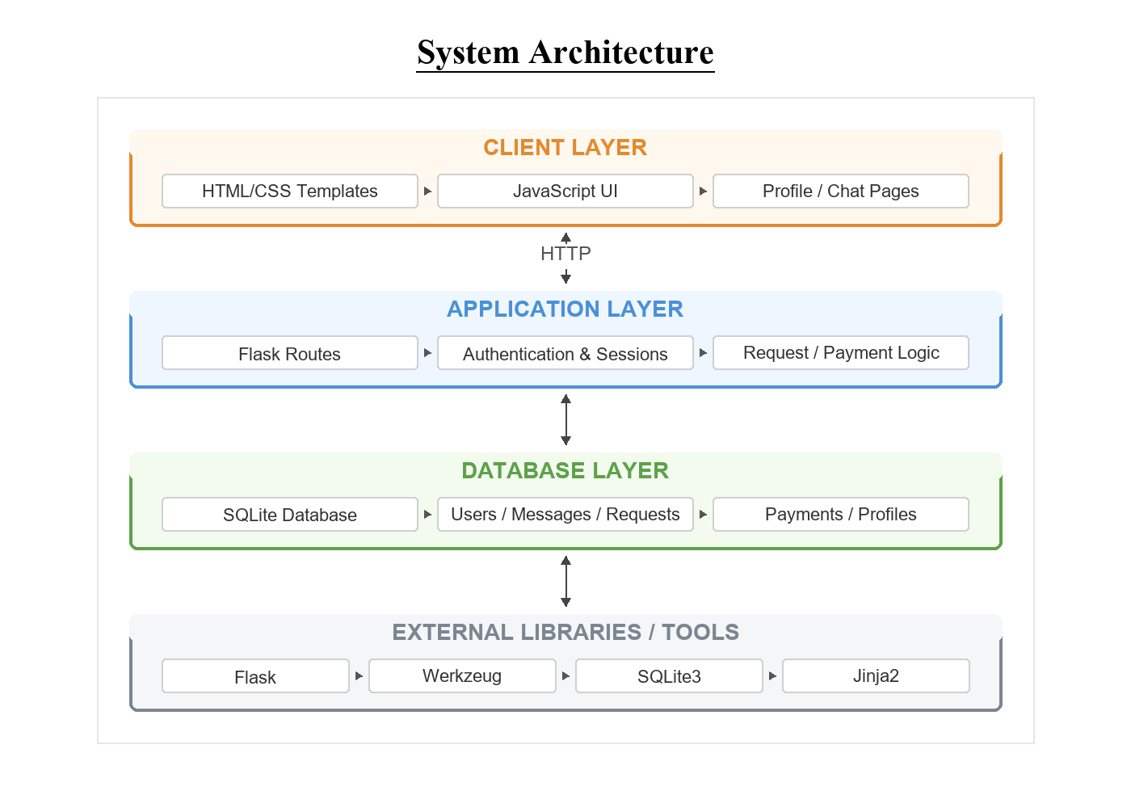
Data Flow:
The data flow of the Online Mentorship Platform follows these steps: (1) The process starts when the user opens the web application through a browser; (2) The user registers or logs in as a mentor or mentee, and the system validates the credentials; (3) After successful login, the user is directed to the dashboard where profile information is displayed; (4) The system checks whether mentorship access is approved and ready—if not, access is restricted and the user is prompted to retry; (5) If approved, the mentee can send a mentorship request and the mentor can accept it; (6) If the mentor has a premium plan, the mentee completes the payment process before gaining access; (7) Once access is granted, both users can communicate through chat and share files; (8) All messages, requests, and payment details are stored in the database; (9) Finally, the user logs out from the system, and the process ends.
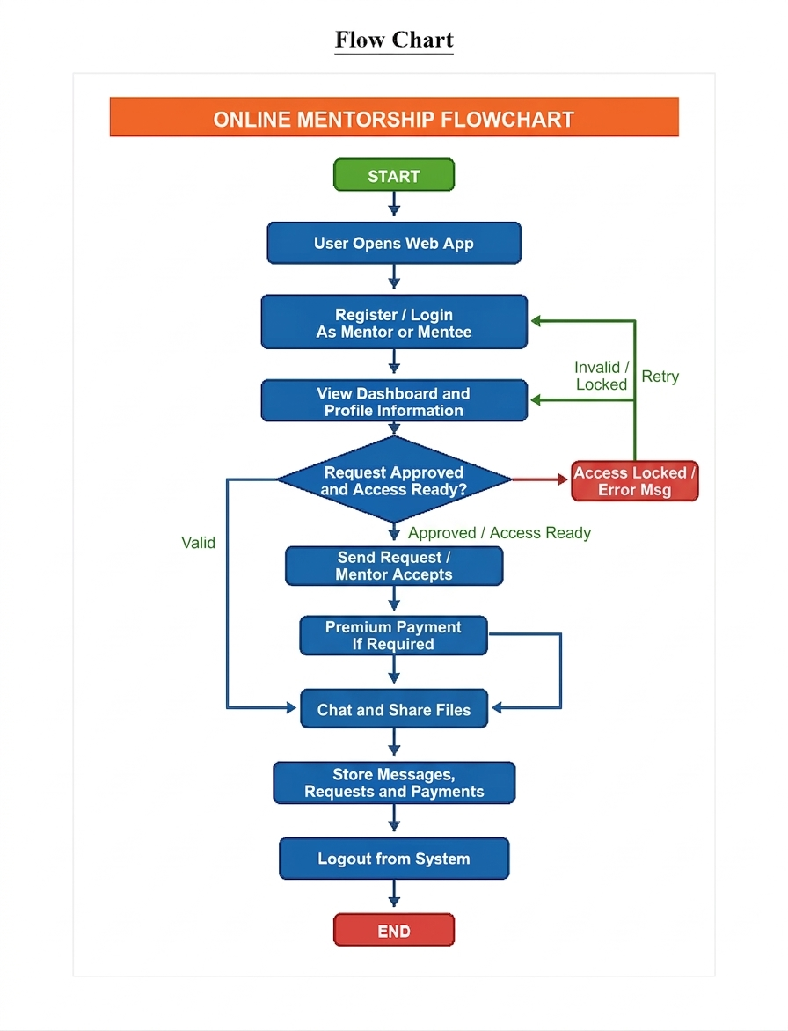

System Model: DFD, ERD, Data Dictionary Data Flow Diagram:

Context Level (0 Level) DFD

The Context Level DFD provides a high-level overview of the system. It represents the entire Online Mentorship Platform as a single process that interacts with external entities such as mentors and mentees.
The context level DFD illustrates the overall interaction between the Online Mentorship Platform and its external entities, namely the mentee and the mentor. The mentee sends inputs such as registration details, mentorship requests, and messages to the system, while receiving recommendations, replies, and request status in return. Similarly, the mentor interacts with the system by receiving requests and messages, and responds through profile updates, as well as accepting or declining mentorship requests. This diagram represents the system as a single process (0.0), showing how data flows between users and the platform in a simplified manner.

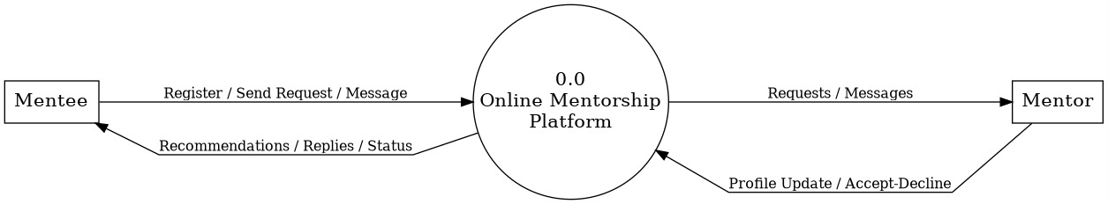

Level 1 DFD

This diagram illustrates the data flow through four main processes:
1.0 User Management: Handles user registration and login. It stores and retrieves user profile data from the database.
2.0 Mentor Matching: Provides mentor suggestions to the user based on interests, goals, and skills.
3.0 Request Handling: Manages mentorship requests. Users send requests, and the system tracks status (pending, accepted, declined).
4.0 Chat System: Enables communication between mentor and mentee after request approval. It stores and retrieves chat messages from the database.

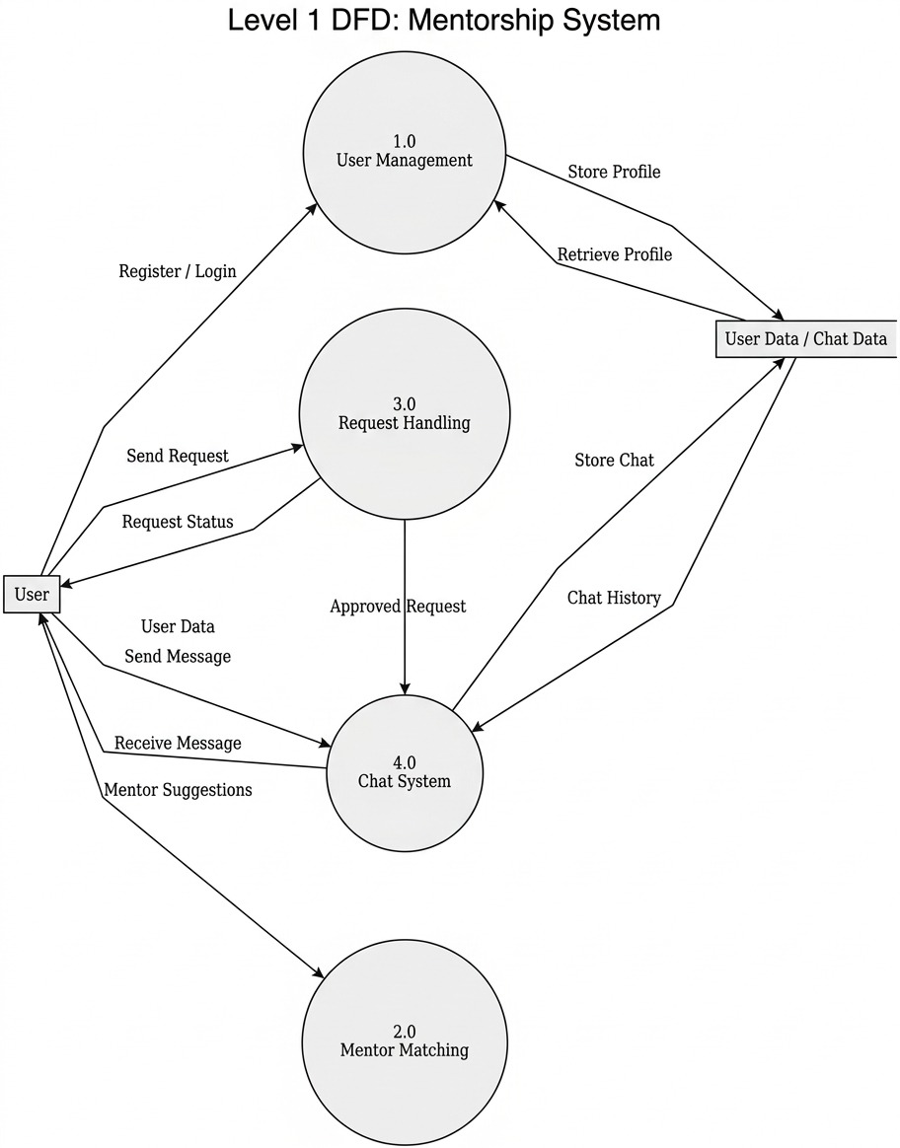

ER Diagram

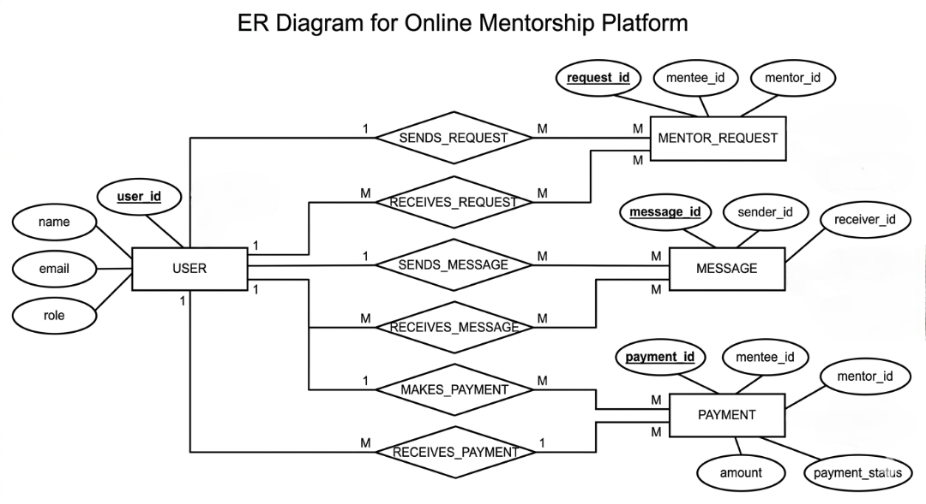
Data Dictionary – Online Mentorship Platform

- USER table

Field Name | Data Type | Key | Description
id | INTEGER | Primary Key | Unique identifier of the user
name | TEXT | - | Full name of the user
email | TEXT | Unique | Email address used for login
password_hash | TEXT | - | Encrypted password of the user
membership_type | TEXT | - | Type of mentor membership: free or premium
price | INTEGER | - | Amount charged for premium mentorship

- MESSAGE TABLE

Field Name | Data Type | Key | Description
id | INTEGER | Primary Key | Unique identifier of the message
sender_id | INTEGER | Foreign Key | References the sender user
receiver_id | INTEGER | Foreign Key | References the receiver user
body | TEXT | - | Text content of the message
attachment_name | TEXT | - | Name of attached file
attachment_path | TEXT | - | Stored path of attached file

- Mentor_Request TABLE

Field Name | Data Type | Key | Description
id | INTEGER | Primary Key | Unique identifier of the mentorship request
mentee_id | INTEGER | Foreign Key | References the mentee user
mentor_id | INTEGER | Foreign Key | References the mentor user
topic | TEXT | - | Topic selected for mentorship
request_message | TEXT | - | Message sent by mentee while requesting mentorship
status | TEXT | - | Request status: pending, accepted, or declined
Field Name | Data Type | Key | Description
id | INTEGER | Primary Key | Unique identifier of the payment
mentee_id | INTEGER | Foreign Key | ID of the mentee making the payment
mentor_id | INTEGER | Foreign Key | ID of the mentor receiving the payment
amount | INTEGER | - | Payment amount

- Payments

UI Design (Screens)

The user interface of the Online Mentorship platform is designed with a modern and visually appealing layout, featuring a clean header, smooth gradient colours, and intuitive navigation. The design uses card-based components, soft shadows, and a structured layout to enhance readability and user interaction. The main screen includes:
• Navigation Bar: A top navigation bar displaying the platform name “MentorLink” along with options like Home, Login, Register, and a Dark Mode toggle for better user experience.
• Landing Section: A prominent heading “Connect with industry mentors. Learn, grow, and achieve your goals.” that clearly communicates the purpose of the platform, along with a short descriptive text.
• Call-to-Action Buttons: Buttons such as “Find a Mentor” and “Become a Mentor” to guide users towards key actions on the platform.
• Information Card: A side panel showing the mentorship flow steps such as creating a profile, getting matched, and starting one-to-one chat.
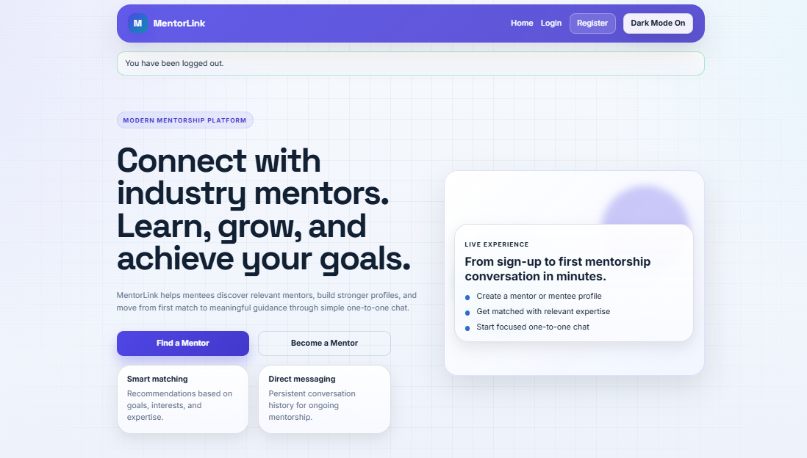

Registration (UI interface)
The registration interface of the Online Mentorship platform is designed with a clean and structured layout, combining a simple form design with helpful guidance for users. The main screen includes:
• Header Section: Navigation bar with options like Home, Login, Register, and Dark Mode toggle.
• Introduction Panel: A left-side section displaying the heading “Join MentorLink as a mentor or mentee” along with brief instructions and profile tips.
• Registration Form: A well-organized form on the right side including fields such as Full Name, Email, Password, Role selection, and Profile Image upload.
• Profile Details Section: Additional fields for headline, bio, skills, interests, and goals to create a detailed user profile.
• User Guidance: Tips and helper text are provided to assist users in filling accurate and meaningful information
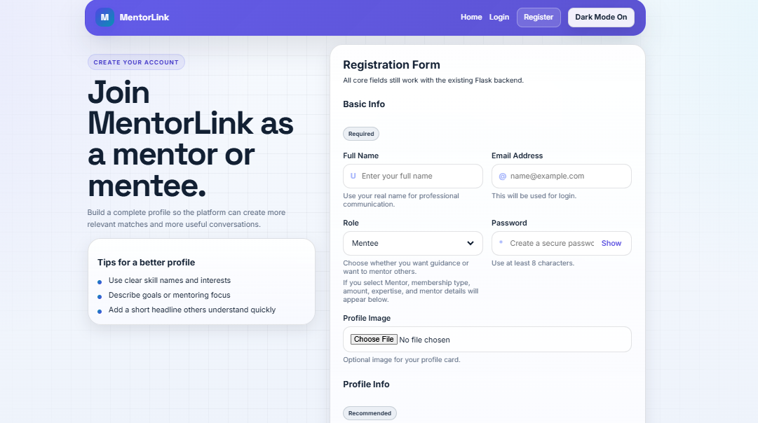

Login Page (Sign in Interface)
The login page of the Online Mentorship platform is designed with a clean and modern layout to provide a smooth and secure sign-in experience. The left side displays a welcoming message “Continue your mentorship journey” along with a brief description to guide users. On the right side, a structured login form is provided with fields for email and password, along with options like “Remember Me” and “Forgot Password” for better usability. A prominent “Sign In” button allows users to access their dashboard easily, and a link is provided for new users to create an account. The overall design ensures simplicity, clarity, and ease of navigation.
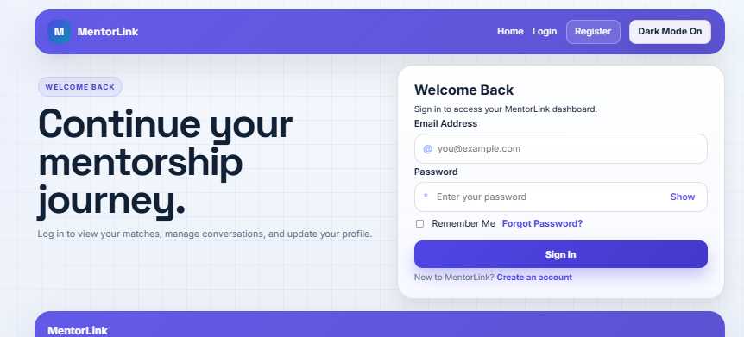
Key features
• User-Friendly Form: Simple input fields for email and password with clear labels.
• Password Visibility: Option to show/hide password for convenience.
• Additional Options: “Remember Me” and “Forgot Password” features for better user control.
• Call-to-Action Button: Clearly visible “Sign In” button for quick access.
• Signup Link: Option for new users to create an account easily
Mentee Dashboard
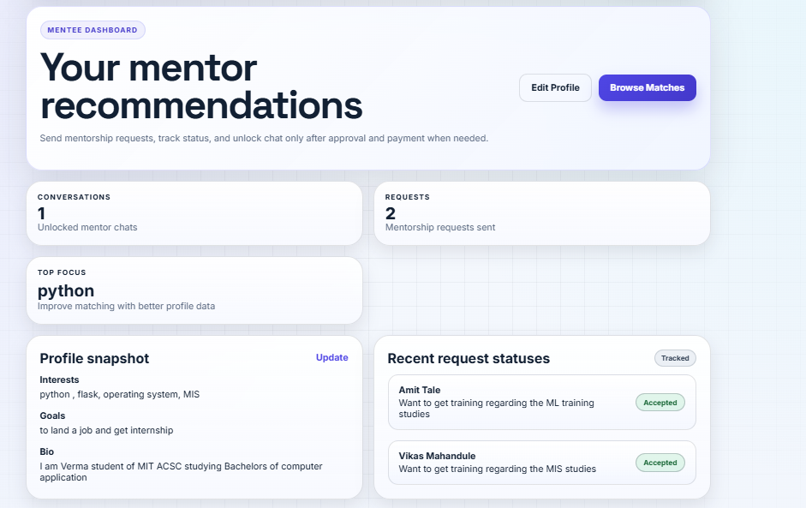
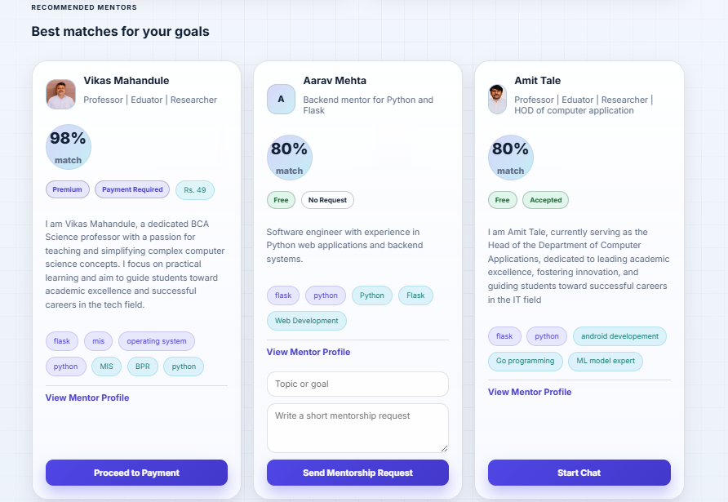

Mentee Dashboard (User Interface)
The mentee dashboard of the Online Mentorship platform provides a centralized and user-friendly interface that helps users manage their mentorship journey efficiently. It displays personalized mentor recommendations, request statuses, and profile details in a clean and organized layout. The dashboard allows mentees to explore suitable mentors, send requests, track progress, and access chats after approval, ensuring a smooth and structured mentorship experience.
Key Features:
• Mentor Recommendations: Displays best-matched mentors based on skills, interests, and goals with match percentage.
• Mentor Cards: Each mentor card shows profile details, expertise, tags, and actions like “View Profile,” “Send Request,” or “Start Chat.”
• Request Management: Allows users to send mentorship requests and track their status (pending/accepted).
• Dashboard Overview: Shows summary details like number of conversations, requests sent, and focus area.
• Profile Snapshot: Displays user interests, goals, and bio with an option to update profile.
• Recent Activity: Section to view latest request updates and their status.
• Action Buttons: Options like “Edit Profile” and “Browse Matches” for easy navigation.
The mentee dashboard of the Online Mentorship platform provides a well-structured and efficient interface that enables users to manage their entire mentorship journey in one place. It combines mentor recommendations, request tracking, and profile management into a single view, making it easy for mentees to find suitable mentors, communicate effectively, and monitor their progress. Overall, the dashboard enhances user experience by offering a clear, organized, and interactive environment for continuous learning and guidance.

Mentor Dashboard (User Interface)

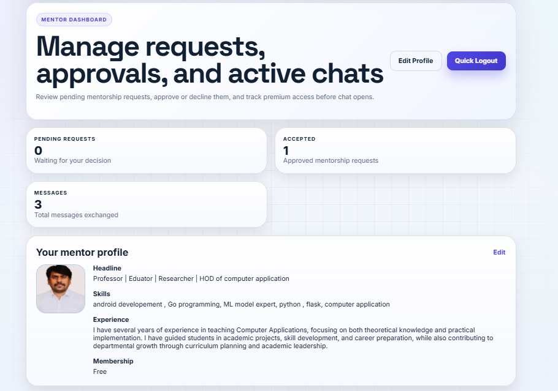

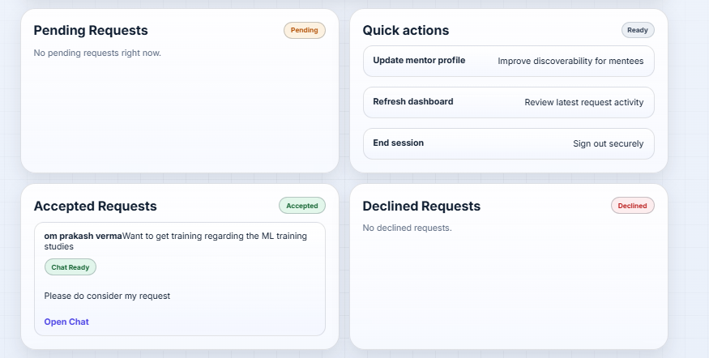

Mentor Dashboard (User Interface)
The mentor dashboard of the Online Mentorship platform is designed to help mentors efficiently manage mentorship requests, approvals, and ongoing conversations in a structured and organized manner. It provides a clear overview of pending requests, accepted mentorships, and message activity, along with quick access to profile management and session controls. The dashboard ensures that mentors can easily review requests, take actions, and interact with mentees through a simple and user-friendly interface.
Key Features:
• Request Overview: Displays the number of pending and accepted mentorship requests.
• Request Management: Allows mentors to view, accept, or decline mentorship requests.
• Chat Access: Enables mentors to start or continue chats with accepted mentees.
• Profile Section: Shows mentor details such as headline, skills, experience, and membership with an edit option.
• Quick Actions: Provides options like updating profile, refreshing dashboard, and secure logout.
• Message Summary: Displays total messages exchanged for tracking communication activity.

Conclusion (Mentor Dashboard)
The mentor dashboard provides a centralized and efficient interface for managing mentorship activities, enabling mentors to handle requests, maintain their profiles, and communicate with mentees seamlessly. It enhances productivity by offering a clear, organized, and easy-to-use system for managing the entire mentorship process.

Chat Module (Direct Communication Interface)

The chat module of the Online Mentorship platform provides a clean and structured interface for one-to-one communication between mentors and mentees. It allows users to interact seamlessly after mentorship request approval, ensuring controlled and secure communication. The interface displays conversation details, message history, and file-sharing options in an organized layout for better usability

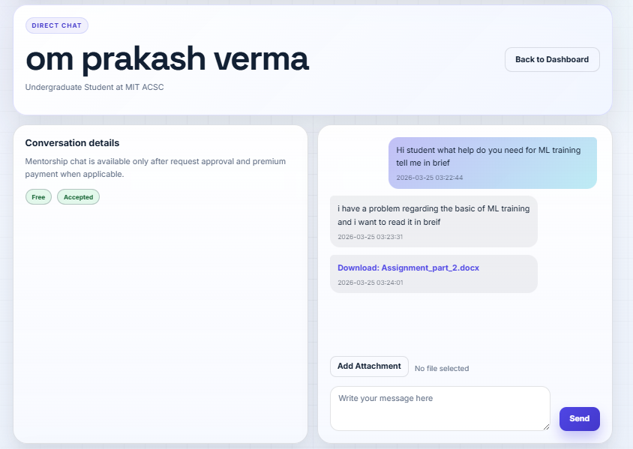

Feedback / Contact Module
The feedback module of the Online Mentorship platform provides a simple and user-friendly interface for users to share their suggestions, report issues, or contact the support team. It ensures smooth communication between users and the platform administrators by offering both direct contact options and a structured feedback form.
Key Features:
• User Input Fields: Includes fields for name, email, and feedback message for clear communication.
• Feedback Form: Allows users to write and submit their queries or suggestions easily.
• Contact Options: Provides buttons like “Email MentorLink Team” and “Contact Support” for quick access.
• Call-to-Action Button: “Send Feedback” button to submit the message efficiently.
• User Guidance: Includes helpful text to guide users on how to use the form.
• Simple Interface: Clean and minimal design for better usability.

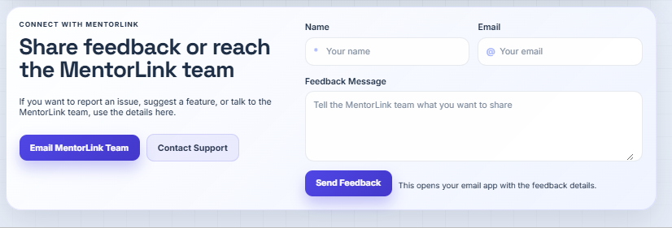

CHAPTER 4. IMPLEMENTATION DETAILS

4.1 Technology Stack
The Online Mentorship Platform is implemented as a web-based application using Python Flask as the backend framework. Flask handles routing, form processing, session management, and communication between the frontend and database. SQLite is used as the database to store user data, mentorship requests, messages, and payment records. The frontend is developed using HTML, CSS, and JavaScript to provide a simple and user-friendly interface.

4.2 User Authentication Module
The implementation begins with user authentication where users can register and log in as either mentors or mentees. During registration, user details such as name, email, password, and role are stored securely in the database. After successful login, session management is used to maintain user access, and users are redirected to their respective dashboards based on their roles.

4.3 Profile Management Module
The system allows users to create and update their profiles. Mentors can add details such as skills, experience, pricing, and membership type, while mentees can specify their interests and goals. The system also supports profile image upload to enhance user identity and profile presentation.

4.4 Mentor Recommendation and Request Module
The platform provides a mentor recommendation feature based on matching mentee interests and goals with mentor skills. Mentees can send mentorship requests by specifying a topic and message. Mentors can view incoming requests and accept or decline them. The system maintains proper request flow and status updates.

4.5 Chat and Communication Module
The chat functionality is implemented to allow communication only after mentorship request approval. Users can exchange text messages and share files such as documents and images. File upload and sharing are handled securely within the application.

4.6 Payment Module
For premium mentors, the system includes a mock payment module. Mentees are required to complete payment before accessing chat with premium mentors. Payment details are stored in the database and used to control mentorship access.

4.7 Database Management
SQLite is used to manage all application data, including users, mentorship requests, messages, and payments. Database operations are performed using SQL queries to ensure efficient data storage and retrieval.

4.8 System Integration
All modules such as authentication, profile management, mentor recommendation, request handling, chat, and payment are integrated into a single system. This ensures smooth interaction between frontend, backend, and database, resulting in a complete and functional Online Mentorship Platform.

CHAPTER 5. FEATURES OF THE APPLICATION

The Online Mentorship Platform provides a useful set of features designed to support smooth interaction between mentors and mentees. These features help users register, connect, communicate, and manage mentorship activities in an organized digital environment.
Feature | Description
User Registration | Allows new users to create an account as a mentor or mentee
User Login | Provides secure login access using registered email and password
Profile Management | Enables users to create and update personal, academic, and professional details
Mentor Recommendation | Suggests suitable mentors based on mentee interests, goals, and mentor skills
Mentorship Request | Allows mentees to send mentorship requests with topic and message
Request Approval | Enables mentors to accept or decline mentorship requests
Chat System | Allows communication between mentors and mentees after approval
File Sharing | Supports sending documents and images through chat
Premium Mentorship | Allows mentors to offer free or premium mentorship plans
Payment Module | Unlocks premium mentor access through mock payment functionality
Role-Based Dashboard | Provides separate dashboard views for mentors and mentees

CHAPTER 6. RESULTS / OUTPUT

The Online Mentorship Platform successfully implements all the planned features with proper functionality and reliable performance. The application provides a structured and user-friendly environment where mentors and mentees can connect, communicate, and manage mentorship activities efficiently. The system demonstrates smooth operation across all major modules and fulfills the intended objectives of the project.
The following outcomes were achieved through the development of this project:
- User registration and login are successfully implemented for both mentors and mentees.
- Profile management allows users to add and update personal, academic, and professional details.
- Mentor recommendation helps mentees find suitable mentors based on interests, goals, and skills.
- Mentorship request functionality allows mentees to send requests and mentors to accept or decline them.
- Dashboard features provide role-based access and display relevant information for mentors and mentees.
- Chat functionality enables communication between approved mentor-mentee pairs.
- File sharing in chat allows users to upload and exchange supported documents and images.
- Premium mentorship access is supported through membership type and payment-based unlocking.
- Profile image upload is implemented to improve user identity and profile presentation.
- Data is stored and managed effectively using SQLite, ensuring proper handling of users, messages, requests, and payments.
Overall, the project meets its main objectives and demonstrates that the Online Mentorship Platform can function as a useful and practical system for guidance, communication, and mentorship management.

CHAPTER 7. LIMITATIONS

While the Online Mentorship Platform provides useful features for connecting mentors and mentees, there are certain limitations that should be considered. These limitations arise mainly due to the scope of the project being designed as an academic prototype and the use of basic technologies and simplified implementations. Although the system performs its core functionalities effectively, it lacks some advanced features, scalability, and real-world integration capabilities that are required for a fully developed commercial platform:
- The system uses SQLite as the database, which is suitable for small to medium-scale applications but not ideal for handling large-scale data and heavy concurrent users.
- The payment module is a mock implementation and does not support real online transactions through secure payment gateways.
- The platform supports chat and file sharing, but it lacks advanced communication features such as video calling, audio calls, and live meeting scheduling.
- Mentor recommendation is based on simple matching of skills, interests, and goals, which may not always provide highly accurate results.
- The system does not include an admin panel for monitoring activities, managing users, or handling issues and disputes.
- Real-time notifications for messages, request updates, and payments are not implemented in the current version.
- The application depends on internet connectivity and server availability, which may affect performance if the system is offline or resources are limited.
- Security and scalability features are basic, making the project more suitable as an academic prototype rather than a large-scale commercial platform.

CHAPTER 8. CONCLUSION & FUTURE SCOPE

Conclusion
The Online Mentorship Platform is a web-based application developed to create a proper connection between mentors and mentees in an organized, simple, and effective manner. The main purpose of this project is to reduce the difficulty faced by students, learners, and job seekers in finding the right guidance for academic, technical, and career-related growth. By using this platform, users can connect digitally without depending on physical meetings, making mentorship more accessible, flexible, and convenient.
This project successfully implements the essential functionalities required in a mentorship system. It provides secure user registration and login for both mentors and mentees, profile creation and management, mentor recommendation based on interests and goals, mentorship request handling, and communication through chat. It also supports file sharing, profile image uploads, and both free and premium mentorship options. The inclusion of a payment feature for premium mentors ensures controlled and structured access to mentorship services.
From a technical perspective, the system is built using Python Flask for backend development, SQLite for database management, and HTML, CSS, and JavaScript for the frontend interface. The design is simple, modular, and suitable for academic implementation. It demonstrates how key concepts like database integration, role-based access, request processing, and communication can be combined into a single working system.
In conclusion, the Online Mentorship Platform fulfils its objective of providing a structured and efficient environment for mentor-mentee interaction. It enhances accessibility, simplifies communication, and supports learning and professional growth. Although the system has certain limitations, it serves as a strong foundation for future improvements and can be expanded into a more advanced and scalable real-world application.

Future Scope

Future versions of Online Mentorship Platform can be extended to include advanced features:

  - The system can be enhanced by adding real-time video calling and meeting scheduling to improve interaction between mentors and mentees.
  - A notification system can be implemented to inform users about new messages, request updates, and payment status.
  - The platform can integrate a real online payment gateway instead of the current mock payment system.
  - Advanced search and filtering options can be added to help mentees find mentors based on domain, experience, rating, and availability.
  - A feedback and rating system can be introduced along with an admin panel for better management and control.
  - Mobile application support can be developed to improve accessibility and user experience.
  - AI-based mentor recommendation can be implemented to provide smarter and more accurate matching.
  - Features like progress tracking and learning resource sharing can be added to enhance the overall mentoring experience.

CHAPTER 9. REFERENCES

- Flask Documentation. (2024). Flask Web Framework. Available at: https://flask.palletsprojects.com/
- Python Software Foundation. (2024). Python Documentation. Available at: https://docs.python.org/3/
- SQLite Documentation. (2024). SQLite Database Engine. Available at: https://www.sqlite.org/docs.html
- Mozilla Developer Network (MDN). (2024). HTML, CSS, and JavaScript Documentation. Available at: https://developer.mozilla.org/
- W3Schools. (2024). Web Development Tutorials. Available at: https://www.w3schools.com/
- Werkzeug Documentation. (2024). WSGI Utility Library for Python. Available at: https://werkzeug.palletsprojects.com/
- GitHub. (2024). Code Hosting and Version Control Platform. Available at: https://github.com/

