**AWS-Fundamental**

**Benefit of Cloud**

**o Security**

--> AWS provides a wide range of security services and features to protect data and infrastructure. This includes secure access controls, encryption, DDoS protection, network firewalls, and threat detection mechanisms. AWS has a strong track record of maintaining the security and compliance of its services

**o Reliability**

-->AWS offers a highly reliable infrastructure with built-in redundancies and failover mechanisms. It operates data centers in multiple geographic regions, allowing for replication and backup of data across different locations. This ensures that applications and services hosted on AWS have minimal downtime and are available to users at all times.

**o High Availability**

-->AWS provides the capability to design applications that are highly available and fault-tolerant. It offers services such as Elastic Load Balancing, Auto Scaling, and Amazon Route 53 that distribute traffic across multiple instances and regions, automatically scale resources based on demand, and provide DNS management for routing traffic to the most available resources.

**o Elasticity**

-->AWS enables businesses to scale their resources up or down based on demand. With services like Amazon EC2 Auto Scaling and Amazon RDS, businesses can automatically adjust the capacity of their applications to handle spikes or drops in traffic. This elasticity allows for cost optimization and ensures that resources are allocated efficiently.

**o Agility**

-->: AWS offers a wide range of services and tools that enable rapid development and deployment of applications. It provides pre-configured templates, managed services, and a vast marketplace of third-party integrations, allowing businesses to quickly build, test, and deploy applications without worrying about infrastructure provisioning and management.

**o Pay-as-you go pricing**

-->AWS follows a pay-as-you-go model, where businesses only pay for the resources they consume. There are no upfront costs or long-term commitments, and pricing is based on actual usage. This allows businesses to scale their infrastructure according to their needs and optimize costs by avoiding over-provisioning.

**o Scalability**

-->AWS provides the ability to scale resources both vertically and horizontally. Vertical scaling involves increasing the capacity of individual resources, such as upgrading the size of an instance. Horizontal scaling involves adding or removing resources to handle changes in demand. AWS services like Amazon EC2, Amazon S3, and Amazon DynamoDB offer easy scalability options.

**o Global Reach**

-->AWS operates a global infrastructure with data centers located in multiple regions around the world. This allows businesses to deploy their applications closer to their users, reducing latency and improving performance. AWS also offers content delivery services like Amazon CloudFront, enabling businesses to distribute content globally with low latency.

**o Economy of scale**

-->AWS's vast customer base and extensive infrastructure allow it to achieve economies of scale. This means that businesses can benefit from lower costs compared to building and managing their own infrastructure. Additionally, AWS regularly introduces new services and features, providing access to cutting-edge technologies without the need for significant upfront investments.

**Total Cost Ownership Proposal(TCO)**

**1)OpEx(Operational Expenses)**

-->It is defined as ongoing /daily expenses that require the operation of a system or infra, including subscription fees, data transfer costs, monitoring, management tools, software licenses, etc.

**2)CapEx(Capital Expenses)**

-->It is defined as the total cost required to build infrastructure including all types of hardware, software, networking equipment etc.

**3)Labor Cost**

-->IT is a cost associated with the number of employees required to run and maintain the operation.

**Design Principles**

**1)Decouple Components Versus Monolithic Architecture**

-->Decoupling components refers to designing systems where individual components or services are loosely connected and can operate independently. This approach allows for flexibility, scalability, and easier maintenance. In contrast, a monolithic architecture tightly couples all components, making it harder to scale, update, and maintain. By decoupling components, each service can evolve independently, leading to more agility and better overall system performance.

**2)Implement Elasticity in the Cloud versus On-Premises:**

--> Elasticity refers to the ability to dynamically scale resources based on demand. Cloud environments provide inherent capabilities for elastic scaling, allowing applications to automatically adjust resource allocation to match workload fluctuations. On-premises environments typically have limited scalability options due to infrastructure constraints. Leveraging the cloud's elasticity enables businesses to optimize resource usage, improve performance, and achieve cost efficiency by scaling resources up or down as needed.

**AWS Responsibility**

1)AWS is responsible for securing cloud infra and its services like compute network and storage.

2)Providing high availability and durability of its services

3)Providing high security of data and services.

**Cloud Service Model**

**1. Infrastructure as a Service (IaaS):**

IaaS is the most basic cloud service model. It provides customers with virtualized computing resources over the Internet. With IaaS, customers have control over their operating systems, applications, and data, while the cloud provider manages the underlying infrastructure, including servers, storage, and networking. Customers can scale their resources up or down as needed, paying only for the resources they consume. Popular IaaS examples include Amazon EC2, Microsoft Azure Virtual Machines, and Google Compute Engine.

**2. Platform as a Service (PaaS):**

PaaS builds upon the infrastructure layer and offers a higher level of abstraction. It provides a platform on which customers can develop, deploy, and manage their applications without worrying about the underlying infrastructure. PaaS typically includes development tools, middleware, databases, and runtime environments. Customers focus on application development and data, while the cloud provider manages the infrastructure, operating system, and networking aspects. PaaS enables faster application development and deployment. Examples of PaaS offerings include AWS Elastic Beanstalk, Microsoft Azure App Service, and Google App Engine.

**3. Software as a Service (SaaS):**

SaaS is the highest level of abstraction in the cloud service model. It delivers fully functional applications over the internet. Customers can access and use software applications without the need for installation, maintenance, or infrastructure management. The cloud provider hosts and manages the entire software application stack, including the infrastructure, platform, and application itself. Users only need a web browser or a specific client to access the SaaS application. Popular examples of SaaS include Salesforce, Microsoft Office 365, and Google Workspace.

**Cloud Deployment Models**

**1)Public Cloud**

→A public cloud is a deployment model where cloud services and resources are provided by a third-party cloud service provider and made available to the general public over the Internet.

**Ex: AWS, Microsoft Azure, GCP**

**2)Hybrid**

→A hybrid cloud deployment model combines elements of both public and private clouds. It involves the integration and orchestration of resources across multiple environments,

**3)On-Premises**

→A private cloud is a deployment model where cloud services and resources are exclusively used by a single organization. In a private cloud, the infrastructure can be owned, managed, and operated by the organization itself or by a third-party provider

**BASIC AWS TERMS**

**1)Region**

→AWS divides the world into geographical regions, which are separate geographic areas with multiple data centers. Each region is designed to be isolated from other regions in terms of infrastructure, power, and network connectivity. AWS Regions are identified by names such as "us-west-2" (Oregon) or "eu-central-1" (Frankfurt). Regions are entirely independent of each other, and they are isolated to provide fault tolerance and minimize the impact of potential disasters or outages.

**2)AZ-Availability Zones**

→Within each AWS Region, there are multiple Availability Zones. An Availability Zone is essentially a separate data center within a region. These zones are physically separate from each other and are connected through high-speed, low-latency links. The purpose of Availability Zones is to provide fault tolerance and resilience. By deploying resources across multiple Availability Zones, you can achieve high availability and redundancy for yours.

**3)Edge Location**

→Edge Locations, sometimes referred to as Points of Presence (PoPs), are endpoints of the AWS global network infrastructure. These locations are spread across different cities worldwide and are separate from AWS Regions and Availability Zones. Edge Locations are used to accelerate content delivery and reduce latency for end users accessing AWS services. They act as caching endpoints for services like Amazon CloudFront, AWS's content delivery network (CDN). Edge Locations are strategically placed in areas with high user demand, allowing for faster content delivery by caching frequently accessed content closer to the end user.

The relationships among these components are as follows:

* Regions consist of multiple Availability Zones and are completely independent of each other.
* Each Availability Zone within a Region is a physically separate data center with its own power, network, and cooling infrastructure.
* Edge Locations are distributed globally and act as endpoints of AWS's global network infrastructure. They are not directly related to Regions or Availability Zones but serve as caching endpoints for content delivery.

At a high level, both Amazon CloudFront and AWS Global Accelerator leverage the concept of Edge Locations to provide benefits such as improved performance, low latency, and high availability for applications and content delivery.

**Amazon CloudFront:**

* Amazon CloudFront is a content delivery network (CDN) service provided by AWS. It uses a global network of Edge Locations to cache and deliver content to end users with low latency. Some benefits of Edge Locations in the context of CloudFront include:
* Improved Performance: By caching content at Edge Locations closest to end users, CloudFront reduces the round-trip time required to fetch content from origin servers. This leads to faster delivery and improved performance for users accessing the content.
* Reduced Latency: Edge Locations bring content closer to end users geographically, minimizing the distance data needs to travel. This results in lower latency and faster response times for content delivery.
* Scalability: CloudFront's Edge Locations are distributed globally, allowing for scalability to handle high volumes of traffic and concurrent requests. The distributed nature of Edge Locations helps distribute the load and reduces the burden on origin servers.
* High Availability: CloudFront uses Edge Locations to provide redundancy and failover capabilities. If one Edge Location becomes unavailable, CloudFront automatically routes requests to the nearest available Edge Location, ensuring high availability and reliability.

**AWS Global Accelerator:**

* AWS Global Accelerator is a service designed to improve the availability and performance of applications for a global user base. It leverages the AWS network infrastructure and a global network of Edge Locations to provide the following benefits:
* Improved Performance: Global Accelerator uses the AWS network backbone to route user traffic to the nearest Edge Location. This reduces the distance and network hops, resulting in lower latency and improved application performance.
* High Availability: Global Accelerator automatically detects unhealthy endpoints and routes traffic to healthy endpoints, providing failover capabilities and high availability for applications. It ensures that user traffic is directed to healthy endpoints, minimizing downtime and service disruptions.
* Global Reach: Global Accelerator leverages Edge Locations in multiple regions worldwide, allowing businesses to reach a global user base with reduced latency and improved connectivity.
* Simplified Network Management: Global Accelerator simplifies network management by providing a single static IP address that can be used as an entry point for your applications. It eliminates the complexity of managing multiple IP addresses and helps streamline network configuration.

**AWS CONNECTIVITY OPTIONS:**

**1)VPN**

→VPC is a virtual network service offered by AWS that allows you to create an isolated virtual network environment in the cloud. It enables you to define your own IP address range, subnets, routing tables, and network gateways. With VPC, you have control over network configuration and can launch AWS resources like EC2 instances, RDS databases, and load balancers within your virtual network. VPC uses the public internet as the underlying network infrastructure, and you can connect to your VPC using VPN or Direct Connect.

**2)AWS DIRECT CONNECT**

→AWS Direct Connect is a dedicated network connection service that provides a private and dedicated connection between your on-premises network and AWS. It bypasses the public internet, offering a more reliable, secure, and consistent network performance compared to VPN. With Direct Connect, you can establish a high-speed, low-latency connection to your AWS resources, making it suitable for scenarios that require large data transfers, real-time applications, or low-latency access to AWS services. Direct Connect is typically used for hybrid cloud deployments, where you need a dedicated and private connection between your on-premises infrastructure and AWS.

**AWS Identity Access Management (IAM)**

AWS Identity and Access Management (IAM) is a web service offered by Amazon Web Services (AWS) that helps you securely control access to AWS services and resources. IAM allows you to manage users, groups, roles, and policies to control who can do what in your AWS environment.

**Feature of IAM**

**1)Shared access to your AWS account**

-->You can grant other people permission to administer and use resources in your AWS account without having to share your password or access key.

**2)Granular permissions**

-->You can grant different permissions to different people for different resources. For example, you might allow some users complete access to Amazon Elastic Compute Cloud (Amazon EC2), Amazon Simple Storage Service (Amazon S3), Amazon DynamoDB, Amazon Redshift, and other AWS services. For other users, you can allow read-only access to just some S3 buckets, or permission to administer just some EC2 instances, or to access your billing information but nothing else.

**3)Secure access to AWS resources for applications that run on Amazon EC2**

-->You can use IAM features to securely provide credentials for applications that run on EC2 instances. These credentials provide permissions for your application to access other AWS resources. Examples include S3 buckets and DynamoDB tables.

**4)Multi-factor authentication (MFA)**

-->You can add two-factor authentication to your account and to individual users for extra security. With MFA you or your users must provide not only a password or access key to work with your account but also a code from a specially configured device. If you already use a FIDO security key with other services, and it has an AWS-supported configuration, you can use WebAuthn for MFA security

**5)Identity federation**

-->You can allow users who already have passwords elsewhere—for example, in your corporate network or with an internet identity provider—to get temporary access to your AWS account.

**6)Identity information for assurance**

-->If you use AWS CloudTrail, you receive log records that include information about those who made requests for resources in your account. That information is based on IAM identities.

**7)Free to use**

-->AWS Identity and Access Management (IAM) and AWS Security Token Service (AWS STS) are features of your AWS account offered at no additional charge. You are charged only when you access other AWS services using your IAM users or AWS STS temporary security credentials.

**# IAM USER AND GROUP**

→ IAM enables you to create groups and users. A group is a collection of IAM users with similar permissions, making managing and assigning permissions to multiple users easier. Users are individual identities that can be assigned to groups and granted permission directly.

**#ROLES**

→ Roles in IAM are used to grant permissions to entities that are not AWS identities, such as AWS services or external applications. Roles allow you to define a set of permissions and then assign those permissions to AWS services or entities that assume the role temporarily.

**#Policies:**

IAM policies are JSON documents that define permissions for users, groups, or roles. Policies specify what actions are allowed or denied on which resources. There are two types of policies in IAM:

a. Managed Policies: Managed policies are standalone policies that can be attached to multiple IAM identities. AWS provides a set of pre-defined managed policies, such as AdministratorAccess or ReadOnlyAccess, which contain commonly used permissions. These policies are maintained by AWS and can be attached to multiple users, groups, or roles.

b. Custom Policies: Custom policies are created and managed by you. They are specific to your use case and can be attached to IAM users, groups, or roles. Custom policies give you more granular control over permissions by allowing you to define precise permissions for individual resources or actions.

**AWS SERVICES**

**AWS Compute Services**

**1)Amazon Elastic Compute Cloud (Amazon EC2):**

Amazon EC2 is a web service that provides resizable computing capacity in the cloud. It allows you to provision virtual servers, known as instances, with different configurations (e.g., CPU, memory, storage) to meet your specific needs. EC2 supports a wide variety of operating systems and offers flexibility in terms of scalability, security, and control over your compute resources.

**2)Amazon Elastic Container Service (Amazon ECS):**

Amazon ECS is a fully managed container orchestration service that enables you to run and manage Docker containers. It simplifies the deployment and scaling of containerized applications by handling the underlying infrastructure management. Amazon ECS integrates with other AWS services such as Elastic Load Balancing, Amazon VPC, and AWS IAM to provide a comprehensive container management solution.

**3)AWS Lambda:**

AWS Lambda is a serverless computing service that lets you run code without provisioning or managing servers. With Lambda, you can execute code in response to events, such as changes to data in an Amazon S3 bucket or updates to a DynamoDB table. It supports multiple programming languages, and you only pay for the compute time consumed by your code.

**4)Amazon Lightsail:**

Amazon Lightsail is a simplified computing service that offers virtual private servers (instances) with pre-configured resource bundles. It is designed for developers, small businesses, or those getting started with AWS who require a straightforward and cost-effective solution. Lightsail provides a user-friendly interface and takes care of the underlying infrastructure management tasks.

**5)AWS Elastic Beanstalk:**

AWS Elastic Beanstalk is a platform-as-a-service (PaaS) offering that simplifies the deployment and management of web applications. You can deploy your application code in multiple languages, and Elastic Beanstalk automatically handles capacity provisioning, load balancing, and scaling. It supports popular development platforms such as Java, .NET, Node.js, PHP, Python, and Ruby.

**6)Amazon EC2 Auto Scaling:**

Amazon EC2 Auto Scaling enables you to automatically scale the number of Amazon EC2 instances based on predefined conditions. You can set up scaling policies to ensure that your applications have enough capacity to handle the workload efficiently. EC2 Auto Scaling integrates with other AWS services like Amazon CloudWatch for monitoring and maintaining the desired number of instances.

**7)AWS Batch:**

AWS Batch is a fully managed service that helps you run batch computing workloads in the cloud. It allows you to define jobs, specify dependencies, and allocate the required compute resources automatically. AWS Batch optimizes the distribution of your workloads and dynamically scales the resources based on demand.

**Type Of EC2 Instance**

1. **General Purpose Instances**: These instances provide a balance of computing, memory, and networking resources and are suitable for a wide range of applications.

Example: m5.large (2 vCPUs, 8 GB RAM)

Use Cases: Web servers, small to medium-sized databases, development, and test environments

1. **Compute-Optimized Instances:** Designed for computationally intensive workloads, these instances offer a high-performance CPU, ideal for applications that require high computing power.

Example: c5.4xlarge (16 vCPUs, 32 GB RAM) Use Cases: High-performance computing (HPC), scientific modeling, gaming servers, media transcoding.

1. **Memory-Optimized Instances:** These instances are optimized for memory-intensive workloads and provide a larger amount of RAM relative to CPU power.

Example: r5.8xlarge (32 vCPUs, 256 GB RAM)

Use Cases: In-memory databases (e.g., Redis), real-time big data processing, high-performance data analytics

1. **Storage-Optimized Instances**: Designed for workloads that require high-speed, low-latency access to data, these instances offer large amounts of local storage.

Example: i3.2xlarge (8 vCPUs, 61 GB RAM, NVMe SSD storage)

Use Cases: NoSQL databases (e.g., Cassandra), distributed file systems, data warehousing, log processing.

1. **GPU Instances**: These instances are equipped with powerful Graphics Processing Units (GPUs), making them suitable for applications that require substantial parallel processing capabilities, such as machine learning, 3D rendering, and video encoding.

Example: p3.2xlarge (1 NVIDIA V100 GPU, 16 GB GPU memory)

Use Cases: Machine learning, deep learning, video encoding, graphics-intensive applications.

1. **FPGA Instances**: These instances include Field-Programmable Gate Arrays (FPGAs), which can be customized to accelerate specific workloads, such as genomics research or financial simulations.
2. **AWS Graviton Instances**: These instances are powered by Arm-based processors and are optimized for performance, cost-efficiency, and power efficiency.

Example: m6g.large (2 vCPUs, 8 GB RAM)

Use Cases: Web servers, microservices, containerized applications, cost-effective workloads.

1. **AWS Inferentia Instances:** These instances are designed for running machine learning inference workloads at scale, leveraging custom-built chips known as AWS Inferentia.

Example: inf1.X-Large (4 vCPUs, 8 GB RAM, AWS Inferential chips)

Use Cases: Machine learning inference, natural language processing, computer vision.

1. **Bare Metal Instances:** These instances provide direct access to the underlying hardware and are suitable for workloads that require access to specific hardware features or applications with specific licensing requirements.

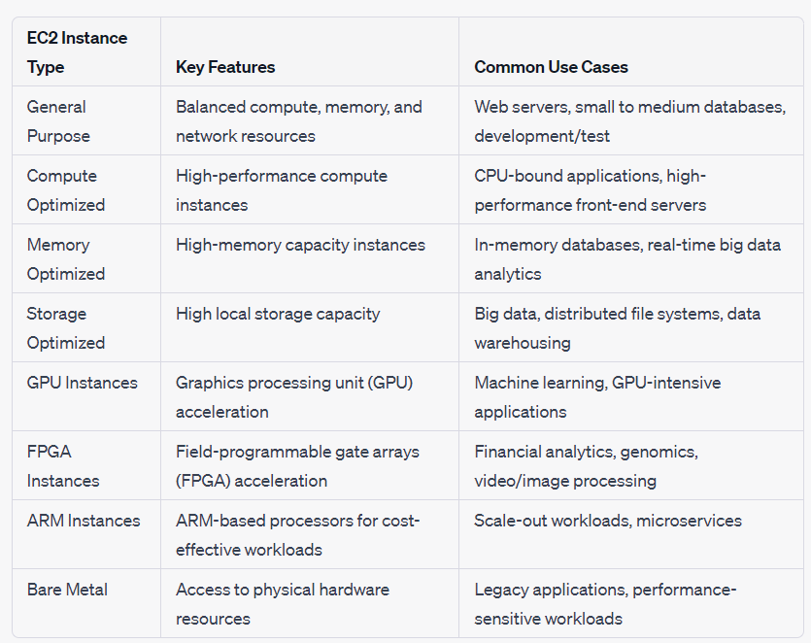

**AUTO SCALING**

AWS Auto Scaling is a service provided by Amazon Web Services (AWS) that enables automatic scaling of your resources based on demand. It helps you optimize the performance, cost, and availability of your applications by automatically adjusting the capacity of your AWS resources.

**Key features and concepts of AWS Auto Scaling include:**

* Scaling Policies: Auto Scaling allows you to define scaling policies that determine how and when your resources should scale. Scaling policies can be based on various metrics, such as CPU utilization, network traffic, or application-specific metrics. You can configure scaling policies to add or remove instances, adjust capacity, or change the instance type based on these metrics.
* Scaling Groups: Auto Scaling uses scaling groups to manage and maintain a group of resources. A scaling group is a logical grouping of instances that are launched and terminated together based on the scaling policies. It ensures that the desired number of instances is maintained to handle the workload efficiently.
* Elastic Load Balancing: Auto Scaling integrates with Elastic Load Balancing to distribute traffic across instances within a scaling group. This ensures that the workload is evenly distributed and provides high availability by automatically replacing unhealthy instances.
* Health Checks: Auto Scaling performs regular health checks on instances to identify any unhealthy instances. If an instance fails a health check, Auto Scaling automatically terminates the instance and replaces it with a healthy one, maintaining the desired capacity.
* Integration with AWS Services: Auto Scaling can be integrated with other AWS services to provide additional functionality. For example, it can be combined with AWS CloudWatch to monitor metrics and trigger scaling actions based on predefined thresholds. It also works seamlessly with AWS Elastic Beanstalk, Amazon ECS (Elastic Container Service), and Amazon EC2 (Elastic Compute Cloud) instances.

**Benefits of AWS Auto Scaling include:**

* Improved Application Performance: Auto Scaling ensures that your application has the appropriate amount of resources to handle the current workload, thereby optimizing performance and responsiveness.
* Cost Optimization: By automatically scaling resources based on demand, you can avoid over-provisioning and reduce costs. Resources are added or removed as needed, aligning with the current workload.
* High Availability: Auto Scaling replaces unhealthy instances and distributes traffic across healthy instances, improving the availability and reliability of your application.
* Simplified Management: Auto Scaling automates the process of adding or removing resources, reducing the manual effort required for capacity management.

**ELB(ELASTIC LOAD BALANCING)**

AWS ELB (Elastic Load Balancing) is a service provided by Amazon Web Services that distribute incoming network traffic across multiple targets, such as Amazon EC2 instances, containers, IP addresses, or AWS Lambda functions, in order to improve the availability and scalability of your applications.

**Key features and concepts of AWS ELB include:**

Application Load Balancer (ALB): ALB operates at the application layer (Layer 7) of the OSI model and provides advanced request routing based on content, allowing you to route traffic based on URL path, host, or query parameters. It supports features like path-based routing, host-based routing, and integration with AWS services such as AWS WAF (Web Application Firewall).

Network Load Balancer (NLB): NLB operates at the transport layer (Layer 4) and provides ultra-low latency load balancing. It is designed for high-throughput, low-latency traffic and is commonly used for TCP and UDP-based applications.

Classic Load Balancer (CLB): CLB is the legacy load balancer that works at both the application and transport layers. While ALB and NLB provide more advanced features, CLB still supports basic load balancing functionality.

Target Groups: Target groups are used with ALB and NLB to route requests to registered targets. Targets can be instances, IP addresses, containers, or Lambda functions that are registered with the target group. You can configure health checks on target groups to ensure that only healthy targets receive traffic.

Listener Rules: Listeners are configured on load balancers to define the protocols and ports on which the load balancer listens for incoming traffic. Listener rules are used to determine how traffic is routed to different target groups based on conditions such as the incoming URL, path, or host.

SSL/TLS Termination: AWS ELB supports SSL/TLS termination, allowing you to offload SSL/TLS encryption and decryption from your backend instances. It can handle SSL/TLS certificates and negotiate secure connections with clients, improving security and reducing the processing load on your backend instances.

Auto Scaling Integration: AWS ELB seamlessly integrates with Auto Scaling, allowing you to automatically distribute incoming traffic across instances that are launched or terminated based on scaling policies. This ensures that the load balancer can adapt to changes in capacity and maintain optimal performance.

**Benefits of AWS ELB include:**

High Availability and Fault Tolerance: ELB distributes traffic across multiple targets, providing fault tolerance and high availability for your applications. If a target becomes unhealthy, ELB automatically routes traffic to healthy targets.

Scalability: ELB scales automatically based on the incoming traffic load, allowing your application to handle increasing traffic without manual intervention.

Traffic Management and Load Balancing: ELB provides advanced traffic management features, such as SSL/TLS termination, content-based routing, and health checks, to ensure efficient load balancing and optimal application performance.

Simplified Architecture: ELB simplifies the architecture of your application by handling the distribution of traffic, allowing you to focus on your application logic rather than infrastructure management.

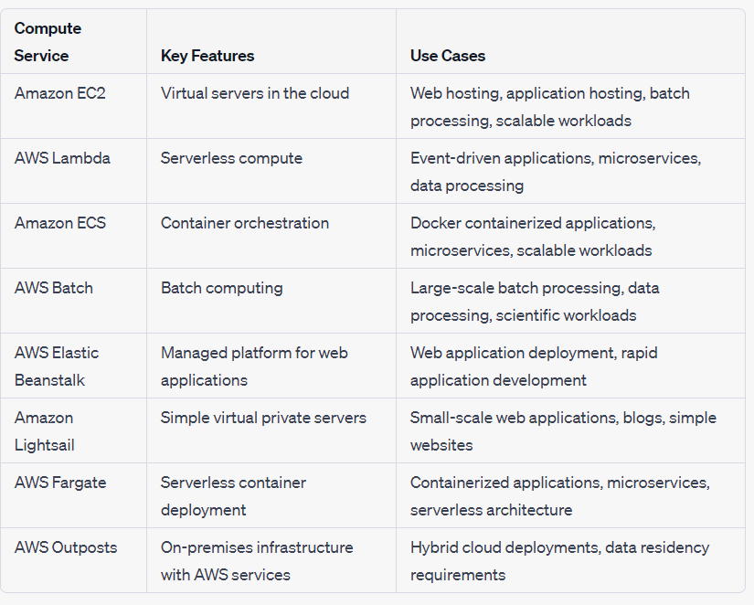

**AWS STORAGE SERVICE**

**Simple Storage Service(S3)**

* Amazon S3 (Simple Storage Service) is an object storage service provided by Amazon Web Services (AWS). It offers secure, scalable, and durable storage for a wide range of data types, including files, images, videos, backups, logs, and documents. Here's an overview of AWS S3:
* Object-Based Storage: S3 is based on an object storage model, where data is stored in containers called "buckets." Each bucket can store an unlimited number of objects, and each object consists of data, a unique key (URL), and metadata (custom information about the object).
* Scalability and Durability: S3 is highly scalable, allowing you to store and retrieve vast amounts of data. It automatically scales to accommodate growing storage needs without upfront capacity planning. S3 also provides high durability, ensuring that data is stored redundantly across multiple devices and facilities to protect against hardware failures.
* Data Availability and Access: S3 provides high availability, allowing you to access your data with low latency. It offers multiple storage classes to optimize cost and performance, including Standard (for frequently accessed data), Intelligent-Tiering (for automatic cost optimization), Glacier (for archival storage), and Glacier Deep Archive (for long-term archival at the lowest cost).
* Security and Compliance: S3 offers robust security features to protect your data. These include access control policies, bucket policies, and fine-grained permissions to control access at the bucket and object levels. S3 also supports encryption at rest and in transit, allowing you to encrypt your data using AWS Key Management Service (KMS) or your own encryption keys.
* Data Management: S3 provides various features for data management, including versioning, which allows you to preserve, retrieve, and restore previous versions of objects. Lifecycle policies enable automated data lifecycle management, automatically transitioning objects to different storage classes or deleting them based on predefined rules. S3 also integrates with AWS CloudTrail for monitoring and logging API activity on your S3 resources.
* Integration and Ecosystem: S3 integrates seamlessly with other AWS services, such as Amazon EC2, AWS Lambda, Amazon EMR, and AWS Glue, enabling you to build scalable and data-intensive applications. Additionally, S3 has an extensive ecosystem of third-party tools and services that integrate with it for data backup, migration, analytics, and more.
* Event Notifications and Triggers: S3 can generate event notifications for specific bucket and object operations, which can be used to trigger workflows and automate processes using AWS Lambda or other services. This allows you to build event-driven architectures and automate tasks based on changes in your S3 data

**ELASTIC BLOCK STORAGE(EBS)**

Amazon Elastic Block Store (EBS) is a block-level storage service provided by Amazon Web Services (AWS). It offers durable, high-performance block storage volumes that can be attached to Amazon EC2 instances. Here's an overview of AWS EBS:

* Block-Level Storage: EBS provides block-level storage volumes, which can be thought of as virtual hard disk drives. These volumes can be attached to EC2 instances and are used to store data persistently, independent of the instance's lifecycle. Each EBS volume is divided into fixed-size blocks, which can be accessed and managed individually.
* Volume Types: EBS offers multiple volume types to meet different performance and cost requirements:

1. General Purpose SSD (gp2): It provides a balance of price and performance for a broad range of workloads, suitable for most applications.
2. Provisioned IOPS SSD (io1): It offers high-performance SSD volumes designed for I/O-intensive applications that require low-latency and consistent throughput.
3. Throughput Optimized HDD (st1): It provides low-cost HDD volumes optimized for frequently accessed, throughput-intensive workloads, such as big data and log processing.
4. Cold HDD (sc1): It offers low-cost HDD volumes for less frequently accessed workloads, such as infrequent data backups and archival storage.
5. Magnetic (standard): It is the original EBS volume type, providing low-cost HDD storage for workloads with moderate performance needs.

* Elasticity and Scalability: EBS volumes can be dynamically resized to meet changing storage requirements without disrupting the associated EC2 instances. You can increase or decrease the volume size and change the volume type as needed, providing flexibility and scalability for your applications.
* Snapshots and Backups: EBS allows you to create point-in-time snapshots of your volumes, which are stored in Amazon S3. Snapshots are incremental, meaning only the changes made since the last snapshot are stored, resulting in efficient backup and restore operations. Snapshots can be used to create new volumes, migrate data, and protect against data loss.
* High Durability and Availability: EBS volumes are designed for durability, with data automatically replicated within the same Availability Zone to protect against component failures. For additional availability, you can create EBS snapshots and copy them across different Availability Zones or regions.
* Encryption: EBS supports encryption at rest using AWS Key Management Service (KMS) keys. You can enable encryption for your EBS volumes to ensure the security and privacy of your data.
* Integration with AWS Services: EBS seamlessly integrates with other AWS services. For example, you can use EBS volumes as primary storage for relational databases running on Amazon RDS or as data volumes for EC2 instances running applications.

**AWS S3 Glacier**

AWS S3 Glacier is a storage service offered by Amazon Web Services (AWS) designed for long-term data archival and backup. It provides secure, durable, and cost-effective storage for data that is infrequently accessed. Here's an overview of AWS S3 Glacier:

* Data Archival: S3 Glacier is optimized for long-term data archival, where data is stored for months, years, or even decades. It is suitable for storing data that is accessed less frequently but needs to be retained for compliance, regulatory, or business purposes.
* Low-Cost Storage: S3 Glacier offers a cost-effective storage solution compared to other storage options in AWS. The pricing is based on the volume of data stored, with lower costs associated with longer data retention periods.
* Durability and Availability: S3 Glacier provides high durability, ensuring that data is stored redundantly across multiple facilities within an AWS Region. This protects data against hardware failures and provides a reliable storage solution.
* Retrieval Options: Retrieving data from S3 Glacier involves a retrieval process that can take several hours. S3 Glacier provides different retrieval options based on the urgency of data access:
* Expedited: This retrieval option allows you to access your data within minutes, making it suitable for situations where immediate access is required.
* Standard: This retrieval option takes hours to access your data, making it appropriate for non-urgent data access needs.
* Bulk: This retrieval option is the most cost-effective but can take several hours to access data. It is suitable for long-term archival data that is rarely accessed.
* Lifecycle Policies: S3 Glacier integrates with S3 lifecycle policies, allowing you to automate the transition of data from S3 to S3 Glacier based on predefined rules. This helps optimize costs by automatically moving infrequently accessed data to Glacier storage.
* Vault and Archive Structure: In S3 Glacier, data is organized into "vaults," which act as containers for storing archives. Archives are individual objects within a vault and can be thought of as files or sets of data that you want to store. Each archive has a unique identifier that can be used to retrieve the specific data when needed.
* Security and Compliance: S3 Glacier supports server-side encryption for data at rest, ensuring the security and integrity of your archived data. It also integrates with AWS Identity and Access Management (IAM) for access control, allowing you to manage user permissions and roles.

**AWS SNOW-BALL**

* AWS Snowball is a physical data transfer and storage device offered by Amazon Web Services (AWS). It is designed to simplify the process of transferring large amounts of data securely and efficiently between on-premises environments and AWS cloud storage.
* The Snowball device resembles a ruggedized briefcase or shipping container and comes in two versions: Snowball and Snowball Edge. The original Snowball is equipped with a built-in E Ink shipping label, while the Snowball Edge has additional compute capabilities. Both versions provide a secure and tamper-proof enclosure for data transportation.
* The primary purpose of AWS Snowball is to address challenges associated with transferring large volumes of data over the internet, especially in cases where network bandwidth or latency limitations make it impractical or time-consuming. It offers a reliable and cost-effective alternative to uploading or downloading massive datasets over the network.
* To use AWS Snowball, customers request a Snowball device from the AWS Management Console. Once received, they can connect it to their on-premises network and use it to transfer data. The Snowball device supports a variety of connectors, such as Ethernet and USB, enabling easy integration with existing infrastructure.
* Users can load their data onto the Snowball device using various methods, including direct transfer from network-attached storage, integration with backup software, or by manually copying the data. AWS Snowball devices have high storage capacity, typically ranging from 50 terabytes to 100 petabytes, depending on the specific device.
* Once the data is loaded onto the Snowball device, it is encrypted using 256-bit encryption and protected with a tamper-evident seal. The device also has built-in sensors that monitor temperature, acceleration, and other parameters to ensure the integrity and security of the data during transportation.
* After the data transfer is complete, the Snowball device is shipped back to AWS. Upon arrival, AWS transfers the data from the device to the designated AWS storage service, such as Amazon S3 or Amazon Glacier. Once the data is securely transferred to the AWS cloud, customers can access and manage it using various AWS services.
* Overall, AWS Snowball provides a reliable and efficient method for transferring large datasets to and from the AWS cloud, enabling organizations to overcome network limitations and accelerate their data migration or backup processes.

**ELASTIC FILE SYSTEM (EFS)**

Amazon Elastic File System (Amazon EFS) is a scalable and fully managed cloud-based file storage service provided by Amazon Web Services (AWS). It offers a simple and scalable solution for creating and managing file systems that can be accessed concurrently from multiple EC2 instances or on-premises servers.

Amazon EFS provides a file system interface, similar to traditional on-premises file systems, such as Network File System (NFS) version 4.1. It allows multiple instances to access the same file system simultaneously, enabling collaboration and shared access to data across different compute resources.

Key features and characteristics of Amazon EFS include:

1. **Scalability**: Amazon EFS automatically scales storage capacity and throughput as your file system grows, allowing you to store and retrieve petabytes of data without worrying about capacity planning or performance limitations.

2. **Performance**: Amazon EFS offers low-latency performance and high throughput, making it suitable for a wide range of workloads, including big data processing, media processing, content management, and web serving.

3. **Elasticity**: You can easily increase or decrease the capacity of your Amazon EFS file system on-demand, without any disruption to your applications. This flexibility allows you to adjust your storage resources based on changing workload demands.

4. **Durability and Availability**: Amazon EFS provides high durability and availability by storing data across multiple Availability Zones within a region. It automatically replicates data and metadata across these zones, ensuring redundancy and protection against infrastructure failures.

5. **Security**: Amazon EFS integrates with AWS Identity and Access Management (IAM) for fine-grained access control. You can manage access permissions at the directory and file level, restricting access to specific users or groups.

6. **Lifecycle Management:** Amazon EFS supports lifecycle management policies, allowing you to automatically move files between different storage classes based on access patterns. This helps optimize costs by storing infrequently accessed data in a lower-cost storage tier.

7. **Integration with AWS Services**: Amazon EFS seamlessly integrates with other AWS services, such as Amazon EC2, AWS Lambda, and AWS Batch. This enables you to use EFS as a shared storage backend for various applications and compute resources in your AWS environment.

**AWS FSx(File system for windows/linux)**

Amazon FSx (Amazon File System for Windows/Linux) is a fully managed file storage service provided by Amazon Web Services (AWS). It is designed to provide scalable and high-performance file storage for Windows and Linux workloads, making it easier for users to access and share files across multiple instances or servers.

Amazon FSx offers two types of file systems: Amazon FSx for Windows File Server and Amazon FSx for Lustre. Each type is optimized for different use cases and workloads.

**1. Amazon FSx for Windows File Server:**

Amazon FSx for Windows File Server provides a fully managed native Windows file system, compatible with the Server Message Block (SMB) protocol. It allows users to access their file data using standard Windows file sharing tools and APIs.

**Key features of Amazon FSx for Windows File Server include:**

* - Integration with Active Directory: It seamlessly integrates with Microsoft Active Directory, enabling users to manage file system permissions using familiar Active Directory tools.
* - High availability: It automatically replicates data within an AWS Availability Zone for durability and provides the option to enable cross-Availability Zone replication for additional resiliency.
* - Automated backups: It offers automated backups with configurable retention periods, allowing users to easily restore files or file systems to previous states.
* - Multi-AZ deployments: It supports deploying file systems across multiple Availability Zones for enhanced availability and durability.
* - Seamless data migration: It provides easy data migration from existing on-premises Windows file servers to Amazon FSx using AWS DataSync or other data transfer tools.

**2. Amazon FSx for Lustre:**

Amazon FSx for Lustre is a high-performance file system optimized for compute-intensive workloads. It is designed to deliver low-latency, high-throughput performance for processing large data sets, such as high-performance computing (HPC), analytics, and machine learning applications.

**Key features of Amazon FSx for Lustre include:**

* - High performance: It offers sub-millisecond latencies and high throughput, enabling fast data access and processing for compute-intensive workloads.
* - Seamless integration with AWS services: It integrates with other AWS services, such as Amazon S3, Amazon EC2, and AWS Batch, allowing users to efficiently transfer and process data.
* - Data durability: It provides data durability by automatically replicating data within an AWS Availability Zone and allowing users to enable cross-Availability Zone replication.
* - Scalability: It can scale up to hundreds of gigabytes per second of read and write throughput, making it suitable for demanding workloads.

**AWS STORAGE GETWAY**

AWS Storage Gateway is a hybrid cloud storage service provided by Amazon Web Services (AWS). It enables businesses to seamlessly integrate on-premises IT environments with AWS cloud storage, providing a unified storage solution that combines the benefits of both local and cloud storage.

AWS Storage Gateway supports three different types of gateways, each serving a specific purpose:

**1. File Gateway:**

File Gateway allows users to access Amazon S3 (Simple Storage Service) as a file system. It presents a file interface, using Network File System (NFS) and Server Message Block (SMB) protocols, to on-premises applications. It seamlessly integrates with existing applications and file-based workflows, allowing users to store and retrieve objects in Amazon S3 as files.

**Key features of File Gateway include:**

* - Cached volumes: It caches frequently accessed data on-premises, providing low-latency access while storing the full dataset in Amazon S3.
* - Stored volumes: It stores the entire dataset on-premises while asynchronously backing up the data to Amazon S3 for durability and scalability.
* - Direct NFS access to S3: It allows on-premises applications to directly access data in Amazon S3 over NFS, without requiring a local cache.

**2. Volume Gateway:**

Volume Gateway provides block storage volumes that can be mounted as iSCSI devices to on-premises servers. It gives users the flexibility to use their preferred operating systems, applications, and file systems while storing data as Amazon Elastic Block Store (EBS) snapshots.

**Volume Gateway offers two modes:**

* **- Cached volumes:**

It caches frequently accessed data on-premises while asynchronously backing up the entire dataset to Amazon EBS for durability and scalability.

* **- Stored volumes:**

It stores the entire dataset on-premises, while asynchronously backing up point-in-time snapshots to Amazon EBS.

**3. Tape Gateway:**

Tape Gateway allows users to replace physical tape infrastructure with virtual tape libraries (VTLs) in the AWS cloud. It provides a cost-effective and scalable solution for archival and long-term data retention.

**Key features of Tape Gateway include:**

* - Virtual tape libraries: It presents a virtual tape library interface to existing backup applications, enabling seamless integration without requiring changes to backup workflows.
* - Virtual tapes and archives: It supports creating virtual tapes that are stored as Amazon S3 objects, providing durability, scalability, and cost optimization.
* - Data transfer: It enables importing and exporting virtual tapes using AWS Snowball, enabling efficient and secure data transfer to and from the cloud.

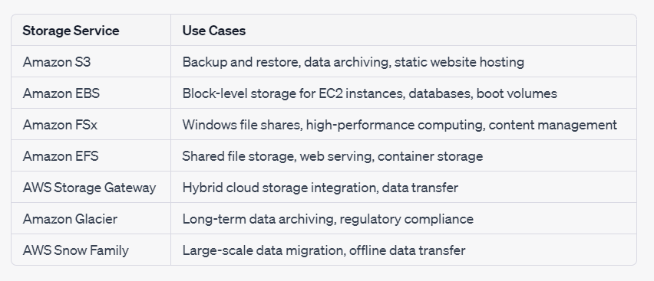

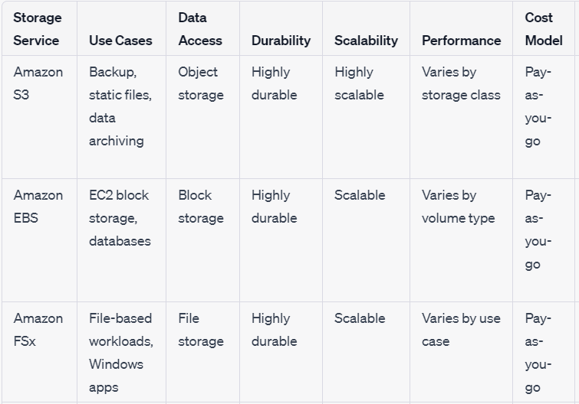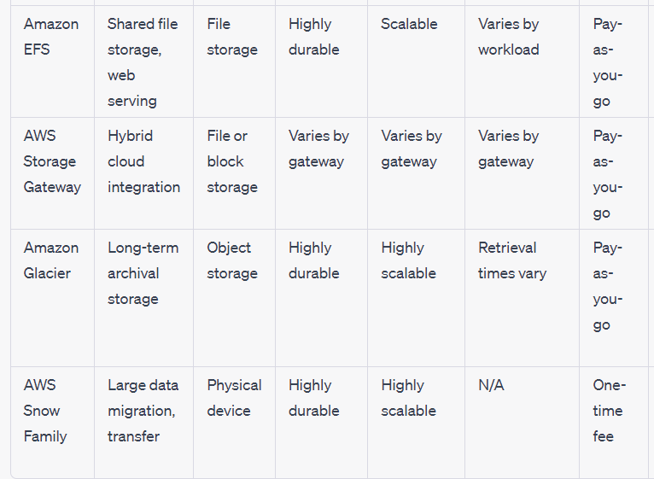

**NETWORKING SERVICES**

**AWS VPC (VIRTUAL PRIVATE CLOUD)**

In AWS, a VPC (Virtual Private Cloud) is a logically isolated virtual network that you can provision in the cloud. It allows you to create a private, secure environment to run your AWS resources, such as Amazon EC2 instances, RDS databases, and Lambda functions. VPC provides you with control over your network configuration and enables you to define your own IP address range, subnets, route tables, and network gateways.

**Here are some key aspects and features of VPC in AWS:**

1. Network Isolation: A VPC provides network isolation and allows you to create a virtual network environment that is isolated from other VPCs and the public internet. This isolation provides security and control over your resources.

2. Subnets: Within a VPC, you can create multiple subnets, each representing a segmented portion of your network. Subnets can be public or private, and they help in organizing resources and controlling network access.

3. IP Address Range: When creating a VPC, you define an IP address range using CIDR notation. This address range determines the range of IP addresses that can be assigned to the resources within your VPC.

4. Routing: VPC includes a routing table that controls the traffic flow between subnets and to the internet. You can configure custom routes to direct traffic within the VPC and to external networks.

5. Internet Gateway: An internet gateway allows communication between your VPC and the internet. It enables resources within your VPC to access the internet and also allows inbound traffic from the internet to your VPC.

6. Security: VPC provides security features such as security groups and network access control lists (ACLs) to control inbound and outbound traffic to your resources. You can define fine-grained rules to allow or deny specific network traffic.

7. VPN and Direct Connect: VPC allows you to establish secure connections between your on-premises infrastructure and the VPC using AWS Site-to-Site VPN or AWS Direct Connect. This enables hybrid cloud scenarios and extends your existing network to the cloud.

8. Integration with Other AWS Services: VPC seamlessly integrates with other AWS services, allowing you to launch EC2 instances, RDS databases, Elastic Load Balancers, and other resources within your VPC.

9.Use cases for VPC include creating multi-tier web applications, running highly available databases, setting up secure development and testing environments, and establishing hybrid cloud architectures. VPC provides a flexible and scalable network infrastructure that gives you full control over your AWS resources' connectivity, security, and network configuration.

**AWS SECUIRTY GROUP**

In AWS, security groups are a fundamental aspect of network security and play a crucial role in controlling inbound and outbound traffic to AWS resources within a VPC (Virtual Private Cloud). Security groups act as virtual firewalls at the instance level, allowing you to define rules that control the traffic flow to and from your instances.

**Here are some key points about security groups:**

1. Security Group Basics: A security group acts as a virtual firewall that regulates inbound and outbound traffic for one or more EC2 instances or other AWS resources. It operates at the instance level, controlling traffic based on rules defined within the security group.

2. Inbound and Outbound Rules: Security groups have inbound and outbound rules that define what traffic is allowed to access the instances. Inbound rules control incoming traffic, while outbound rules control outgoing traffic. Each rule consists of a protocol (e.g., TCP, UDP), a port range, and a source or destination IP address or security group.

3. Allow/Deny Rules: Security group rules can be configured to allow or deny specific types of traffic. For example, you can allow inbound HTTP traffic (port 80) from any source, but restrict SSH access (port 22) to a specific IP range.

4. Port-Level Security: Security groups work at the transport layer (Layer 4) of the OSI model, meaning they control traffic based on protocols and port numbers. You can specify a single port or a range of ports for a particular protocol.

5. Stateful Traffic Filtering: Security groups automatically track the state of traffic, which means that if an inbound rule permits traffic, the corresponding outbound rule allows the response traffic to flow back out. This simplifies the management of rules and reduces the need to define symmetric rules for inbound and outbound traffic.

6. Flexible Configuration: You can assign one or more security groups to an instance, and you can also apply security groups to other AWS resources such as load balancers and RDS instances. Security groups can be modified at any time to add or remove rules.

7. Default Security Group: When you create a VPC, a default security group is automatically created. This security group allows all outbound traffic and permits inbound traffic from other instances within the same security group.

8.Security groups are an essential component of network security in AWS, providing granular control over traffic access to your resources. By configuring security group rules effectively, you can enforce network segmentation, restrict access to sensitive services, and protect your instances from unauthorized access.

**ROUTE 53**

Amazon Route 53 is a highly scalable and reliable cloud-based domain name system (DNS) web service provided by Amazon Web Services (AWS). It is designed to help route end-users to Internet applications by translating human-readable domain names, such as www.example.com, into IP addresses that computers can understand.

**Here are some key aspects and features of Amazon Route 53:**

1. Domain Registration: Route 53 allows you to register new domain names or transfer existing domain names to be managed within the service. This makes it easy to manage your domains and DNS settings in one place.

2. DNS Management: Route 53 provides a full-featured DNS management system. You can create and manage DNS records such as A records, CNAME records, MX records, and more. These records define the mapping between domain names and IP addresses or other resources.

3. Global DNS Service: Route 53 operates a global network of DNS servers strategically distributed around the world. This enables low-latency DNS resolution for end-users regardless of their geographic location, improving the performance and availability of your applications.

4. Health Checking and Failover: Route 53 allows you to configure health checks for your resources, such as web servers or load balancers. It can automatically route traffic away from unhealthy resources to healthy ones, providing failover and improving the overall availability of your applications.

5. Traffic Management: Route 53 offers various traffic management features, including weighted routing, latency-based routing, geolocation routing, and more. These features enable you to distribute traffic across multiple endpoints based on various criteria, optimizing performance and providing intelligent routing.

6. Integration with AWS Services: Route 53 seamlessly integrates with other AWS services, such as Amazon S3, Amazon EC2, Elastic Load Balancing, and AWS Certificate Manager. This allows you to easily configure DNS settings for your AWS resources and manage them from a single console.

7. DNS Security: Route 53 supports DNSSEC (Domain Name System Security Extensions), which provides an additional layer of security by digitally signing DNS records. DNSSEC helps prevent DNS spoofing and other malicious activities.

**AWS VPN**

VPN (Virtual Private Network) and AWS Direct Connect are both networking solutions provided by Amazon Web Services (AWS) that enable secure connectivity between on-premises environments and AWS cloud resources.

A VPN establishes a secure encrypted tunnel over the public internet, allowing remote users or on-premises networks to securely access resources in the AWS cloud. The VPN connection encrypts the traffic between the on-premises network and the AWS Virtual Private Cloud (VPC).

Key points about VPN include:

* - Secure Remote Access: VPN enables secure remote access for individuals or teams to connect to AWS resources, such as EC2 instances or RDS databases, over the internet.
* - Site-to-Site Connectivity: VPN provides secure connectivity between an on-premises network and a VPC, allowing on-premises resources to securely communicate with AWS resources.
* - Internet-based Connectivity: VPN connections rely on the public internet for transmitting encrypted traffic between the on-premises network and the AWS cloud.
* - Lower Bandwidth, Flexible Setup: VPN is suitable for lower bandwidth requirements and offers flexibility in terms of configuration and setup.

**AWS Direct Connect:**

AWS Direct Connect establishes a dedicated and private network connection between an on-premises network and the AWS cloud. It provides a direct, private, and high-bandwidth link that bypasses the public internet.

**Key points about Direct Connect include:**

* - Private Connectivity: Direct Connect provides a private, dedicated network connection that bypasses the internet, offering enhanced security and performance.
* - High-Bandwidth Connections: Direct Connect supports higher bandwidth connections, ranging from 1 Gbps to 100 Gbps, enabling large data transfers and low-latency access to AWS resources.
* - Reliable and Consistent Performance: Direct Connect offers a predictable and reliable network performance compared to VPN, as it is not subject to the variations and congestion of the public internet.
* - Hybrid Cloud Connectivity: Direct Connect is well-suited for hybrid cloud architectures, where organizations have on-premises infrastructure that needs to seamlessly integrate with resources in the AWS cloud.

- Colocation Options: Direct Connect can be established through AWS Direct Connect locations or through a partner network, allowing for colocation options and flexible connectivity solutions.

| **Networking services** | **Description** | **Use Cases** |
| --- | --- | --- |
| **VPC** | Isolated virtual network in AWS, allowing you to define a custom network configuration, create subnets, configure routing, and control inbound/outbound traffic | Hosting multi-tier applications, secure communication between resources, creating a private cloud environment, connecting on-premises networks. |
| **AWS DIRECT CONNECT** | Dedicated, private network connection between on-premises networks and AWS, providing higher bandwidth and lower latency access to AWS resources. | Hybrid cloud architectures, large data transfers, consistent and reliable network performance, compliance requirements, bypassing the public internet. |
| **AWS GLOBAL ACCELERATOR** | Improves the availability and performance of your applications for global users by routing traffic through AWS's global network infrastructure | Global application delivery, minimizing latency, improved performance, distributed application architectures. |
| **ROUTE 53** | Scalable and highly available DNS web service, allowing you to manage domain names, translate domain names to IP addresses, and perform traffic management | Scalable and highly available DNS web service, allowing you to manage domain names, translate domain names to IP addresses, and perform traffic management |
| **TRANSIT GETWAY** | Simplifies connectivity between multiple VPCs, AWS accounts, and on-premises networks, providing centralized control and efficient network traffic routing | . Hub and spoke network architectures, multi-account connectivity, simplifying network management, scaling connectivity. |
| **VPN** | Securely connects your network to AWS resources using encrypted tunnels over the public internet, providing remote access and site-to-site connectivity. | Remote access to AWS resources, site-to-site connectivity, secure communication over the internet, extending on-premises networks to the cloud. |

**AWS DATABASE SERVICES**

1. **AWS RDS (RATIONAL DATABASE SERVICES)**

Amazon RDS (Relational Database Service) is a fully managed database service provided by Amazon Web Services (AWS). It simplifies the process of setting up, operating, and scaling a relational database in the cloud. With RDS, you can choose from multiple popular database engines, such as Amazon Aurora, MySQL, PostgreSQL, MariaDB, Oracle, and Microsoft SQL Server, and leverage AWS's infrastructure to handle administrative tasks, backups, and scaling automatically.

**Here are the key aspects and features of Amazon RDS:**

1. Managed Database Service: RDS takes care of administrative tasks such as hardware provisioning, database setup, patching, software updates, and backups, allowing you to focus on your applications rather than managing the underlying infrastructure.

2. Multiple Database Engine Options: RDS offers a variety of database engines, including Amazon Aurora (a MySQL and PostgreSQL-compatible database engine developed by AWS), MySQL, PostgreSQL, MariaDB, Oracle Database, and Microsoft SQL Server. This allows you to choose the database engine that best suits your application requirements.

3. Scalability and High Availability: RDS provides scalability options to handle varying workloads. You can easily scale your database instance vertically by changing its size or scale horizontally by using read replicas for read scalability. RDS also offers Multi-AZ deployments for high availability, automatically replicating data across multiple Availability Zones to ensure data durability and minimize downtime in the event of a failure.

4. Automated Backups and Point-in-Time Recovery: RDS automatically backs up your database according to the specified retention period. You can also initiate manual backups or enable automated snapshots. RDS supports point-in-time recovery, allowing you to restore your database to any point within your backup retention period.

5. Security and Encryption: RDS ensures data security through network isolation and access control mechanisms. It integrates with AWS Identity and Access Management (IAM) for managing user access. RDS also provides encryption at rest and in transit, allowing you to secure your sensitive data.

6. Monitoring and Metrics: RDS offers monitoring capabilities and integrates with Amazon CloudWatch for real-time monitoring and gathering of performance metrics. You can set alarms and receive notifications based on specified thresholds.

7. Database Migration: RDS provides tools and services to simplify database migration to AWS. You can easily migrate your existing on-premises or cloud-based databases to RDS using the AWS Database Migration Service (DMS) or other supported migration methods.

8. Integration with AWS Ecosystem: RDS seamlessly integrates with other AWS services such as AWS Identity and Access Management (IAM), Amazon VPC (Virtual Private Cloud), AWS CloudFormation, and AWS Management Console, allowing you to leverage the full capabilities of the AWS ecosystem.

**2.AWS AURORA.**

Amazon Aurora is a relational database engine provided by Amazon Web Services (AWS) that is designed to offer high performance, scalability, and durability. It is compatible with MySQL and PostgreSQL, providing a seamless migration path for applications already using these database engines.

**Here's an explanation of the key aspects and features of Amazon Aurora:**

1. Performance: Amazon Aurora is built to deliver high-performance database capabilities. It uses a distributed storage system that replicates data across multiple instances, allowing for faster read and write operations. It also employs an SSD-based storage layer for low-latency access to data.

2. Compatibility: Amazon Aurora is compatible with the MySQL and PostgreSQL database engines. This means that applications that are already built to work with MySQL or PostgreSQL can easily migrate to Aurora with minimal modifications.

3. High Availability: Aurora provides high availability through its Multi-AZ deployments. It automatically replicates data across multiple Availability Zones, allowing for quick failover in case of a primary instance failure. This ensures that your database remains accessible and minimizes downtime.

4. Scalability: Aurora is designed to scale both storage and compute resources to handle growing workloads. It can automatically add replicas to handle increased read traffic and can scale storage up to 64 terabytes (TB) without downtime.

5. Durability: Aurora offers enhanced data durability by automatically replicating data across multiple storage nodes within a single AWS Region. It also continuously backs up your database to Amazon S3, allowing you to restore the database to any point within a specified retention period.

6. Performance Insights: Aurora provides Performance Insights, a feature that helps you monitor the performance of your database instances. It provides a detailed view of the database's load patterns, allowing you to identify and troubleshoot performance bottlenecks.

7. Data Security: Aurora ensures data security through encryption at rest and in transit. It supports encryption using AWS Key Management Service (KMS), allowing you to encrypt your data using keys you control.

8. Integration with AWS Services: Aurora seamlessly integrates with other AWS services such as AWS Identity and Access Management (IAM), AWS CloudFormation, AWS Database Migration Service (DMS), and AWS Management Console, enabling easy management and integration with the broader AWS ecosystem.

**3. AWS DocumnetDB**

Amazon DocumentDB is a fully managed NoSQL document database service provided by Amazon Web Services (AWS). It is designed to be compatible with MongoDB, a popular open-source NoSQL database, while offering the scalability, availability, and performance benefits of a managed service.

**Here's an explanation of the key aspects and features of Amazon DocumentDB:**

1. MongoDB Compatibility: Amazon DocumentDB is designed to be compatible with existing MongoDB applications, drivers, and tools. This means you can migrate your MongoDB workloads to DocumentDB with minimal code changes, making it easier to adopt the managed service.

2. Fully Managed Service: With Amazon DocumentDB, AWS takes care of the infrastructure management, including database setup, scaling, patching, backups, and automated failover. This allows you to focus on developing your applications rather than managing the underlying database infrastructure.

3. Scalability: DocumentDB provides the ability to scale both storage and compute resources independently. You can easily scale storage capacity up to 64 terabytes (TB) without any impact on database performance, allowing your application to handle growing data volumes.

4. High Availability: DocumentDB replicates your data across multiple Availability Zones, providing built-in high availability and durability. In case of a failure, DocumentDB automatically performs failover to a standby replica, ensuring minimal downtime for your applications.

5. Performance: DocumentDB is designed to deliver low-latency, high-throughput performance for read-heavy workloads. It uses a distributed, fault-tolerant architecture that distributes data across multiple nodes, allowing for fast and scalable read operations.

6. Security and Encryption: DocumentDB supports encryption at rest using AWS Key Management Service (KMS). It encrypts your data and automated backups to ensure data security. DocumentDB also integrates with AWS Identity and Access Management (IAM) for access control and user authentication.

7. Backup and Restore: Amazon DocumentDB automatically creates continuous backups of your database within a retention period of 35 days. You can restore your database to any point within this period, providing flexibility and protection against data loss.

8. Integration with AWS Services: DocumentDB integrates with other AWS services such as AWS Identity and Access Management (IAM), AWS CloudFormation, AWS Database Migration Service (DMS), and AWS Management Console. This enables seamless integration and management within the broader AWS ecosystem.

**AWS REDSHIFT**

Amazon Redshift is a fully managed data warehousing service provided by Amazon Web Services (AWS). It is designed to efficiently analyze large datasets and provide high-performance, scalable data warehousing capabilities.

**Here's an explanation of the key aspects and features of Amazon Redshift:**

1. Columnar Storage: Redshift stores data in a columnar format, where each column is stored separately, allowing for efficient compression and improved query performance. This architecture enables quick data retrieval and analysis, especially for analytical workloads involving large datasets.

2. Scalability: Redshift is designed to scale horizontally, allowing you to add or remove compute resources (nodes) to match your performance and storage needs. You can scale up to hundreds of nodes, providing the ability to handle petabytes of data.

3. Performance: Redshift leverages massively parallel processing (MPP) to distribute query execution across multiple nodes, enabling fast query performance on large datasets. It also uses query optimization techniques and intelligent caching to speed up query execution.

4. Data Compression: Redshift automatically applies compression algorithms to reduce storage requirements and improve query performance. It uses column-level compression and encoding techniques, resulting in significant storage savings.

5. Integration with Analytics Tools: Redshift integrates seamlessly with popular business intelligence (BI) and analytics tools, such as Amazon QuickSight, Tableau, and Power BI. This allows you to easily connect and visualize your data stored in Redshift.

6. Data Loading and ETL: Redshift provides various options for loading data into the data warehouse, including COPY command, AWS Data Pipeline, AWS Glue, and direct query execution. It supports parallel data loading from multiple sources, making it efficient for ETL (Extract, Transform, Load) processes.

7. Data Durability: Redshift automatically and continuously backs up your data to Amazon S3, providing durability and allowing you to restore your data in case of accidental deletion or system failures. Redshift also supports snapshots, allowing you to create point-in-time backups.

8. Security and Compliance: Redshift offers multiple security features, including encryption at rest and in transit, AWS Identity and Access Management (IAM) integration for access control, and Virtual Private Cloud (VPC) for network isolation. It also supports integration with AWS Key Management Service (KMS) for key management.

9. Cost-Effective: Redshift offers a pay-as-you-go pricing model, where you pay only for the resources you use. It provides cost optimization features such as automated workload management and on-demand scaling, allowing you to balance performance and cost efficiency.

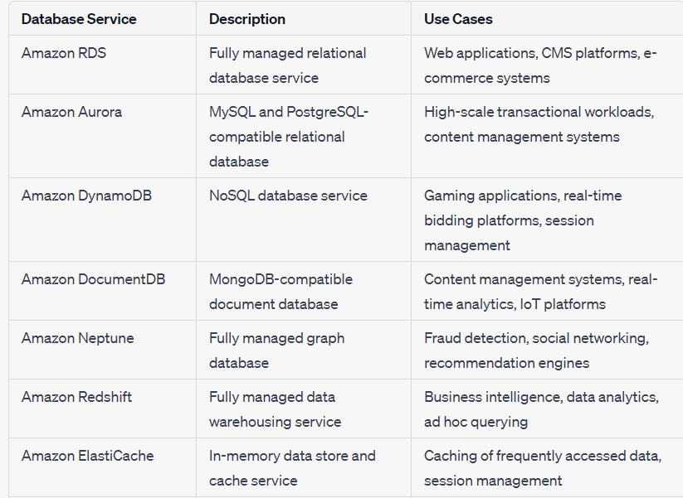

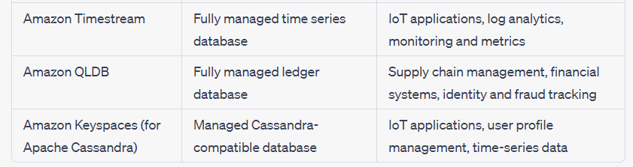

**AWS TECHNOLOGY SUPPORT**

**AWS Abuse**

AWS Abuse refers to any unauthorized or inappropriate use of Amazon Web Services (AWS) resources or services that violate the AWS Acceptable Use Policy. It includes activities such as hacking attempts, malicious activities, spamming, intellectual property infringement, and any actions that compromise the security, availability, or integrity of AWS services. AWS takes abuse reports seriously and has mechanisms in place to investigate and respond to such incidents to ensure the security and reliability of its platform.

**AWS Support Cases**

AWS Support Cases are a means of communication between AWS customers and AWS Support. When customers encounter technical issues or have questions about AWS services, they can open support cases through the AWS Management Console, AWS Support Center, or programmatically using the AWS Support API. Support cases allow customers to seek assistance, report problems, request guidance, and track the progress of their inquiries. AWS provides different levels of support plans, including Basic, Developer, Business, and Enterprise, with varying response times and features.

**Premium Support**

Premium Support, also known as AWS Support Plans, is a paid support offering provided by AWS. It offers enhanced technical support services and benefits beyond the basic support level included with AWS accounts. Premium Support customers have access to faster response times, 24/7 global support, guidance on architectural best practices, assistance with service limits, and access to AWS Trusted Advisor, which provides recommendations for optimizing AWS resources. Premium Support is designed to meet the needs of organizations requiring high-level support and assistance for their AWS environments.

**Technical Account Managers (TAMs)**

Technical Account Managers (TAMs) are AWS personnel who work closely with enterprise customers to provide personalized technical guidance and support. TAMs serve as a single point of contact and advocate for customers, helping them navigate AWS services, optimize their infrastructure, and achieve their business goals. TAMs have in-depth knowledge of AWS services and architectures and work collaboratively with customers to understand their specific requirements and provide strategic guidance. They assist in areas such as architectural reviews, service optimization, cost management, and proactive support to ensure customers maximize the value of their AWS investments. TAMs are available to customers with AWS Enterprise Support or Business Support plans.

**AWS TRUST ADVISOR**

AWS Trusted Advisor is an online tool provided by Amazon Web Services (AWS) that helps customers optimize their AWS infrastructure, improve security, and reduce costs. It analyzes your AWS environment and provides recommendations based on best practices and AWS service limits.

**AWS BILLING**

**PRICING MODAL OF AWS**

**1. On-Demand Instances:**

* - Pricing: Pay for computing capacity by the hour or second, with no upfront costs or long-term commitments.
* - Flexibility: Offers the most flexibility and allows you to scale capacity up or down as needed.
* - Use Case: Suitable for applications with unpredictable workloads, short-term projects, or when you need to quickly launch instances.

**2. Reserved Instances (RI):**

* - Pricing: Upfront payment for a discounted hourly rate, offering significant cost savings compared to On-Demand Instances.
* - Contract Term: RIs are purchased for a specific contract term, either 1 or 3 years.
* - Capacity Reservation: RIs provide capacity reservation, ensuring availability even during peak times.
* - Use Case: Ideal for steady-state or predictable workloads that require reserved capacity and can commit to a longer-term usage.

**3. Spot Instances:**

* - Pricing: Bid on unused EC2 instances, with prices fluctuating based on supply and demand. The bid price must be higher than the current Spot price.
* - Cost Savings: Offers the lowest pricing compared to On-Demand and Reserved Instances but can be terminated with a 2-minute notice when the Spot price exceeds your bid.
* - Use Case: Well-suited for fault-tolerant workloads, batch processing, and applications that can handle interruptions or have flexible start and end times.

**4. Dedicated Hosts:**

* - Pricing: Pay for the entire host, providing visibility into the underlying infrastructure and offering fixed pricing.
* - Isolation: Dedicated Hosts provide physical isolation, allowing you to bring your own licenses or meet specific compliance requirements.
* - Use Case: Ideal for software that has licensing restrictions, regulatory compliance needs, or for workloads that require host-level isolation.

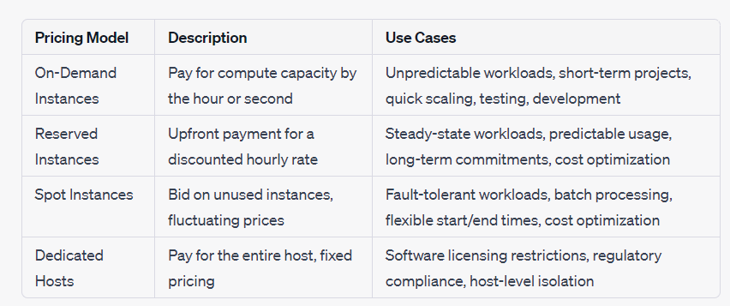

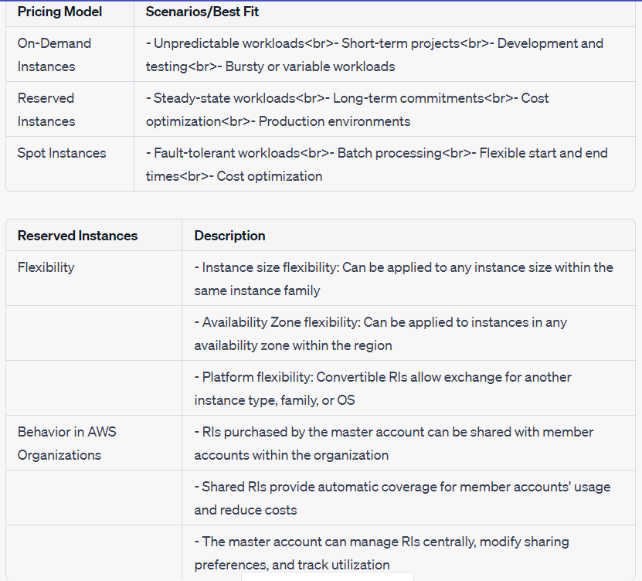

**AWS BILLING DEFINITION**

**1.Cost Explorer**:

It provides a comprehensive set of visualizations and reports to analyze and understand your AWS costs and usage patterns.

**2.AWS Cost and Usage Report:**

It offers detailed cost and usage data in a machine-readable format for advanced analysis and customization.

**3.Amazon QuickSight**

It allows you to create interactive dashboards and visualizations for analyzing your AWS cost and usage data.

**4.Third-Party Partners and AWS Marketplace:**

You can explore and leverage third-party tools available in the AWS Marketplace to gain insights and optimize your billing.

**5. Open a Billing Support Case:**

* - You can open a billing support case through the AWS Support Center to seek assistance with billing-related inquiries, questions, or issues.
* - Billing support cases can help address concerns such as billing discrepancies, account-related questions, invoice clarifications, or assistance with billing tools.

**6. Concierge for AWS Enterprise Support Plan Customers:**

* - If you are subscribed to the AWS Enterprise Support plan, you have access to a dedicated AWS Support Concierge.
* - The Concierge can assist you with billing-related inquiries, provide guidance on cost optimization strategies, and help address any billing challenges you may encounter.

**AWS TAGS**

**Resource Categorization**: Tags help categorize resources based on specific attributes or characteristics. For cost allocation, tags can be used to group resources based on different dimensions, such as departments, projects, environments, or business units.

**Cost Tracking:** By assigning tags to resources, you can track and analyze costs based on different tag values. Tags allow you to break down your AWS cost and usage data based on the assigned tags, providing granular insights into how costs are distributed across different categories.

**Cost Allocation Reports**: AWS Cost Allocation Reports provide detailed cost and usage data based on tagged resources. These reports can be customized to include specific tags, enabling you to generate cost allocation reports based on your desired tag dimensions.

**Cost Allocation Tags**: AWS provides a specific tag called "Cost Allocation Tags" that can be assigned to resources for cost tracking and allocation purposes. These tags are designed specifically for cost allocation and can be used to organize and report costs at a more detailed level.