**Lecture 2 Intercultural competence**

**一、Intercultural competence**

1. Definition : a complex of abilities needed to perform effectively and appropriately when interacting with others who are linguistically and culturally different from oneself.
2. Including intercultural communicative competence (ICC)，transcultural communication, cross-cultural adaptation, intercultural sensitivity.

**二、Cultural Symbols**

1. Definition: a cultural symbol is a physical manifestation that signifies the ideology of a particular cultural or that merely has meaning within a cultural.

2.Examples

The bald eagle. The hamsa.

**三、Cultural**

1.Definition Cultural is an accumulation of the beliefs, traditions, language and values of a particular group of people.

**Lecture 3 Interpersonal & intercultural communication skills**

1. **Intercultural communication**
2. Intercultural communication is the process by which people exchange information, feelings, and meaning through verbal and non-verbal messages: It is face-to-face communication.
3. What is said—the language used

How it is said—the non-verbal messages sent through tone of voice, facial expressions, gestures and body language.

1. **Elements of communication**
2. **Context**

* Situational context
* Social context
* The emotional climate
* Participants’ expectations of the interaction

1. **Communicators**

* Two people
* Sending and receiving
* One way process
* Two way process

1. **Messages**

* Verbal
* Non-verbal

1. **Channel**

* The physical means by which the message is transferred from one person to another
* Speech
* Vision

1. **Feedback**

* Messages the receiver returns
* Direct verbal statements
* Suitable facial expressions
* Changes in posture

1. **noise** (factors affecting communication)

* physical ‘noise’
* complicated jargon
* inappropriate body language
* inattention
* disinterest
* cultural differences

**Lecture 4 Intercultural communication skills**

1. **The Ritual(惯例、仪式) of Conversation across Cultures**
2. **Absent presence**

Kenneth J. Gergen (2002) calls this behavior absent presence or a state where one, while physically present ,is so absorbed in a technological device that mentally he or she is somewhere else.

1. **Conversational initiation**

* The first stage of conversation
* Be open to interaction
* Nonverbal signals
* A light conversation about the weekend
* An in-depth conversation about how the financial markets are performing this morning

1. **Phatic communion**

The famous anthropologist Bronislaw Malinowski called small talk phatic communion

1. **Conversational preview**

The preview is an indication, verbal or nonverbal, of what the conversation is about, both in terms of content and in terms of the relationship.

1. **Conversational talking points**

Getting down to the goal of the conversation

High-context

Low-context

1. **Conversational feedback**

The conversation feedback stage allows the conversational partners to clarify, restate, or discuss the points of the conversation to arrive a sense of mutual understanding.

1. **Conversational closing**

It is a verbal and/or nonverbal exchange where the conversational partners agree to end the interaction.

**Lecture 5 High-context and low-context cultures**

**一、Definition**

High-context culture and low-context culture are terms used to describe cultures based on how explicit the messages exchanged are and how much the context means in certain situations.

1. Examples

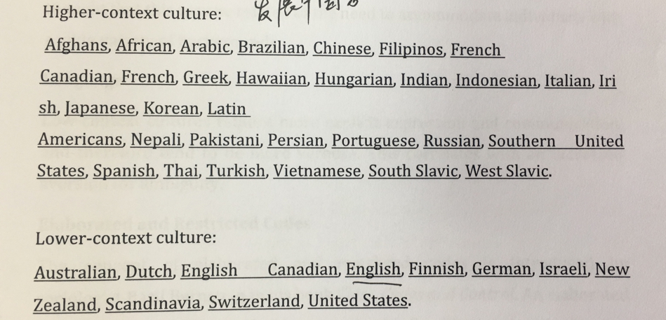

1. high-context culture
2. common in the Asian cultures than in European
3. common in countries with low racial diversity
4. group community is valued over individual
5. the in-groups and group favor higher-context cultures.(?)
6. ?
7. low-context culture
8. explain things further, and it is thought that may be related to the need to accommorate(?) individuals with a wide variety of backgrounds.

|  |  |
| --- | --- |
| High-context | Low-context |
| 内隐、含蓄 | 外显、明了 |
| 暗码信息 | 明码信息 |
| 较多的非言语编码 | 较多的言语编码 |
| 反应很少外露 | 反应外露 |
| 圈内外有别 | 圈内外灵活 |
| 人际关系紧密 | 人际关系不密切 |
| 高承诺 | 低承诺 |
| 时间处理高度灵活 | 时间高度组织化 |

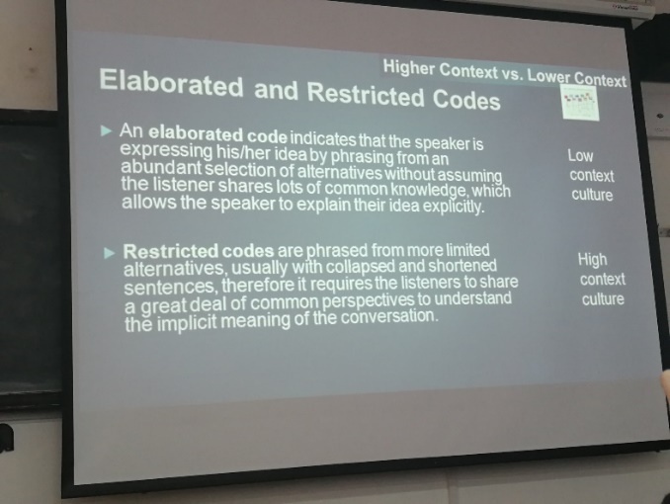

**Lecture 6 Linguistic differences via translation**

some examples:

I want Martini **dry.** 不甜的

There're still some **dry** states in the US. 禁酒的

She prefers dry bread. 无奶油的

The cows are **dry**. 不产奶的

He gave us a **dry** lecture yesterday. 枯燥无味的

* Beware of emotional color when translate

hand-in-glove 亲如手足/狼狈为奸

* correspondence between E&C

at word level?

Secretary of State 国务卿

to teach a duck to swim/ to show off before an expert 班门弄斧

Her beauty puts flower to shame. 她有沉鱼落雁之容，闭月羞花之貌。

* **6 major differences in C&E**

1. English emphasizes the structure, while Chinese focuses on the meaning.
2. In English the passive voice is very commonly used. Unlike English, Chinese usually uses the active voice.
3. In Chinese, idioms and short four characters expressions are very widely used to make the expressions more vivid, live and compact.

*In the retrospect, the past one hundred years of human existence have been* ***extremely fantastic****, and* ***extremely frightening*** *as well.*

*回首过去一百年，人类世界可以说是****精彩绝伦****，但也****惊心动魄****。*

1. English widely used abstract nouns while Chinese usually uses concrete nouns.

disintegration 土崩瓦解

*total exhaustion 筋疲力尽*

*careful consideration 深思熟虑*

*perfection harmony 水乳交融*

*feed on fancies 画饼充饥*

*with great eagerness 如饥似渴*

*lack of perseverance 三天打鱼两天晒网*

*make a little contribution 添砖加瓦*

*on the verge of destruction 危在旦夕*

1. In English words often being omitted to avoid recurrences and to make the sentence shorter and simpler. In Chinese, in contrast, words are generally nit being omitted and instead may be repeated.

*Reading exercises one's eyes; Speaking, one's tongue; While writing, one's mind.*

*阅读训练人的眼睛，说话训练人的口齿，写作训练人的思维。*

1. English puts more emphasis on the first part of the sentence (conclusion first) while Chinese puts the emphasis on the last part of the sentence (reason first).

**Lecture 7&8 Nonverbal communication**

**verbal communication & non-verbal communication** ----- P53

NVC between people is communication through sending and receiving wordless clues.

* body language -- kinesics
* distance -- proxemics
* physical environment/appearance -- paralanguage
* touch -- haptics
* chronemics -- the use of time
* oculesics -- eye contact and the action of looking while talking and listening, frequency of glances, patterns of fixation, pupil dilation, and blink rate.

**Chronemics**

**monochromic people:**

* Do one thing at a time.
* Concentrate on the job.
* Take time commitments (ddls, schdls) seriously.
* Are committed to the job.
* Adhere to plans.
* Are concerned about not disturbing others; follow rules of privacy.
* Show great respect for private property; seldom borrow or lend.
* Emphasize promptness.
* Are accustomed to short-term relationships.

**polychromic people:**

* Do many things at once.
* Are easily distracted and subject to the interruptions.
* Consider time commitments an objective to be achieved, if possible.
* Are committed to people and human relationships.
* Change plans often and easily.
* Are more concerned with people closed to them (family, friends, close business associates) than with privacy.
* Borrow and lend things often and easily.
* Base promptness on the relationship.
* Have strong tendency to build lifetime relationships.

**Gestures:** maybe made with hands, arms or body, and also include movements of the head, face and eyes, such as winking, nodding, or rolling one's eyes.

**speech-independent gestures:** are dependent upon culturally accepted interpretation and have a direct verbal translation. (wave, peace sign)

**speech-related gestures:** are used in parallel with verbal speech.

**Proxemics:**

Proxemics is the study of the cultural, behavioral, and sociological aspects of spatial distances between individuals.

* **Intimate distance:** used for close encounters like embracing, touching, or whispering.
* **Personal distance:** for interactions with close friends and family members.
* **Social distance:** for interactions among acquaintances. (mostly used in workplace and school settings where is no physical contact.)
* **Public distance:** for strangers or public speaking.

**Haptics:** the study of touching as nonverbal communication, and haptic communication refers to how people and other animals communicate via touching.

touching is treated differently from one country to another and socially acceptable levels of touching vary from one culture to another.

**Lecture 9 Culture Shock**

**Culture conflicts:** a type of conflict that occurs where different culture values and beliefs clash.

**Conflict is complicated:**

* culture is multi-layered --- what you see on the surface may mask differences below it.
* culture is constantly in flux --- culture groups adapt in dynamic and sometimes unpredictable ways.
* culture is elastic --- one member of a culture group may not participate in the norms of the culture.
* culture is largely below the surface --- it isn't easy to reach the deeper levels of culture and its meanings.

**Four stages of culture shock:**

* honeymoon
* depressions (frustration/ hostility)
* adjustment
* acceptance

**Lecture 10 Barriers to Intercultural Communication**

**Intercultural adaptation:**

**Acculturation:** the process of modifying one's attitudes, knowledge and behavior.

**Culture Shock**: anxiety resulting from the disorientation encountered upon entering a new culture.

*estrangement, hostility, frustration, fear, anger, even physical illness*

**Barriers to Intercultural Communication:**

* ethnocentrism
* stereotyping
* prejudice
* discrimination

**A model of ICC**

**Attitudes:** relativizing self, value others

**Skills:** interpret and relate, discover and/or interact

**Knowledge:**  of self and other, of interaction: individual and societal

**Critical cultural awareness**