第一次上机作业 12班 卢睿博 201892383

1.a

> a<-rnorm(1000,0,1)

> a

[1] -0.454861420 -2.108232430 -0.492637038 -1.160397135 0.027399261

[6] -2.277158851 -1.003225977 -1.823111438 -1.386214956 0.354895630

[11] -0.720128258 0.352927015 -0.824548160 -0.650572423 0.369593424

[16] -0.520631953 0.809302248 -2.238899352 0.639505624 0.905908567

[21] -0.824461639 -0.506455142 -0.671502163 -0.880297664 0.067177856

[26] -1.587212549 0.672547108 0.775366863 -0.630218204 0.492946492

[31] 0.542529327 0.900352218 0.528813762 0.502912001 -0.826563044

[36] 1.185437867 -0.811702941 -0.243506237 0.635434328 0.673359231

[41] -1.502112187 -0.231257712 -1.354481919 0.419915613 0.609199867

[46] 0.832084438 1.192559166 0.479612357 -0.516863321 -1.216104925

[51] 1.403704030 -0.003275296 -0.779052636 0.715797637 0.223390659

[56] -0.775978817 -0.619334776 0.621531342 0.055443002 0.166333063

[61] 0.610856692 -1.358735905 0.333055167 0.331454283 0.340750508

[66] 0.403573723 1.385661387 -1.414635523 -1.176787057 -1.368905953

[71] 1.120789440 -0.237804122 0.184688167 0.272676995 -1.809345508

[76] -0.687414339 0.254449202 0.624842374 -0.441113343 1.697529660

[81] 0.111895208 -1.369898214 -0.320963611 0.950898965 2.025611201

[86] 1.854177331 -0.256472302 0.750163002 -0.756280395 -0.659461558

[91] -1.305270274 -0.079636728 -0.473095615 -1.797065160 -0.976266415

[96] 0.200857210 1.260783318 0.729928979 -0.621828889 -0.227736710

[101] -0.829887184 0.228989416 -0.501377846 1.026417283 -1.625935174

[106] 1.469541775 -0.238953142 1.222129191 -0.995070681 0.277026884

[111] -1.145590467 -0.915882938 0.795190985 -1.227873781 -0.536806329

[116] -0.381638100 1.523354777 -1.118670755 -0.798249995 0.294543965

[121] -0.677766204 0.952093802 -0.335027231 -0.509354930 1.063820854

[126] -1.408250322 0.383870035 1.058580407 0.931549254 1.033995231

[131] -0.287815812 -0.360896961 -0.636568546 -0.255240156 1.777342287

[136] -0.861920274 -0.772015364 0.360573992 -0.826608378 0.565896309

[141] 1.036446097 -0.010265029 1.028770462 -0.110893446 1.084416052

[146] 1.907154015 0.891092995 0.666711905 0.669228245 -0.684648656

[151] -1.149105995 1.873989956 -0.506730973 -0.836388058 -0.308934132

[156] -0.241939015 -0.339358093 -0.835695241 0.898557313 1.888245723

[161] -1.964286024 0.133025167 4.103686953 -0.765321225 -1.019709711

[166] -0.069359873 0.693801023 -1.845111121 0.054530336 -1.405037343

[171] 0.384835001 -0.754967066 -0.464460990 0.555291398 0.205756806

[176] 0.407346083 -0.145801362 -0.496804869 -0.270293056 0.165882824

[181] -1.266420391 0.315809153 -0.943483429 1.170350352 0.044688664

[186] 0.666900927 0.906605675 -0.369008718 0.857792610 -0.029485227

[191] -0.047396976 0.770897395 -0.749700779 -0.147451115 -1.255262668

[196] 2.001607674 0.426383882 0.367995168 1.172858035 0.270342737

[201] -0.479304546 -0.573812136 -0.691653554 0.912203497 0.755985381

[206] 0.290220161 0.873410971 0.050127324 -0.578231468 -1.440848919

[211] 1.563623979 0.459428984 -0.238863935 1.202582126 0.224717097

[216] 0.941864864 -0.248192224 -0.141565331 -0.571312962 -0.154056357

[221] -0.707780763 -0.030426842 0.977015512 0.875709187 -1.497080257

[226] -1.468291050 0.183673760 -0.868387866 0.248857471 -0.005612363

[231] -0.756231383 0.070763512 -0.588590933 1.568100288 0.702951005

[236] 0.909379958 -1.327642657 0.636435415 -0.584471812 -0.085455982

[241] 1.697496480 0.403398039 0.394806722 1.984815620 0.071686247

[246] 0.536521660 0.181554884 -1.251188393 0.724588189 1.787719638

[251] -0.259965136 1.286837895 -0.461325171 0.573452859 0.082853254

[256] -1.387938810 0.369191791 -0.917468334 -0.882947740 -0.529135252

[261] 0.209287974 -0.573633959 -0.803142934 -0.564301817 0.884158572

[266] -1.568965831 0.518432403 0.855753579 -0.522711699 0.084342055

[271] 0.874580763 2.192616354 -0.467137270 -1.034074318 0.248884414

[276] -1.009314140 -0.485176630 -0.724706037 0.841726576 0.578224695

[281] -0.297263774 -0.405249653 0.816949641 1.775675060 -0.886881139

[286] -0.034173433 1.306953675 1.594098567 -0.243274900 -0.297863933

[291] -0.192466472 0.700540952 -1.308515197 -0.070583796 -0.161740494

[296] -0.451108314 -0.418751578 -0.540097214 -1.056089496 0.758474439

[301] -0.361419758 -2.013015878 0.355590307 0.236120768 0.019754486

[306] 0.489385880 1.188516658 -0.823212922 -1.069243846 0.644272142

[311] 0.986730147 0.665842608 0.594668716 1.869751111 1.855357071

[316] -1.436351275 1.347547120 -1.204432977 0.264710528 -0.352344694

[321] 2.097938730 -0.939019911 -0.570070405 1.038232225 -2.010778176

[326] -1.023622575 0.108725981 0.272399301 0.016379334 0.416808900

[331] -2.096772080 0.111903537 -0.461109099 -2.225917521 -1.196632564

[336] 0.166869651 0.945751806 0.183523589 0.460818427 -0.100835723

[341] -0.050793473 -1.029446096 -0.029182657 -0.296949929 -1.926348743

[346] 2.471172994 -0.895412583 -0.320396686 -0.427125854 0.430333820

[351] -0.055379918 0.400787048 1.807402156 0.502507121 -0.394907196

[356] 0.210976625 -0.799385741 -1.438107357 -1.652021200 0.466998988

[361] -0.860320927 -0.228764017 1.634320351 -0.478505019 0.954488298

[366] -0.495775905 1.017459135 0.482681848 0.570474621 0.947443682

[371] 0.140801072 0.714596393 -0.016119955 0.590649692 0.199668409

[376] -0.111579915 0.155702290 0.425412090 -0.003118867 0.347627549

[381] 0.722714967 -1.215227567 1.250875937 0.319863775 0.620774672

[386] -0.418093640 0.808133823 0.284446570 1.239295234 -1.888894356

[391] 0.224306685 0.704806640 0.119641555 -1.463206568 0.008560797

[396] -1.441617328 1.713231204 -0.329835849 -0.946761631 -0.342179708

[401] -1.727813432 -0.933819544 -0.370509626 -0.476818532 0.153963813

[406] 0.281897943 0.474090459 -2.787032349 1.524079223 0.085530955

[411] -0.263970876 2.315979161 -0.290467993 1.152801525 0.299183423

[416] -1.481955273 0.993632612 -1.560462697 -0.452342429 -0.706431622

[421] -0.830058591 0.945625776 -0.573043048 0.327434572 -0.583860385

[426] -0.780809633 1.441546850 0.138010639 0.281207556 -0.814324964

[431] 1.412705673 -1.263964299 0.691802638 -0.272235944 -0.124748026

[436] 0.068305299 -0.335901171 -1.747468199 -0.566429179 -0.131889099

[441] -0.128607298 -0.695560748 0.085059758 -0.095839008 -1.172358587

[446] 1.049512165 -0.819676813 -1.177229990 -0.151047974 0.988354196

[451] 0.290853810 -0.758552538 1.887826437 0.310735945 1.634580867

[456] 0.542316322 -0.712752361 0.122659283 -0.691120674 -2.051902836

[461] 0.236465543 0.892706588 -0.232551097 1.105163756 1.450147445

[466] 2.597318960 0.819885997 0.129410965 -0.706700296 0.419332438

[471] -1.200967179 -0.466342492 1.221442743 -1.459376886 -1.309251150

[476] -1.050506315 0.124512473 -1.380501315 -0.498776963 -1.917260152

[481] 1.779437671 0.397549517 -0.337236977 0.165947282 1.733267545

[486] 0.107087167 -1.321406852 -0.365828495 -1.509749690 -0.784098356

[491] -0.002745525 1.232831912 -0.309584117 0.218268330 0.475734549

[496] -1.132625749 -0.694713814 -1.295591477 -0.534518519 -0.641034182

[501] 0.585207988 -0.362848474 0.008296570 -0.719446314 1.445027088

[506] 0.797355074 1.558951816 1.404804457 -1.557724825 0.230265657

[511] 0.747206469 0.945777840 -0.424672798 0.368242237 -0.602277137

[516] -0.070096590 0.415725959 0.276738135 1.877183437 0.196933110

[521] 0.871559487 -0.269239124 -0.051132528 -0.402281425 -1.807634793

[526] -1.820545022 -0.899017640 0.728999027 1.346320896 0.279193036

[531] -0.758506519 0.333703177 0.242291755 0.227656468 0.186536390

[536] -1.139548944 -0.339801787 -0.380783509 2.187183235 0.976915931

[541] 0.874355831 1.998548155 0.918317735 -1.091632476 -1.641346247

[546] -2.149755909 -2.093054151 -0.370087384 0.983316031 -0.722205310

[551] -1.267218866 0.585127025 -0.993061935 1.104605501 -0.892856618

[556] 0.116475253 -0.182939952 -1.750729001 -1.871086478 1.343521067

[561] -0.314841347 -0.175620147 -1.088525411 -1.430636556 -1.005586946

[566] -1.333986203 -1.191498788 -1.543241292 0.818285706 1.445111021

[571] 0.262188412 -0.037542906 -0.497652489 0.598410059 -0.234637813

[576] -0.320280824 1.316874598 -1.165905803 0.596025770 -0.266604632

[581] 1.913073049 -1.098829855 1.460782593 0.087384359 -0.274808049

[586] 0.560394228 -0.279210848 -0.330693558 -1.148538029 1.434004997

[591] -0.866470279 0.747750659 -0.685179952 -0.757475155 -0.843528209

[596] -2.136900309 0.052487999 -0.024328985 -0.456702656 0.541910254

[601] -0.458084379 0.425944695 0.969085023 -2.126861994 1.785133128

[606] 0.221920409 -0.814061352 0.710552791 1.467021456 -0.936587068

[611] -0.075507755 0.215246482 0.588638858 -0.219746068 1.671777184

[616] -0.103281684 0.621704582 0.320834753 0.660629689 -0.564386852

[621] 0.772597289 0.322848001 -0.464347153 0.260692753 0.449765720

[626] 1.325022221 -0.324009778 0.659551033 0.084300667 -0.787386596

[631] -0.649121826 -0.987382073 -0.790964819 2.351623505 2.668379561

[636] -0.497710446 0.153313502 0.023425371 -0.186092282 -1.553693194

[641] -0.003000607 0.848625749 -0.090780860 0.679208355 -0.400393844

[646] 1.116364801 0.287869890 2.012509414 -0.994215802 -1.589785835

[651] 1.834470137 -1.185876629 -0.417215062 0.023178887 0.214301871

[656] -0.547179608 -1.007621340 -1.637672276 1.736163929 0.151300843

[661] -1.680439015 -0.587989287 1.673206957 0.674081987 0.034516262

[666] -1.057679320 -0.747485879 1.807297366 0.468232667 0.066154923

[671] -1.596731921 -0.280059084 -0.037656542 0.475270763 0.933247358

[676] -0.483843263 -0.672594716 0.528735503 -0.275568130 -0.678163844

[681] 0.387352230 1.167670519 -0.240355364 -0.106521865 0.329176435

[686] -1.292588438 0.694044491 2.065116895 0.745126186 0.537057556

[691] -1.297531140 -1.333669082 1.118396056 0.937378163 0.171371620

[696] -0.989093884 1.008216109 -0.571232358 0.211958816 1.198082931

[701] -0.229867043 0.282975009 2.658459659 0.482009615 -0.337156134

[706] -0.779252438 0.782119818 -0.776042095 1.239087102 0.258958478

[711] 0.909067971 0.514117514 -0.116761913 0.179569540 -0.192066952

[716] 0.014971400 0.465042106 -1.398140759 -0.161434995 1.312038221

[721] -0.963291853 -0.243423660 0.859583083 1.405595504 -0.530609376

[726] 1.244814533 -0.760545771 -0.333862567 1.274206047 -0.071239911

[731] -1.977698287 0.179207304 -1.182385656 -0.641757601 -1.676477259

[736] -1.495990681 -0.627267310 -0.372042854 1.817313572 -2.086191639

[741] -2.238501531 -0.128107804 -1.320453902 -0.847311909 -1.395022400

[746] 0.014477184 -1.665800334 0.277795173 -0.491378152 -1.372433169

[751] 0.089679836 -1.367146536 -1.486015361 -0.603363604 -0.499748125

[756] 0.676108575 0.830080599 0.046296119 -0.469313226 -0.137437519

[761] -0.592227819 -0.192638766 -0.213844391 0.034524928 0.881707037

[766] 0.011335444 0.524246369 -1.444793807 0.096230409 -0.224070417

[771] -0.291591765 -0.584792247 0.305931229 1.536757766 -0.508553470

[776] 0.110686154 1.115157838 -0.505294102 -0.037278738 2.045722886

[781] -0.615295147 0.889770945 -0.688082664 0.966032615 1.347448481

[786] -0.720207920 0.291904967 -1.092833018 -3.044083630 0.421340060

[791] 0.344642528 -0.276936057 -2.120538640 0.279744941 0.449723215

[796] -1.341289074 -0.035524664 0.872658351 -0.758896568 0.256651477

[801] 0.932571656 -0.443313832 -0.310674120 1.141116876 0.116317274

[806] 0.020529617 0.634524423 0.881485472 -1.482288352 0.003638574

[811] -0.002292889 1.048818465 0.311876283 0.114813709 0.214787699

[816] 1.254752250 -0.287043221 0.800199252 -2.846693657 1.490644192

[821] 0.327315972 -0.935403495 1.055675003 0.962191706 0.631236909

[826] 0.965981628 0.669761396 -1.106205043 -1.905928246 -1.130333478

[831] 2.102975471 0.649049438 0.656196104 -0.797497335 1.113375876

[836] -0.665019872 0.900291012 -1.231614743 -0.754367913 -1.360306143

[841] 1.500592966 -0.240417720 -0.857715186 -0.671184817 1.293099090

[846] 1.309929509 0.013189244 1.492877273 0.338258343 1.111352257

[851] -0.619279248 1.250433463 -0.693669069 -1.065326150 1.114187335

[856] -0.086698102 2.566219221 -0.794870664 0.220548963 0.710277947

[861] 0.505189192 -1.183515141 1.035038556 -0.139097639 -0.455215053

[866] 0.215343586 -1.044554163 -0.001362186 0.959296107 0.916223353

[871] -0.680812280 2.118103764 1.491200020 -1.321280587 0.844847904

[876] 1.298447402 -0.132960051 1.193641976 0.372573490 -1.323201412

[881] 0.429887763 0.174744172 -0.600034411 1.435043398 -2.084025262

[886] 0.125373957 -0.649062872 -0.124236593 0.281528160 1.221570529

[891] 0.395654349 -1.000500833 0.403136150 0.890866460 0.176097298

[896] -0.599979830 1.045588778 1.350655126 2.989619307 -0.881855413

[901] -0.593020910 -0.259002266 1.057689754 -1.069277616 0.898051359

[906] 1.392626869 -0.107013005 0.463941204 -0.288347036 -0.004648132

[911] -0.363926399 0.766075730 -1.385248421 0.212408433 0.762719935

[916] 1.955603377 -0.052037432 0.342358575 0.577608874 -0.506175253

[921] -0.394340987 -0.675449412 -0.254219247 1.286882613 -0.524915379

[926] -0.725166075 0.850448687 0.932000143 0.001293667 0.894394890

[931] 0.646366679 -0.241300883 -1.064950462 0.125305803 -0.398778353

[936] 0.790862829 -0.610760364 -0.347496892 -0.906098777 -0.459797406

[941] 0.046218799 0.212814252 -0.236441427 1.007888026 -0.905512409

[946] -0.087732959 -1.058081541 -2.725471031 1.695216730 -0.082806788

[951] -0.333607436 -0.344996099 1.580211885 -0.879173762 -1.565907899

[956] -0.149149060 -0.612135385 0.237872428 -0.063641677 1.514341865

[961] -0.087186503 0.899608486 0.538303444 0.004493410 -0.251161578

[966] 0.359751606 1.269963749 -0.853376491 -1.672599727 -1.127081234

[971] 0.931591387 -1.022638197 -0.232492076 0.775101601 1.090635520

[976] -0.067899272 0.530282509 -0.435891550 -0.989525570 2.617179685

[981] 0.193937623 1.694805039 0.537600075 0.914210711 0.591974299

[986] -0.829094587 0.569148065 1.158782133 1.137430059 -0.439309596

[991] 0.897422550 -1.743249817 -0.149311909 0.431566572 1.015259524

[996] 1.848431619 1.836157909 -0.524014491 -1.275433127 -1.097889015

> Mean_a = mean(a)

> Mean_a

[1] 0.004185372

> Var_a = var(a)

> Var_a

[1] 0.964178

> ?hist

starting httpd help server ... done

> hist(a,freq=F)

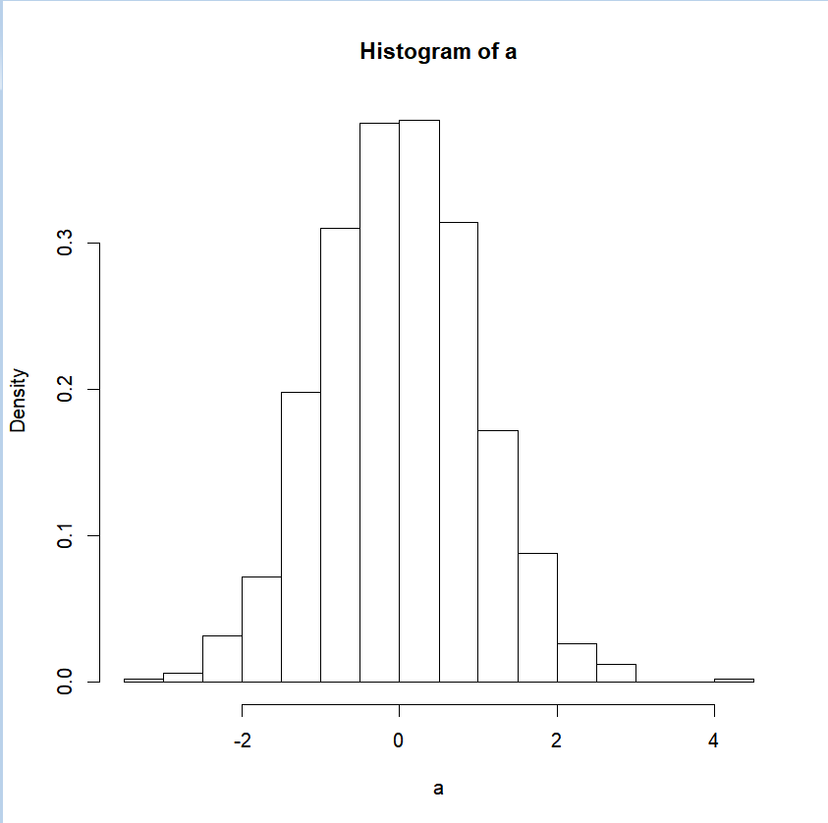

2.a

> b<-c(rpois(100,lambda=2))

> b

[1] 1 1 2 5 1 0 2 2 3 3 2 2 2 5 1 0 1 0 2 4 2 2 5 1 2 1 2 2 1 2 0 2 0 2 6 1

[37] 1 1 1 1 2 0 4 3 2 1 2 2 1 1 2 3 0 0 2 1 1 4 2 2 2 3 1 3 1 1 2 2 1 1 3 2

[73] 4 2 4 1 2 2 1 2 5 0 1 3 5 3 2 3 2 2 3 1 1 1 3 1 1 0 2 0

> Mean_b = mean(b)

> Mean_b

[1] 1.88

> Var_b = var(b)

> Var_b

[1] 1.682424

> hist(b,freq=F)

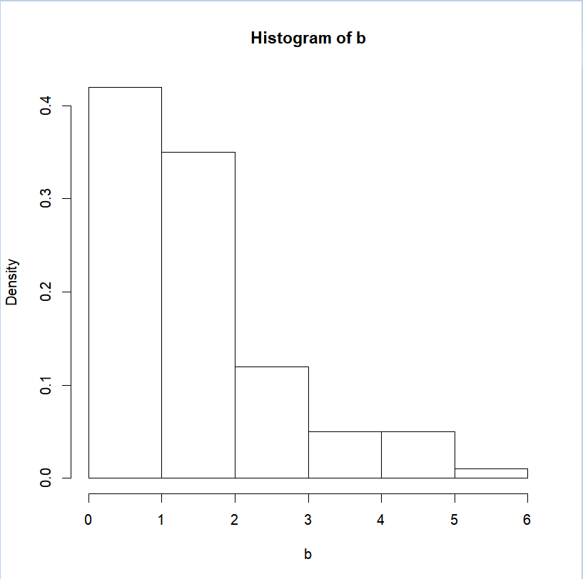

# 2.b

> y<-c(1:1000)

> for ( i in 1:1000){

+ x<-c(rpois(100,lambda = 2))

+ y[i] = mean(x)}

> Mean_y = mean(y)

> Mean_y

[1] 2.00349

> y

[1] 2.21 2.17 2.12 2.18 1.99 2.03 1.95 2.06 1.88 1.99 2.03 2.03 1.89 1.96

[15] 1.98 2.09 1.90 2.09 2.34 2.12 2.03 1.91 2.05 2.08 1.79 1.62 1.65 2.12

[29] 1.76 1.88 2.03 1.89 2.00 1.68 2.21 2.12 2.11 2.18 1.97 1.94 1.96 1.96

[43] 1.98 2.32 1.94 1.98 1.93 2.07 2.20 2.01 1.90 2.30 2.02 2.21 1.95 2.01

[57] 1.90 1.93 1.81 2.12 1.90 1.89 1.87 1.86 2.17 2.14 1.99 1.84 2.17 1.81

[71] 1.79 1.82 2.09 2.14 1.63 1.86 1.84 2.06 2.08 1.97 1.94 2.05 2.09 1.66

[85] 2.01 1.97 1.94 2.02 2.10 1.86 1.88 2.13 2.26 1.83 1.94 2.00 1.75 1.85

[99] 1.80 2.20 1.79 2.13 1.93 1.85 2.17 1.99 2.13 2.02 1.81 2.00 2.14 1.98

[113] 1.88 1.98 1.91 1.97 1.97 2.13 2.17 1.73 1.84 2.00 2.11 2.03 2.01 1.86

[127] 1.99 2.18 1.82 1.97 1.98 1.93 1.95 1.67 2.14 1.91 2.04 1.92 1.96 2.13

[141] 2.08 2.08 1.94 2.00 2.10 1.93 2.15 2.20 2.05 1.86 2.01 2.32 2.04 2.01

[155] 1.96 2.35 2.09 2.12 2.34 1.83 1.83 1.83 1.99 1.81 2.11 2.25 1.85 1.98

[169] 2.20 2.08 1.88 1.97 1.95 2.13 2.14 2.07 1.84 2.20 2.03 2.14 1.93 1.84

[183] 2.16 2.21 1.65 2.24 1.78 2.18 1.82 1.80 1.85 2.02 1.95 1.99 1.91 1.89

[197] 1.89 1.84 2.15 2.32 2.01 1.85 1.99 1.83 2.17 1.95 1.93 2.28 1.91 2.18

[211] 2.13 2.10 2.13 2.24 2.00 1.98 1.85 1.84 1.97 2.10 2.12 2.01 1.91 2.12

[225] 2.05 2.10 1.74 2.16 1.85 1.99 1.97 2.00 1.98 2.07 1.89 2.00 2.13 2.01

[239] 1.85 1.98 2.04 1.94 2.00 2.12 1.83 2.08 2.04 1.96 2.16 1.79 1.91 2.09

[253] 1.77 2.03 1.95 1.88 2.11 1.80 1.78 2.10 2.18 2.14 1.67 2.09 1.89 1.94

[267] 1.95 2.03 2.13 1.96 2.12 2.19 1.76 2.04 2.01 2.11 2.26 1.94 1.97 1.90

[281] 2.13 2.14 2.11 2.15 1.93 1.88 2.06 2.08 2.14 2.07 2.01 1.84 1.97 1.90

[295] 1.86 1.92 2.07 2.15 2.12 2.22 1.98 2.35 2.18 2.10 1.84 2.20 1.97 1.86

[309] 1.96 1.91 2.05 2.27 1.82 2.05 1.77 2.05 2.19 2.24 2.12 2.06 1.94 1.93

[323] 2.06 2.02 1.89 1.94 1.98 1.98 1.97 1.94 2.14 2.23 1.74 1.97 1.88 1.96

[337] 1.78 1.81 1.95 2.24 1.98 1.95 1.93 2.01 2.26 2.20 1.92 1.72 2.30 2.09

[351] 2.22 1.85 1.94 1.90 2.27 2.03 2.18 1.82 1.98 1.93 2.01 1.98 1.74 1.94

[365] 2.06 2.37 1.94 1.86 2.04 1.91 2.05 2.03 2.08 2.12 2.08 1.90 2.00 1.94

[379] 1.80 2.13 1.91 2.29 2.22 1.97 2.00 2.00 1.96 2.19 2.08 2.03 2.13 2.17

[393] 1.62 1.84 2.27 1.93 1.94 2.03 2.15 2.09 2.23 2.02 1.73 2.05 2.15 2.21

[407] 2.12 1.96 2.03 2.25 2.16 2.36 1.89 2.31 1.90 1.94 2.19 2.20 2.02 2.10

[421] 1.74 1.68 2.03 2.13 1.92 2.17 2.05 2.52 2.32 1.99 1.86 2.08 1.88 1.95

[435] 1.88 2.16 2.13 2.05 2.01 2.11 2.24 2.00 1.84 2.19 2.03 2.12 2.25 2.14

[449] 2.21 1.83 2.17 1.88 1.90 1.95 1.87 2.21 1.93 1.96 1.83 1.93 2.04 2.11

[463] 1.97 1.94 2.35 2.05 2.04 1.71 2.02 1.95 1.93 2.17 2.18 2.19 2.07 1.75

[477] 1.95 2.18 2.10 1.90 1.96 2.13 1.98 1.89 1.77 1.69 1.95 2.04 1.89 2.09

[491] 2.06 1.87 2.01 1.98 2.15 1.76 1.80 2.01 1.99 1.81 1.98 2.12 2.13 1.99

[505] 2.02 2.04 1.92 2.08 1.97 1.97 1.94 1.91 1.98 2.13 2.04 1.91 1.95 1.97

[519] 1.88 2.12 2.12 1.98 1.89 2.15 2.08 2.22 2.00 1.84 1.81 1.84 2.06 2.05

[533] 1.96 2.10 2.00 1.94 2.22 1.97 1.89 1.87 1.96 1.92 2.14 2.04 1.97 2.00

[547] 2.07 2.17 2.13 1.91 2.09 1.92 2.19 2.00 2.15 2.14 2.22 2.23 1.78 2.07

[561] 1.82 2.04 1.82 2.07 1.91 2.06 1.72 1.97 1.93 1.98 2.02 1.80 1.97 1.99

[575] 2.13 1.89 2.11 1.87 2.17 1.88 1.96 2.04 1.83 2.04 1.82 2.08 1.68 1.93

[589] 2.06 2.01 1.94 2.05 2.00 2.26 2.05 2.37 2.17 2.16 2.01 2.08 2.15 1.84

[603] 2.14 2.10 1.90 1.96 2.02 1.99 2.06 1.81 1.90 1.78 1.56 1.91 1.93 2.19

[617] 1.75 2.02 1.80 1.69 2.08 2.27 2.17 1.88 1.80 1.73 2.25 2.16 2.03 1.94

[631] 2.09 2.05 2.26 2.05 1.81 1.99 2.25 1.95 1.85 1.90 2.00 1.99 2.15 1.84

[645] 2.15 1.83 1.94 2.16 1.92 1.71 2.07 1.99 2.15 2.03 2.09 2.01 1.89 1.79

[659] 2.14 2.10 2.03 1.76 2.15 1.92 1.95 1.97 1.97 1.99 1.79 2.03 1.93 1.94

[673] 2.14 2.06 2.05 1.95 2.05 1.79 1.94 2.06 2.09 1.96 1.95 2.12 1.96 2.07

[687] 2.02 1.87 2.07 1.97 1.90 2.05 1.96 1.97 1.90 2.13 1.99 2.15 1.99 1.96

[701] 2.06 2.19 1.74 1.77 2.08 1.94 2.18 2.12 2.29 1.89 2.04 1.97 2.10 1.75

[715] 1.98 2.02 2.20 1.99 2.06 2.02 1.80 1.90 2.11 1.93 1.99 1.88 1.74 1.94

[729] 2.22 2.08 1.94 1.97 2.38 1.90 1.94 2.09 1.84 2.04 2.04 2.00 2.05 2.11

[743] 2.13 1.96 2.14 1.88 2.01 2.24 1.80 2.06 1.93 2.06 2.19 2.07 1.69 2.22

[757] 2.19 2.11 2.02 1.94 2.16 1.89 2.02 1.80 2.06 2.08 2.04 2.01 1.79 1.98

[771] 1.92 1.79 1.99 2.15 1.94 2.06 2.05 1.80 2.10 1.83 1.89 2.28 2.11 2.21

[785] 1.81 1.91 1.85 2.24 2.10 2.21 2.17 2.07 1.79 2.04 1.96 2.10 2.08 1.60

[799] 2.01 1.92 1.71 1.74 1.86 1.94 1.87 2.31 1.71 2.08 1.97 1.81 2.09 1.97

[813] 2.29 2.00 2.00 2.02 1.97 2.05 1.88 2.13 1.83 1.99 2.12 2.03 2.11 1.89

[827] 1.76 2.01 2.24 1.89 2.20 1.90 1.56 1.84 2.04 2.19 2.22 1.93 2.04 1.96

[841] 1.83 1.95 1.86 2.21 1.81 1.90 1.94 1.92 1.82 2.23 2.14 1.85 1.90 2.12

[855] 2.02 1.96 1.99 1.88 2.00 1.86 2.00 2.31 2.09 1.95 2.13 1.86 2.13 1.90

[869] 1.97 2.00 1.83 2.14 2.10 2.00 2.09 1.91 2.08 1.93 1.97 2.19 2.28 2.13

[883] 2.00 1.90 2.10 2.01 1.87 1.78 1.94 2.11 1.84 2.07 1.97 2.11 2.26 1.91

[897] 2.12 1.93 2.11 1.86 2.05 1.86 2.08 1.95 1.83 2.10 1.91 2.09 2.08 1.77

[911] 2.02 2.18 1.86 2.04 1.90 1.85 2.11 2.07 2.06 2.00 2.07 2.18 2.13 2.08

[925] 1.89 1.82 1.98 1.92 2.10 2.12 1.97 2.17 2.05 2.25 2.02 1.89 1.97 1.96

[939] 2.02 1.84 1.93 2.04 2.03 2.17 1.88 2.01 2.00 1.99 1.97 1.86 1.89 2.01

[953] 2.07 1.94 1.67 2.16 1.79 1.98 2.52 1.79 1.87 1.91 1.91 2.09 2.31 2.10

[967] 1.80 1.83 2.11 2.16 2.25 2.12 2.05 1.81 2.12 2.22 1.93 2.22 2.19 1.92

[981] 2.22 1.84 2.01 1.99 1.83 2.05 1.98 1.82 1.86 1.82 1.73 2.07 2.04 1.97

[995] 1.83 2.20 2.12 2.07 2.07 2.04

**2.c**

> sy<-c(1:1000)

> for(i in 1:1000){

+ sy[i] = (y[i]-2)/sqrt(2/100)}

> sy

[1] 1.48492424 1.20208153 0.84852814 1.27279221 -0.07071068

[6] 0.21213203 -0.35355339 0.42426407 -0.84852814 -0.07071068

[11] 0.21213203 0.21213203 -0.77781746 -0.28284271 -0.14142136

[16] 0.63639610 -0.70710678 0.63639610 2.40416306 0.84852814

[21] 0.21213203 -0.63639610 0.35355339 0.56568542 -1.48492424

[26] -2.68700577 -2.47487373 0.84852814 -1.69705627 -0.84852814

[31] 0.21213203 -0.77781746 0.00000000 -2.26274170 1.48492424

[36] 0.84852814 0.77781746 1.27279221 -0.21213203 -0.42426407

[41] -0.28284271 -0.28284271 -0.14142136 2.26274170 -0.42426407

[46] -0.14142136 -0.49497475 0.49497475 1.41421356 0.07071068

[51] -0.70710678 2.12132034 0.14142136 1.48492424 -0.35355339

[56] 0.07071068 -0.70710678 -0.49497475 -1.34350288 0.84852814

[61] -0.70710678 -0.77781746 -0.91923882 -0.98994949 1.20208153

[66] 0.98994949 -0.07071068 -1.13137085 1.20208153 -1.34350288

[71] -1.48492424 -1.27279221 0.63639610 0.98994949 -2.61629509

[76] -0.98994949 -1.13137085 0.42426407 0.56568542 -0.21213203

[81] -0.42426407 0.35355339 0.63639610 -2.40416306 0.07071068

[86] -0.21213203 -0.42426407 0.14142136 0.70710678 -0.98994949

[91] -0.84852814 0.91923882 1.83847763 -1.20208153 -0.42426407

[96] 0.00000000 -1.76776695 -1.06066017 -1.41421356 1.41421356

[101] -1.48492424 0.91923882 -0.49497475 -1.06066017 1.20208153

[106] -0.07071068 0.91923882 0.14142136 -1.34350288 0.00000000

[111] 0.98994949 -0.14142136 -0.84852814 -0.14142136 -0.63639610

[116] -0.21213203 -0.21213203 0.91923882 1.20208153 -1.90918831

[121] -1.13137085 0.00000000 0.77781746 0.21213203 0.07071068

[126] -0.98994949 -0.07071068 1.27279221 -1.27279221 -0.21213203

[131] -0.14142136 -0.49497475 -0.35355339 -2.33345238 0.98994949

[136] -0.63639610 0.28284271 -0.56568542 -0.28284271 0.91923882

[141] 0.56568542 0.56568542 -0.42426407 0.00000000 0.70710678

[146] -0.49497475 1.06066017 1.41421356 0.35355339 -0.98994949

[151] 0.07071068 2.26274170 0.28284271 0.07071068 -0.28284271

[156] 2.47487373 0.63639610 0.84852814 2.40416306 -1.20208153

[161] -1.20208153 -1.20208153 -0.07071068 -1.34350288 0.77781746

[166] 1.76776695 -1.06066017 -0.14142136 1.41421356 0.56568542

[171] -0.84852814 -0.21213203 -0.35355339 0.91923882 0.98994949

[176] 0.49497475 -1.13137085 1.41421356 0.21213203 0.98994949

[181] -0.49497475 -1.13137085 1.13137085 1.48492424 -2.47487373

[186] 1.69705627 -1.55563492 1.27279221 -1.27279221 -1.41421356

[191] -1.06066017 0.14142136 -0.35355339 -0.07071068 -0.63639610

[196] -0.77781746 -0.77781746 -1.13137085 1.06066017 2.26274170

[201] 0.07071068 -1.06066017 -0.07071068 -1.20208153 1.20208153

[206] -0.35355339 -0.49497475 1.97989899 -0.63639610 1.27279221

[211] 0.91923882 0.70710678 0.91923882 1.69705627 0.00000000

[216] -0.14142136 -1.06066017 -1.13137085 -0.21213203 0.70710678

[221] 0.84852814 0.07071068 -0.63639610 0.84852814 0.35355339

[226] 0.70710678 -1.83847763 1.13137085 -1.06066017 -0.07071068

[231] -0.21213203 0.00000000 -0.14142136 0.49497475 -0.77781746

[236] 0.00000000 0.91923882 0.07071068 -1.06066017 -0.14142136

[241] 0.28284271 -0.42426407 0.00000000 0.84852814 -1.20208153

[246] 0.56568542 0.28284271 -0.28284271 1.13137085 -1.48492424

[251] -0.63639610 0.63639610 -1.62634560 0.21213203 -0.35355339

[256] -0.84852814 0.77781746 -1.41421356 -1.55563492 0.70710678

[261] 1.27279221 0.98994949 -2.33345238 0.63639610 -0.77781746

[266] -0.42426407 -0.35355339 0.21213203 0.91923882 -0.28284271

[271] 0.84852814 1.34350288 -1.69705627 0.28284271 0.07071068

[276] 0.77781746 1.83847763 -0.42426407 -0.21213203 -0.70710678

[281] 0.91923882 0.98994949 0.77781746 1.06066017 -0.49497475

[286] -0.84852814 0.42426407 0.56568542 0.98994949 0.49497475

[291] 0.07071068 -1.13137085 -0.21213203 -0.70710678 -0.98994949

[296] -0.56568542 0.49497475 1.06066017 0.84852814 1.55563492

[301] -0.14142136 2.47487373 1.27279221 0.70710678 -1.13137085

[306] 1.41421356 -0.21213203 -0.98994949 -0.28284271 -0.63639610

[311] 0.35355339 1.90918831 -1.27279221 0.35355339 -1.62634560

[316] 0.35355339 1.34350288 1.69705627 0.84852814 0.42426407

[321] -0.42426407 -0.49497475 0.42426407 0.14142136 -0.77781746

[326] -0.42426407 -0.14142136 -0.14142136 -0.21213203 -0.42426407

[331] 0.98994949 1.62634560 -1.83847763 -0.21213203 -0.84852814

[336] -0.28284271 -1.55563492 -1.34350288 -0.35355339 1.69705627

[341] -0.14142136 -0.35355339 -0.49497475 0.07071068 1.83847763

[346] 1.41421356 -0.56568542 -1.97989899 2.12132034 0.63639610

[351] 1.55563492 -1.06066017 -0.42426407 -0.70710678 1.90918831

[356] 0.21213203 1.27279221 -1.27279221 -0.14142136 -0.49497475

[361] 0.07071068 -0.14142136 -1.83847763 -0.42426407 0.42426407

[366] 2.61629509 -0.42426407 -0.98994949 0.28284271 -0.63639610

[371] 0.35355339 0.21213203 0.56568542 0.84852814 0.56568542

[376] -0.70710678 0.00000000 -0.42426407 -1.41421356 0.91923882

[381] -0.63639610 2.05060967 1.55563492 -0.21213203 0.00000000

[386] 0.00000000 -0.28284271 1.34350288 0.56568542 0.21213203

[391] 0.91923882 1.20208153 -2.68700577 -1.13137085 1.90918831

[396] -0.49497475 -0.42426407 0.21213203 1.06066017 0.63639610

[401] 1.62634560 0.14142136 -1.90918831 0.35355339 1.06066017

[406] 1.48492424 0.84852814 -0.28284271 0.21213203 1.76776695

[411] 1.13137085 2.54558441 -0.77781746 2.19203102 -0.70710678

[416] -0.42426407 1.34350288 1.41421356 0.14142136 0.70710678

[421] -1.83847763 -2.26274170 0.21213203 0.91923882 -0.56568542

[426] 1.20208153 0.35355339 3.67695526 2.26274170 -0.07071068

[431] -0.98994949 0.56568542 -0.84852814 -0.35355339 -0.84852814

[436] 1.13137085 0.91923882 0.35355339 0.07071068 0.77781746

[441] 1.69705627 0.00000000 -1.13137085 1.34350288 0.21213203

[446] 0.84852814 1.76776695 0.98994949 1.48492424 -1.20208153

[451] 1.20208153 -0.84852814 -0.70710678 -0.35355339 -0.91923882

[456] 1.48492424 -0.49497475 -0.28284271 -1.20208153 -0.49497475

[461] 0.28284271 0.77781746 -0.21213203 -0.42426407 2.47487373

[466] 0.35355339 0.28284271 -2.05060967 0.14142136 -0.35355339

[471] -0.49497475 1.20208153 1.27279221 1.34350288 0.49497475

[476] -1.76776695 -0.35355339 1.27279221 0.70710678 -0.70710678

[481] -0.28284271 0.91923882 -0.14142136 -0.77781746 -1.62634560

[486] -2.19203102 -0.35355339 0.28284271 -0.77781746 0.63639610

[491] 0.42426407 -0.91923882 0.07071068 -0.14142136 1.06066017

[496] -1.69705627 -1.41421356 0.07071068 -0.07071068 -1.34350288

[501] -0.14142136 0.84852814 0.91923882 -0.07071068 0.14142136

[506] 0.28284271 -0.56568542 0.56568542 -0.21213203 -0.21213203

[511] -0.42426407 -0.63639610 -0.14142136 0.91923882 0.28284271

[516] -0.63639610 -0.35355339 -0.21213203 -0.84852814 0.84852814

[521] 0.84852814 -0.14142136 -0.77781746 1.06066017 0.56568542

[526] 1.55563492 0.00000000 -1.13137085 -1.34350288 -1.13137085

[531] 0.42426407 0.35355339 -0.28284271 0.70710678 0.00000000

[536] -0.42426407 1.55563492 -0.21213203 -0.77781746 -0.91923882

[541] -0.28284271 -0.56568542 0.98994949 0.28284271 -0.21213203

[546] 0.00000000 0.49497475 1.20208153 0.91923882 -0.63639610

[551] 0.63639610 -0.56568542 1.34350288 0.00000000 1.06066017

[556] 0.98994949 1.55563492 1.62634560 -1.55563492 0.49497475

[561] -1.27279221 0.28284271 -1.27279221 0.49497475 -0.63639610

[566] 0.42426407 -1.97989899 -0.21213203 -0.49497475 -0.14142136

[571] 0.14142136 -1.41421356 -0.21213203 -0.07071068 0.91923882

[576] -0.77781746 0.77781746 -0.91923882 1.20208153 -0.84852814

[581] -0.28284271 0.28284271 -1.20208153 0.28284271 -1.27279221

[586] 0.56568542 -2.26274170 -0.49497475 0.42426407 0.07071068

[591] -0.42426407 0.35355339 0.00000000 1.83847763 0.35355339

[596] 2.61629509 1.20208153 1.13137085 0.07071068 0.56568542

[601] 1.06066017 -1.13137085 0.98994949 0.70710678 -0.70710678

[606] -0.28284271 0.14142136 -0.07071068 0.42426407 -1.34350288

[611] -0.70710678 -1.55563492 -3.11126984 -0.63639610 -0.49497475

[616] 1.34350288 -1.76776695 0.14142136 -1.41421356 -2.19203102

[621] 0.56568542 1.90918831 1.20208153 -0.84852814 -1.41421356

[626] -1.90918831 1.76776695 1.13137085 0.21213203 -0.42426407

[631] 0.63639610 0.35355339 1.83847763 0.35355339 -1.34350288

[636] -0.07071068 1.76776695 -0.35355339 -1.06066017 -0.70710678

[641] 0.00000000 -0.07071068 1.06066017 -1.13137085 1.06066017

[646] -1.20208153 -0.42426407 1.13137085 -0.56568542 -2.05060967

[651] 0.49497475 -0.07071068 1.06066017 0.21213203 0.63639610

[656] 0.07071068 -0.77781746 -1.48492424 0.98994949 0.70710678

[661] 0.21213203 -1.69705627 1.06066017 -0.56568542 -0.35355339

[666] -0.21213203 -0.21213203 -0.07071068 -1.48492424 0.21213203

[671] -0.49497475 -0.42426407 0.98994949 0.42426407 0.35355339

[676] -0.35355339 0.35355339 -1.48492424 -0.42426407 0.42426407

[681] 0.63639610 -0.28284271 -0.35355339 0.84852814 -0.28284271

[686] 0.49497475 0.14142136 -0.91923882 0.49497475 -0.21213203

[691] -0.70710678 0.35355339 -0.28284271 -0.21213203 -0.70710678

[696] 0.91923882 -0.07071068 1.06066017 -0.07071068 -0.28284271

[701] 0.42426407 1.34350288 -1.83847763 -1.62634560 0.56568542

[706] -0.42426407 1.27279221 0.84852814 2.05060967 -0.77781746

[711] 0.28284271 -0.21213203 0.70710678 -1.76776695 -0.14142136

[716] 0.14142136 1.41421356 -0.07071068 0.42426407 0.14142136

[721] -1.41421356 -0.70710678 0.77781746 -0.49497475 -0.07071068

[726] -0.84852814 -1.83847763 -0.42426407 1.55563492 0.56568542

[731] -0.42426407 -0.21213203 2.68700577 -0.70710678 -0.42426407

[736] 0.63639610 -1.13137085 0.28284271 0.28284271 0.00000000

[741] 0.35355339 0.77781746 0.91923882 -0.28284271 0.98994949

[746] -0.84852814 0.07071068 1.69705627 -1.41421356 0.42426407

[751] -0.49497475 0.42426407 1.34350288 0.49497475 -2.19203102

[756] 1.55563492 1.34350288 0.77781746 0.14142136 -0.42426407

[761] 1.13137085 -0.77781746 0.14142136 -1.41421356 0.42426407

[766] 0.56568542 0.28284271 0.07071068 -1.48492424 -0.14142136

[771] -0.56568542 -1.48492424 -0.07071068 1.06066017 -0.42426407

[776] 0.42426407 0.35355339 -1.41421356 0.70710678 -1.20208153

[781] -0.77781746 1.97989899 0.77781746 1.48492424 -1.34350288

[786] -0.63639610 -1.06066017 1.69705627 0.70710678 1.48492424

[791] 1.20208153 0.49497475 -1.48492424 0.28284271 -0.28284271

[796] 0.70710678 0.56568542 -2.82842712 0.07071068 -0.56568542

[801] -2.05060967 -1.83847763 -0.98994949 -0.42426407 -0.91923882

[806] 2.19203102 -2.05060967 0.56568542 -0.21213203 -1.34350288

[811] 0.63639610 -0.21213203 2.05060967 0.00000000 0.00000000

[816] 0.14142136 -0.21213203 0.35355339 -0.84852814 0.91923882

[821] -1.20208153 -0.07071068 0.84852814 0.21213203 0.77781746

[826] -0.77781746 -1.69705627 0.07071068 1.69705627 -0.77781746

[831] 1.41421356 -0.70710678 -3.11126984 -1.13137085 0.28284271

[836] 1.34350288 1.55563492 -0.49497475 0.28284271 -0.28284271

[841] -1.20208153 -0.35355339 -0.98994949 1.48492424 -1.34350288

[846] -0.70710678 -0.42426407 -0.56568542 -1.27279221 1.62634560

[851] 0.98994949 -1.06066017 -0.70710678 0.84852814 0.14142136

[856] -0.28284271 -0.07071068 -0.84852814 0.00000000 -0.98994949

[861] 0.00000000 2.19203102 0.63639610 -0.35355339 0.91923882

[866] -0.98994949 0.91923882 -0.70710678 -0.21213203 0.00000000

[871] -1.20208153 0.98994949 0.70710678 0.00000000 0.63639610

[876] -0.63639610 0.56568542 -0.49497475 -0.21213203 1.34350288

[881] 1.97989899 0.91923882 0.00000000 -0.70710678 0.70710678

[886] 0.07071068 -0.91923882 -1.55563492 -0.42426407 0.77781746

[891] -1.13137085 0.49497475 -0.21213203 0.77781746 1.83847763

[896] -0.63639610 0.84852814 -0.49497475 0.77781746 -0.98994949

[901] 0.35355339 -0.98994949 0.56568542 -0.35355339 -1.20208153

[906] 0.70710678 -0.63639610 0.63639610 0.56568542 -1.62634560

[911] 0.14142136 1.27279221 -0.98994949 0.28284271 -0.70710678

[916] -1.06066017 0.77781746 0.49497475 0.42426407 0.00000000

[921] 0.49497475 1.27279221 0.91923882 0.56568542 -0.77781746

[926] -1.27279221 -0.14142136 -0.56568542 0.70710678 0.84852814

[931] -0.21213203 1.20208153 0.35355339 1.76776695 0.14142136

[936] -0.77781746 -0.21213203 -0.28284271 0.14142136 -1.13137085

[941] -0.49497475 0.28284271 0.21213203 1.20208153 -0.84852814

[946] 0.07071068 0.00000000 -0.07071068 -0.21213203 -0.98994949

[951] -0.77781746 0.07071068 0.49497475 -0.42426407 -2.33345238

[956] 1.13137085 -1.48492424 -0.14142136 3.67695526 -1.48492424

[961] -0.91923882 -0.63639610 -0.63639610 0.63639610 2.19203102

[966] 0.70710678 -1.41421356 -1.20208153 0.77781746 1.13137085

[971] 1.76776695 0.84852814 0.35355339 -1.34350288 0.84852814

[976] 1.55563492 -0.49497475 1.55563492 1.34350288 -0.56568542

[981] 1.55563492 -1.13137085 0.07071068 -0.07071068 -1.20208153

[986] 0.35355339 -0.14142136 -1.27279221 -0.98994949 -1.27279221

[991] -1.90918831 0.49497475 0.28284271 -0.21213203 -1.20208153

[996] 1.41421356 0.84852814 0.49497475 0.49497475 0.28284271

> Mean_sy = mean(sy)

> Mean_sy

[1] 0.02467803

> Var_sy = var(sy)

> Var_sy

[1] 1.029005

> hist(sy,freq=F)

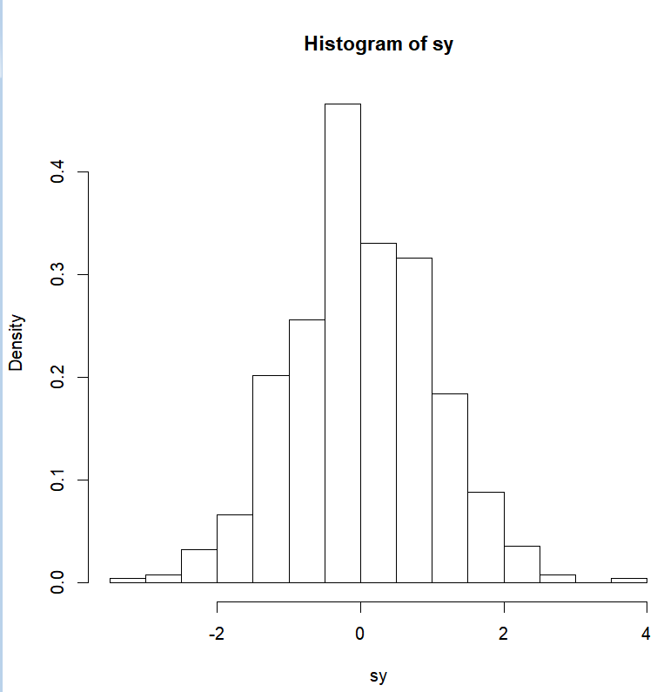

经比较可得，sy属于均值为0方差为1的正态分布.