**TRISTAN CAÑETE TLE**

**WHAT IS HTML?**

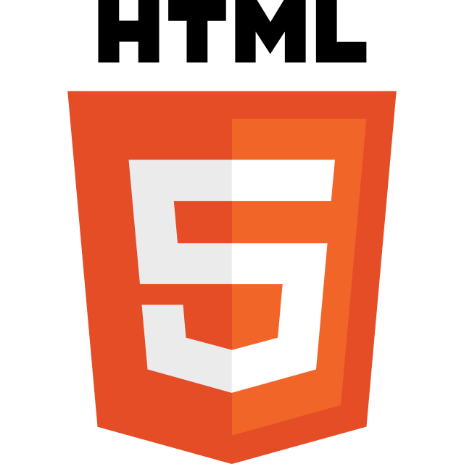The HyperText Markup Language or HTML is the standard markup language for documents designed to be displayed in a web browser. It can be assisted by technologies such as Cascading Style Sheets and scripting languages such as JavaScript.

**WHAT IS CSS?**

Cascading Style Sheets is a style sheet language used for describing the presentation of a document written in a markup language such as HTML or XML. CSS is a cornerstone technology of the World Wide Web, alongside HTML and JavaScript.

**WHAT ARE THE DIFFERENCES OF HTML AND CSS?**

 HTML is a markup language used to create static web pages and web applications. CSS is a style sheet language responsible for the presentation of documents written in a markup language. They both provide different functionalities. As HTML is used to structure the content on websites. On the other hand, CSS provides styling to those websites by adding style properties like font size, font family, margin, padding, border, so on and so forth.

