**COMPUTER NETWORKS LAB**

**PES1UG19CS545**

**TUSHAR Y S**

**IPv6 Configuration and static routing**

1) Topology creation and IPv4 addressing:

- The topology which was created and deployed on claynet is shown below:

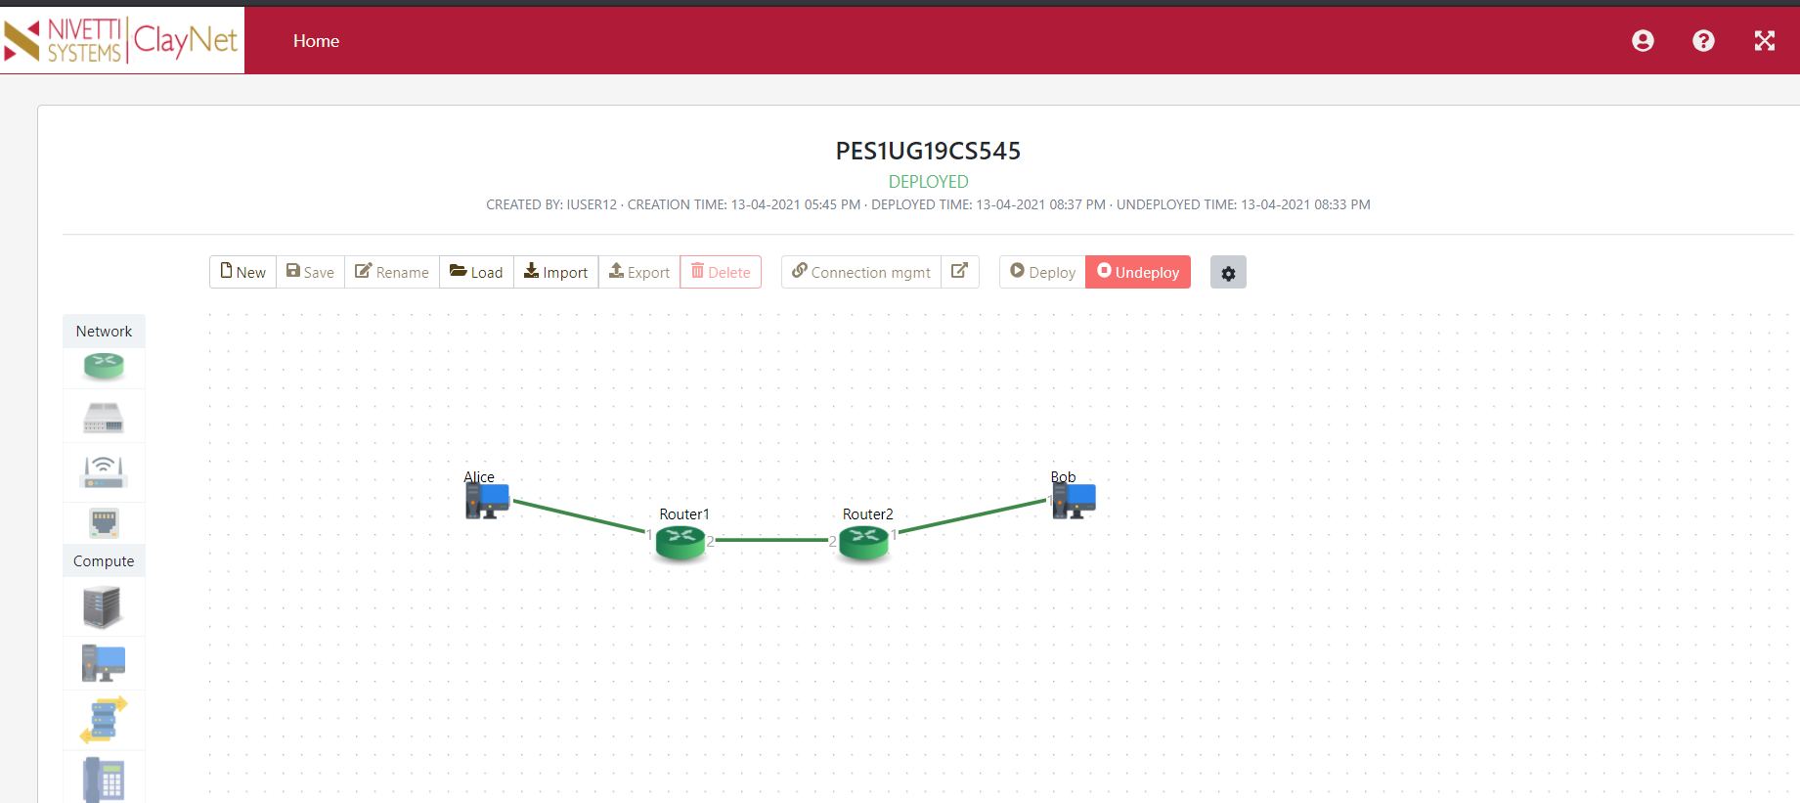

- As can be seen in the topology, there are 2 end systems and 2 routers.

- The end systems are configured as given below:

|  |  |  |
| --- | --- | --- |
| End system | IP Address | Gateway |
| Alice | 2001::02/24 | 2001::02 |
| Bob | 2003::02/24 | 2003::01 |

2) Router configuration:

- IPv6 addresses must be set for both the routers.

- Firstly, we need to enable IPv6 mode in both the routers.

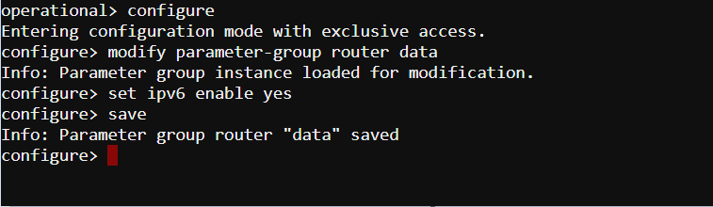

2.1. Router 1:

- if-port-1 interface of Router 1 is assigned with an IPv6 address 2001::01/64.

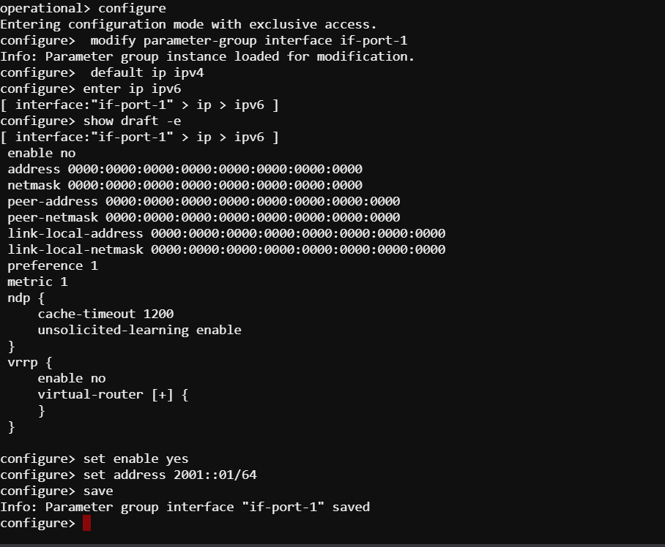

- Similarly, if-port-2 interface of Router 2 is assigned with an IPv6 address 2002::01/64.

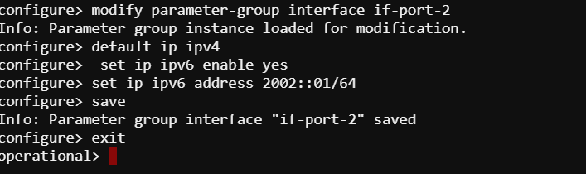

- Full interface configuration of Router 1:

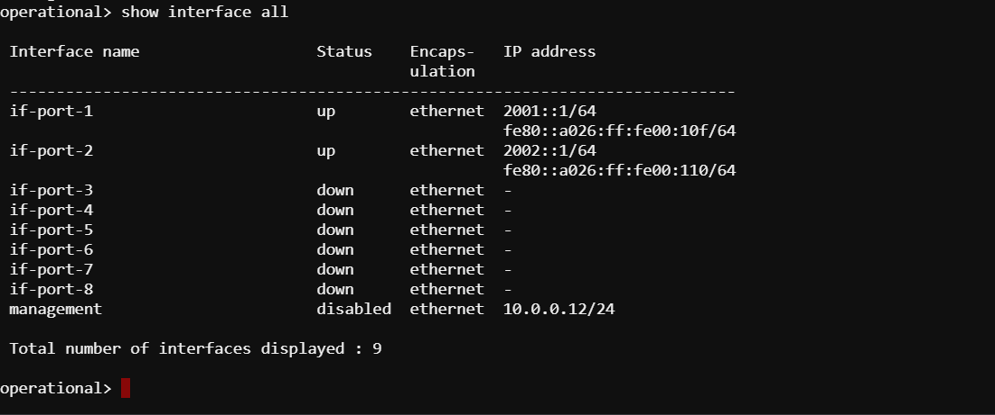

- Routing table for Router 1:

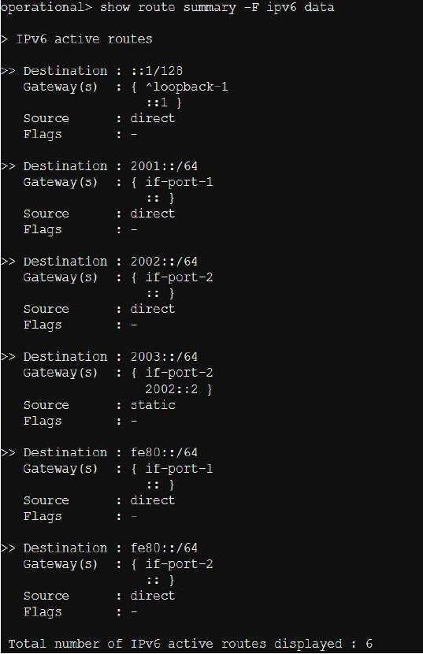

2.2. Router 2:

- if-port-1 interface of Router 1 is assigned with an IPv6 address 2003::01/64.

- if-port-2 interface of Router 2 is assigned with an IPv6 address 2002::02/64.

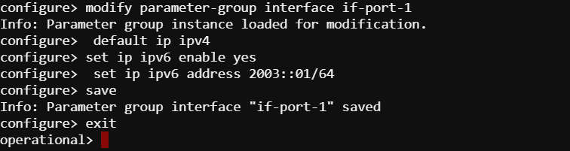

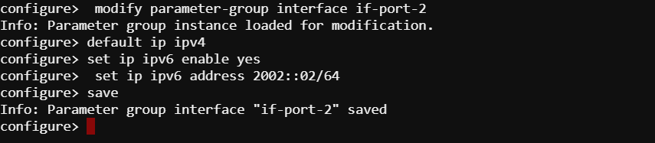

- Interfaces:

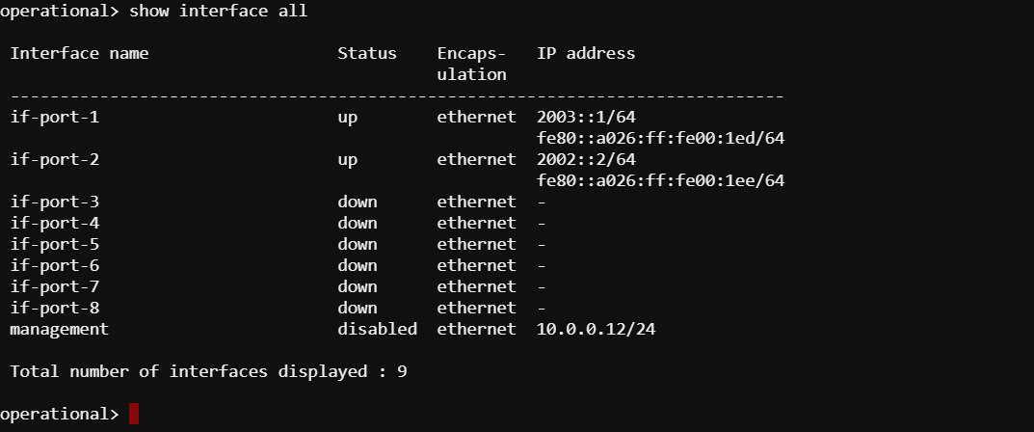

- Routing table entries for Router 2:

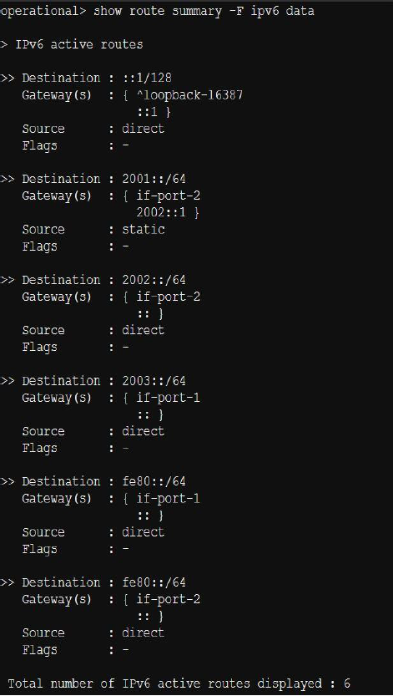

3) Observations:

3.1. Pinging

- Alice can ping Bob successfully. Screenshot of the same is shown below:

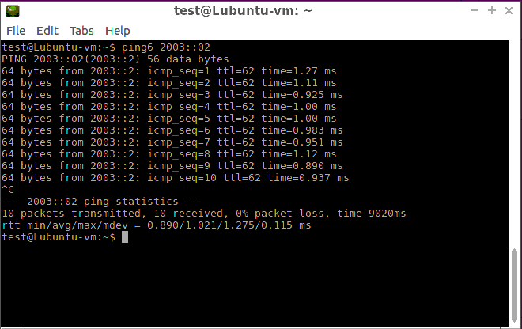

- As can be observed above , the TTL is reduced to 62 from 64 (as there are 2 hops between the workstations).

3.2. Wireshark Packet Capture:

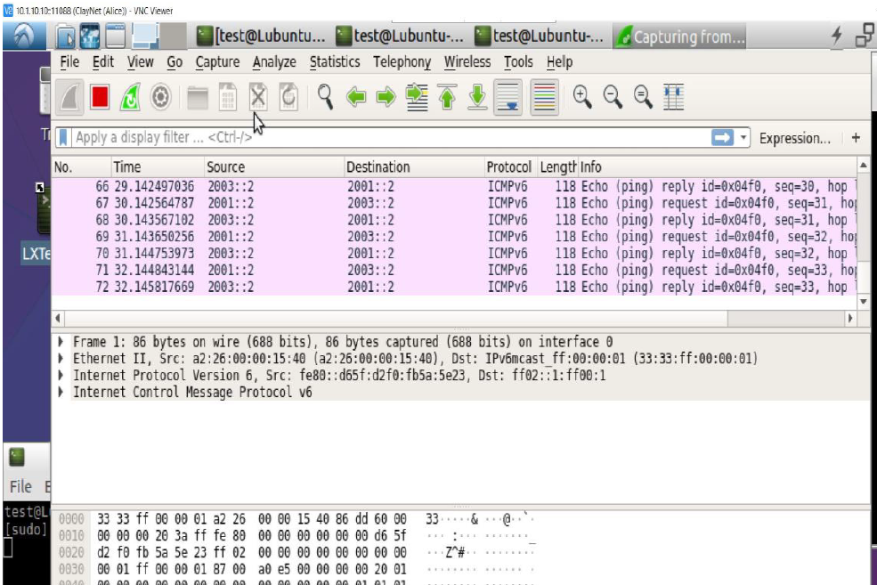

3.3. Tracepath

- Tracepath command from Alice to Bob.

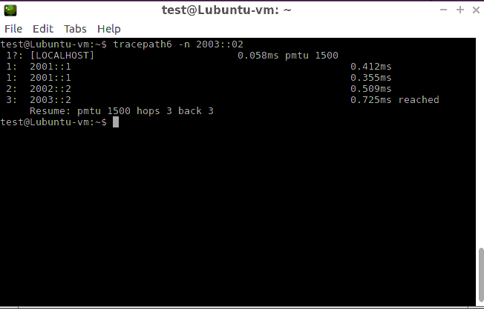

3.4. Neighbour table

- Neighbour table for Router 1:

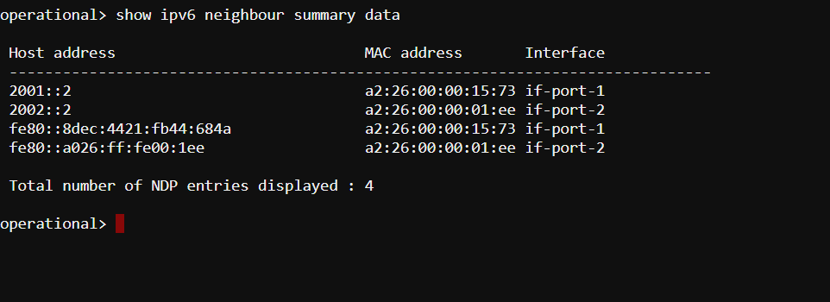

- Link local address from Router 2:

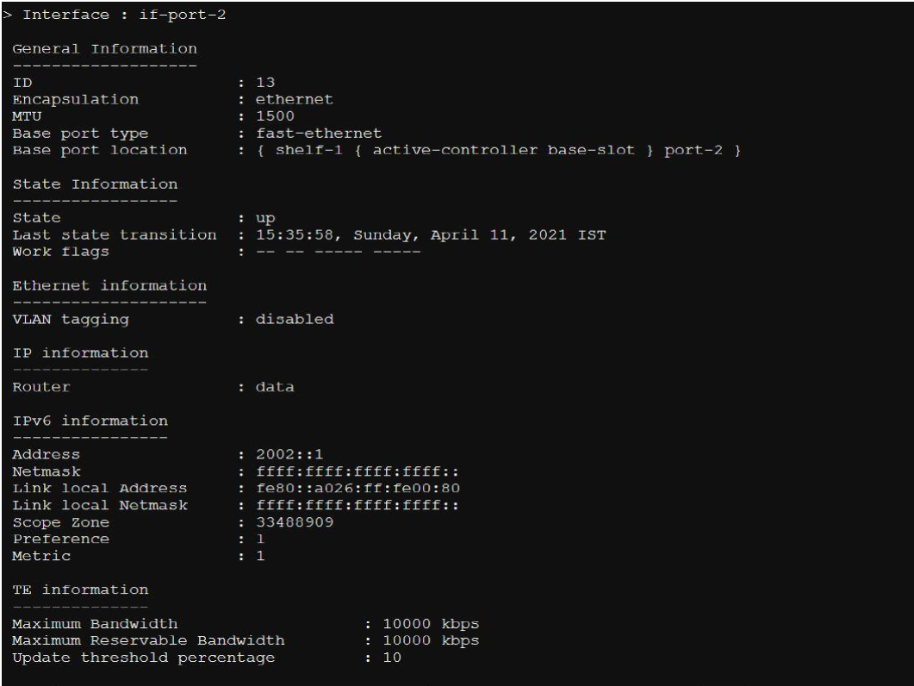

- Fastethernet interface:

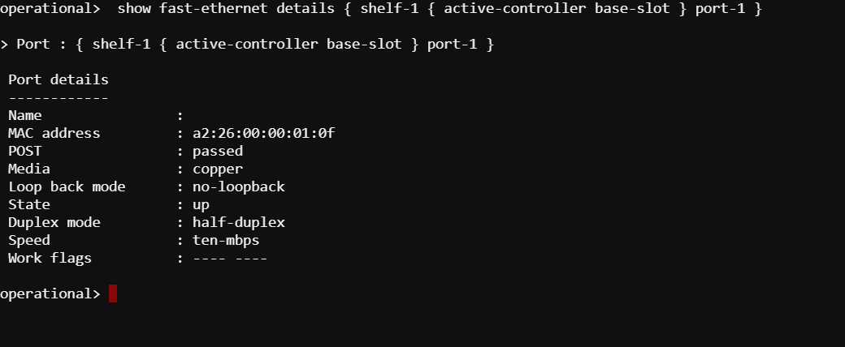

- The link local address that was retrieved from Router 2 is used to ping from Router 1.

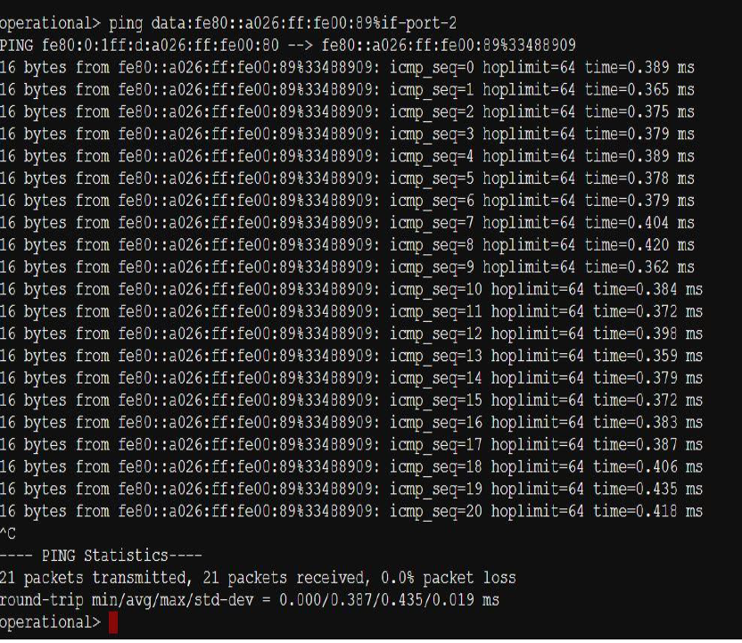

As can be seen above, the ping request is successful.