COMPUTER NETWORKS LAB – WEEK 2

Name: TUSHAR Y S

SRN: PES1UG19CS545

**1. CONFIGURATION OF SERVER AND CLIENT:**

1.1. Server side(ubuntu) configuration

- The Apache server is installed in server machine using the following command:

sudo apt-get install apache2

- To make sure that the web server is running , we use the following command in the server machine:

sudo systemctl status apache2

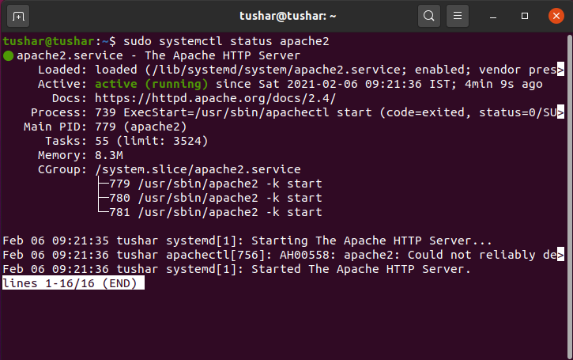

The above image says that the server is active and running successfully.

- The server IP address is set manually using “Edit Connections”. It is set to :10.0.9.12.

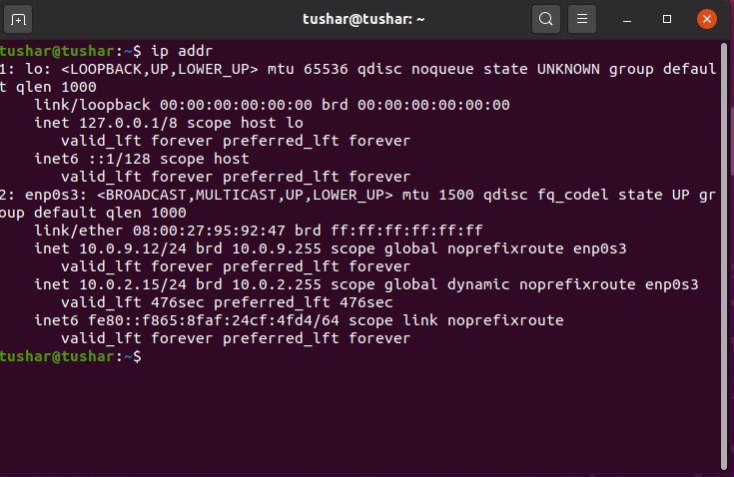

- The apache.config file in etc/apache2 directory is modified as:

-‘keep alive’ option is set to on.

-‘MaximumKeepAliveRequests’ is set to 2.

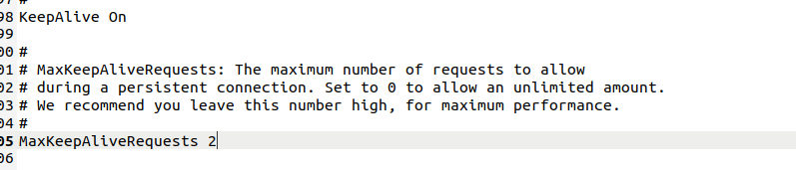

- A html page consisting of 10 images (img1.jpg-img10.jpg) is stored(along with the images) in the path:

/var/www/html/new.html



- A web page(new.html) is created as shown:

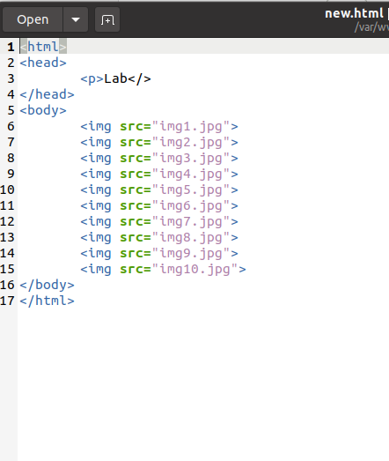

1.2. Client side (parrot)configuration

- The server IP address is set manually using “Edit Connections”. It is set to :10.0.9.50.

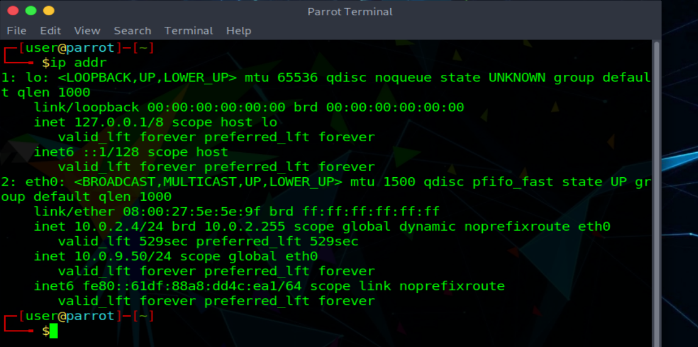

**2. NON-PERSISTENT CONNECTION**:

- The value of max-persistent-connections-per-server is set to 0 in the client’s machine. Also, spdy.persistent-settings is set to ‘false’ as shown in the screenshot below.

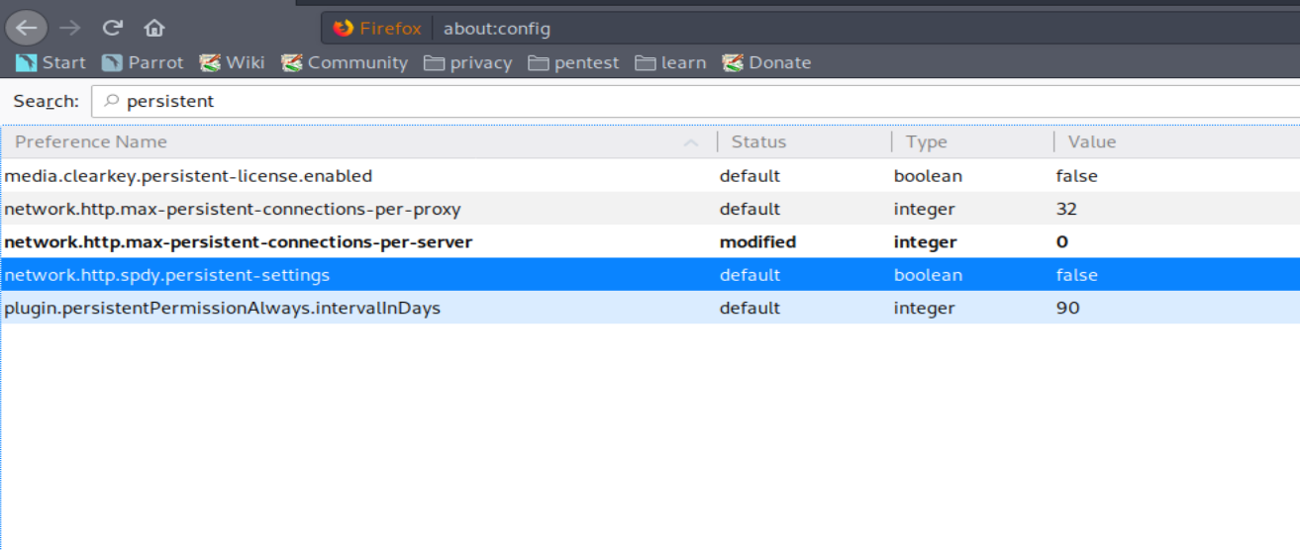

- The web page is accessed on client-side browser by typing in: 10.0.9.12/new.html, where “10.0.9.12” is server’s IP address and “new.html” is the file which is in the server side.



- Wireshark is launched and ‘http’ filter is applied and we can observe the packets as below.

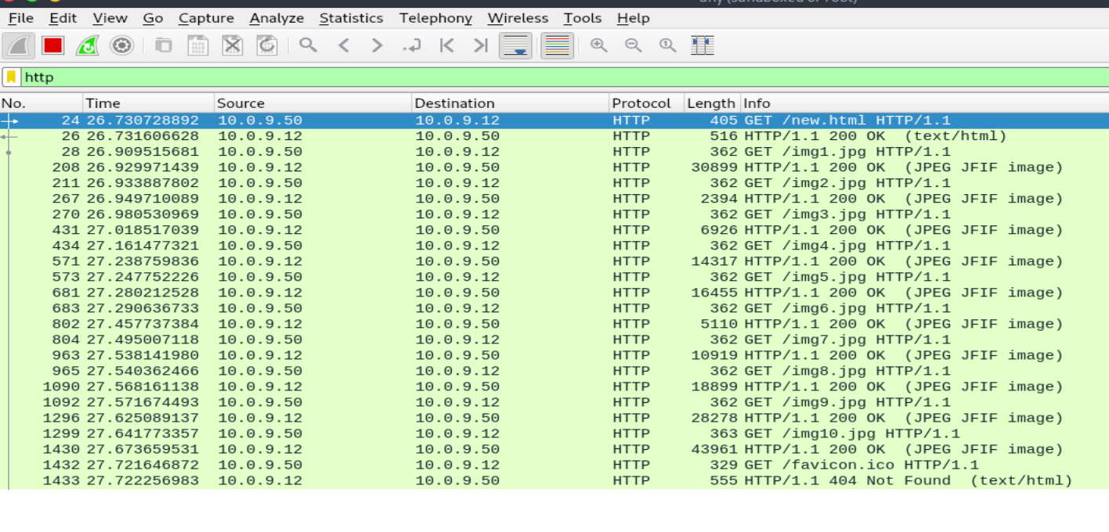Time to capture all the 10 images =

Time at last Response-Time at first GET request

= 27.673659531-26.730728892

= 0.942930639

**3. PERSISTENT CONNECTIONS:**

- The spdy.persistent-settings is set to ‘true’ in all types of persistent connections in the client browser.

3.1: 2 Persistent Connections:

- The value of max-persistent-connections-per-server is set to 2 in the client’s machine.

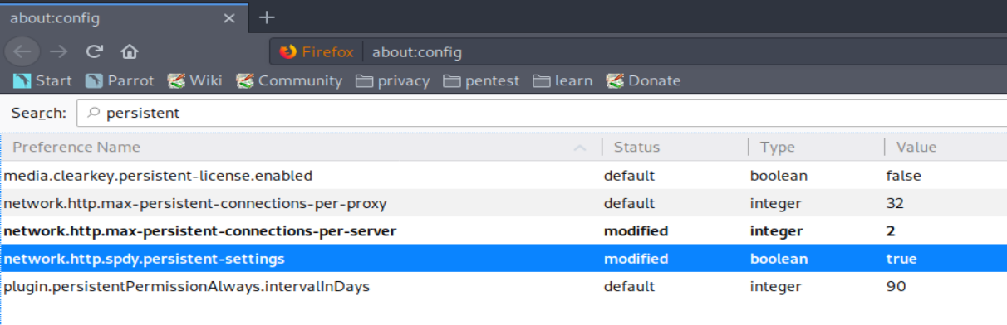

- Wireshark packet capture:

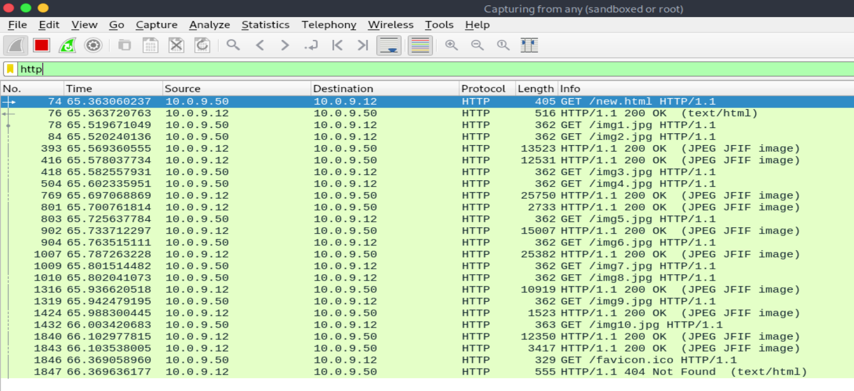

Time to capture all the 10 images =

Time at last Response-Time at first GET request

= 66.103538005-65.363060237

= 0.740477768

3.2: 4 Persistent Connections:

- The value of max-persistent-connections-per-server is set to 4 in the client’s machine.

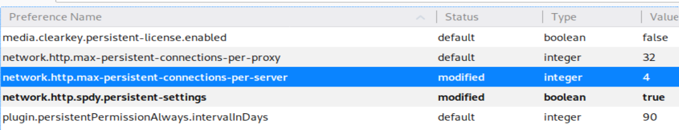

- Wireshark Packet Capture:

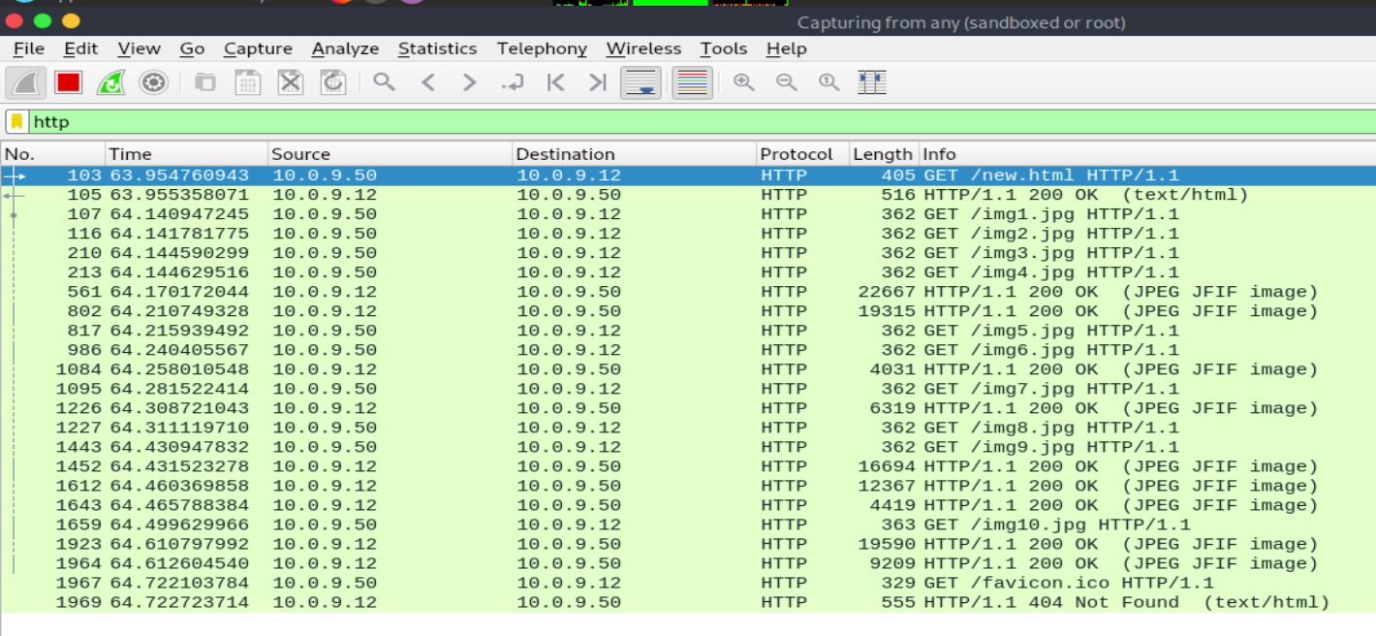

Time to capture all the 10 images = Time at last Response-Time at first GET request =64.612604540-63.954760943

= 0.657843597

3.3: 6 Persistent Connections:

- The value of max-persistent-connections-per-server is set to 6 in the client’s machine.

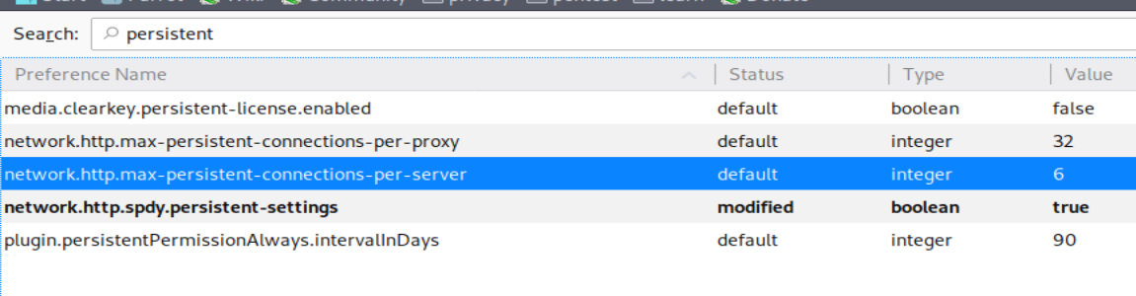

- Wireshark Packet Capture:

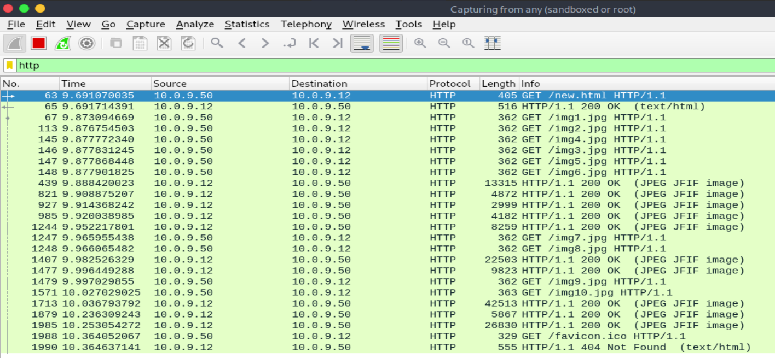

Time to capture all the 10 images =

Time at last Response-Time at first GET request

= 10.253054272-9.691070035

= 0.561984237

3.4: 10 Persistent Connections:

- The value of max-persistent-connections-per-server is set to 10 in the client’s machine.

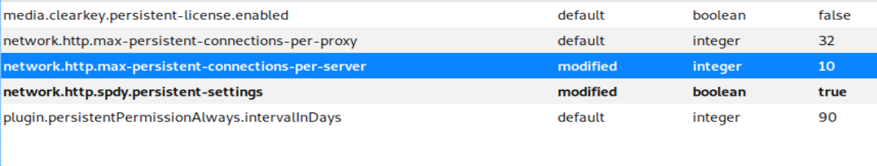

- Wireshark Packet Capture:

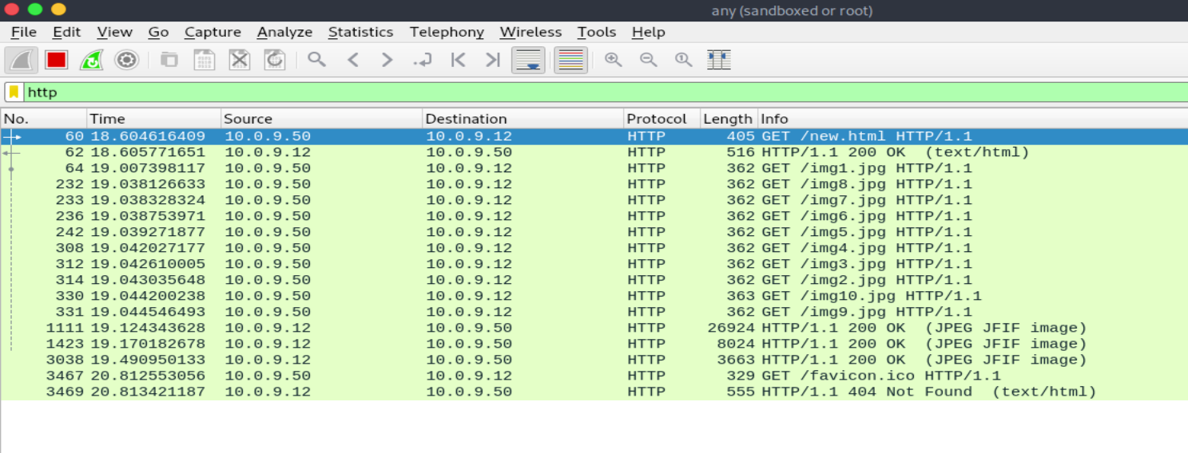

Time to capture all the 10 images=

Time at last Response-Time at first GET request

= 19.490950133-18.604616409

= 0.886333724

**4. Observations:**

- To tabulate the times required for different types of connections.

|  |  |
| --- | --- |
| Number of Persistent connections | Time to capture all the 10 images |
| 0 (non-persistent) | 0.942930639 |
| 2 | 0.740477768 |
| 4 | 0.657843597 |
| 6 | 0.561984237 |
| 10 | 0.886333724 |

- The time required to load initially decreases as the number of persistent connections increases. However as the number of persistent connections further increases, the load time also increases.

- From the above table it is clear that the lowest load time corresponds to 6 persistent connections. Therefore, the optimal number of HTTP persistent connections is 6.