COMPUTER NETWORKS LAB – WEEK 4

Name: Tushar Y S

SRN: PES1UG19CS545

• **Wireshark packet capture – source and destination IP**

**addresses [observation 1-3]**

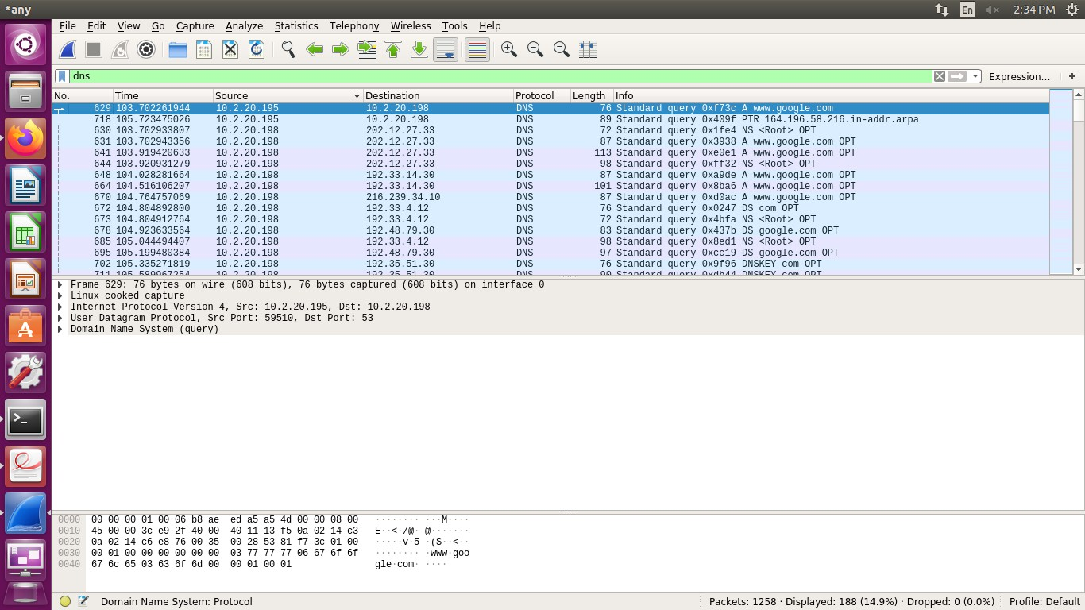

• **(DNS filter for** [**www.example.com)**](http://www.example.com/)

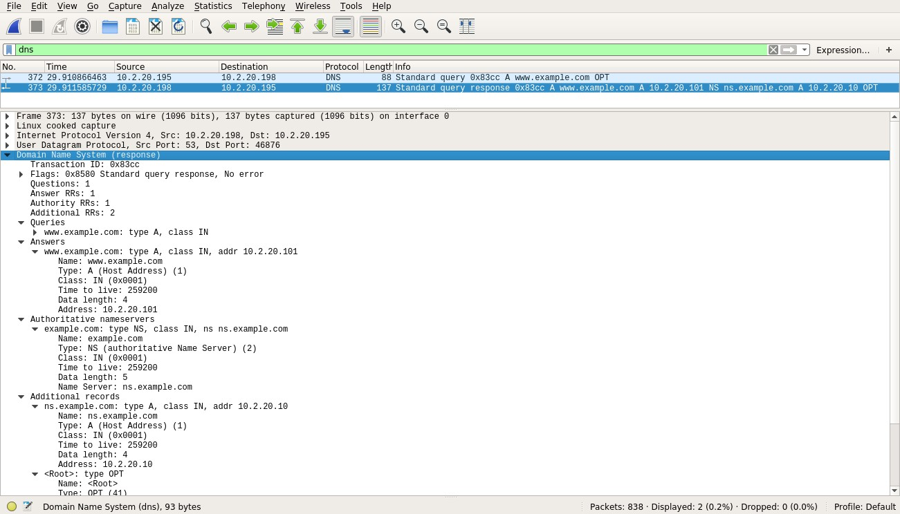

• **(dig** [**www.example.com command in terminal)**](http://www.example.com/)

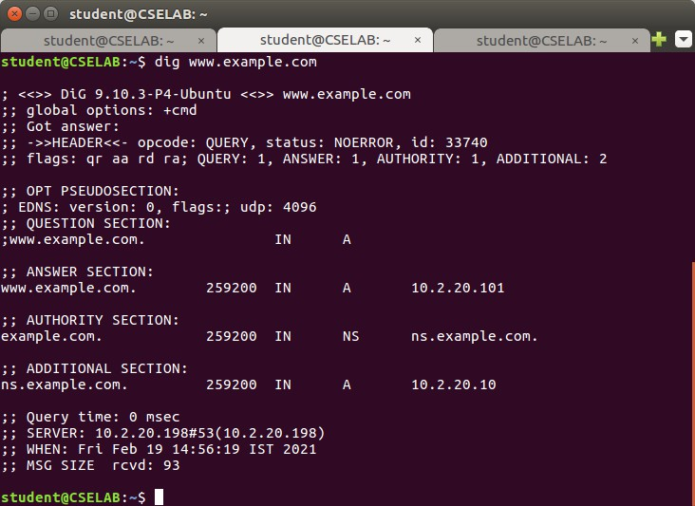

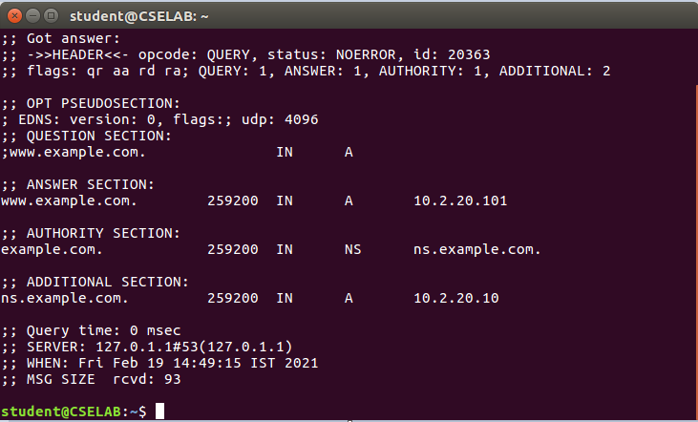

• **DNS Cache for www.google.com**

