Computer Networks Lab

Week 6

# PES1UG19CS545

TUSHAR Y S

## Task 1

### Configuring Topology

* + - IP Addresses have been assigned to each router and end systems.
    - The routing tables are then configured manually by adding the required routing information
    - A PDU packet is then transferred from one end system on a network to another on a different network.
    - If the packet transfer is successful, a successful status is shown in the bottom right corner.

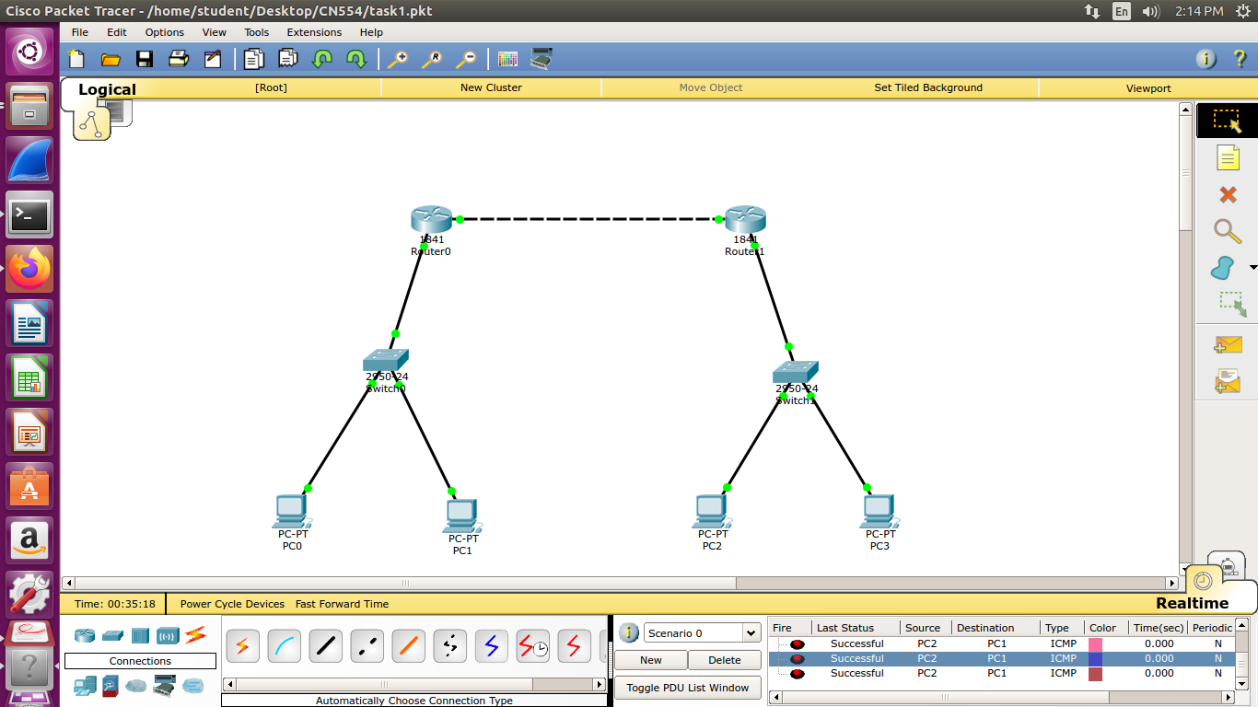

* 1. **Configuring Network and Routing Tables**

**1.2.1 End Systems**

|  |  |  |  |  |
| --- | --- | --- | --- | --- |
| End System | Interface Name | IP Address | Subnet Mask | Gateway |
| PC0 | FastEthernet0 | 10.0.0.1 | 255.0.0.0 | 10.0.0.3 |
| PC1 | FastEthernet0 | 10.0.0.2 | 255.0.0.0 | 10.0.0.3 |
| PC2 | FastEthernet0 | 30.0.0.2 | 255.0.0.0 | 30.0.0.1 |
| PC3 | FastEthernet0 | 30.0.0.3 | 255.0.0.0 | 30.0.0.1 |

#### Routers

|  |  |  |  |
| --- | --- | --- | --- |
| Router | Interface Name | IP Address | Subnet Mask |
| Router0 | FastEthernet0/0 | 10.0.0.3 | 255.0.0.0 |
| Router0 | FastEthernet0/1 | 20.0.0.1 | 255.0.0.0 |
| Router1 | FastEthernet0/0 | 20.0.0.2 | 255.0.0.0 |
| Router1 | FastEthernet0/1 | 30.0.0.1 | 255.0.0.0 |

* + 1. **Routing Table**

|  |  |  |
| --- | --- | --- |
| Router | Destination Network | Next Hop |
| Router0 | 30.0.0.0 | 20.0.0.2 |
| Router1 | 10.0.0.0 | 20.0.0.1 |

1. **Task 2**

The task performed above is repeated with another topology and the routing tables are configured appropriately.

### Configuring Topology

### 

* 1. **Configuring Network and Routing Tables**

#### End Systems

|  |  |  |  |  |
| --- | --- | --- | --- | --- |
| End System | Interface Name | IP Address | Subnet Mask | Gateway |
| PC0-1.1.1.2/8 | FastEthernet0 | 1.1.1.0 | 255.0.0.0 | 1.1.1.1 |
| PC1-1.1.1.3/8 | FastEthernet0 | 1.1.1.3 | 255.0.0.0 | 1.1.1.1 |
| PC4 | FastEthernet0 | 6.6.6.2 | 255.0.0.0 | 6.6.6.1 |
| PC2-2.2.2.2/8 | FastEthernet0 | 2.2.2.2 | 255.0.0.0 | 2.2.2.1 |
| PC3-2.2.2.3/8 | FastEthernet0 | 2.2.2.3 | 255.0.0.0 | 2.2.2.1 |

* + 1. **Routers**

|  |  |  |  |
| --- | --- | --- | --- |
| Router | Interface Name | IP Address | Subnet Mask |
| Router0 | FastEthernet0/0 | 1.1.1.1 | 255.0.0.0 |
| Router0 | FastEthernet0/1 | 3.3.3.1 | 255.0.0.0 |
| Router1 | FastEthernet0/0 | 3.3.3.2 | 255.0.0.0 |
| Router1 | FastEthernet0/1 | 2.2.2.1 | 255.0.0.0 |
| Router1 | Ethernet0/0/0 | 5.5.5.2 | 255.0.0.0 |
| Router2 | FastEthernet0/0 | 5.5.5.1 | 255.0.0.0 |
| Router2 | FastEthernet0/1 | 6.6.6.1 | 255.0.0.0 |

* + 1. **Routing Table**

|  |  |  |
| --- | --- | --- |
| Router | Destination Network | Next Hop |
| Router0 | 2.2.2.0 | 3.3.3.2 |
| Router0 | 5.5.5.0 | 3.3.3.2 |
| Router0 | 6.6.6.0 | 3.3.3.2 |
| Router1 | 1.1.1.0 | 3.3.3.1 |
| Router1 | 6.6.6.0 | 5.5.5.1 |
| Router2 | 3.3.3.0 | 5.5.5.2 |
| Router2 | 1.1.1.0 | 5.5.5.2 |
| Router2 | 2.2.2.0 | 5.5.5.2 |