**COMPUTER NETWORKS**

**WEEK 8**

**PES1UG19CS545**

**TUSHAR Y S – I1**

**Claynet – IPv4 Static Addressing and routing**

The following topology is created and deployed in claynet.

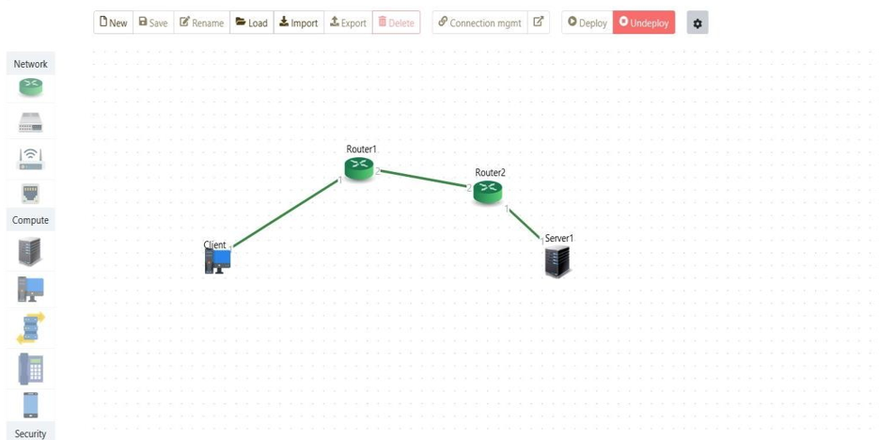

Configurations of End systems :

|  |  |  |
| --- | --- | --- |
| End System | IP Address | Gateway |
| Client | 10.10.10.2/24 | 10.10.10.1 |
| Server | 30.30.30.2/24 | 30.30.30.1 |

Routers Configuration:

|  |  |  |
| --- | --- | --- |
| Router | Interface Number(port) | IP Address |
| Router1 | 1 | 10.10.10.1/24 |
| Router1 | 2 | 20.20.20.1/24 |
| Router2 | 1 | 30.30.30.1/24 |
| Router2 | 2 | 20.20.20.2/24 |

Configuring Routing Table entries

Router 1:

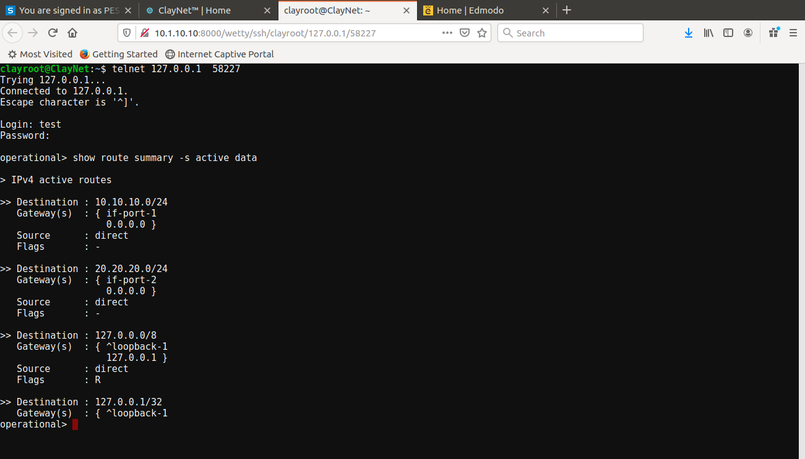

Router 2:

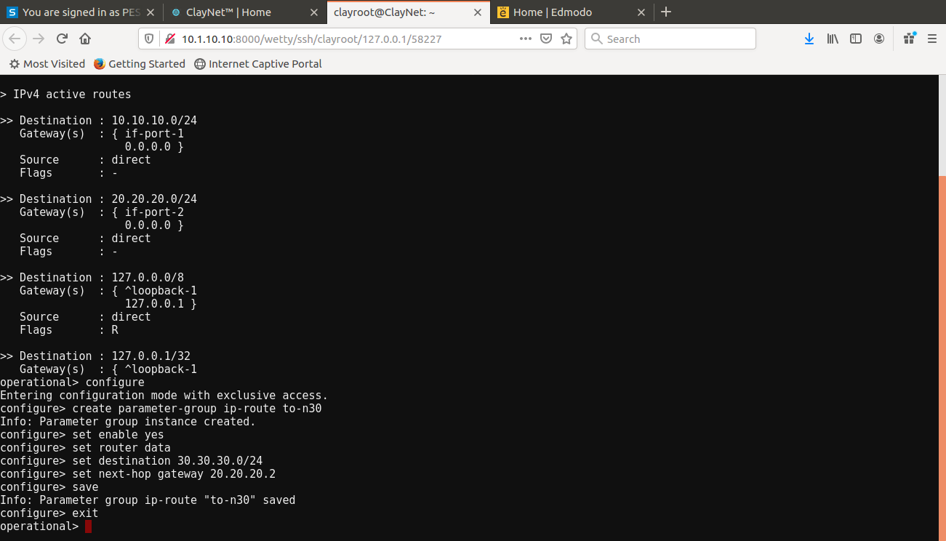

Client and server are now reachable. We can verify that by using the ping command.

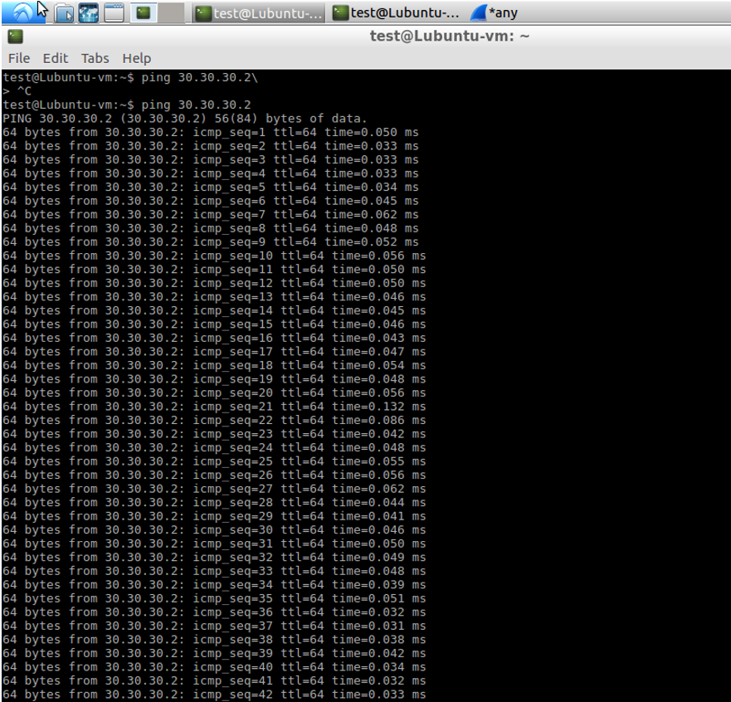

Wireshark packet capture:

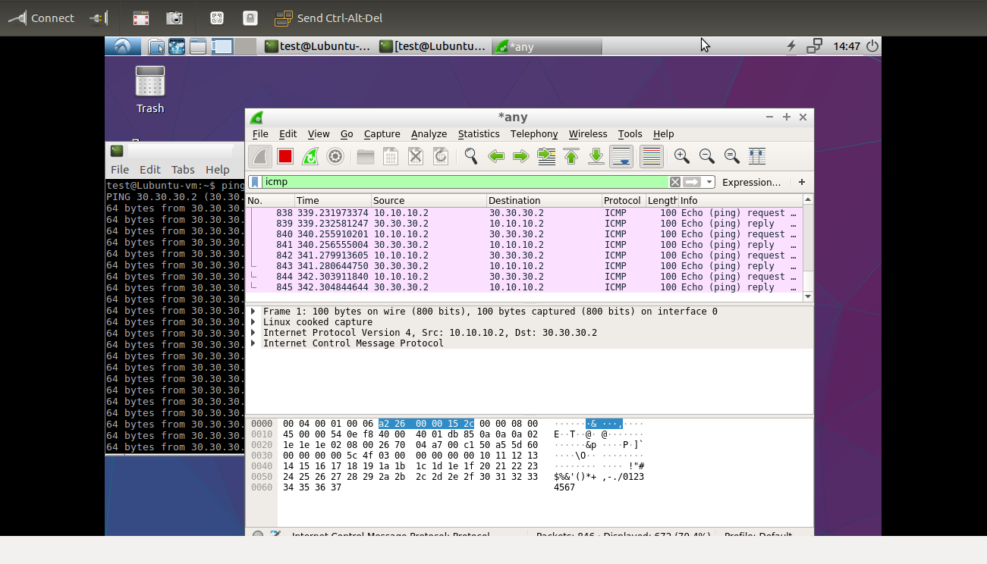

Using tracepath command:

