**COMPUTER NETWORKS LAB**

**WEEK 9**

**PES1UG19CS545**

**TUSHAR Y S**

**CICSO PACKET TRACER 2 – Life of a packet in Internet**

Task 1

Configuring Topology

An HTTP request is made from the PC for the page index.html in the domain google.com

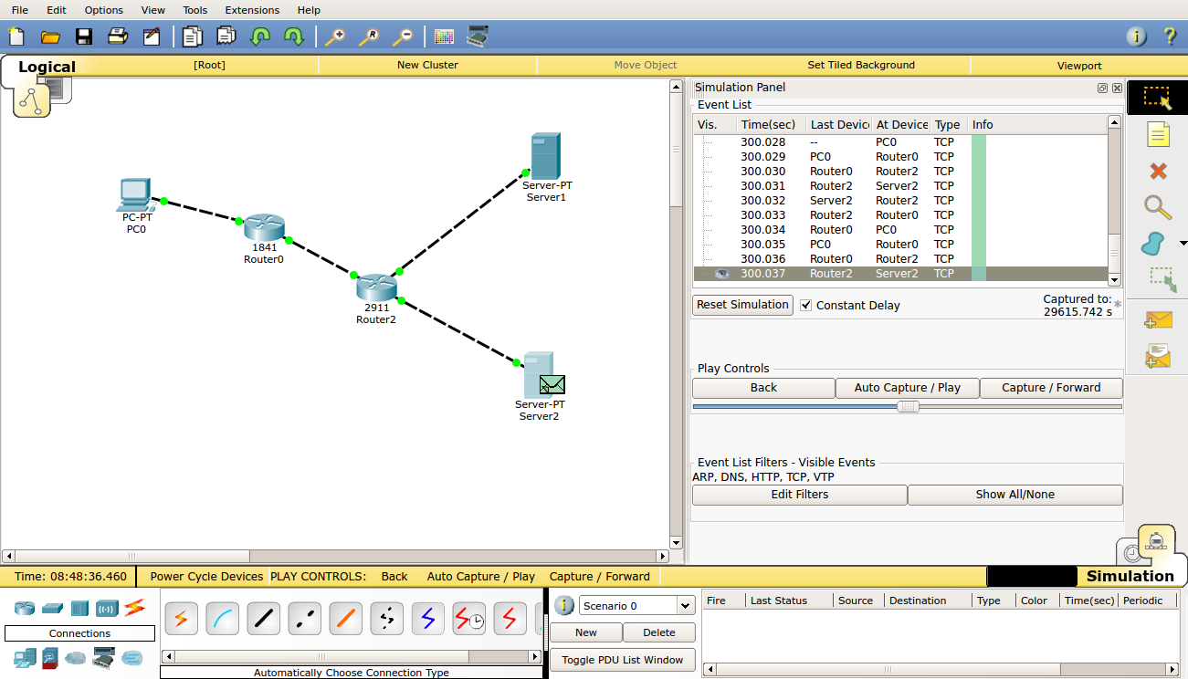

HTTP Request with DNS service

Configuring Network and Routing Table

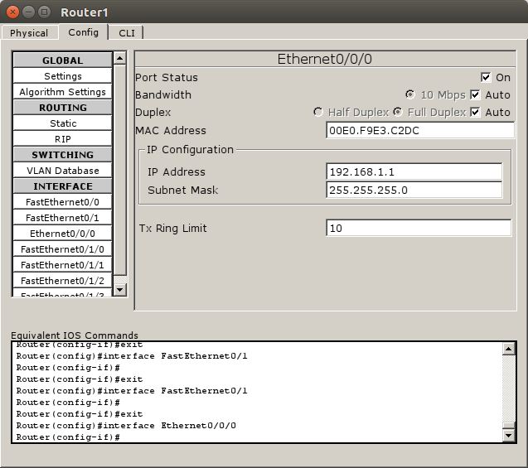

|  |  |  |  |  |  |
| --- | --- | --- | --- | --- | --- |
| End System | Interface Name | IP address | Subnet mask | Gateway | DNS server |
| PC0 | FastEthernet0 | 10.10.1.1 | 255.255.255.0 | 10.0.0.3 | 192.168.1.2 |
| Server0-  DNS | FastEthernet0 | 192.168.1.2 | 255.255.255.0 | 192.168.1.1 |  |
| Server1-  Web | FastEthernet0 | 192.168.2.2 | 255.255.255.0 | 192.168.2.1 |  |

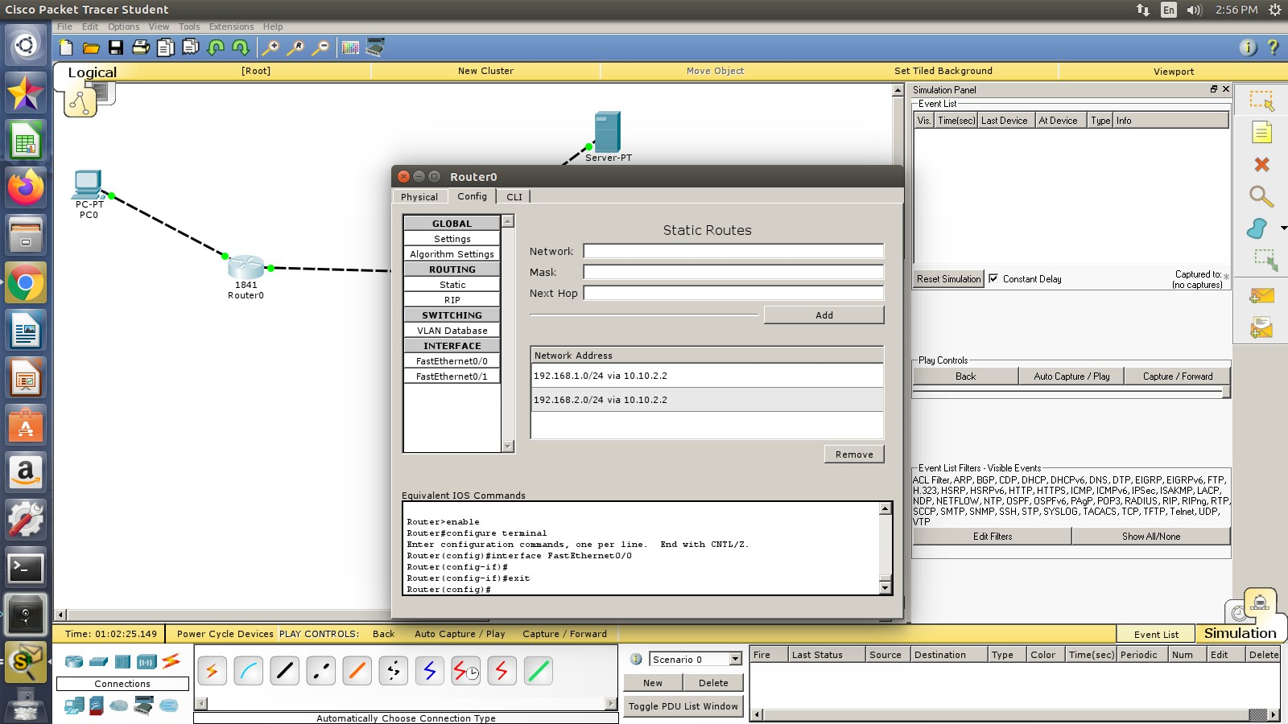

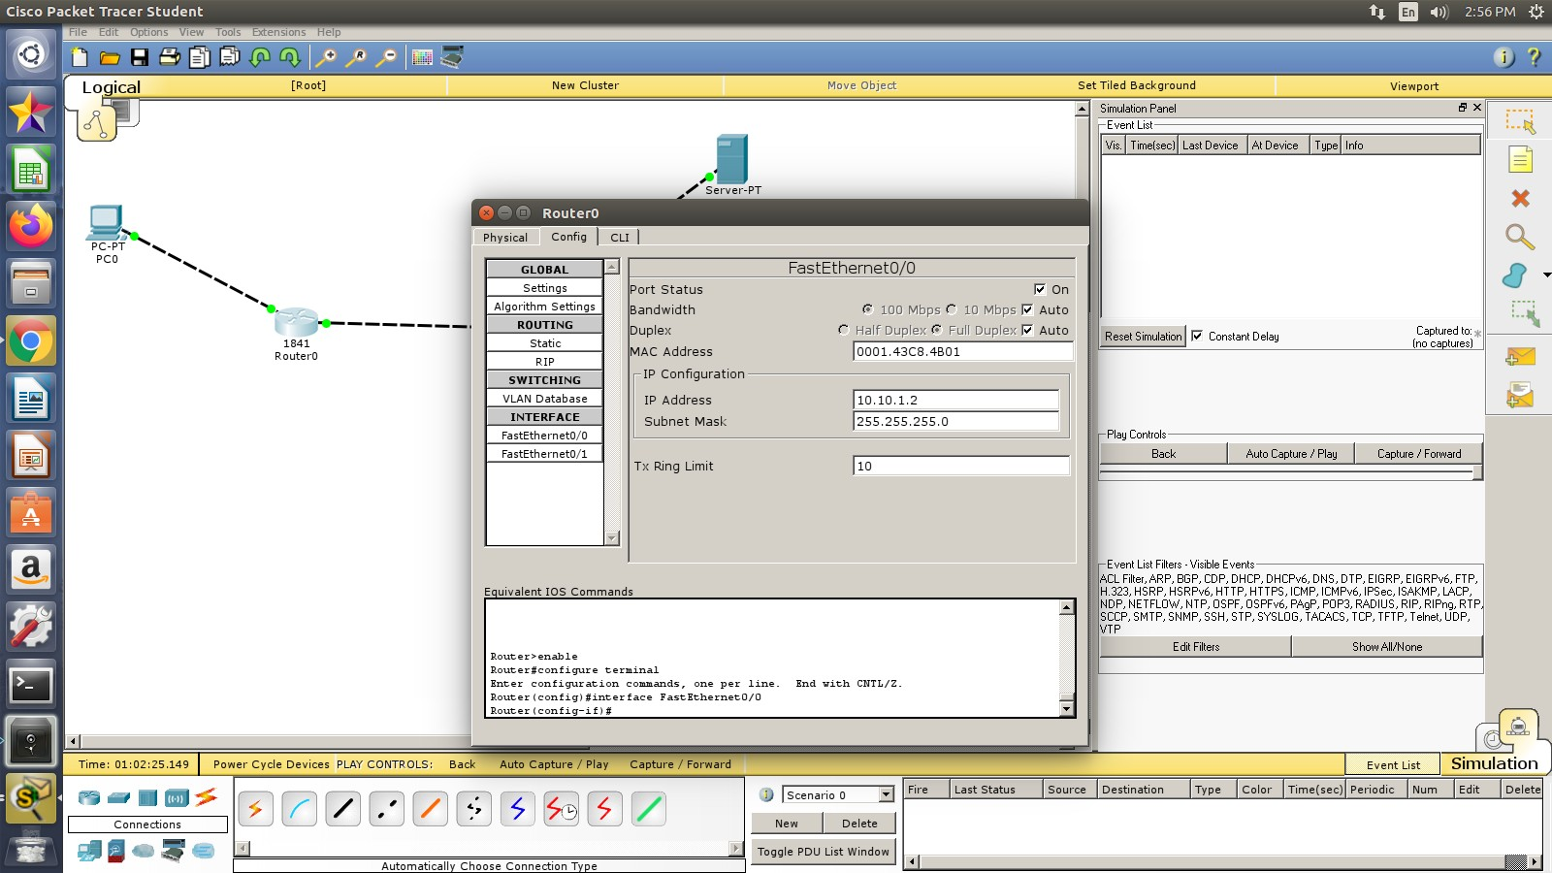

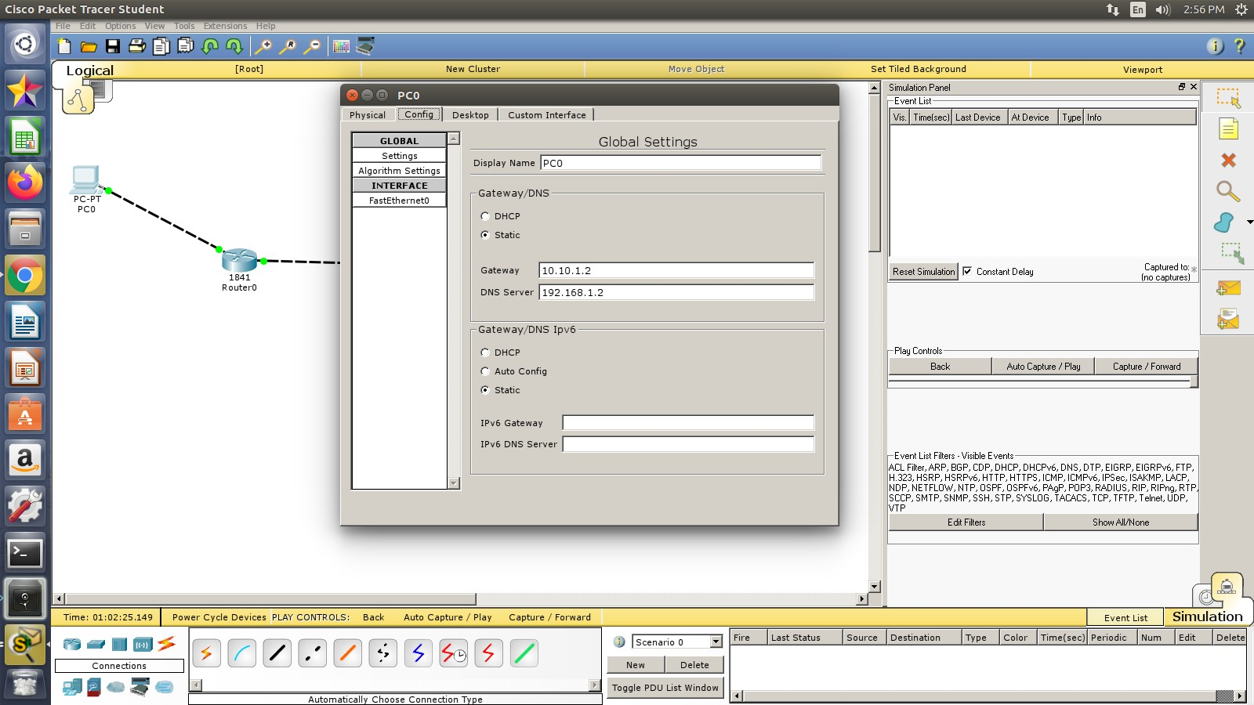

Routers

|  |  |  |  |
| --- | --- | --- | --- |
| Router | Interface Name | IP Address | Subnet Mask |
| Router0 | FastEthernet0/0 | 10.10.1.2 | 255.255.255.0 |
| Router0 | FastEthernet0/0 | 10.10.2.1 | 255.255.255.0 |
| Router1 | FastEthernet0/0 | 10.10.2.2 | 255.255.255.0 |
| Router1 | FastEthernet0/0 | 192.168.1.1 | 255.255.255.0 |
| Router1 | Ethernet0/0/0 | 192.168.2.1 | 255.255.255.0 |

Routing Table

|  |  |  |
| --- | --- | --- |
| Router | Destination Network | Next Hop |
| Router0 | 192.168.1.0 | 10.10.2.2 |
| Router0 | 192.168.2.0 | 10.10.2.2 |
| Router1 | 10.10.1.0 | 10.10.2.1 |

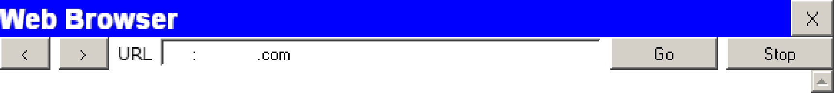

CO



 

http //qooqIe

Cisco Packet Tracer

Welcome to Cisco Packet Tracer. Opening doors to new opportunities. Mind Wide Open.

Quick Links: A small pane Copyrights

 

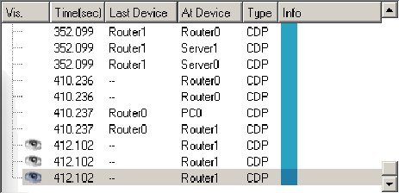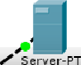



“" "“"" " ' " “ ‘” ”'' ‘*% “’"’” ”

Wcclomc to Cisc o Pac kc I Trac cr Og cnmg do ore to new' opg ortlmtbcs Mmd hid c 0 p en

Qwck Ws p gpt„p,t







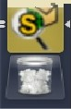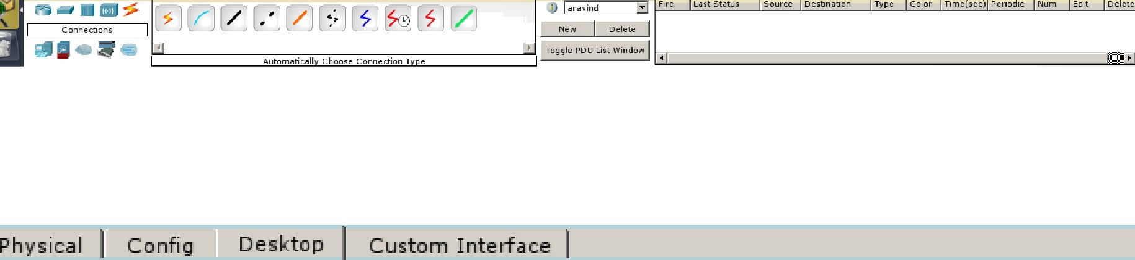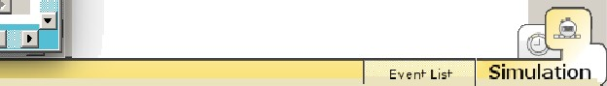

S

P