WEEK1: MONGO Database (No SQL)

NAME: TUSHAR Y S

SRN: PES1UG19CS545 (Section: I)

1. Create Operations:



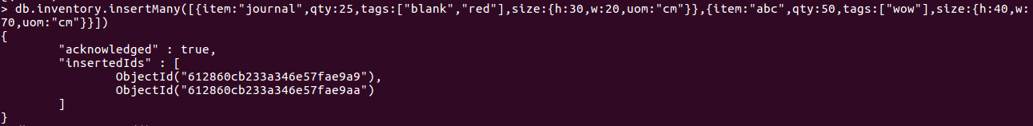

2. Read Operations:





3. Update Operations:



After updating:



4. Delete Operations:



After deleting:

