**UE19CS304 – DBMS LABORATORY**

**Week 3: ER Diagram and PostgreSQL**

Name: TUSHAR Y S

SRN: PES1UG19CS545 (I section)

**Task1:**

- ER (Entity Relationship) Diagram:

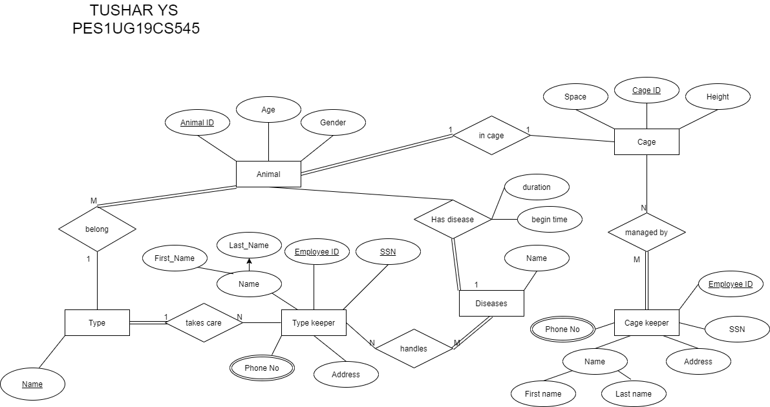

- Relational Table:

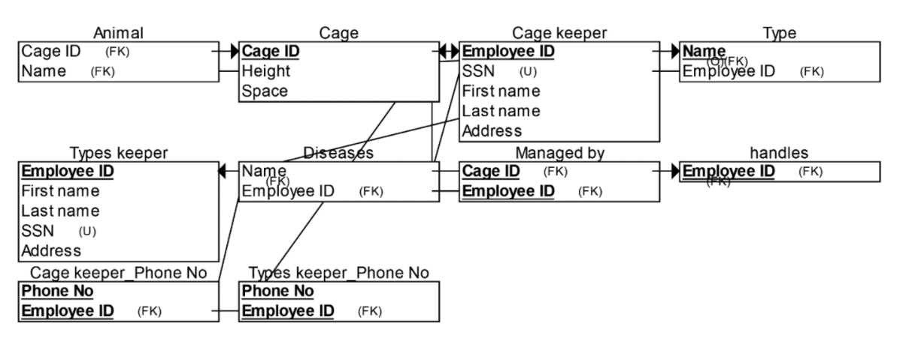

**Task2: PostgreSQL**

- Creating a database called ‘tushar18’ and connecting to it.

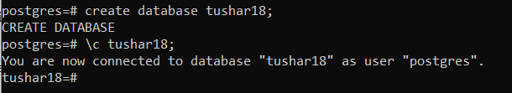

- Creating different tables with constraints of primary keys and foreign keys.



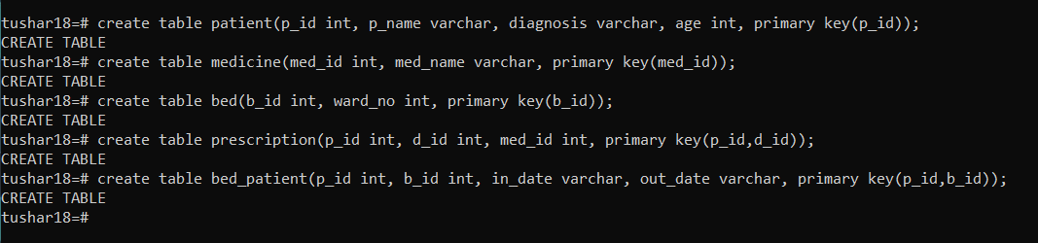



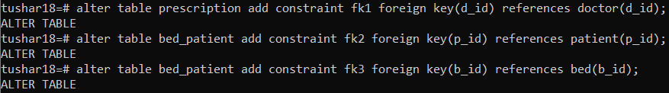

- 6 tables are present in ‘tushar18’ database.

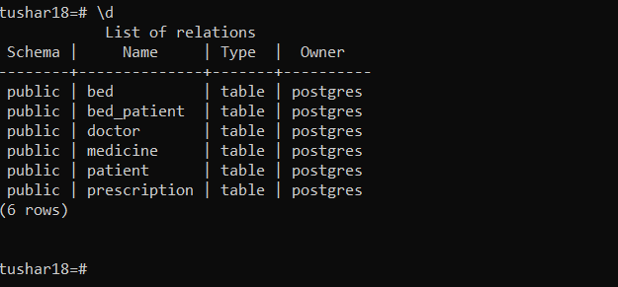

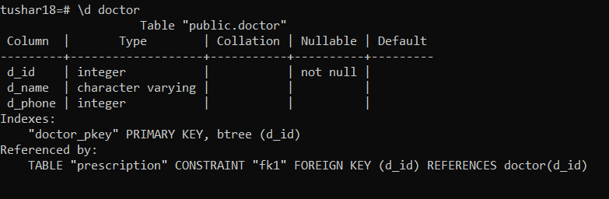

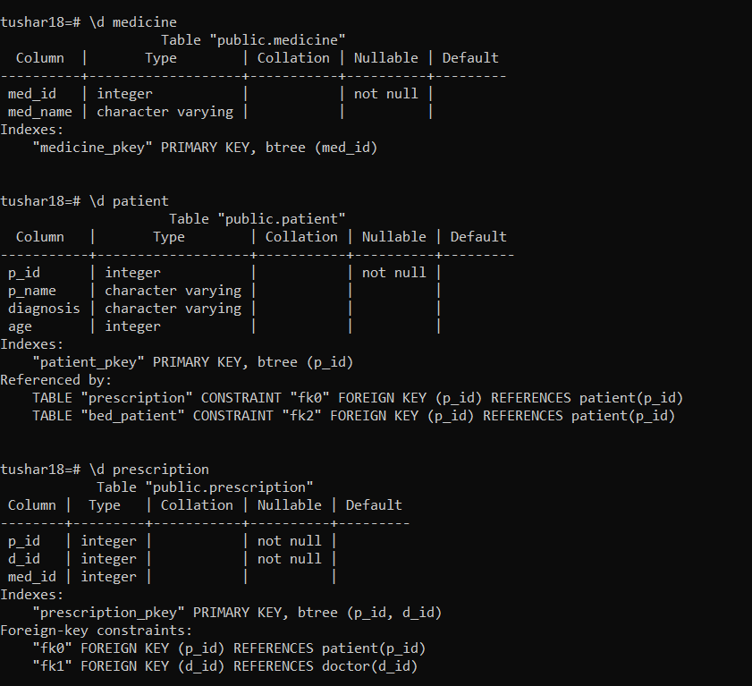

- Inserting 5 values into ‘doctor’ table:

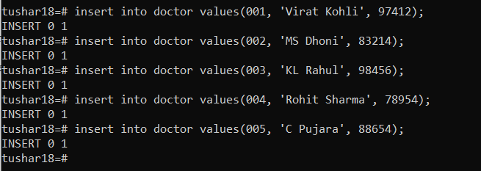

- Inserting 5 values into ‘patient’ table:

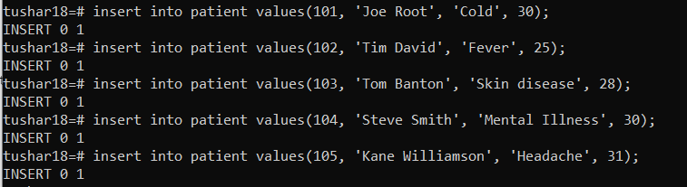

- Inserting 5 values into ‘medicine’ table:

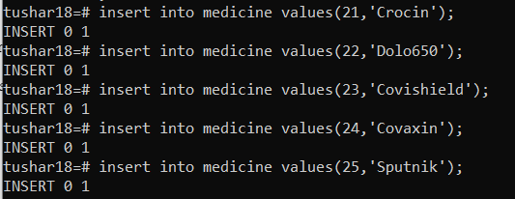

- Inserting 5 values into ‘prescription’ table:



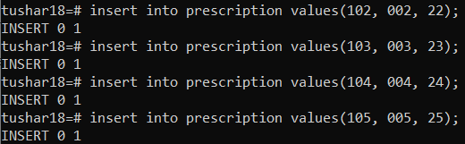

- Inserting 5 values into ‘bed’ table:

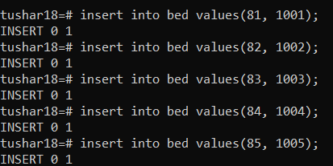

- Inserting 5 values into ‘bed patient’ table:

