**UE19CS304 – DBMS LABORATORY**

**Week 4: SQL Constraints, Views, Truncate, delete and update operations.**

Name: TUSHAR Y S

SRN: PES1UG19CS545 (I section)

Task1:

- Creating database and creating tables (6).

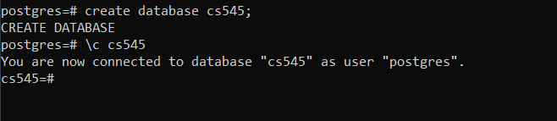

- Listing all tables:

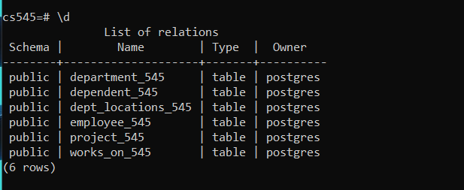

- Inserting values to:

-Department table:

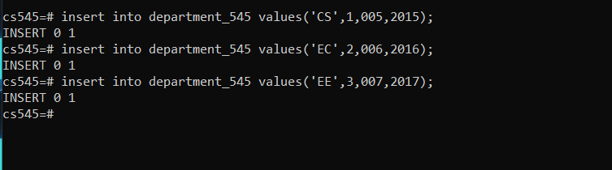

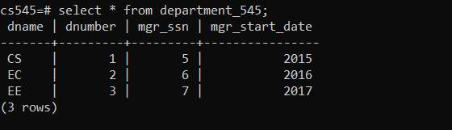

-Employee table:

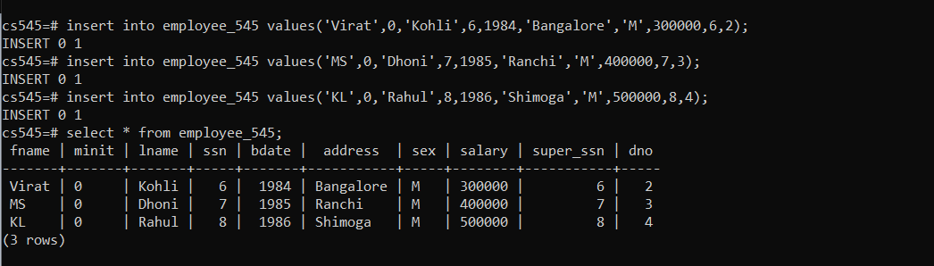

- Dept_locations table:

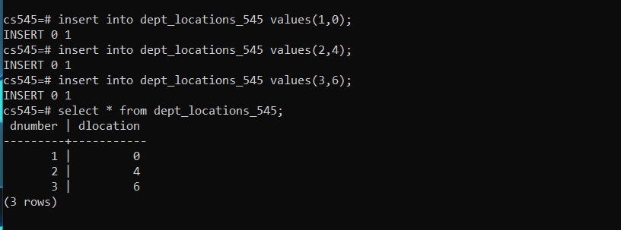

- Project table:

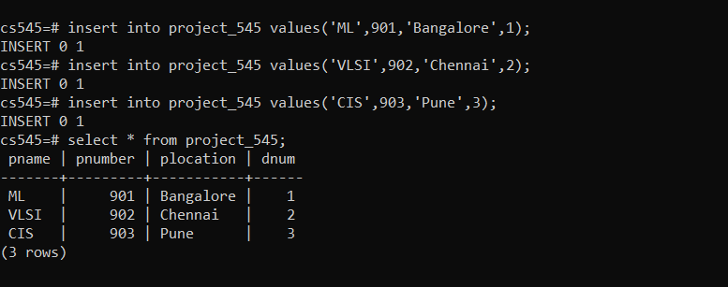

- Works_on table:

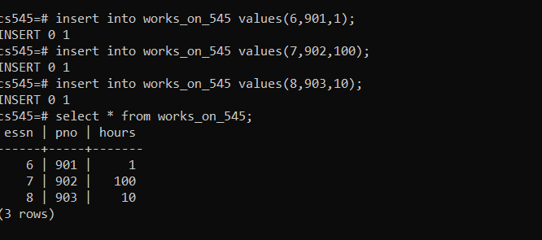

- dependent table:

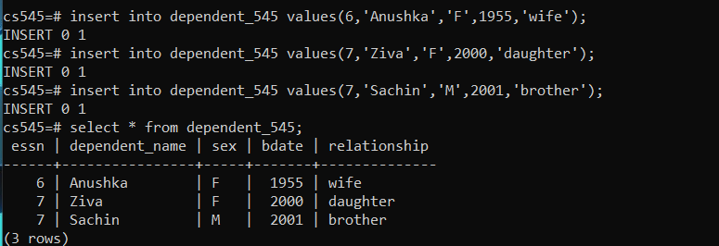

- Adding the foreign key constraints:

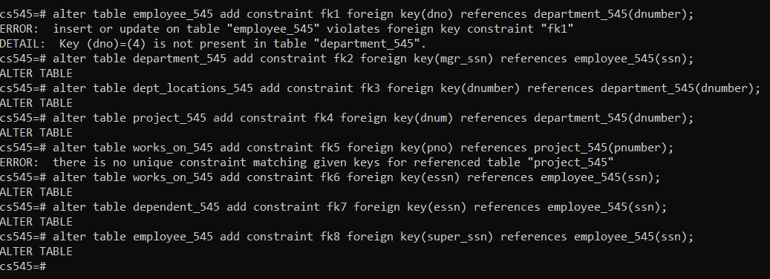

Task2:

a) Drop and truncate:

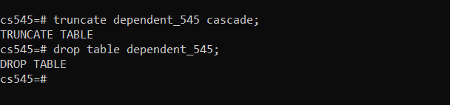

b)

- Create views:

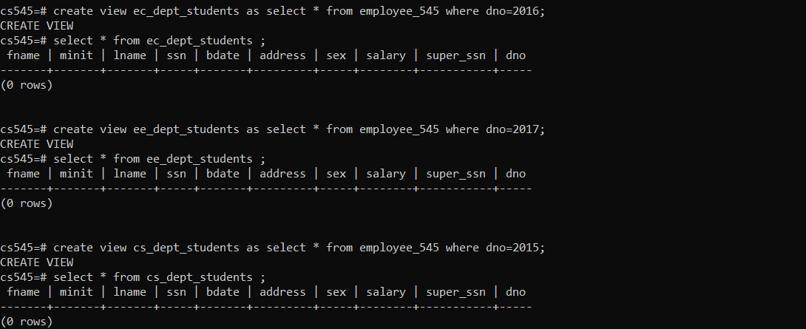

- Drop views:

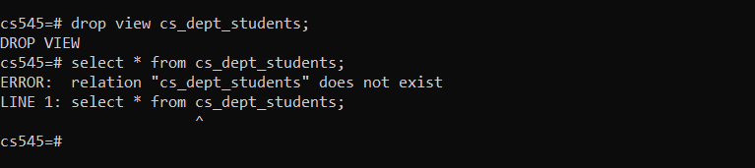

c)

- Creating users and granting permissions:

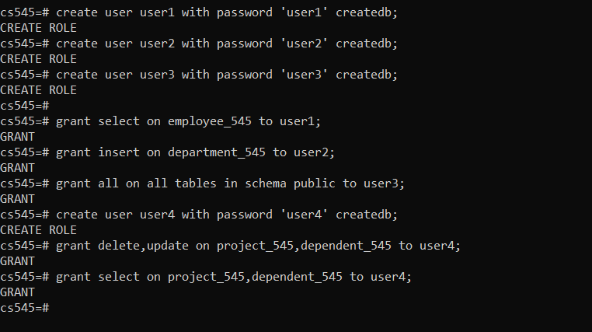

- User 1 has only select permission for employee table and hence can only perform select operation on the employee table.

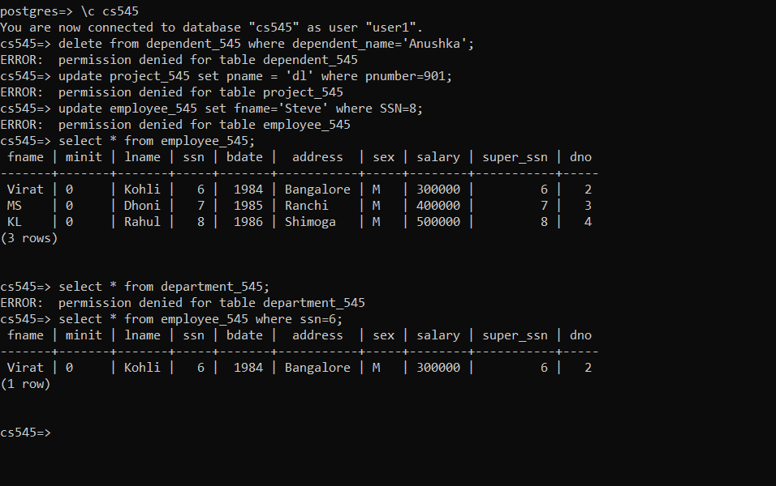

- User 2 has insert permissions on the employee table. But it throws an error as there are many foreign key constraints. It doesn’t deny the permission to insert values.

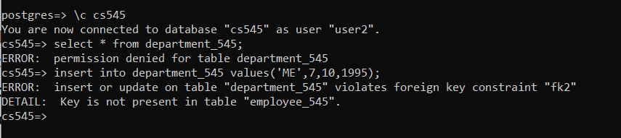

- User 3 has all permissions on all tables.

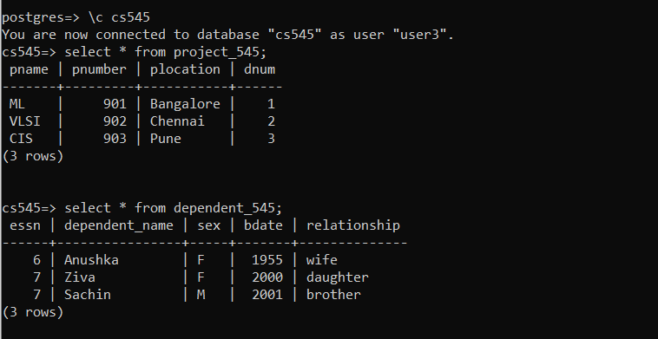

- User 4 has delete and update permissions on the project and dependent tables.

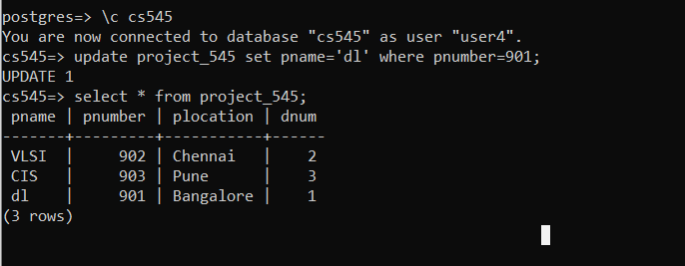

d)

- Adding a new column to employee table.

Before:

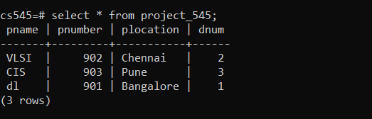

After adding new column(‘new_col’):

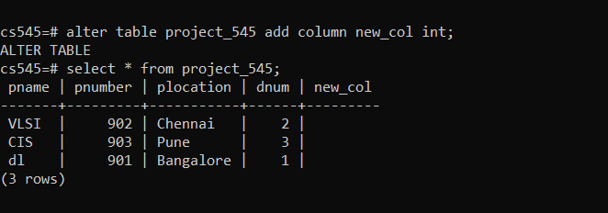

- Deleting a column (‘new_col’ here):

