**UE19CS304 – DBMS LABORATORY**

**SRN: PES1UG19CS545**

**Name: Tushar Y S**

**Week5: SQL DML- Insert (using select) Update and delete, Transactions commit rollback and savepoint .**

Task1: SQL DML

1.1:

- Creating tables using given companyddl file.

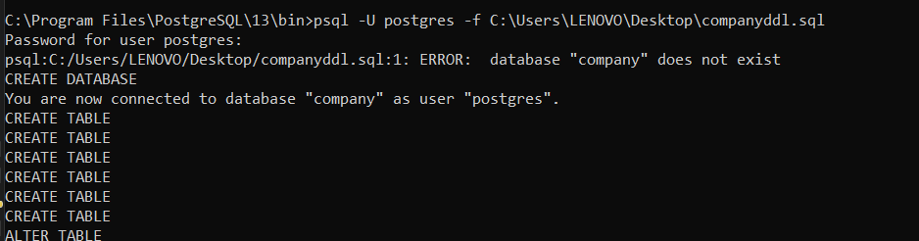

- Inserting values using given company_insert file.

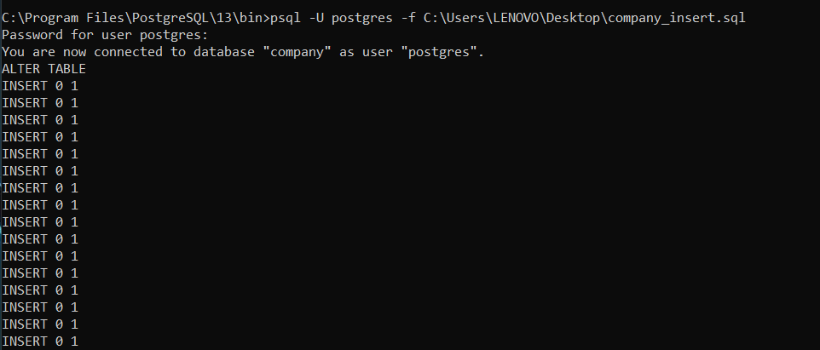

- Creating table and inserting values into it.

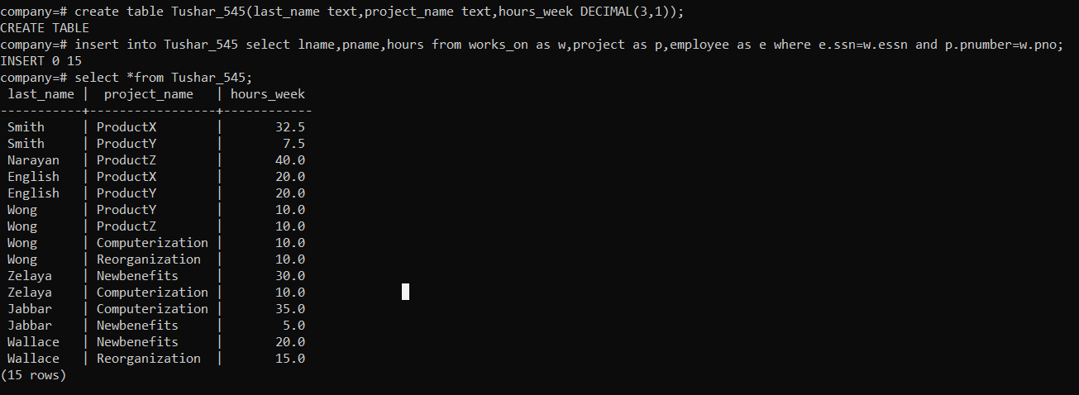

1.2:

- Updating the location and controlling department number of project number 10 to ‘Bellaire’ and 5, respectively.

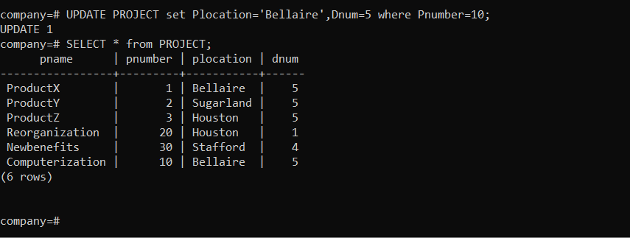

1.3:

- Giving all employees in ‘Research’ department a 10% raise in salary.

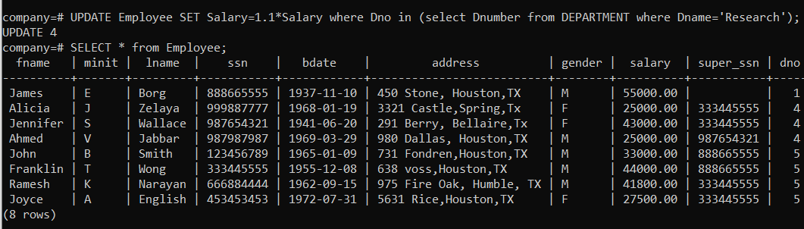

1.4:

- Delete employee record whose lname=’Brown’

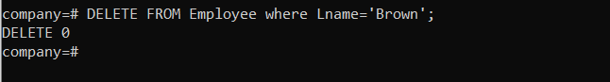

1.5:

- Delete all the records of the employee who doesn’t have dependent.

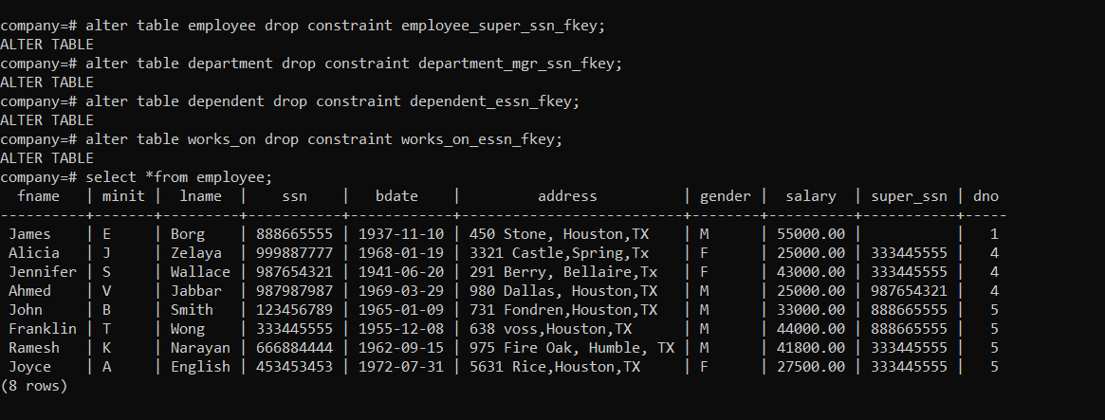

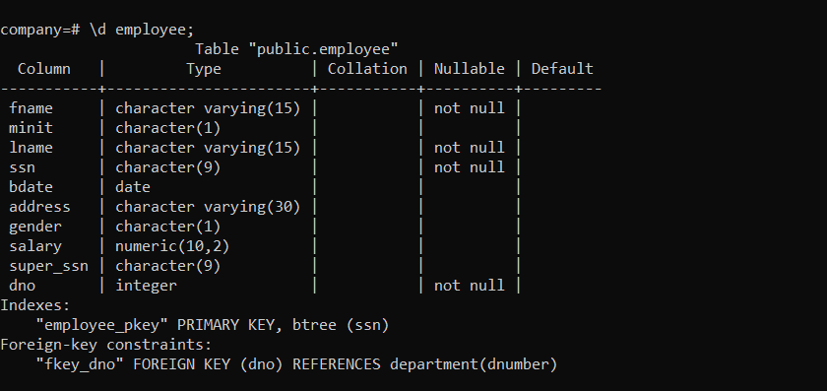

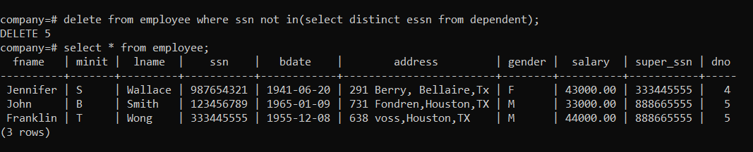

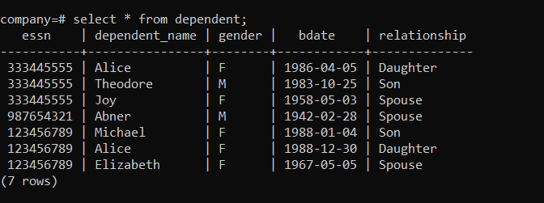

Task2: Transactions

2.1:

- Create a transaction consisting of a create table and multiple insert statements. After End transaction the changes should be committed and can be checked using select statement.

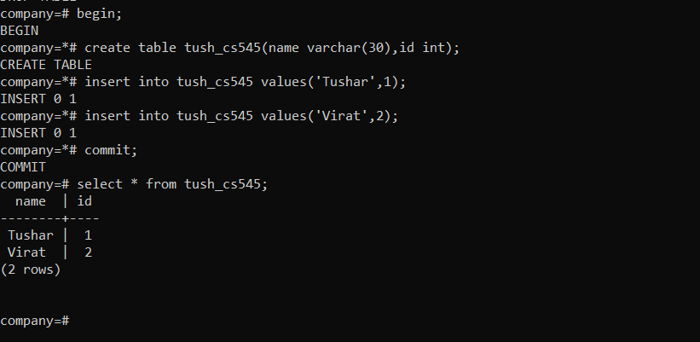

2.2:

- For the above transaction introduce a roll back after inserting 2 records. The create and insert should not be reflected in the database.

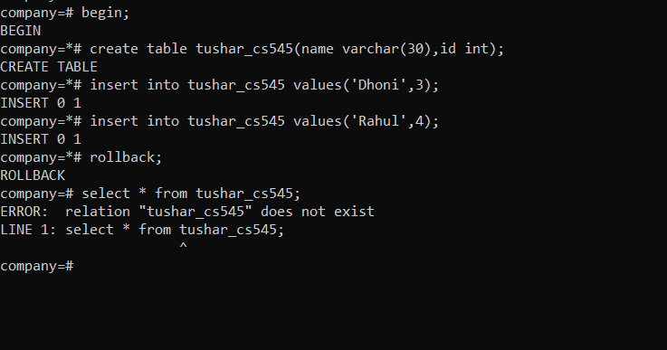

2.3:

- For the first transaction introduce a save point after inserting 2 records and insert 2 more records and rollback to savepoint . They database should reflect only first 2 insert.

