**UE19CS304 – DBMS LABORATORY**

**SRN: PES1UG19CS545**

**Name: Tushar Y S**

**Week6 : SQL – Aggregate functions.**

- Creating Database and inserting data:

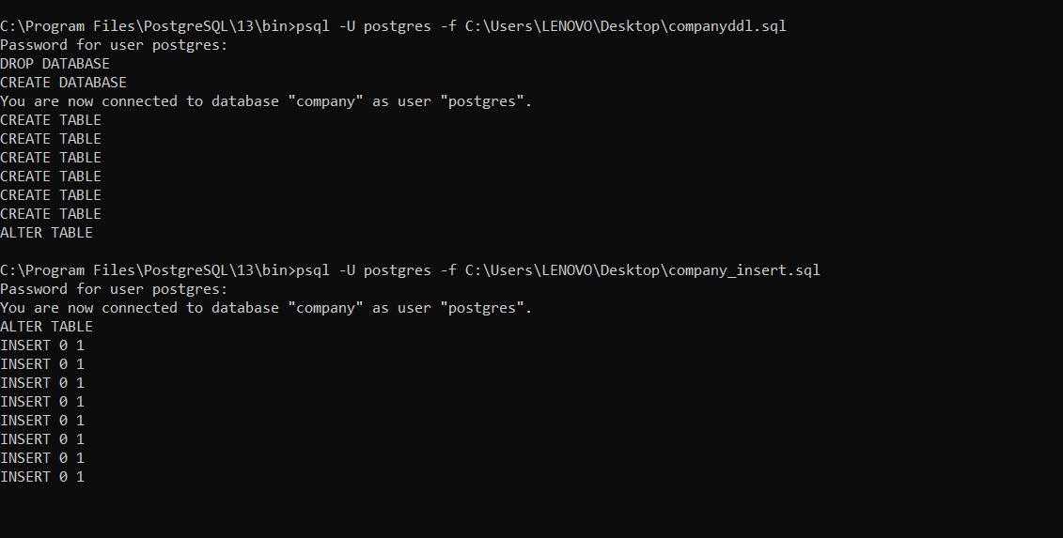

1. Show the resulting salaries if every employee working on the ‘ProductX’ project is given a 10% raise.

- SELECT Fname,Minit,Lname, 1.1*Salary from employee as E, project as P, works_on as W where P.Pname=’ProductX’ and P.Pnumber=W.Pno and W.Essn=Ssn;



2. Find the sum of the salaries of all employees of the ‘Research’ department, as well as the maximum salary, the minimum salary, and the average salary in this department.

- SELECT sum(Salary),max(Salary),min(Salary),avg(Salary) from employee as E, department as D where D.Dname=’Research’ and D.Dnumber=E.Dno;



3. Count the number of distinct salary values in the database.

- SELECT count(distinct Salary) from employee;

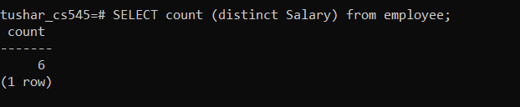

4. Retrieve the names of all employees who have two or more dependents.

- SELECT Fname,Minit,Lname from employee as E where (SELECT count(*) from dependent as D where D.Essn=E.Ssn)>=2;

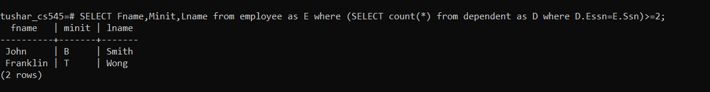

5. For each department, retrieve the department number, the number of employees in the department, and their average salary.

- SELECT Dno,count(*),avg(Salary) from employee group by Dno;

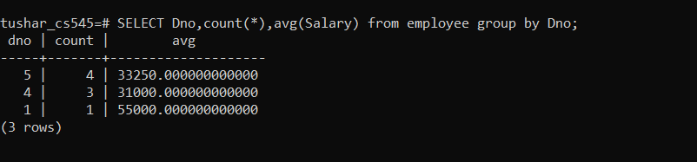

6. Retrieve the names of employees who make at least $10,000 more than the employee who is paid the least in the company.

- SELECT Fname,Minit,Lname from employee as E where (Select min(Salary)+1000 from emplyoee) < Salary;



7. Retrieve the names of all employees who work in the department that has the employee with the highest salary among all employees.

-SELECT Fname,Minit,Lname from employee as E where E.Dno= (Select E.Dno from employee as E where Salary= (select max(Salary) from employee));

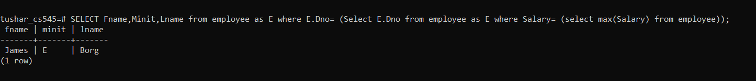

8. Count the total number of employees whose salaries exceed $40,000 in each department.

- SELECT Dno,count(*) from employee where Salary > 40000 group by Dno;

