**UE19CS304 – DBMS LABORATORY**

**SRN: PES1UG19CS545**

**Name: TUSHAR Y S**

**Week7 : SQL – Set Operations – Union, intersect and minus**

- Creating Database and inserting data:

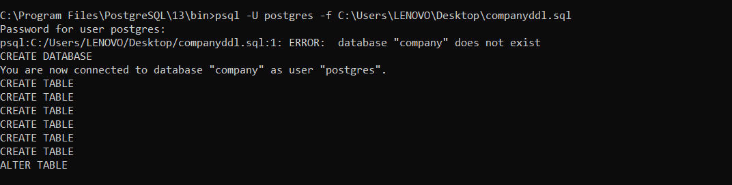

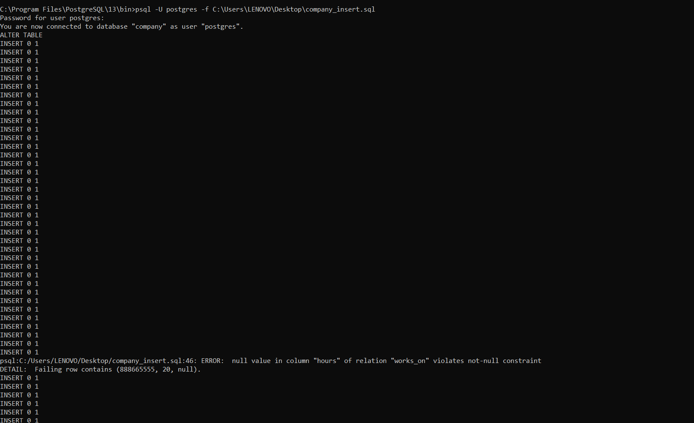

1. Make a list of all project numbers for projects that involve an employee whose last name is ‘Smith’, either as a worker or as a manager of the department that controls the project.

- (SELECT DISTINCT Pnumber from PROJECT,DEPARTMENT,EMPLOYEE where Dnum=Dnumber AND Ssn=Mgr_ssn AND Lname=’Smith’) UNION (SELECT DISTINCT Pno from WORKS_ON where Essn IN (SELECT Ssn from EMPLOYEE WHERE Lname=’Smith’)

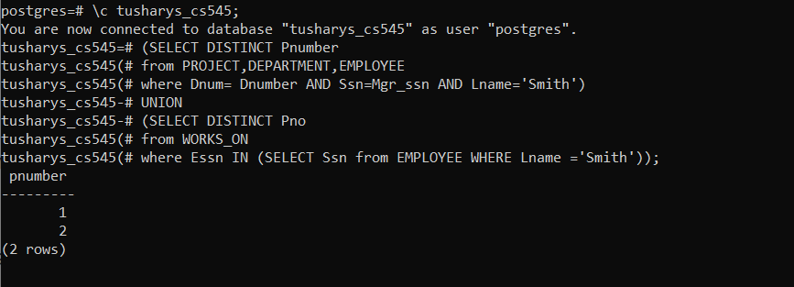

2. Retrieve the names of the employee who does not have dependents.

- SELECT Fname, Lname from EMPLOYEE where not exists (SELECT * FROM DEPENDENT WHERE Ssn=Essn);

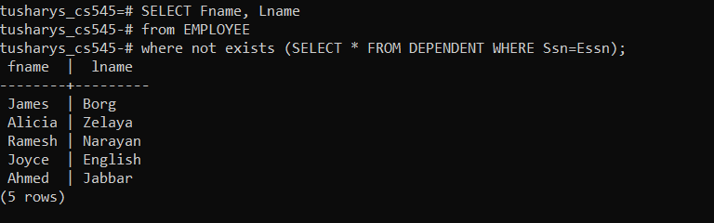

3. Retrieve the Social Security numbers of all employees who either work in department 5 or directly supervise an employee who works in department 5.

- (SELECT Ssn from EMPLOYEE WHERE Dno=5) UNION (SELECT Super_ssn FROM EMPLOYEE WHERE Dno=5);

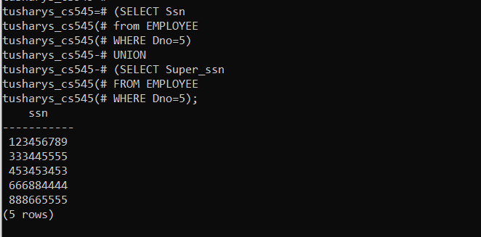

4. Using Intersect find all projects controlled by the department 5 and has employee ssn 123456789 working in that project.

- (SELECT Pname from PROJECT where Dnum=5) INTERSECT (SELECT Pname FROM PROJECT,WORKS_ON where Pno=Pnumber AND Essn IN (SELECT Ssn from EMPLOYEE where Ssn=’123456789’));

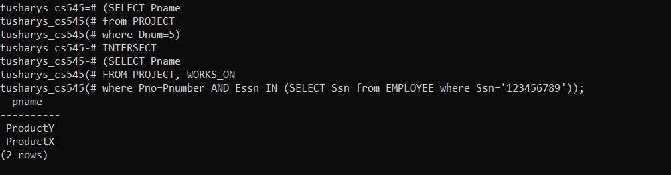

5. Using Except find all ssn of employees who works in department 5 but not in Bellaire location

- (SELECT Ssn from EMPLOYEE where Dno=5) EXCEPT (SELECT Essn from WORKS_ON,PROJECT where Pno=Pnumber AND Ploaction=’Bellaire’);

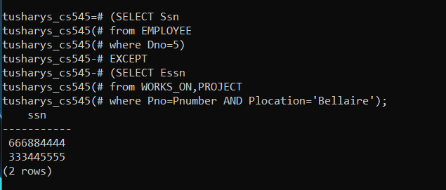

6. Find the name of the employee who has the same name as the dependent of any employee (use intersect ).

- (SELECT Fname FROM EMPLOYEE) INTERSECT (SELECT Dependent_name from DEPENDENT);

