**UE19CS304 – DBMS LABORATORY**

**SRN: PES1UG19CS545**

**Name: TUSHAR Y S**

**Week8: SQL - Joins: inner , outer; Sub queries**

- Creating database and inserting data:

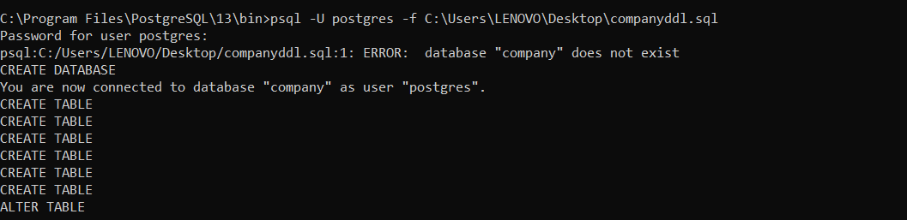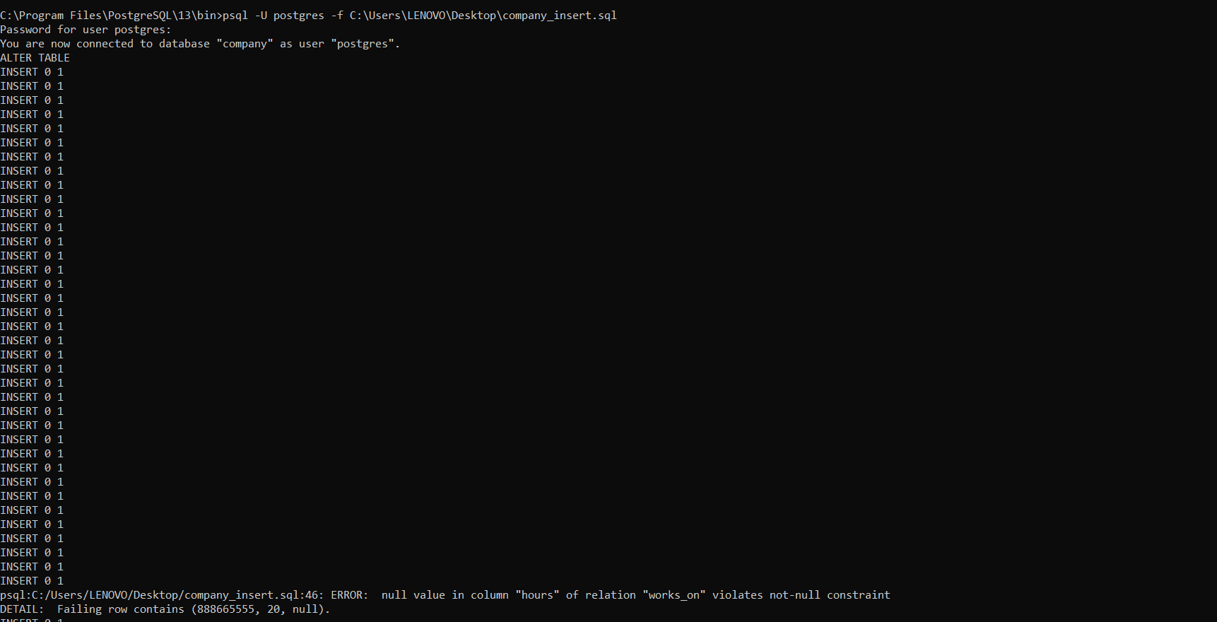



1. Using nested query retrieve the names of all employees who have two or more dependents.

- Select fname,minit,lname from employee where ssn in (select essn from dependent group by essn having count(essn)>=2);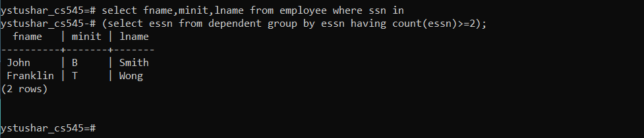

2. Using nested query Retrieve the name of each employee who has a dependent with the same first name and is the same sex as the employee.

- select fname,minit,lname from employee where exists (select dependent_name from dependent where dependent_name=fname and dependent.gender = employee.gender and ssn=essn);

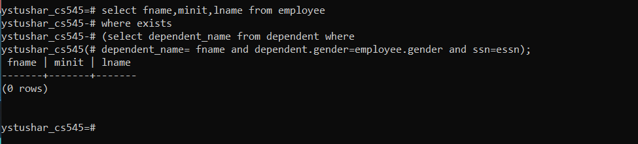

3. Using nested query retrieve names of employees whose salary is greater than the salary of all the employees in department 5.

- select fname,minit,lname from employee where salary>(select max(salary) from employee where dno=5);

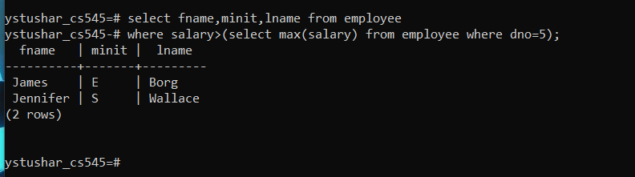

4. Retrieve the names of employees who have no dependents.( use Exists/Not Exists)

- select fname,minit,lname from employee where not exists (select essn from dependent where ssn=essn);

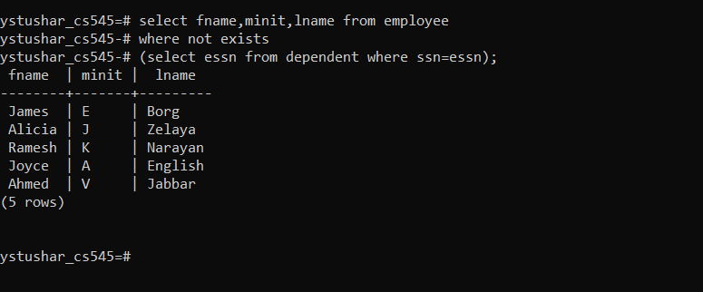

5. List the names of managers who have at least one dependent.

- select fname,minit,lname from employee where ssn in (select mgr_ssn from dependent join dependent on mgr_ssn=essn);

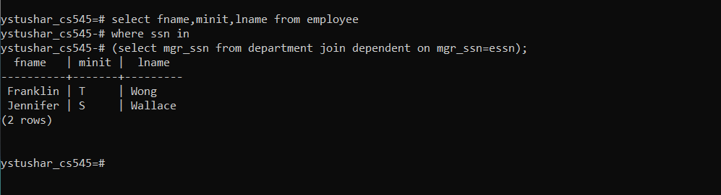

6. Using natural Join retrieve the name and address of every employee who works for the ‘Research’ department.

- select fname,minit,lname,address from employee join department on dno=dnumber where dname=’Research’;

