**UE19CS304 – DBMS LABORATORY**

**SRN: PES1UG19CS545**

**Name: TUSHAR Y S**

**Week 9-10: SQL – Creating Triggers and Functions**

1. Create an employee table which contains employee details and the department he works for. Create another table department consisting of dname and number of employees. Write triggers to increment or decrement the number of employees in a department table when the record in the employee table is inserted or deleted respectively.

- create.sql file containing functions and triggers.

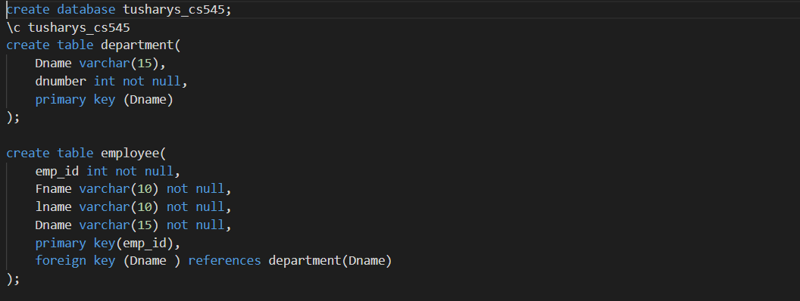

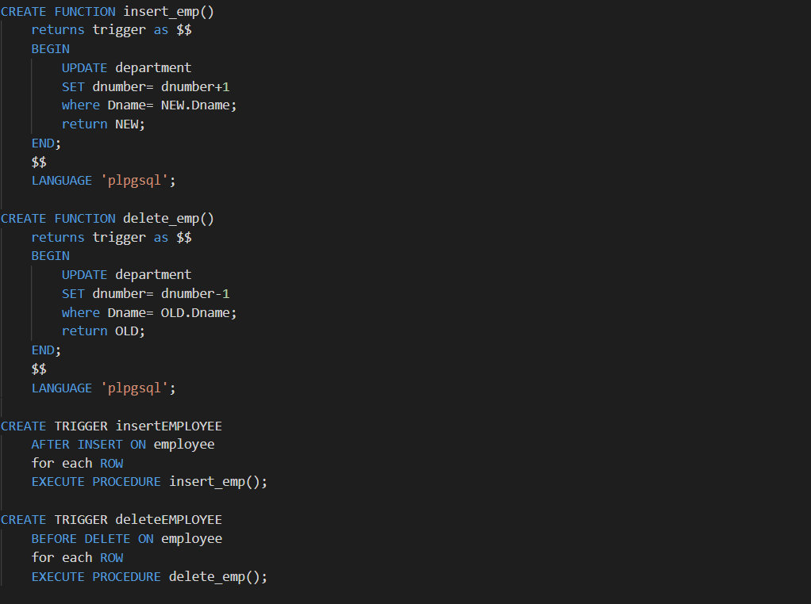

- insert.sql file containing insert statements.

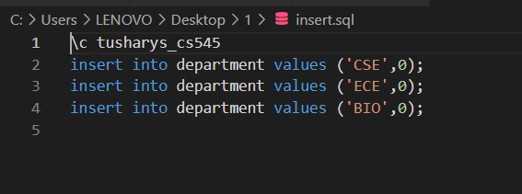

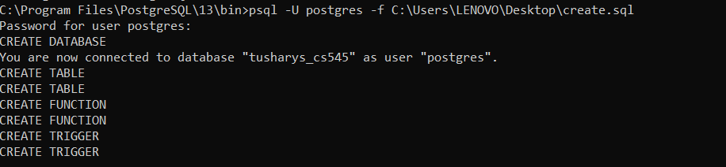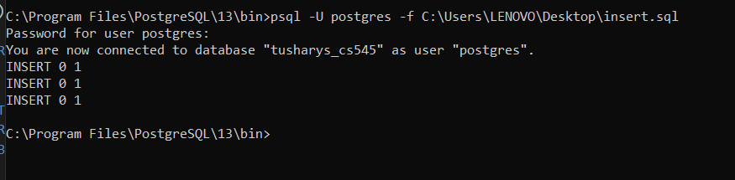

- All fields are initially set to 0 since no record is inserted initially.

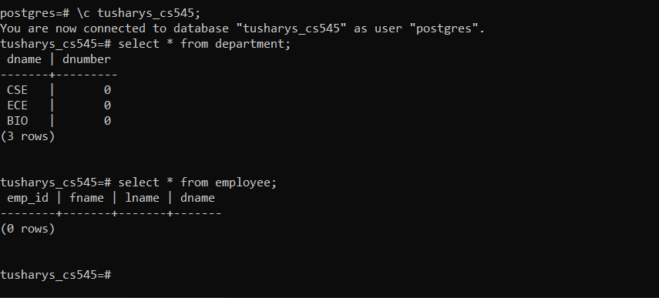

- Triggers to increment number of employees in department table when the record in employee table is inserted.

Adding an employee to CSE department:

insert into EMPLOYEE values(1,’Virat’,’Kohli’,’CSE’);

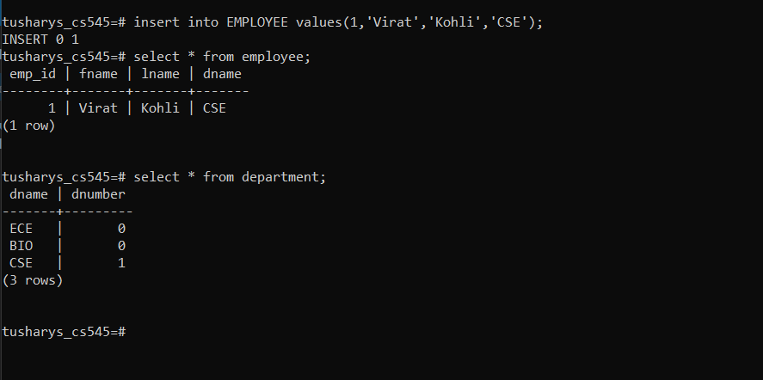

Adding an employee to ECE department:

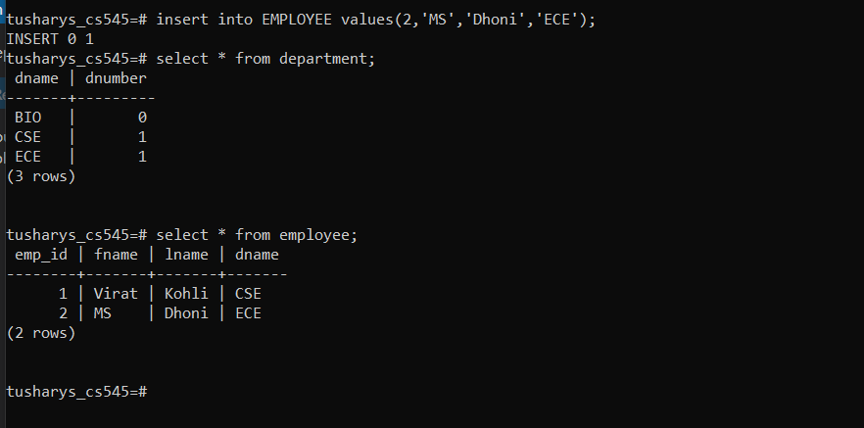

Adding an employee to BIO department:

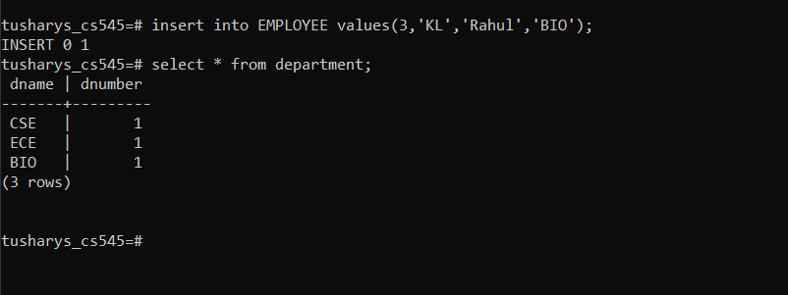

Final data in department table:

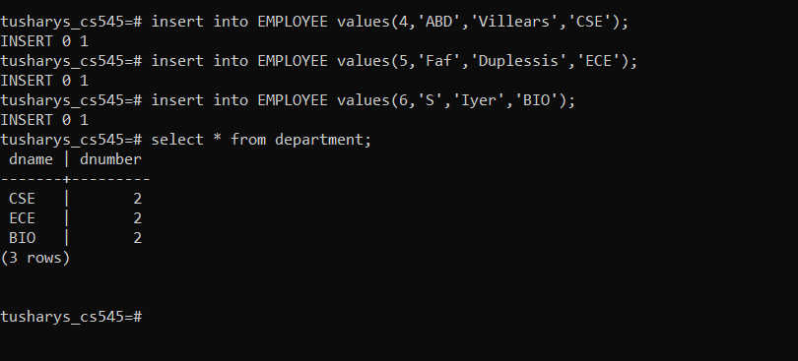

- Triggers to decrement number of employees in department table when the record in employee table is deleted.

Deleting an employee with employee id =5:

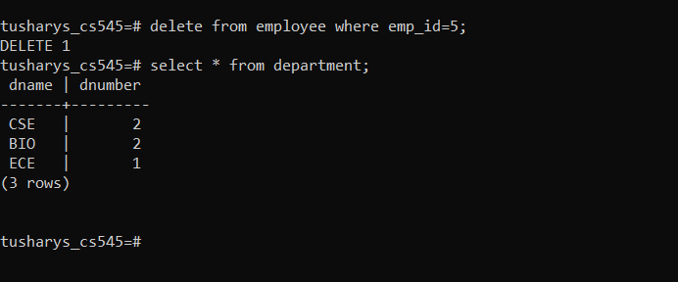

Deleting an employee with employee id =1:

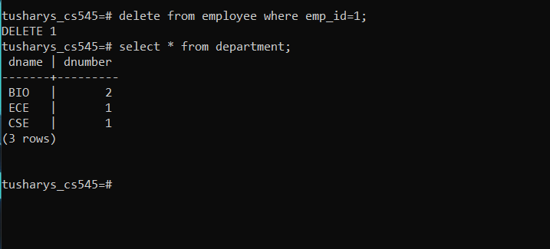

2. Create an order_item table which contains details like name, quantity and unit price of every item purchased. Create an order summary table that contains number of items and total price. Create triggers to update entry in order summary whenever an item is inserted or deleted in the order item table.

- File that contains functions and triggers to update entry in order summary table when an item is inserted or deleted in order item table.

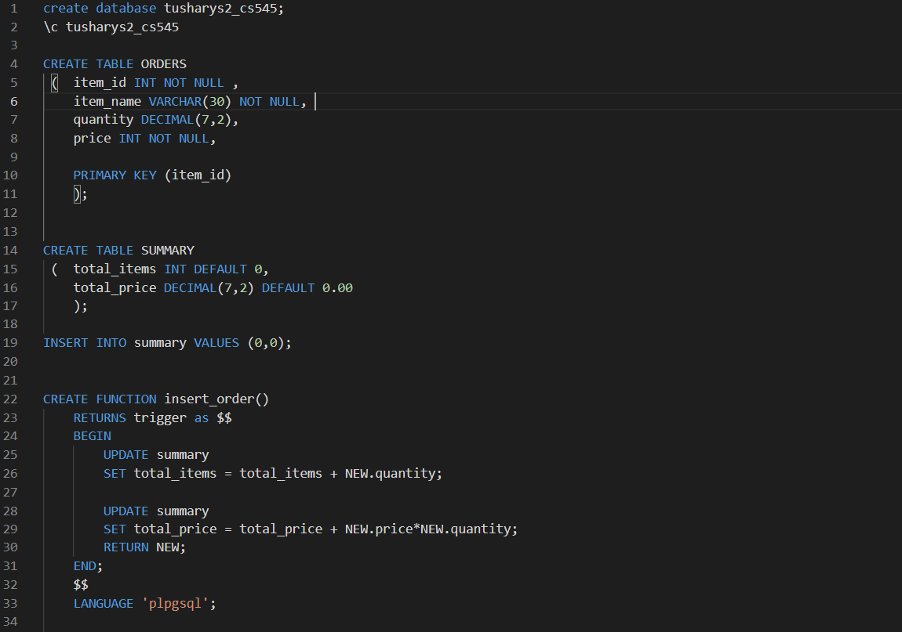

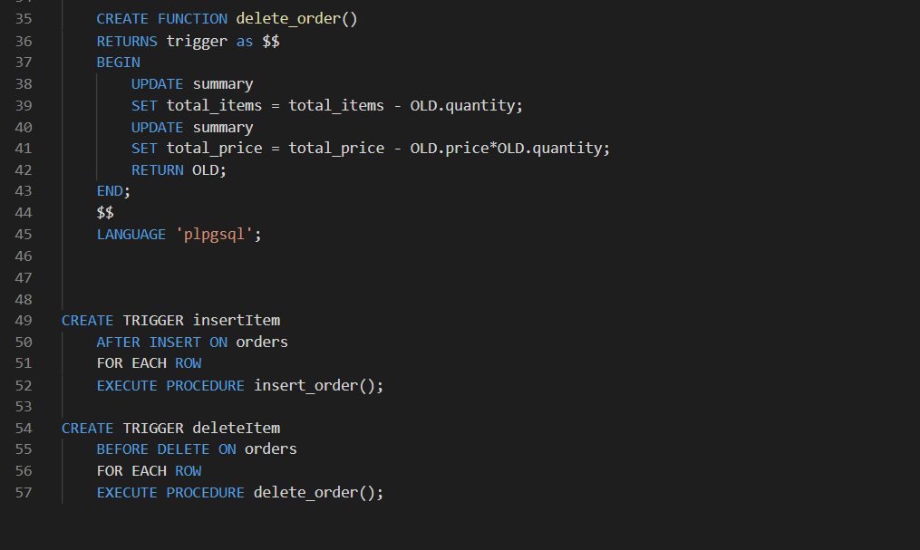

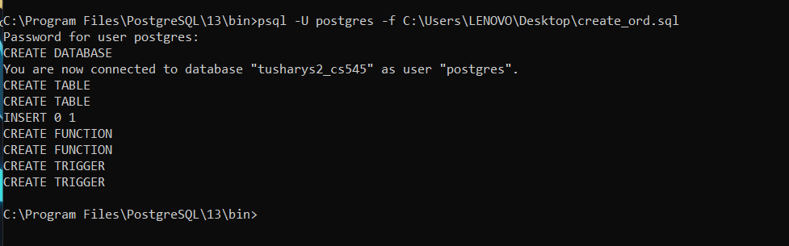

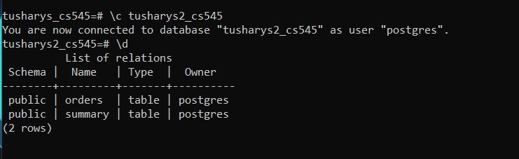

- Initially orders and summary table doesn’t contain anything.

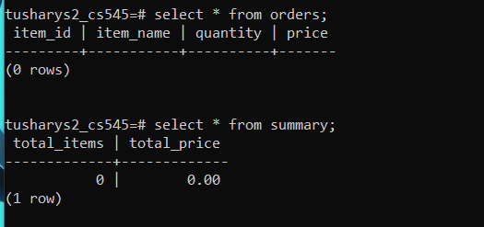

- There is Update (because of trigger) in summary table when an item is inserted in orders table:

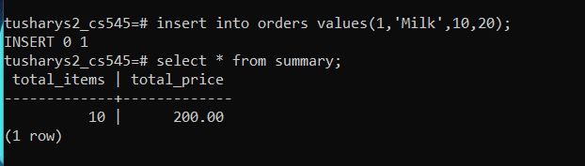

- Similarly when an item is deleted from orders table there is update in summary table:

