**Microprocessor and Computer Architecture Laboratory**

**UE19CS256**

**4th Semester, Academic Year 2020-21**

Date: 5/2/2021

|  |  |  |
| --- | --- | --- |
| Name: TUSHAR Y S | SRN:  PES1UG19CS545 | Section  I |

Week#____3_______ Program Number: __1___

Write an ALP to add two 64 bit numbers loaded from memory and store the result in memory.

ARM Assembly Code:

.text

LDR R0,=A

LDR R1,=B

LDR R2,[R0],#4

LDR R3,[R0]

LDR R4,[R1],#4

LDR R5,[R1]

ADDS R7,R3,R5

ADC R6,R2,R4

LDR R8,=C

STR R6,[R8],#4

STR R7,[R8]

LDR R9,=C

LDR R10,[R9,#4]

LDR R11,[R9]

SWI 0x11

.data

A:.WORD 0x00000001,0xa0000002

B:.WORD 0x00000003,0xa0000004

C:.WORD

Output:

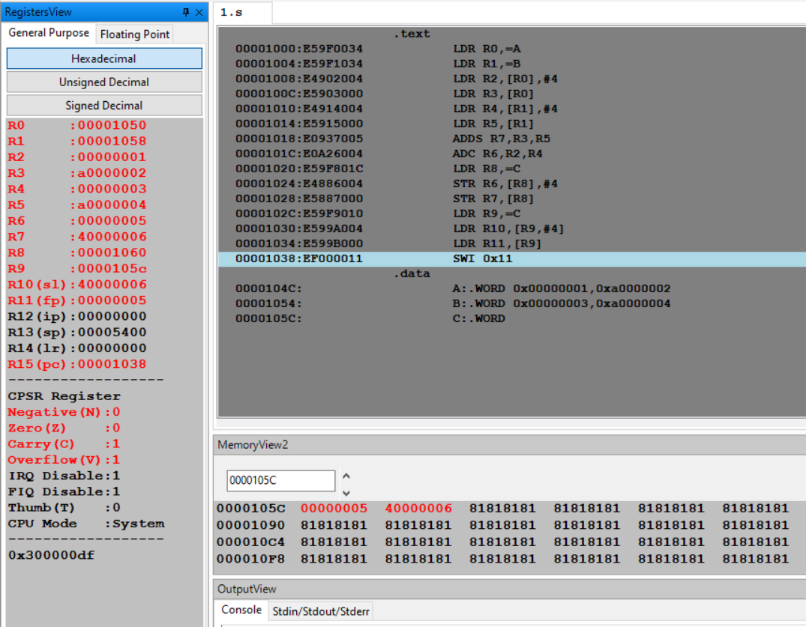

Week#____3_______ Program Number: __2___

Write an ALP to copy n numbers from Memory Location A to Memory Location B.

ARM Assembly Code:

.text

LDR R0,=A

LDR R1,=B

MOV R2,#10

L1:

LDR R3,[R0]

STR R3,[R1]

SUB R2,R2,#1

ADD R0,R0,#4

ADD R1,R1,#4

CMP R2,#0

BNE L1

SWI 0x11

.data

A:.WORD 2,4,6,40,10,12,14,16,18,20

B:.WORD

Output:

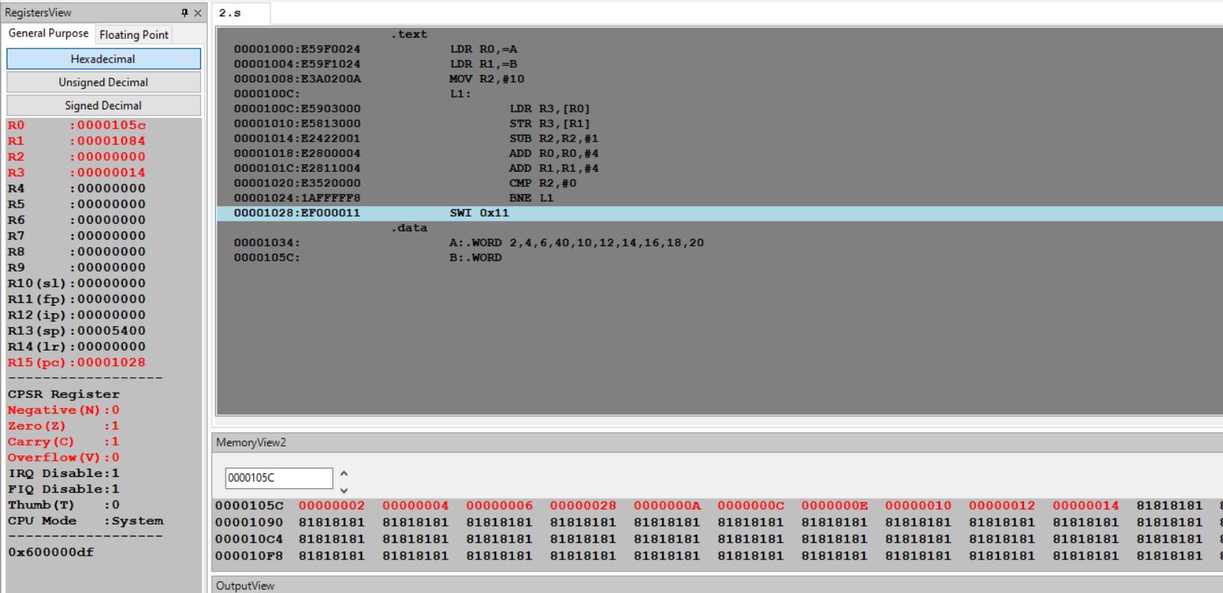

Week#____3_______ Program Number: __3___

Write an ALP to find smallest number in an array of n – 32 bit numbers.

ARM Assembly Code:

.text

LDR R0,=A

LDR R1,=B

LDR R4,[R0],#4

LDR R3,[R1]

CMP R3,#1

BEQ L1

SUB R3,R3,#1

MOV R6,R4 ; Smallest number to be stored in R6

L2:

LDR R4,[R0],#4

CMP R4,R6

MOVLT R6,R4

SUB R3,R3,#1

CMP R3,#0

BNE L2

L1:

SWI 0x11

.data

A:.WORD 5,13,21,4,3,19,30,8,16,42

B:.WORD 10

Output:

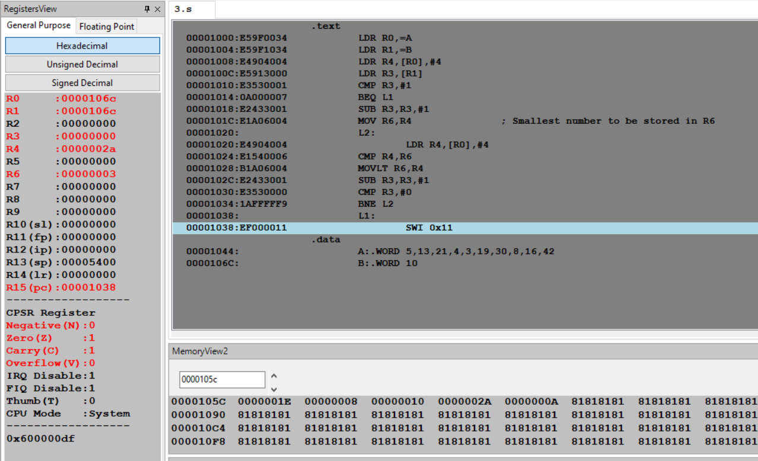

Week#____3_______ Program Number: __4a___

Write an ALP to count the number of 1’s and 0’s in a given 32 bit number.

ARM Assembly Code:

.text

LDR R0,=0b11110010100101001101001100110111

MOV R1,#32

MOV R5,#0

MOV R6,#0

L1:

AND R2,R0,#1

CMP R2,#1

ADDEQ R5,R5,#1 ;Number of 1's is stored in R5

ADDNE R6,R6,#1 ;Number of 0's is stored in R6

MOV R0,R0,LSR #1

SUB R1,R1,#1

CMP R1,#0

BNE L1

SWI 0x11

.end

Output:

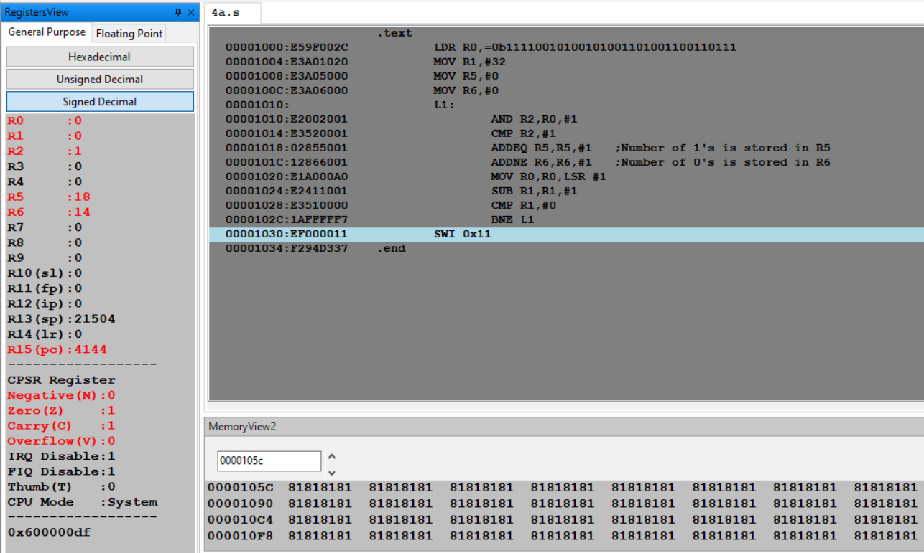

Week#____3_______ Program Number: __4b___

Write an ALP to find the number of zeroes, positive and negative numbers in a given array.

ARM Assembly Code:

.text

LDR R1,=A

LDR R2,=B

LDR R3,[R2]

MOV R7,#0

MOV R8,#0

MOV R9,#0

L1:

LDR R4,[R1],#4

CMP R4,#0

ADDEQ R7,R7,#1 ;Number of 0's is stored in R7

ADDLT R8,R8,#1 ;Number of negative numbers is stored in R8

ADDGT R9,R9,#1 ;Number of positive numbers is stored in R9

SUB R3,R3,#1

CMP R3,#0

BNE L1

SWI 0x11

.data

A:.WORD -1,-2,-3,0,1,2,0,4,5,6

B:.WORD 10

Output:

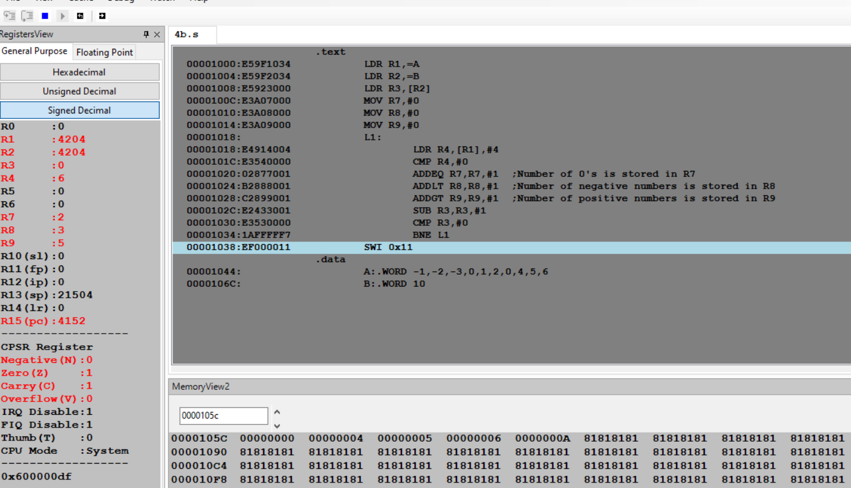

Week#____3_______ Program Number: __5___

Write an ALP to check whether a given number is present in array using Linear Search (Without SWI 0x02), if found move +1 to R6 and key position to R7 else move -1 to R6 (if number not found).

Case 1(Element found):

ARM Assembly Code:

.text

LDR R0,=A

MOV R1,#10

MOV R3,R1

L1:

LDR R2,[R0],#4

CMP R2,#25 ;Element 25 is to be searched in the array

BEQ L2

SUBS R1,R1,#1

CMP R1,#0

BNE L1

MOV R6,#-1

SWI 0x11

L2:

MOV R6,#1

SUB R1,R1,#1

SUB R7,R3,R1

SWI 0x11

.data

A:.WORD 2,4,6,8,12,20,25,30,40,50

Output:

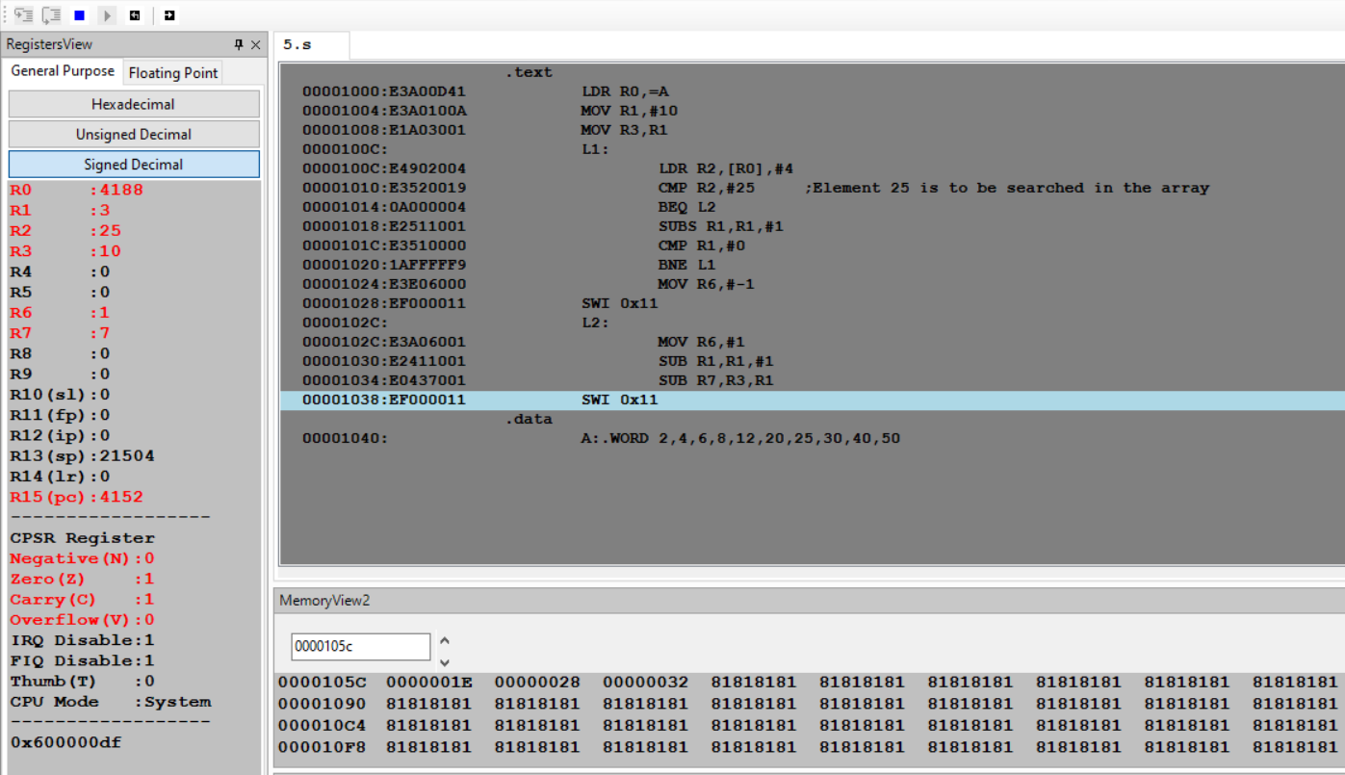

Case 2 (Element NOT found):

ARM Assembly Code:

.text

LDR R0,=A

MOV R1,#10

MOV R3,R1

L1:

LDR R2,[R0],#4

CMP R2,#70 ;Element 70 is to be searched in the array

BEQ L2

SUBS R1,R1,#1

CMP R1,#0

BNE L1

MOV R6,#-1

SWI 0x11

L2:

MOV R6,#1

SUB R1,R1,#1

SUB R7,R3,R1

SWI 0x11

.data

A:.WORD 2,4,6,8,12,20,25,30,40,50

Output:

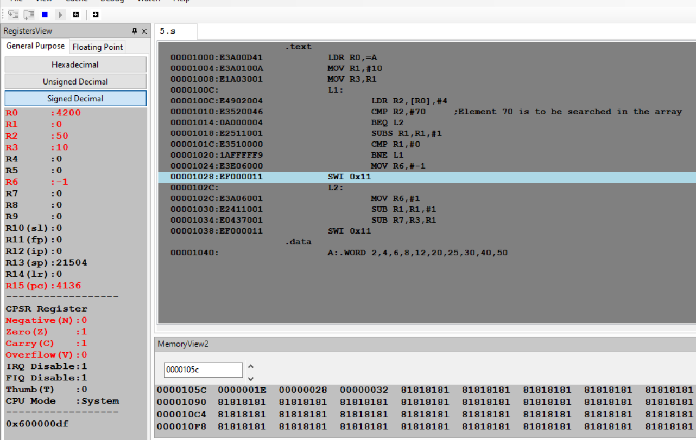

Week#____3_______ Program Number: __6___

Write an ALP to generate Fibonacci Series and store them in an array.

ARM Assembly Code:

.text

LDR R1,=A

MOV R2,#0

STR R2,[R1]

ADD R1,R1,#4

MOV R3,#1

STR R3,[R1]

MOV R5,#8 ; 8 fibonacci numbers will be stored after 0 and 1(So,total=10) in the array

L1:

ADD R4,R2,R3

ADD R1,R1,#4

STR R4,[R1]

MOV R2,R3

MOV R3,R4

SUBS R5,R5,#1

MOV R4,#0

BNE L1

SWI 0x11

.data

A:.WORD

Output:  
