|  |
| --- |
|  |
| Intently – uBlock Developer Handbook |
| 1.0 |

|  |
| --- |
| 10/13/2015 |

Table of Contents

1 Introduction 3

2 Overview 3

3 Build Instructions 3

4 Update uBlock Codebase 6

5 Configuration changes 6

# Introduction

This Guide assists in setting up Intently-uBlock Integration Development environment

# Overview

All generic Intently modules are available under folder ***extension-desktop/src.*** The browser specific modules are available under folder ***extension-desktop/platform.*** The build scripts are available under ***extension-desktop/tools.*** The uBlock core framework integrate is available through script ***extension-desktop/assets/*** ***integrate-ublock.sh***

# Build Instructions

All build scripts requires two arguments one is to specify environment, other is to specify build type.

Args

Environment - {mock|dev|qa|prod}

Build Type - { all|debug }

Following are the build scripts

|  |  |  |  |  |
| --- | --- | --- | --- | --- |
| **Browser** | **Script** | **Build type Output** | | **Comments** |
| **all** | **debug** |
| Chrome | tools/make-chromium.sh | dist/build/intently.chromium.zip | dist/build/intently.chromium/ |  |
| Firefox | tools/make-firefox.sh | dist/build/intently.firefox.xpi | dist/build/intently.firefox/ | Modify file ***tools/make-firefox.sh*** to specify debug folder  The debug will attempt to copy the output folder to  {FIREFOX_PROFILE_DIR}\extensions\jid1-uu3gdWEcFsp4Eg-{ENV}@jetpack  To update existing extension available under firefox profile |
| Safari | tools/make-safari.sh | dist/build/intently.safariextension/ | dist/build/intently.safariextension/ | Only the folders are created, Cant Automate |
| Opera | tools/make-opera.sh | dist/build/intently.opera.zip | dist/build/intently.opera/ |  |

Firefox Debug

Create a new firefox profile through the following instructions

1. Build ***intently.firefox.xpi*** via ***tools/make-firefox.sh dev all.***
2. Type ***firefox -P -no-remote*** , and click Create Profile
   1. On OS X, type **/Applications/Firefox.app/Contents/MacOS/firefox-bin -P**

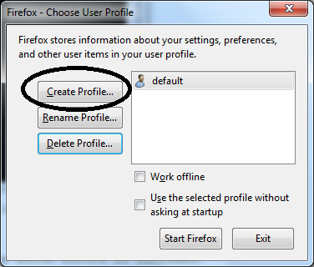

1. Select Next

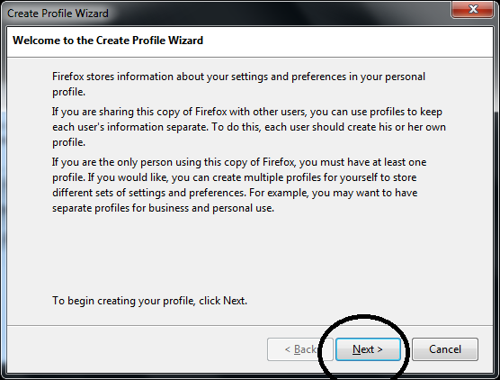

1. Type any name for profile intently-ffprofile & click Choose folder to suite appropriate folder & press finish

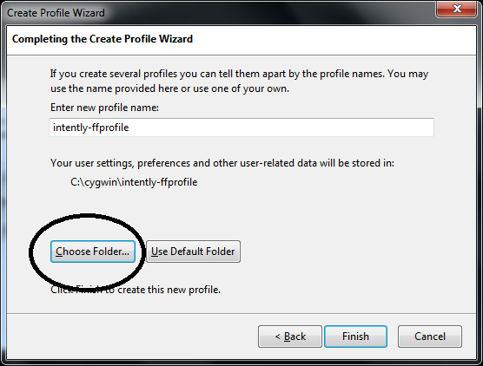

1. The Choosen folder will be referred as **FIREFOX_PROFILE_FOLDER**
2. After firefox opened up drag the xpi file and allow it to install.
3. Once extension is installed , Close the browser
4. Goto path **{FIREFOX_PROFILE_FOLDER}/ extensions** ,

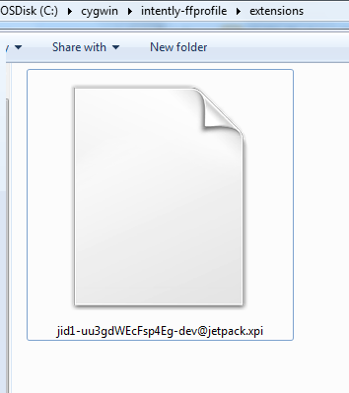

1. In the filename **jid1-uu3gdWEcFsp4Eg-dev@jetpack.xpi** . The value dev refers to the environment. T Create a folder with name **jid1-uu3gdWEcFsp4Eg-dev@jetpack** in the same path and delete the file **jid1-uu3gdWEcFsp4Eg-dev@jetpack .xpi**
2. The **{ EXTENSION_ID }** will be referred through ***jid1-uu3gdWEcFsp4Eg- $ENV @jetpack***
3. Open file  ***tools/make-firefox.sh***
4. Modify variable DEBUG_DIR to **{ FIREFOX_PROFILE_FOLDER }**
5. Modify variable EXTN_ID to **{ EXTENSION_ID }**
6. The script is now ready to debug extension.

*Note : Always open firefox through* ***firefox -P -no-remote -jsconsole*** *to choose profile and start firefox with global JavaScript console. On OS X use* ***/Applications/Firefox.app/Contents/MacOS/firefox-bin -P -no-remote -jsconsole***

# Update uBlock Codebase

All the platform specific files are modified to adapt **Intently** specific changes. Only the generic framework structure of uBlock would be updated through script.

The script ***assets/integrate-ublock.sh*** will incorporate the latest uBlock changes with the code.There are certain files in generic framework which would be left alone , as it requires some Intently specific changes.

If there is a platform specific update in uBlock , Currently It should be identified and updated manually.

# Configuration changes

All environment specific configurations across browsers is in file ***src/intently/env/env.json.*** The API version could be updated on file ***src/intently/js/intently-conf.js.***  The environment specific configurations are available under ***src/intently/env/conf-{ENV}.js***