*Steps to create ARFF file*

* Fill the details in a notepad and save it with .arff extension .
* Open the weka file now.
* Select the attributes and notice the values and bar chart.
* Below is the sample data.

@relation student

@attribute rno numeric

@attribute name string

@attribute dept {cse,ece, eee,it}

@attribute class {PASS, FAIL}

@attribute age numeric

@data

501,Lasya,cse,PASS, 32

502,Sindhu,eee,PASS, 22

503,Pravalika,ece,PASS, 30

504,Nikiha,it, PASS,32

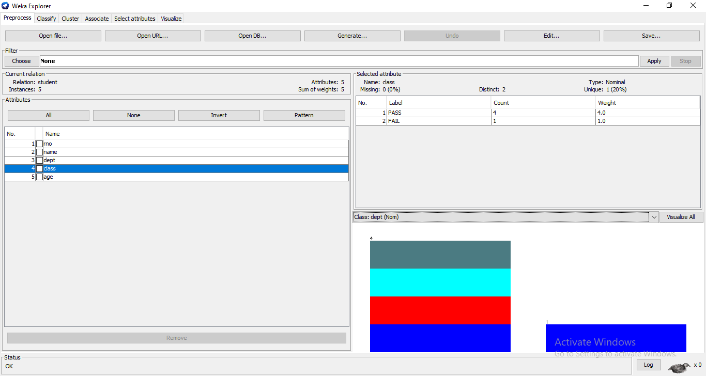

* Now select visualize all button. After visualizing it shows the piechart of all the attributes.
* The histogram chart is shown below:

