**ASSIGNMENT-2**

**Deriving a Decision Tree from given Dataset:**

* Intially open the given Dataset in Weka. And here we are taking the German Credit as Dataset.
* And the select the class attribute from the list of attributes and start classifying the class as it is shown below.

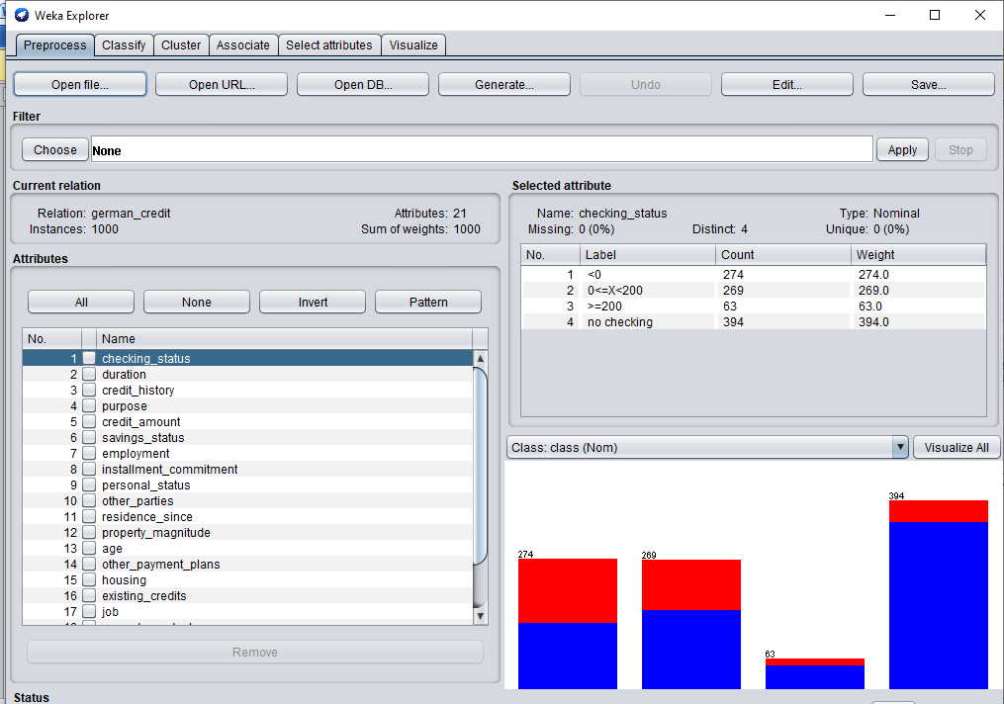

* Click on classify tab and Choose J48 from trees

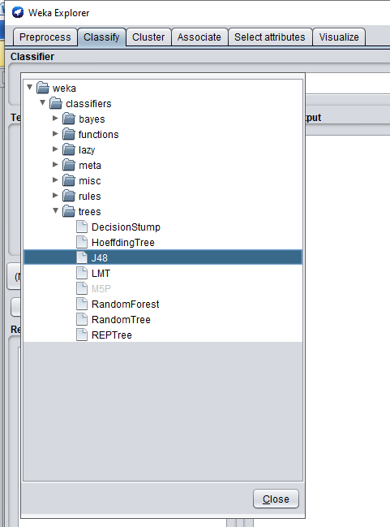

* Choose the Use training setfrom Test options

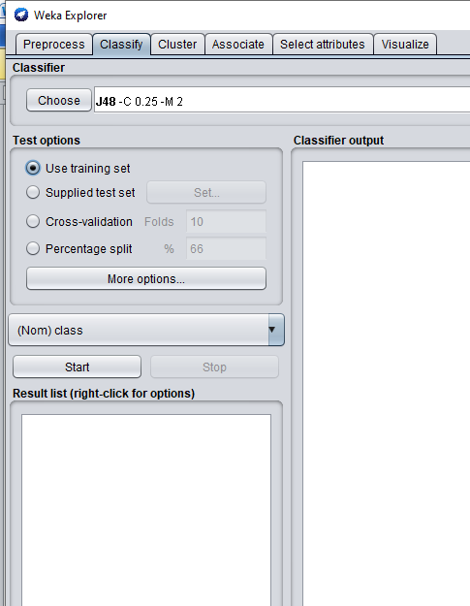

* Now, choose the attribute **class** from the dropdown

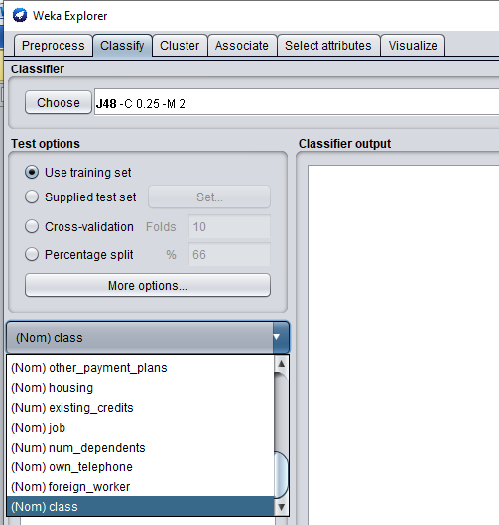

* Next click on Start. We will get Output as below:

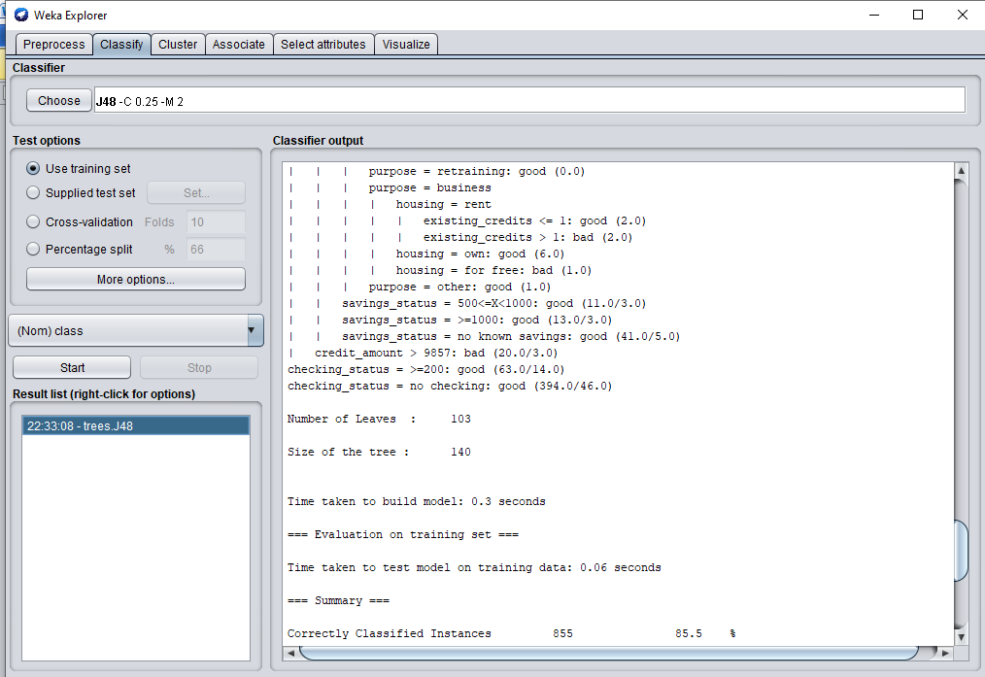

* Number of leaves = 103
* Number of tree = 140
* Time Taken to build Model = 0.3 sec
* We also get the Confusion Matrix as below:

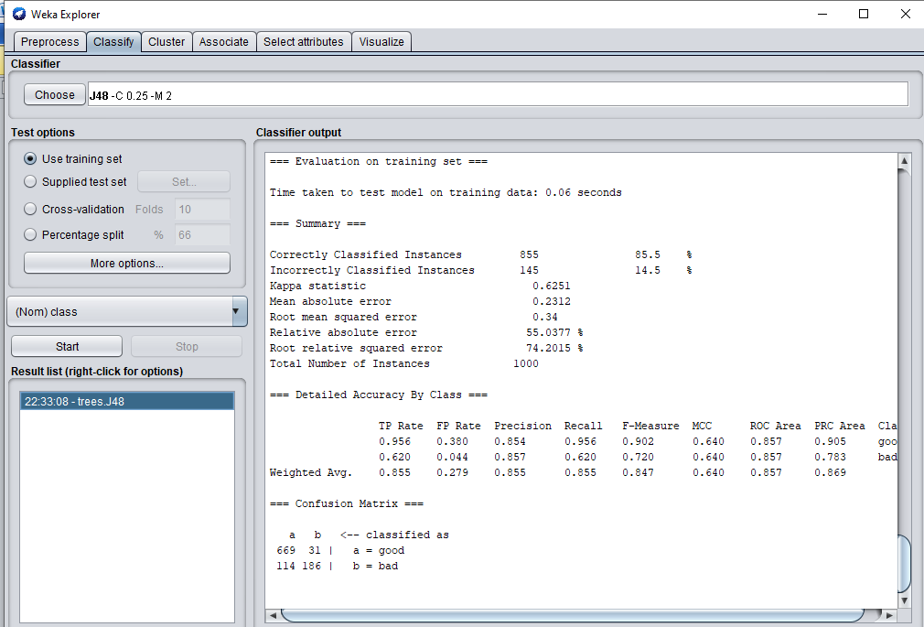

* Right click on the option in the Result list and select the **visualize tree** option.

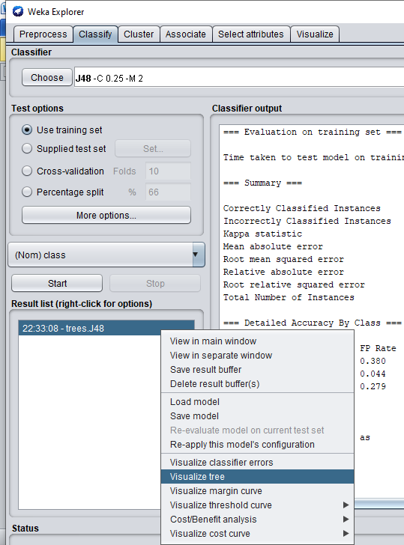

* The Output will be:

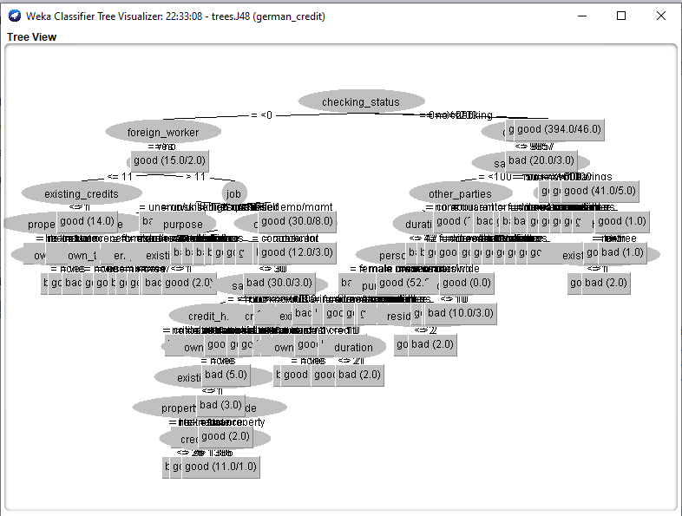

**VARYING THE PERCENTAGE SPLIT FOR ACCURACY:**

1. **FOR J48 CLASSIFIER:**

* Accuracy when Percentage split is 66%

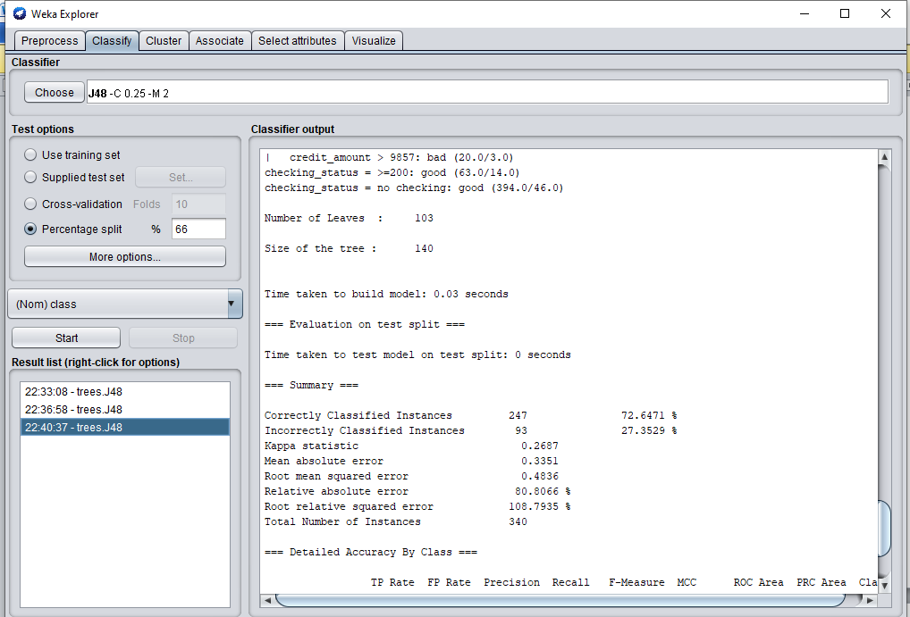

* Accuracy when Percentage split is 80%

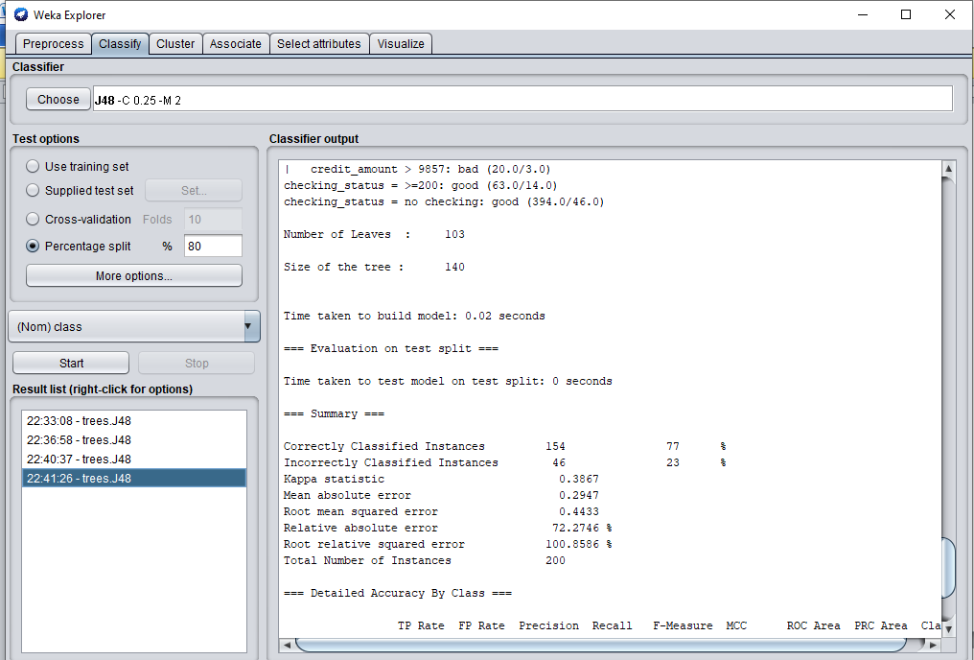

1. **FOR NAIVEBAYES CLASSIFIER:**

* Accuracy when Percentage split is 66%

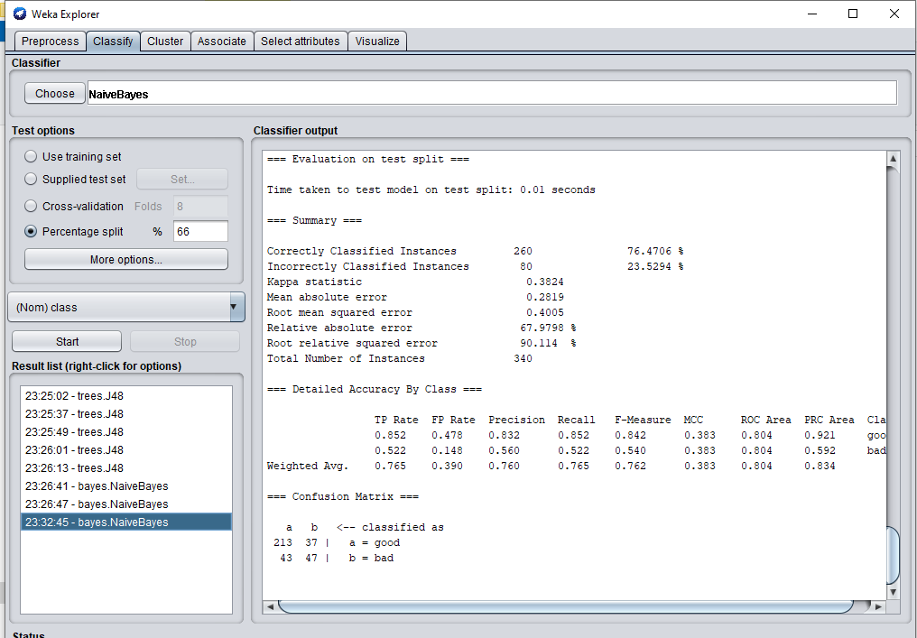

* Accuracy when Percentage split is 80%

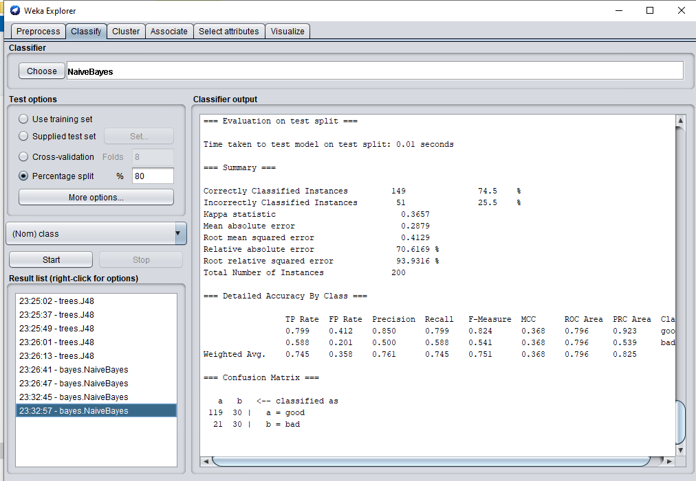

**VARYING THE CROSS VALIDATIONS FOR ACCURACY:**

1. **FOR J48 CLASSIFIER:**

* Accuracy when Cross – validation is 10

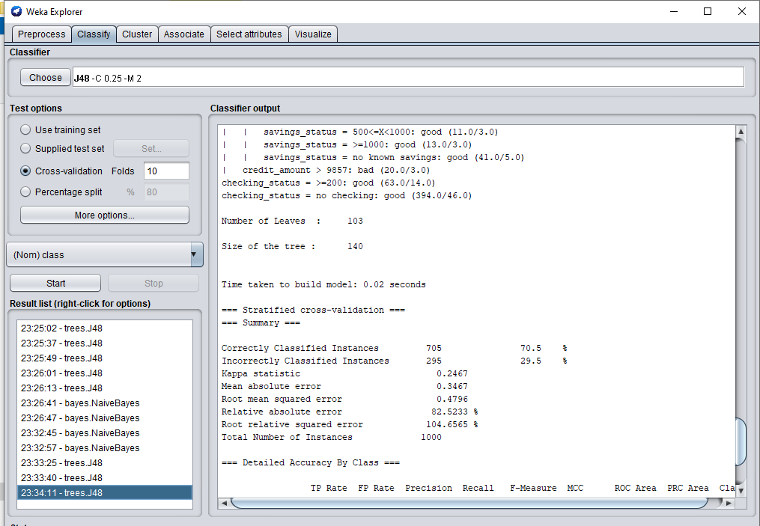

* Accuracy when Cross – validation is 8

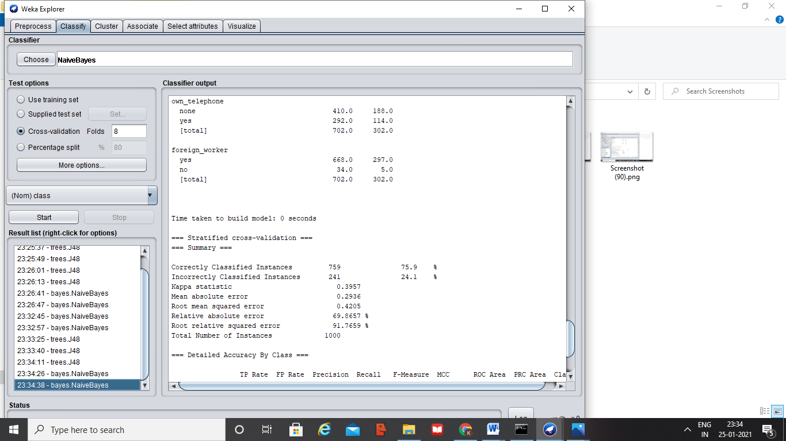

1. **FOR NAIVEBAYES CLASSIFIER:**

* Accuracy when Cross – validation is 10

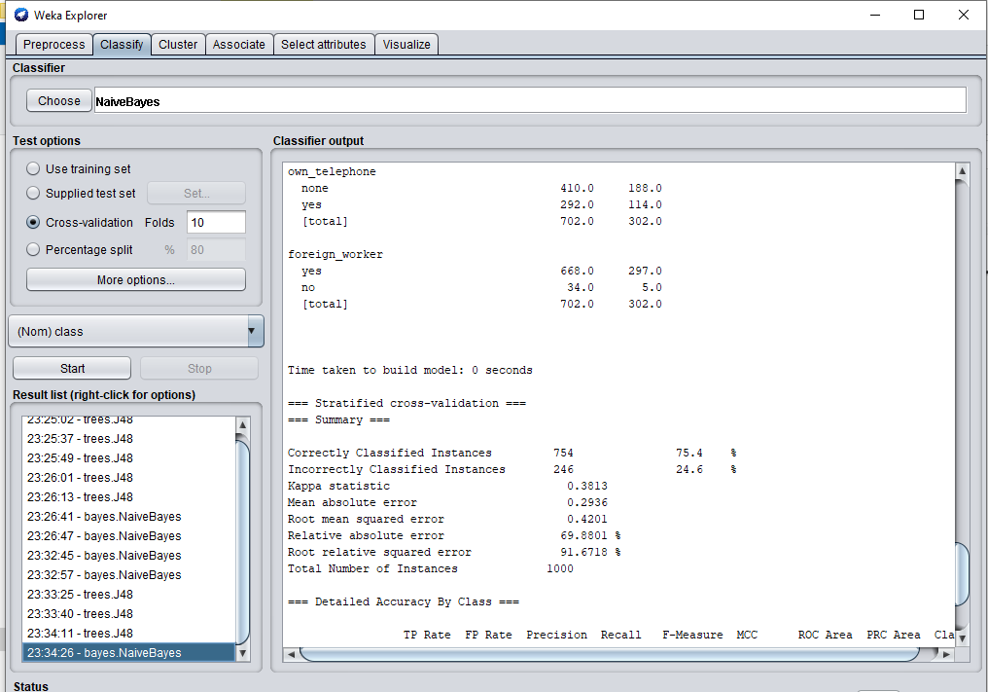

* Accuracy when Cross – validation is 8

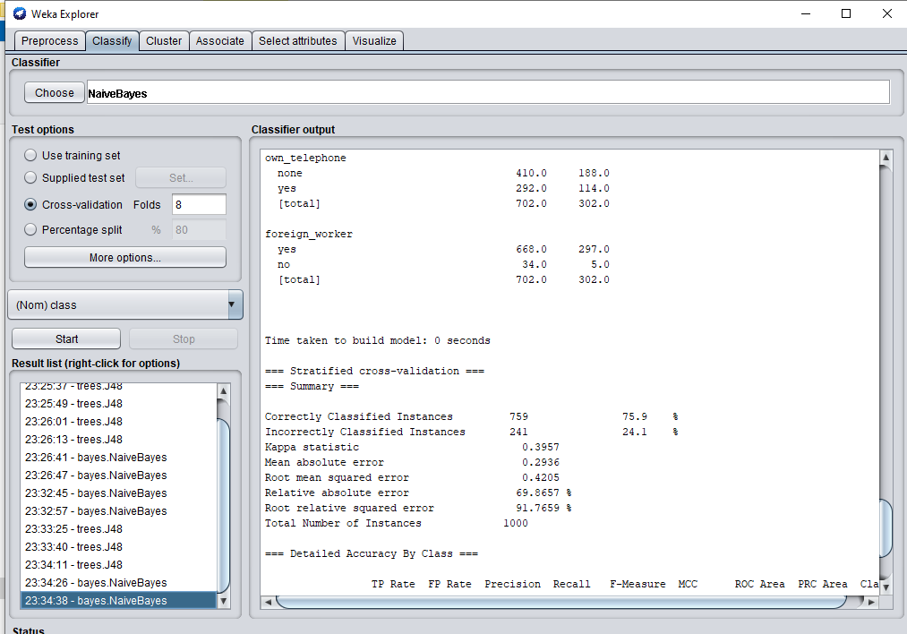

END