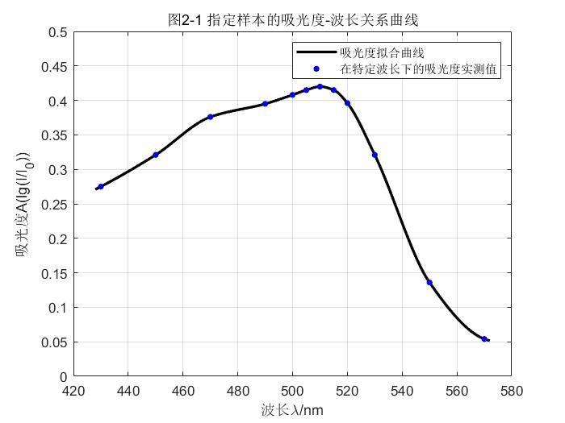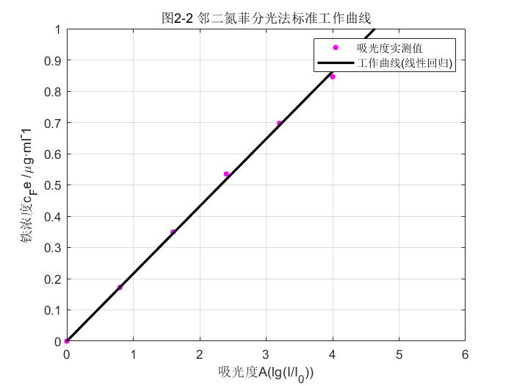

MATLAB源代码：

LEDF1.m

clear;clc;

I=[0.275,0.321,0.376,0.395,0.408,0.415,0.420,0.415,0.396,0.321,0.136,0.054];

lambda=[430,450,470,490,500,505,510,515,520,530,550,570];

lp=428:0.1:572;

%Ip=spline(lambda,I,lp);

Ip=interp1(lambda,I,lp,'pchip');

p1=plot(lp,Ip,'k-','linewidth',2);

hold on

grid on

axis on

axis([420 580 0 0.5])

p2=plot(lambda,I,'b.','markersize',15);

title('图2-1 指定样本的吸光度-波长关系曲线')

xlabel('波长\lambda/nm')

ylabel('吸光度A(lg(I/I_0))')

legend([p1,p2],{'吸光度拟合曲线','在特定波长下的吸光度实测值'})

LEDF2.m

clear;clc;

f=@(k,x)k.*x;

A=[0,0.172,0.349,0.535,0.697,0.846];

c=[0,0.8,1.6,2.4,3.2,4.0];

[k1,resnorm1]=lsqcurvefit(f,[0],c,A);

cp=0:0.1:5;

Ap=k1*cp;

p1=plot(c,A,'m.','markersize',15);

hold on

grid on

p2=plot(cp,Ap,'k-','linewidth',2);

axis([0 6 0 1])

axis on

title('图2-2 邻二氮菲分光法标准工作曲线')

xlabel('吸光度A(lg(I/I_0))')

ylabel('铁浓度c_Fe /\mug·ml^-1')

legend([p1,p2],{'吸光度实测值','工作曲线(线性回归)'})

fprintf("曲线斜率为%03f,参数/epsilon为%f\n",k1,k1*100);