# 

## 

Systers Portal

Requirements Document

**Document Change Control**

The following is the document control for the revisions to this document.

|  |  |  |  |
| --- | --- | --- | --- |
| **Version Number** | **Date of Issue** | **Author(s)** | **Brief Description of Change** |
| 0.1 | 4 Apr 2014 | R. Robinson | Initial document |
|  |  |  |  |
|  |  |  |  |

**Definition**

The following are definitions of terms, abbreviations and acronyms used in this document.

|  |  |
| --- | --- |
| **Term** | **Definition** |
| ABI | Anita Borg Institute |
| GHC | Grace Hopper Celebration |
| WiC | Women in Computing |
| HSK | Her Systers’ Keeper |
|  |  |
|  |  |

Table of Contents

Overview 4

1. Background 4

A. The Problem and Challenges 5

B. Scope 7

Functional Requirements 8

2. Administrator Functionality 8

A. Edit portal administrator profile 8

B. Create new community categories 8

C. Create new community users 8

D. Create new community resource area 8

E. Create and manage organizational meetups 9

F. Approve new community requests 9

G. Organizational administrators full access level 9

3. Community Administrator Functionality 9

A. Edit community profile 9

B. Edit community resource area 9

C. Edit social media accounts 9

D. Create new community resource area 9

4. User Functionality 10

5. Future Enhancements 10

Appendix 11

6. New Community Proposal 11

7. New Communities Setup Checklist 11

A. Email List 11

B. Social Media Channels 11

C. Promotion 11

D. COMMUNICATION 11

# Overview

## Background

Systers, an Anita Borg Institute (ABI) Community is the flagship community for women in computing. Created in 1987, this community has over 4,700 members as well as over 3,000 plus members in special interest groups and affinity groups. Additionally, ABI’s annual conferences, GHC, leverage Systers and sub-communities for GHC volunteer note takers and bloggers.

Figure Current ABI Communities Structure

### The Problem and Challenges

With the continuous growth, new communities and sub-communities, and recent website upgrade, communities do not have a way to post and share pertinent information for Systers and their individual groups.

Before rebranding and new website, ABI (Anita Borg Institute) had sections/pages for Systers and each subgroup (Latinas, LGBT, and Black Women in Computing, TurkishWiC and ArabWiC). This allowed for subgroup members to find information specific to their group.

The portal project is to have administrators from Systers and subgroups to provide the same information above in one portal area. Below are screen shots from old website that we want to similarly implement for new portal.

Figure Previous Systers Main page

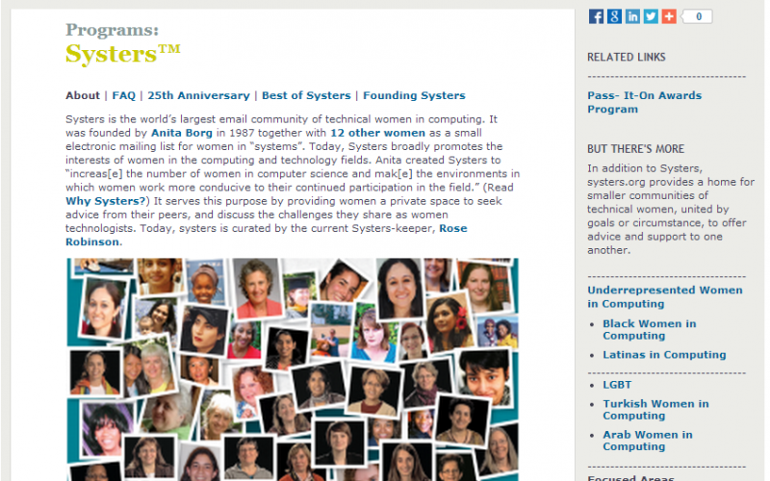

Figure Previous Sub-Community Page

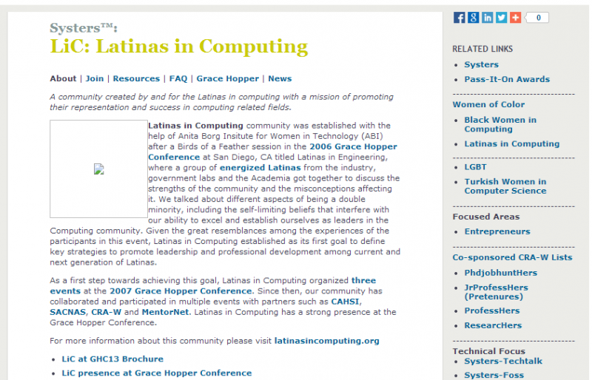

Figure Sample GHC schedule for Black Women in Computing Activities

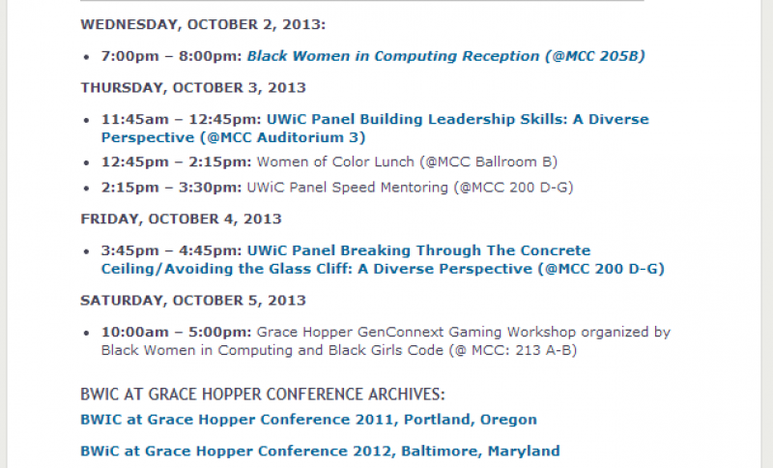

Figure Sample Short Description Page

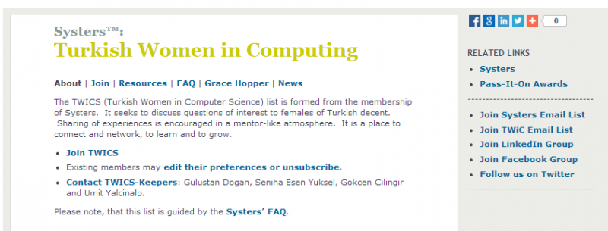

### Scope

For GSoC 2014 project timeline, the scope of the project is defined in the following sections for Requirements, timeline and deliverables.

# Functional Requirements

With many of our Systers communities, many define themselves within a special location or focused groups. Some of the determining factors of starting a community are: sharing similar cultural backgrounds, special interests or topic areas, and geographic location. Each community entity also creates their online space for engagement. But the real problem is how to bring all of these online communities into one organized communication place for our members. To find a solution starts with defining some of the challenges we currently face.

The following user case is addressed:

* Administrator
* Community Users
* Visitors

## Administrator Functionality

Administrative functionalities for the new Portal should include:

### Edit portal administrator profile

This should be at organizational level including basic information like organization name, address, contact person, website url, time zone and social media accounts.

### Create new community categories

Portal administrator should be able to create new community and create new categories based on Figure 1.

### Create new community users

Administrator should be able to create new community administrators, assign a community category and assign different levels. Each level would provide various levels of access. Would like to implement various levels of access, for example,

* Level 5 (Admin all rights)
* Level 4 (Manage users and content)
* Level 3 (Manager content)
* Level 2 (Content contributor)
* Level 1 (Only view mode and comment)

### Create new community resource area

Portal administrator should be able to generate new community resource area that includes the following basic page templates that are specific to the community, including Main Systers area.

* Main Community page
* Join Information
* GHC Activities
* Meetups
* Resources
* News

### Create and manage organizational meetups

Organizational administrators should be able to create and manage meetups, including global and community created meetups.

### Approve new community requests

Administrators should be able to approve new community requests that are submitted by Systers. Only Systers can submit a new community requests. See screenshot in Appendix.

### Organizational administrators full access level

Organizational administrators should have full access to all sub-sequent levels for support.

## Community Administrator Functionality

Administrative functionalities for the new Portal should include:

### Edit community profile

Community administrators should be able to edit community profile including

* Main contact person (name and email)
* Community name
* Short Description
* Long Description

### Edit community resource area

Community administrators should be able to edit resource areas (includes all pages listed in section 1.C).

### Edit social media accounts

Community administrators should be able to edit social media accounts for their specific community for sharing, retweets and posting in their specific social media channels.

### Create new community resource area

Community administrator should be able to generate new community resource area that includes the following basic page templates that are specific to the community, including Main Systers area.

* Main Community page
* Join Information
* GHC Activities
* Meetups
* Resources
* News

Community administrators should be able to identify each page as “public” or “private”. Public is visible by anyone and “private” is viewable by only those users who is registered and belongs to specific community.

## User Functionality

Users could be community members or just visitors to the sites.

* Users/visitors should have an option to create a profile account.
* When creating a profile, users should be able to select community membership.
* Users/visitors should be able to navigate to all of the pages that are
* Systers should be able to submit a request to start a new community.

## Future Enhancements

Some of the features above are precursors to future enhancements below.

* Administrators should be able to verify membership of all registered users.

# Appendix

## New Community Proposal

Currently, Systers sends Her Systers’ Keeper (HSK) and email inquiring about a new sub-community. HSK provides them the community proposal form to complete. They submit the form to HSK. Then HSK forwards form to ABI executive team for review process. Once approved, HSK notifies the community administrators and begins communities setup.



## New Communities Setup Checklist

HSK follows checklist to ensure all community components are setup.

|  |  |
| --- | --- |
| Email List | |
|  | Set up your email list |
| Social Media Channels | |
|  | Facebook group |
|  | LinkedIn group |
|  | Twitter account |
| Promotion | |
|  | Schedule email to main list and submit to Her Systers’ Keeper |
|  | Schedule your social media promotions |
| COMMUNICATION | |
|  | Create your meetup on Systers Meetup site (<http://www.meetup.com/Systers/>) |
|  | Notified everyone in your area about the meetup (use your location Systers meetup site) |
|  | Promote in Systers list, Facebook, LinkedIn, Twitter (@systers_org, @systers_awards) |

## 