**Week-02:**

**Task-01:**

**Xml Output:**

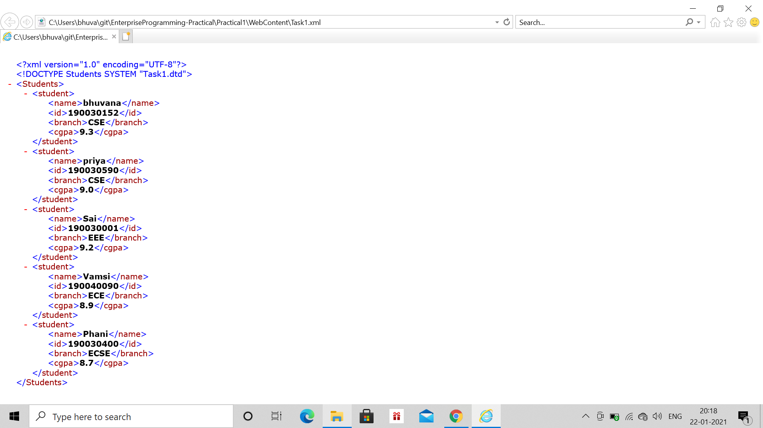

**XSLT Output:**

