# **JavaScript Reserved Words**

[❮ Previous](https://www.w3schools.com/js/js_performance.asp)[Next ❯](https://www.w3schools.com/js/js_versions.asp)

In JavaScript you cannot use these reserved words as variables, labels, or function names:

|  |  |  |  |
| --- | --- | --- | --- |
| abstract | arguments | await* | boolean |
| break | byte | case | catch |
| char | class* | const | continue |
| debugger | default | delete | do |
| double | else | enum* | eval |
| export* | extends* | false | final |
| finally | float | for | function |
| goto | if | implements | import* |
| in | instanceof | int | interface |
| let* | long | native | new |
| null | package | private | protected |
| public | return | short | static |
| super* | switch | synchronized | this |
| throw | throws | transient | true |
| try | typeof | var | void |
| volatile | while | with | yield |

Words marked with* are new in ECMAScript 5 and 6.

You can read more about the different JavaScript versions in the chapter [JS Versions](https://www.w3schools.com/js/js_versions.asp).

## Removed Reserved Words

The following reserved words have been removed from the ECMAScript 5/6 standard:

|  |  |  |  |
| --- | --- | --- | --- |
| abstract | boolean | byte | char |
| double | final | float | goto |
| int | long | native | short |
| synchronized | throws | transient | volatile |

Do not use these words as variables. ECMAScript 5/6 does not have full support in all browsers.

## JavaScript Objects, Properties, and Methods

You should also avoid using the name of JavaScript built-in objects, properties, and methods:

|  |  |  |  |
| --- | --- | --- | --- |
| Array | Date | eval | function |
| hasOwnProperty | Infinity | isFinite | isNaN |
| isPrototypeOf | length | Math | NaN |
| name | Number | Object | prototype |
| String | toString | undefined | valueOf |

## Java Reserved Words

JavaScript is often used together with Java. You should avoid using some Java objects and properties as JavaScript identifiers:

|  |  |  |  |
| --- | --- | --- | --- |
| getClass | java | JavaArray | javaClass |
| JavaObject | JavaPackage |  |  |

## Other Reserved Words

JavaScript can be used as the programming language in many applications.

You should also avoid using the name of HTML and Window objects and properties:

|  |  |  |  |
| --- | --- | --- | --- |
| alert | all | anchor | anchors |
| area | assign | blur | button |
| checkbox | clearInterval | clearTimeout | clientInformation |
| close | closed | confirm | constructor |
| crypto | decodeURI | decodeURIComponent | defaultStatus |
| document | element | elements | embed |
| embeds | encodeURI | encodeURIComponent | escape |
| event | fileUpload | focus | form |
| forms | frame | innerHeight | innerWidth |
| layer | layers | link | location |
| mimeTypes | navigate | navigator | frames |
| frameRate | hidden | history | image |
| images | offscreenBuffering | open | opener |
| option | outerHeight | outerWidth | packages |
| pageXOffset | pageYOffset | parent | parseFloat |
| parseInt | password | pkcs11 | plugin |
| prompt | propertyIsEnum | radio | reset |
| screenX | screenY | scroll | secure |
| select | self | setInterval | setTimeout |
| status | submit | taint | text |
| textarea | top | unescape | untaint |
| window |  |  |  |

## HTML Event Handlers

In addition you should avoid using the name of all HTML event handlers.

Examples:

|  |  |  |  |
| --- | --- | --- | --- |
| onblur | onclick | onerror | onfocus |
| onkeydown | onkeypress | onkeyup | onmouseover |
| onload | onmouseup | onmousedown | onsubmit |

JavaScript in <head> or <body>

You can place any number of scripts in an HTML document.

Scripts can be placed in the <body>, or in the <head> section of an HTML page, or in both.

JavaScript in <head>

In this example, a JavaScript function is placed in the <head> section of an HTML page.

The function is invoked (called) when a button is clicked:

Example

<!DOCTYPE html>  
<html>

<head>  
<script>  
function myFunction() {  
  document.getElementById("demo").innerHTML = "Paragraph changed.";  
}  
</script>  
</head>  
<body>

<h1>A Web Page</h1>  
<p id="demo">A Paragraph</p>  
<button type="button" onclick="myFunction()">Try it</button>

</body>  
</html>

[Try it Yourself »](https://www.w3schools.com/js/tryit.asp?filename=tryjs_whereto_head)

ADVERTISEMENT

JavaScript in <body>

In this example, a JavaScript function is placed in the <body> section of an HTML page.

The function is invoked (called) when a button is clicked:

Example

<!DOCTYPE html>  
<html>  
<body>  
  
<h1>A Web Page</h1>  
<p id="demo">A Paragraph</p>  
<button type="button" onclick="myFunction()">Try it</button>  
  
<script>  
function myFunction() {  
  document.getElementById("demo").innerHTML = "Paragraph changed.";  
}  
</script>  
  
</body>  
</html>

[Try it Yourself »](https://www.w3schools.com/js/tryit.asp?filename=tryjs_whereto_body)

Placing scripts at the bottom of the <body> element improves the display speed, because script interpretation slows down the display.

## JavaScript Display Possibilities

JavaScript can "display" data in different ways:

* Writing into an HTML element, using innerHTML.
* Writing into the HTML output using document.write().
* Writing into an alert box, using window.alert().
* Writing into the browser console, using console.log().

## Using innerHTML

To access an HTML element, JavaScript can use the document.getElementById(id) method.

The id attribute defines the HTML element. The innerHTML property defines the HTML content:

### Example

<!DOCTYPE html>  
<html>  
<body>  
  
<h1>My First Web Page</h1>  
<p>My First Paragraph</p>  
  
<p id="demo"></p>  
  
<script>  
document.getElementById("demo").innerHTML = 5 + 6;  
</script>  
  
</body>  
</html>

[Try it Yourself »](https://www.w3schools.com/js/tryit.asp?filename=tryjs_output_dom)

Changing the innerHTML property of an HTML element is a common way to display data in HTML.

## Using document.write()

For testing purposes, it is convenient to use document.write():

### Example

<!DOCTYPE html>  
<html>  
<body>  
  
<h1>My First Web Page</h1>  
<p>My first paragraph.</p>  
  
<script>  
document.write(5 + 6);  
</script>  
  
</body>  
</html>

[Try it Yourself »](https://www.w3schools.com/js/tryit.asp?filename=tryjs_output_write)

Using document.write() after an HTML document is loaded, will **delete all existing HTML**:

### Example

<!DOCTYPE html>  
<html>  
<body>  
  
<h1>My First Web Page</h1>  
<p>My first paragraph.</p>  
  
<button type="button" onclick="document.write(5 + 6)">Try it</button>  
  
</body>  
</html>

[Try it Yourself »](https://www.w3schools.com/js/tryit.asp?filename=tryjs_output_write_over)

The document.write() method should only be used for testing.

## Using window.alert()

You can use an alert box to display data:

### Example

<!DOCTYPE html>  
<html>  
<body>  
  
<h1>My First Web Page</h1>  
<p>My first paragraph.</p>  
  
<script>  
window.alert(5 + 6);  
</script>  
  
</body>  
</html>

[Try it Yourself »](https://www.w3schools.com/js/tryit.asp?filename=tryjs_output_alert)

You can skip the window keyword.

In JavaScript, the window object is the global scope object, that means that variables, properties, and methods by default belong to the window object. This also means that specifying the window keyword is optional:

### Example

<!DOCTYPE html>  
<html>  
<body>  
  
<h1>My First Web Page</h1>  
<p>My first paragraph.</p>  
  
<script>  
alert(5 + 6);  
</script>  
  
</body>  
</html>

[Try it Yourself »](https://www.w3schools.com/js/tryit.asp?filename=tryjs_output_alert2)

## Using console.log()

For debugging purposes, you can call the console.log() method in the browser to display data.

You will learn more about debugging in a later chapter.

### Example

<!DOCTYPE html>  
<html>  
<body>  
  
<script>  
console.log(5 + 6);  
</script>  
  
</body>  
</html>

[Try it Yourself »](https://www.w3schools.com/js/tryit.asp?filename=tryjs_output_console)

## JavaScript Print

JavaScript does not have any print object or print methods.

You cannot access output devices from JavaScript.

The only exception is that you can call the window.print() method in the browser to print the content of the current window.

### Example

<!DOCTYPE html>  
<html>  
<body>  
  
<button onclick="window.print()">Print this page</button>  
  
</body>  
</html>

[Try it Yourself »](https://www.w3schools.com/js/tryit.asp?filename=tryjs_output_print)

[❮ Previous](https://www.w3schools.com/js/js_whereto.asp)[Next ❯](https://www.w3schools.com/js/js_statements.asp)

# **JavaScript Variables**

## Using let and const (2015)

Before 2015, using the var keyword was the only way to declare a JavaScript variable.

The 2015 version of JavaScript (ES6 - ECMAScript 2015) allows the use of the const keyword to define a variable that cannot be reassigned, and the let keyword to define a variable with restricted scope.

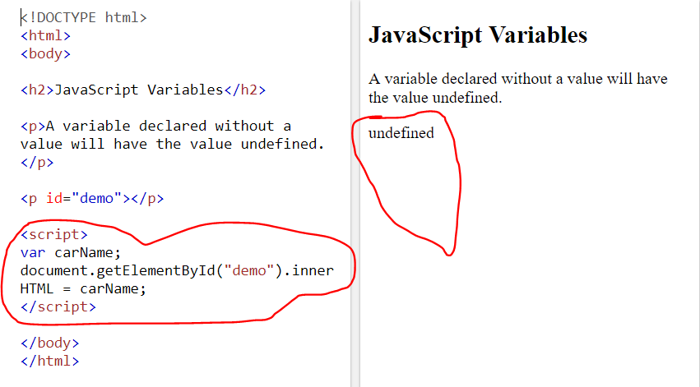

Re-Declaring JavaScript Variables

If you re-declare a JavaScript variable, it will not lose its value.

The variable carName will still have the value "Volvo" after the execution of these statements:

Example

var carName = "Volvo";  
var carName;

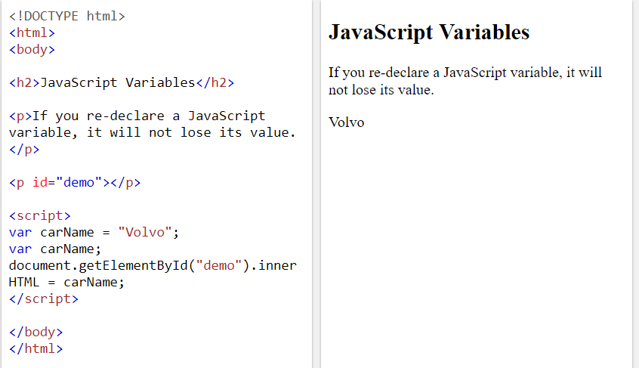

### Example

var x = "5" + 2 + 3;

[Try it Yourself »](https://www.w3schools.com/js/tryit.asp?filename=tryjs_variables_add_string_number)

If you put a number in quotes, the rest of the numbers will be treated as strings, and concatenated.

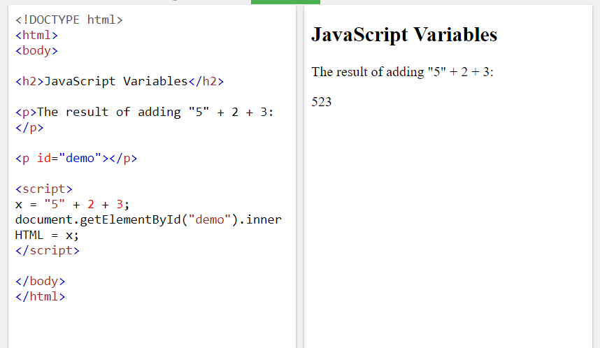

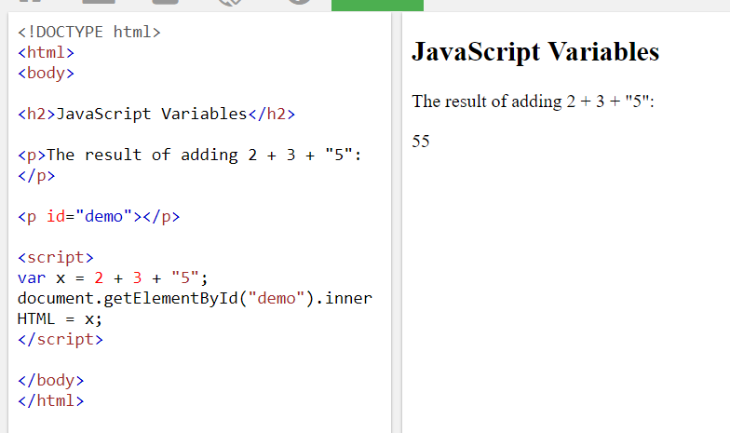

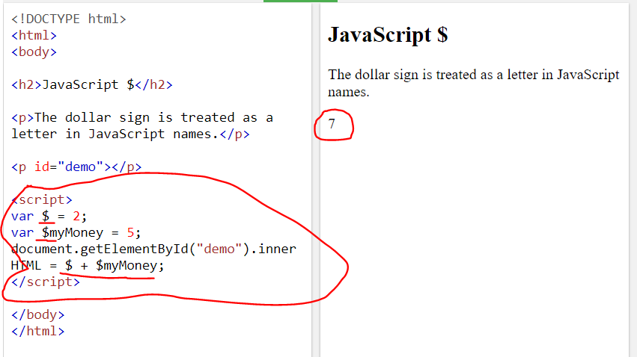

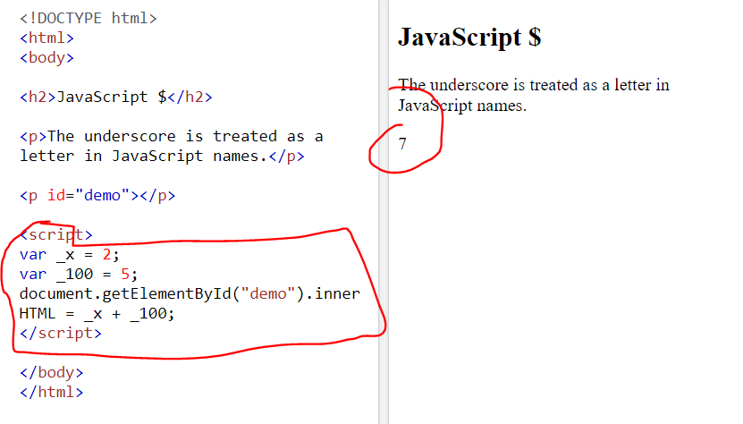

JavaScript Operator Precedence Values

Pale red entries indicates ECMAScript 2015 (ES6) or higher.

|  |  |  |  |
| --- | --- | --- | --- |
| **Value** | **Operator** | **Description** | **Example** |
| 20 | ( ) | Expression grouping | (3 + 4) |
|  |  |  |  |
| 19 | . | Member | person.name |
| 19 | [] | Member | person["name"] |
| 19 | () | Function call | myFunction() |
| 19 | new | Create | new Date() |
|  |  |  |  |
| 17 | ++ | Postfix Increment | i++ |
| 17 | -- | Postfix Decrement | i-- |
|  |  |  |  |
| 16 | ++ | Prefix Increment | ++i |
| 16 | -- | Prefix Decrement | --i |
| 16 | ! | Logical not | !(x==y) |
| 16 | typeof | Type | typeof x |
|  |  |  |  |
| 15 | ** | Exponentiation (ES2016) | 10 ** 2 |
|  |  |  |  |
| 14 | * | Multiplication | 10 * 5 |
| 14 | / | Division | 10 / 5 |
| 14 | % | Division Remainder | 10 % 5 |
|  |  |  |  |
| 13 | + | Addition | 10 + 5 |
| 13 | - | Subtraction | 10 - 5 |
|  |  |  |  |
| 12 | << | Shift left | x << 2 |
| 12 | >> | Shift right | x >> 2 |
| 12 | >>> | Shift right (unsigned) | x >>> 2 |
|  |  |  |  |
| 11 | < | Less than | x < y |
| 11 | <= | Less than or equal | x <= y |
| 11 | > | Greater than | x > y |
| 11 | >= | Greater than or equal | x >= y |
| 11 | in | Property in Object | "PI" in Math |
| 11 | instanceof | Instance of Object | instanceof Array |
|  |  |  |  |
| 10 | == | Equal | x == y |
| 10 | === | Strict equal | x === y |
| 10 | != | Unequal | x != y |
| 10 | !== | Strict unequal | x !== y |
|  |  |  |  |
| 9 | & | Bitwise AND | x & y |
| 8 | ^ | Bitwise XOR | x ^ y |
| 7 | | | Bitwise OR | x | y |
| 6 | && | Logical AND | x && y |
| 5 | || | Logical OR | x || y |
| 4 | ? : | Condition | ? "Yes" : "No" |
|  |  |  |  |
| 3 | += | Assignment | x += y |
| 3 | /= | Assignment | x /= y |
| 3 | -= | Assignment | x -= y |
| 3 | *= | Assignment | x *= y |
| 3 | %= | Assignment | x %= y |
| 3 | <<= | Assignment | x <<= y |
| 3 | >>= | Assignment | x >>= y |
| 3 | >>>= | Assignment | x >>>= y |
| 3 | &= | Assignment | x &= y |
| 3 | ^= | Assignment | x ^= y |
| 3 | |= | Assignment | x |= y |
|  |  |  |  |
| 2 | yield | Pause Function | yield x |
| 1 | , | Comma | 5 , 6 |

Expressions in parentheses are fully computed before the value is used in the rest of the expression.

JavaScript Assignment Operators

Assignment operators assign values to JavaScript variables.

|  |  |  |
| --- | --- | --- |
| **Operator** | **Example** | **Same As** |
| = | x = y | x = y |
| += | x += y | x = x + y |
| -= | x -= y | x = x - y |
| *= | x *= y | x = x * y |
| /= | x /= y | x = x / y |
| %= | x %= y | x = x % y |
| <<= | x <<= y | x = x << y |
| >>= | x >>= y | x = x >> y |
| >>>= | x >>>= y | x = x >>> y |
| &= | x &= y | x = x & y |
| ^= | x ^= y | x = x ^ y |
| |= | x |= y | x = x | y |
| **= | x **= y | x = x ** y |

The **= operator is an experimental part of the ECMAScript 2016 proposal (ES7). It is not stable across browsers. Do not use it.

JavaScript Data Types

JavaScript variables can hold many **data types**: numbers, strings, objects and more:

var length = 16;                               // Number  
var lastName = "Johnson";                      // String  
var x = {firstName:"John", lastName:"Doe"};    // Object

var x = 16 + "Volvo";

Does it make any sense to add "Volvo" to sixteen? Will it produce an error or will it produce a result?

JavaScript will treat the example above as:

var x = "16" + "Volvo";

When adding a number and a string, JavaScript will treat the number as a string.

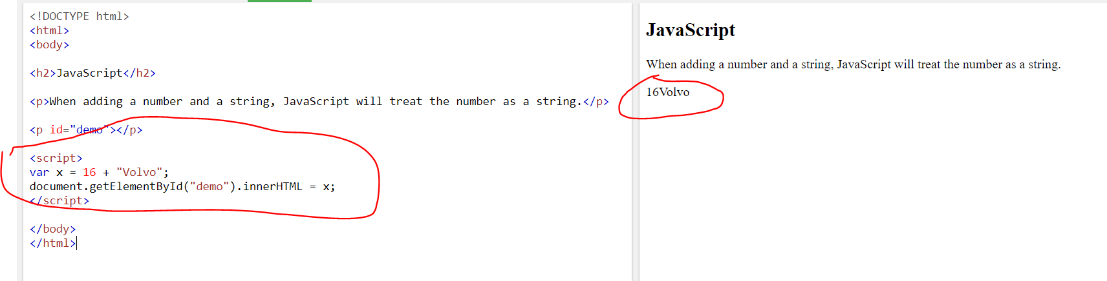

JavaScript:

var x = 16 + 4 + "Volvo";

Result:

20Volvo

JavaScript:

var x = "Volvo" + 16 + 4;

Result:

Volvo164

In the first example, JavaScript treats 16 and 4 as numbers, until it reaches "Volvo".

In the second example, since the first operand is a string, all operands are treated as strings.

JavaScript Types are Dynamic

JavaScript has dynamic types. This means that the same variable can be used to hold different data types:

Example

var x;           // Now x is undefined  
x = 5;           // Now x is a Number  
x = "John";      // Now x is a String

Extra large or extra small numbers can be written with scientific (exponential) notation:

Example

var y = 123e5;      // 12300000  
var z = 123e-5;     // 0.00123

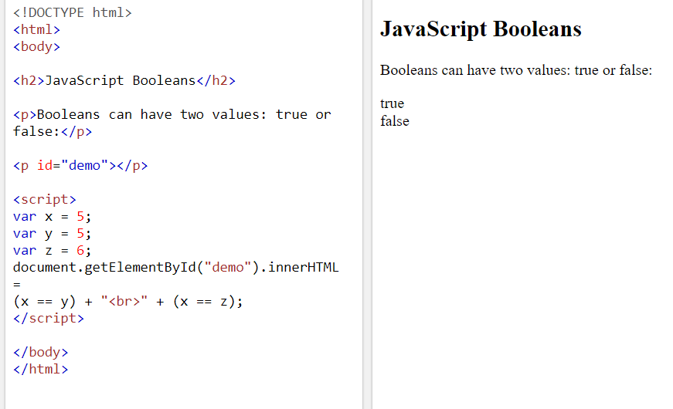

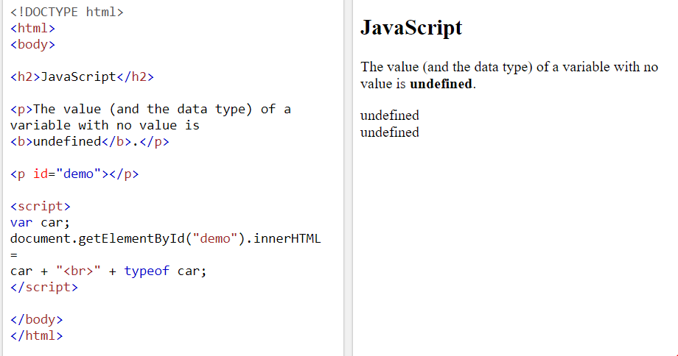

## Empty Values

An empty value has nothing to do with undefined.

An empty string has both a legal value and a type.

### Example

var car = "";    // The value is "", the typeof is "string"

[Try it Yourself »](https://www.w3schools.com/js/tryit.asp?filename=tryjs_datatypes_empty)

## Null

In JavaScript null is "nothing". It is supposed to be something that doesn't exist.

Unfortunately, in JavaScript, the data type of null is an object.

You can consider it a bug in JavaScript that typeof null is an object. It should be null.

You can empty an object by setting it to null:

### Example

var person = {firstName:"John", lastName:"Doe", age:50, eyeColor:"blue"};  
person = null;    // Now value is null, but type is still an object

[Try it Yourself »](https://www.w3schools.com/js/tryit.asp?filename=tryjs_datatypes_null)

You can also empty an object by setting it to undefined:

### Example

var person = {firstName:"John", lastName:"Doe", age:50, eyeColor:"blue"};  
person = undefined;   // Now both value and type is undefined

[Try it Yourself »](https://www.w3schools.com/js/tryit.asp?filename=tryjs_datatypes_undefined_1)

## What is === in JavaScript?

=== (Triple equals) is a strict equality comparison operator in JavaScript, which returns false for the values which are not of a similar type. This operator performs type casting for equality. If we compare 2 with "2" using ===, then it will return a false value.

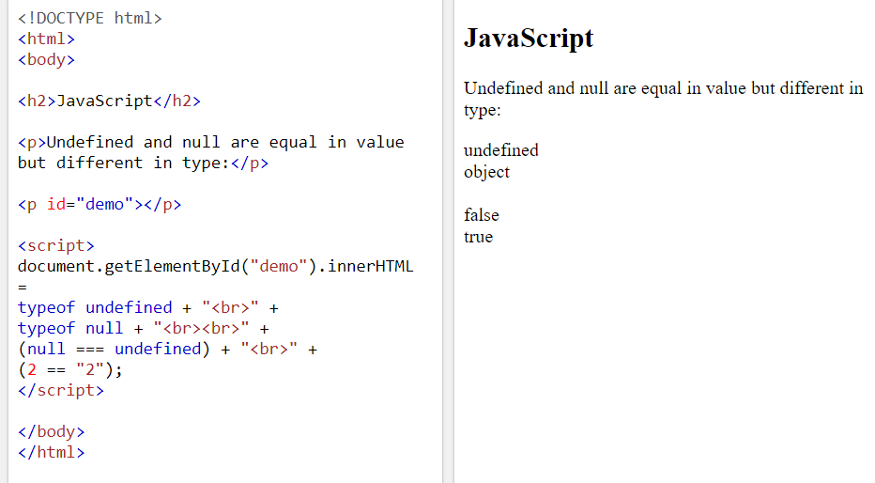

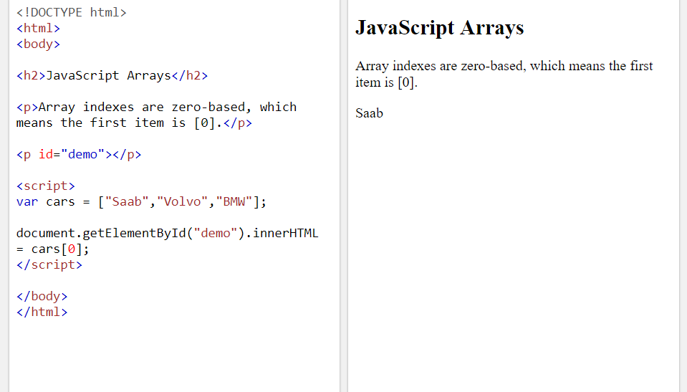

## JavaScript Arrays

JavaScript arrays are written with square brackets.

Array items are separated by commas.

The following code declares (creates) an array called cars, containing three items (car names):

### Example

var cars = ["Saab", "Volvo", "BMW"];

[Try it Yourself »](https://www.w3schools.com/js/tryit.asp?filename=tryjs_datatypes_array)

Array indexes are zero-based, which means the first item is [0], second is [1], and so on.

You will learn more about arrays later in this tutorial.

## JavaScript Objects

JavaScript objects are written with curly braces {}.

Object properties are written as name:value pairs, separated by commas.

### Example

var person = {firstName:"John", lastName:"Doe", age:50, eyeColor:"blue"};

The object (person) in the example above has 4 properties: firstName, lastName, age, and eyeColor.

You will learn more about objects later in this tutorial.

## The typeof Operator

You can use the JavaScript typeof operator to find the type of a JavaScript variable.

The typeof operator returns the type of a variable or an expression:

### Example

typeof ""             // Returns "string"  
typeof "John"         // Returns "string"  
typeof "John Doe"     // Returns "string"

[Try it Yourself »](https://www.w3schools.com/js/tryit.asp?filename=tryjs_datatypes_typeof_string)

### Example

typeof 0              // Returns "number"  
typeof 314            // Returns "number"  
typeof 3.14           // Returns "number"  
typeof (3)            // Returns "number"  
typeof (3 + 4)        // Returns "number"

[Try it Yourself »](https://www.w3schools.com/js/tryit.asp?filename=tryjs_datatypes_typeof_number)

## Undefined

In JavaScript, a variable without a value, has the value undefined. The type is also undefined.

### Example

var car;    // Value is undefined, type is undefined

[Try it Yourself »](https://www.w3schools.com/js/tryit.asp?filename=tryjs_datatypes_undefined)

Any variable can be emptied, by setting the value to undefined. The type will also be undefined.

### Example

car = undefined;    // Value is undefined, type is undefined

[Try it Yourself »](https://www.w3schools.com/js/tryit.asp?filename=tryjs_datatypes_undefined_2)

## Empty Values

An empty value has nothing to do with undefined.

An empty string has both a legal value and a type.

### Example

var car = "";    // The value is "", the typeof is "string"

[Try it Yourself »](https://www.w3schools.com/js/tryit.asp?filename=tryjs_datatypes_empty)

## Null

In JavaScript null is "nothing". It is supposed to be something that doesn't exist.

Unfortunately, in JavaScript, the data type of null is an object.

You can consider it a bug in JavaScript that typeof null is an object. It should be null.

You can empty an object by setting it to null:

### Example

var person = {firstName:"John", lastName:"Doe", age:50, eyeColor:"blue"};  
person = null;    // Now value is null, but type is still an object

[Try it Yourself »](https://www.w3schools.com/js/tryit.asp?filename=tryjs_datatypes_null)

You can also empty an object by setting it to undefined:

### Example

var person = {firstName:"John", lastName:"Doe", age:50, eyeColor:"blue"};  
person = undefined;   // Now both value and type is undefined

[Try it Yourself »](https://www.w3schools.com/js/tryit.asp?filename=tryjs_datatypes_undefined_1)

## Difference Between Undefined and Null

undefined and null are equal in value but different in type:

typeof undefined           // undefined  
typeof null                // object  
  
null === undefined         // false  
null == undefined          // true

[Try it Yourself »](https://www.w3schools.com/js/tryit.asp?filename=tryjs_datatypes_undefined_3)

## Primitive Data

A primitive data value is a single simple data value with no additional properties and methods.

The typeof operator can return one of these primitive types:

* string
* number
* boolean
* undefined

### Example

typeof "John"              // Returns "string"  
typeof 3.14                // Returns "number"  
typeof true                // Returns "boolean"  
typeof false               // Returns "boolean"  
typeof x                   // Returns "undefined" (if x has no value)

[Try it Yourself »](https://www.w3schools.com/js/tryit.asp?filename=tryjs_datatypes_typeof_primitive)

## Complex Data

The typeof operator can return one of two complex types:

* function
* object

The typeof operator returns "object" for objects, arrays, and null.

The typeof operator does not return "object" for functions.

### Example

typeof {name:'John', age:34} // Returns "object"  
typeof [1,2,3,4]             // Returns "object" (not "array", see note below)  
typeof null                  // Returns "object"  
typeof function myFunc(){}   // Returns "function"

[Try it Yourself »](https://www.w3schools.com/js/tryit.asp?filename=tryjs_datatypes_typeof_complex)

The typeof operator returns "object" for arrays because in JavaScript arrays are objects.

## JavaScript Function Syntax

function name(parameter1, parameter2, parameter3) {  
  // code to be executed  
}

A Function is much the same as a Procedure or a Subroutine, in other programming languages.

Calculate the product of two numbers, and return the result:

var x = myFunction(4, 3);   // Function is called, return value will end up in x  
  
function myFunction(a, b) {  
  return a * b;             // Function returns the product of a and b  
}

The result in x will be:

12

[Try it Yourself »](https://www.w3schools.com/js/tryit.asp?filename=tryjs_function_return)

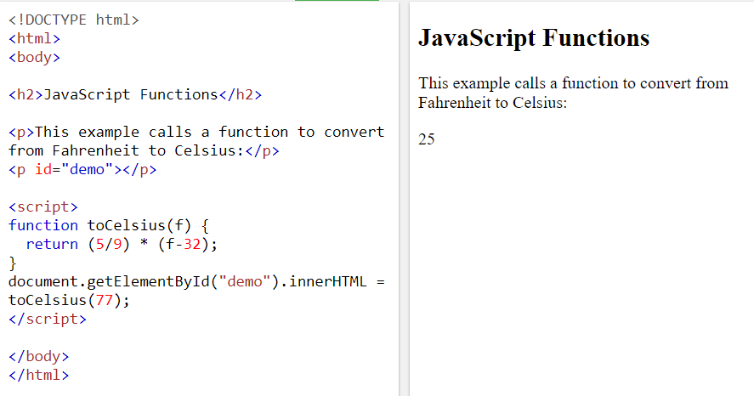

## Local Variables

Variables declared within a JavaScript function, become **LOCAL** to the function.

Local variables can only be accessed from within the function.

### Example

// code here can NOT use carName  
  
function myFunction() {  
  var carName = "Volvo";  
  // code here CAN use carName  
}  
  
// code here can NOT use carName

[Try it Yourself »](https://www.w3schools.com/js/tryit.asp?filename=tryjs_function_scope)

Since local variables are only recognized inside their functions, variables with the same name can be used in different functions.

Local variables are created when a function starts, and deleted when the function is completed.

# **JavaScript Objects**

[❮ Previous](https://www.w3schools.com/js/js_functions.asp)[Next ❯](https://www.w3schools.com/js/js_events.asp)

## Real Life Objects, Properties, and Methods

In real life, a car is an **object**.

A car has **properties** like weight and color, and **methods** like start and stop:

|  |  |  |
| --- | --- | --- |
| **Object** | **Properties** | **Methods** |
| https://www.w3schools.com/js/objectExplained.gif | car.name = Fiat  car.model = 500  car.weight = 850kg  car.color = white | car.start()  car.drive()  car.brake()  car.stop() |

All cars have the same **properties**, but the property **values** differ from car to car.

All cars have the same **methods**, but the methods are performed **at different times**.

## JavaScript Objects

You have already learned that JavaScript variables are containers for data values.

This code assigns a **simple value** (Fiat) to a **variable** named car:

var car = "Fiat";

[Try it Yourself »](https://www.w3schools.com/js/tryit.asp?filename=tryjs_objects_variable)

Objects are variables too. But objects can contain many values.

This code assigns **many values** (Fiat, 500, white) to a **variable** named car:

var car = {type:"Fiat", model:"500", color:"white"};

[Try it Yourself »](https://www.w3schools.com/js/tryit.asp?filename=tryjs_objects_object)

The values are written as **name:value** pairs (name and value separated by a colon).

JavaScript objects are containers for **named values**called properties or methods.

## Object Definition

You define (and create) a JavaScript object with an object literal:

### Example

var person = {firstName:"John", lastName:"Doe", age:50, eyeColor:"blue"};

[Try it Yourself »](https://www.w3schools.com/js/tryit.asp?filename=tryjs_objects_create_1)

Spaces and line breaks are not important. An object definition can span multiple lines:

### Example

var person = {  
  firstName: "John",  
  lastName: "Doe",  
  age: 50,  
  eyeColor: "blue"  
};

[Try it Yourself »](https://www.w3schools.com/js/tryit.asp?filename=tryjs_objects_create_2)

## Object Properties

The **name:values** pairs in JavaScript objects are called **properties**:

|  |  |
| --- | --- |
| **Property** | **Property Value** |
| firstName | John |
| lastName | Doe |
| age | 50 |
| eyeColor | blue |

## Accessing Object Properties

You can access object properties in two ways:

*objectName.propertyName*

or

*objectName["propertyName"]*

### Example1

person.lastName;

[Try it Yourself »](https://www.w3schools.com/js/tryit.asp?filename=tryjs_objects_properties_1)

### Example2

person["lastName"];

[Try it Yourself »](https://www.w3schools.com/js/tryit.asp?filename=tryjs_objects_properties_2)

## Object Methods

Objects can also have **methods**.

Methods are **actions** that can be performed on objects.

Methods are stored in properties as **function definitions**.

|  |  |
| --- | --- |
| **Property** | **Property Value** |
| firstName | John |
| lastName | Doe |
| age | 50 |
| eyeColor | blue |
| fullName | function() {return this.firstName + " " + this.lastName;} |

A method is a function stored as a property.

### Example

var person = {  
  firstName: "John",  
  lastName : "Doe",  
  id       : 5566,  
  fullName : function() {  
    return this.firstName + " " + this.lastName;  
  }  
};

## The ****this**** Keyword

In a function definition, this refers to the "owner" of the function.

In the example above, this is the **person object** that "owns" the fullName function.

In other words, this.firstName means the firstName property of **this object**.

Read more about the this keyword at [JS this Keyword](https://www.w3schools.com/js/js_this.asp).

## Accessing Object Methods

You access an object method with the following syntax:

*objectName.methodName()*

### Example

name = person.fullName();

[Try it Yourself »](https://www.w3schools.com/js/tryit.asp?filename=tryjs_objects_method)

If you access a method **without** the () parentheses, it will return the **function definition**:

### Example

name = person.fullName;

[Try it Yourself »](https://www.w3schools.com/js/tryit.asp?filename=tryjs_objects_function)

## Do Not Declare Strings, Numbers, and Booleans as Objects!

When a JavaScript variable is declared with the keyword "new", the variable is created as an object:

var x = new String();        // Declares x as a String object  
var y = new Number();        // Declares y as a Number object  
var z = new Boolean();       // Declares z as a Boolean object

Avoid String, Number, and Boolean objects. They complicate your code and slow down execution speed.

You will learn more about objects later in this tutorial.

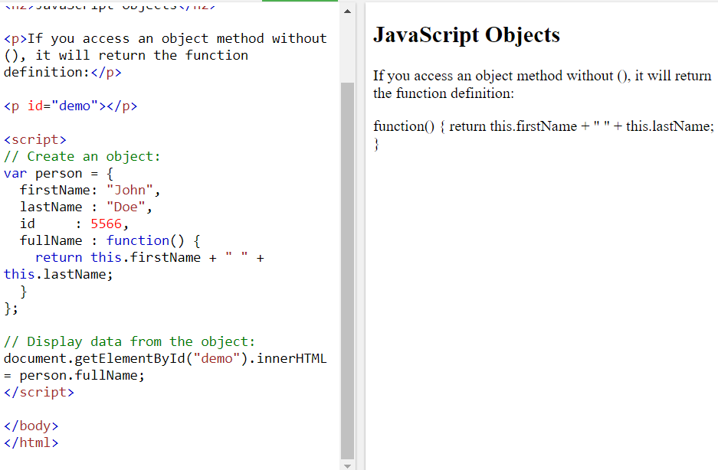

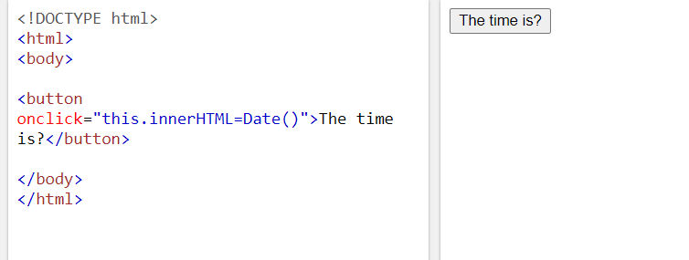

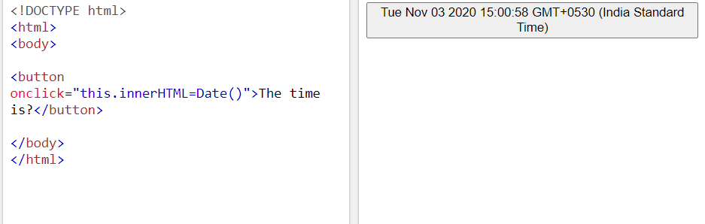

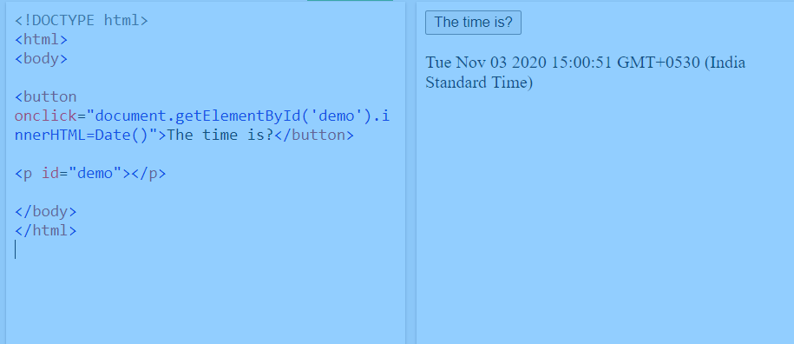

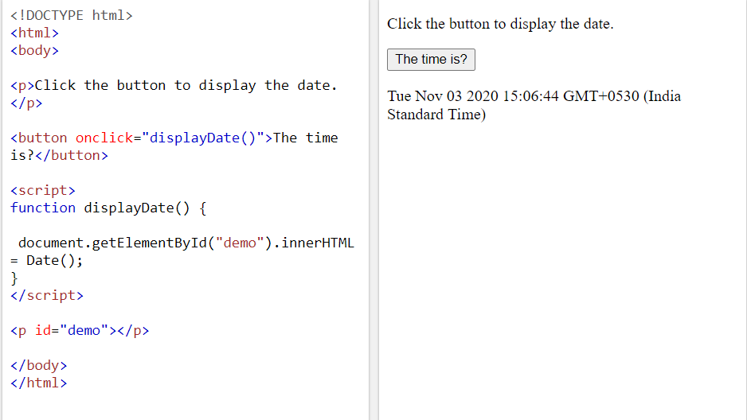

# **JavaScript Events**

[❮ Previous](https://www.w3schools.com/js/js_objects.asp)[Next ❯](https://www.w3schools.com/js/js_strings.asp)

HTML events are **"things"** that happen to HTML elements.

When JavaScript is used in HTML pages, JavaScript can **"react"** on these events.

## HTML Events

An HTML event can be something the browser does, or something a user does.

Here are some examples of HTML events:

* An HTML web page has finished loading
* An HTML input field was changed
* An HTML button was clicked

Often, when events happen, you may want to do something.

JavaScript lets you execute code when events are detected.

HTML allows event handler attributes, **with JavaScript code**, to be added to HTML elements.

With single quotes:

<element event=**'*some JavaScript*'**>

With double quotes:

<element event=**"*some JavaScript*"**>

In the following example, an onclick attribute (with code), is added to a <button> element:

### Example

<button onclick="document.getElementById('demo').innerHTML = Date()">The time is?</button>

[Try it Yourself »](https://www.w3schools.com/js/tryit.asp?filename=tryjs_event_onclick1)

In the example above, the JavaScript code changes the content of the element with id="demo".

In the next example, the code changes the content of its own element (using **this**.innerHTML):

### Example

<button onclick="this.innerHTML = Date()">The time is?</button>

[Try it Yourself »](https://www.w3schools.com/js/tryit.asp?filename=tryjs_event_onclick)

JavaScript code is often several lines long. It is more common to see event attributes calling functions:

### Example

<button onclick="displayDate()">The time is?</button>

[Try it Yourself »](https://www.w3schools.com/js/tryit.asp?filename=tryjs_events1)

## Common HTML Events

Here is a list of some common HTML events:

|  |  |
| --- | --- |
| **Event** | **Description** |
| onchange | An HTML element has been changed |
| onclick | The user clicks an HTML element |
| onmouseover | The user moves the mouse over an HTML element |
| onmouseout | The user moves the mouse away from an HTML element |
| onkeydown | The user pushes a keyboard key |
| onload | The browser has finished loading the page |

The list is much longer: [W3Schools JavaScript Reference HTML DOM Events](https://www.w3schools.com/jsref/dom_obj_event.asp).

## What can JavaScript Do?

Event handlers can be used to handle, and verify, user input, user actions, and browser actions:

* Things that should be done every time a page loads
* Things that should be done when the page is closed
* Action that should be performed when a user clicks a button
* Content that should be verified when a user inputs data
* And more ...

Many different methods can be used to let JavaScript work with events:

* HTML event attributes can execute JavaScript code directly
* HTML event attributes can call JavaScript functions
* You can assign your own event handler functions to HTML elements
* You can prevent events from being sent or being handled
* And more ...

You will learn a lot more about events and event handlers in the HTML DOM chapters.

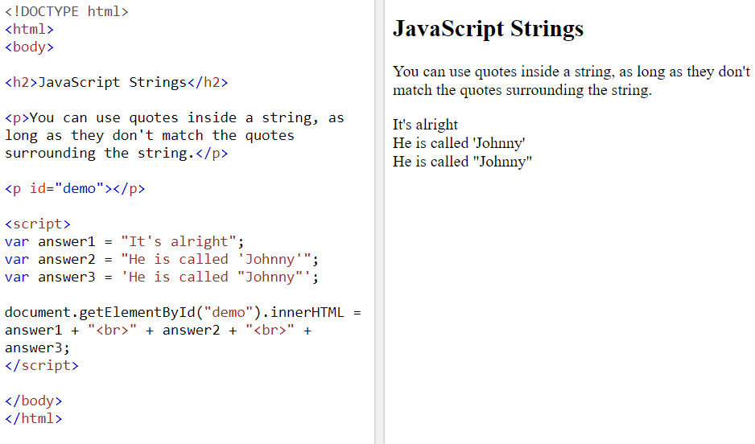

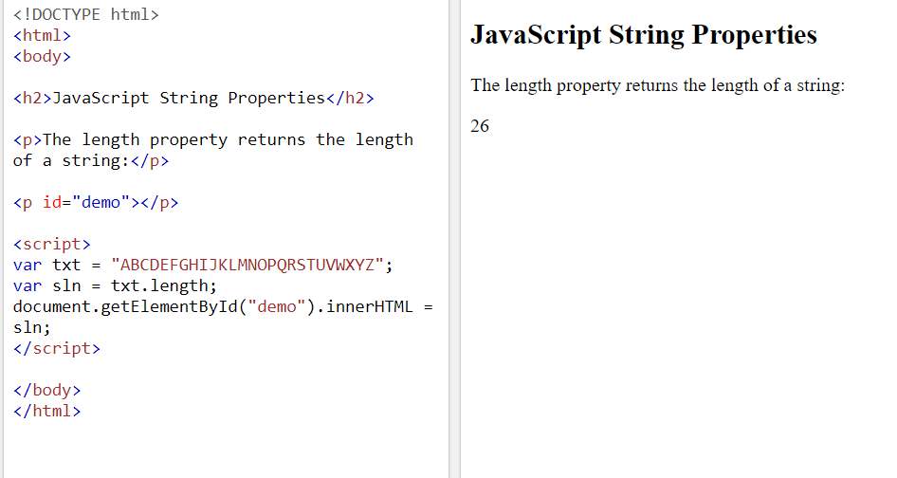

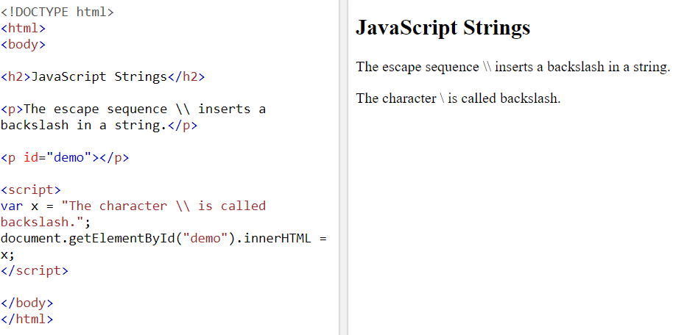

# **JavaScript Strings**

[❮ Previous](https://www.w3schools.com/js/js_events.asp)[Next ❯](https://www.w3schools.com/js/js_string_methods.asp)

JavaScript strings are used for storing and manipulating text.

## JavaScript Strings

A JavaScript string is zero or more characters written inside quotes.

### Example

var x = "John Doe";

[Try it Yourself »](https://www.w3schools.com/js/tryit.asp?filename=tryjs_string)

You can use single or double quotes:

### Example

var carName1 = "Volvo XC60";  // Double quotes  
var carName2 = 'Volvo XC60';  // Single quotes

[Try it Yourself »](https://www.w3schools.com/js/tryit.asp?filename=tryjs_string_quotes)

You can use quotes inside a string, as long as they don't match the quotes surrounding the string:

### Example

var answer1 = "It's alright";  
var answer2 = "He is called 'Johnny'";  
var answer3 = 'He is called "Johnny"';

[Try it Yourself »](https://www.w3schools.com/js/tryit.asp?filename=tryjs_string_quotes_mixed)

## String Length

To find the length of a string, use the built-in length property:

### Example

var txt = "ABCDEFGHIJKLMNOPQRSTUVWXYZ";  
var sln = txt.length;

[Try it Yourself »](https://www.w3schools.com/js/tryit.asp?filename=tryjs_string_length)

## Escape Character

Because strings must be written within quotes, JavaScript will misunderstand this string:

var x = "We are the so-called "Vikings" from the north.";

The string will be chopped to "We are the so-called ".

The solution to avoid this problem, is to use the **backslash escape character**.

The backslash (\) escape character turns special characters into string characters:

|  |  |  |
| --- | --- | --- |
| **Code** | **Result** | **Description** |
| \' | ' | Single quote |
| \" | " | Double quote |
| \\ | \ | Backslash |

The sequence \"  inserts a double quote in a string:

### Example

var x = "We are the so-called \"Vikings\" from the north.";

[Try it Yourself »](https://www.w3schools.com/js/tryit.asp?filename=tryjs_string_escape_quotes2)

The sequence \'  inserts a single quote in a string:

### Example

var x = 'It\'s alright.';

[Try it Yourself »](https://www.w3schools.com/js/tryit.asp?filename=tryjs_string_escape_quotes1)

The sequence \\  inserts a backslash in a string:

### Example

var x = "The character \\ is called backslash.";

[Try it Yourself »](https://www.w3schools.com/js/tryit.asp?filename=tryjs_string_escape_backslash)

Six other escape sequences are valid in JavaScript:

|  |  |
| --- | --- |
| **Code** | **Result** |
| \b | Backspace |
| \f | Form Feed |
| \n | New Line |
| \r | Carriage Return |
| \t | Horizontal Tabulator |
| \v | Vertical Tabulator |

The 6 escape characters above were originally designed to control typewriters, teletypes, and fax machines. They do not make any sense in HTML.

## Breaking Long Code Lines

For best readability, programmers often like to avoid code lines longer than 80 characters.

If a JavaScript statement does not fit on one line, the best place to break it is after an operator:

### Example

document.getElementById("demo").innerHTML =  
"Hello Dolly!";

[Try it Yourself »](https://www.w3schools.com/js/tryit.asp?filename=tryjs_statements_linebreak)

You can also break up a code line **within a text string** with a single backslash:

### Example

document.getElementById("demo").innerHTML = "Hello \  
Dolly!";

[Try it Yourself »](https://www.w3schools.com/js/tryit.asp?filename=tryjs_string_break)

The \ method is not the preferred method. It might not have universal support.  
Some browsers do not allow spaces behind the \ character.

A safer way to break up a string, is to use string addition:

### Example

document.getElementById("demo").innerHTML = "Hello " +  
"Dolly!";

[Try it Yourself »](https://www.w3schools.com/js/tryit.asp?filename=tryjs_string_break_ok)

You cannot break up a code line with a backslash:

### Example

document.getElementById("demo").innerHTML = \  
"Hello Dolly!";

[Try it Yourself »](https://www.w3schools.com/js/tryit.asp?filename=tryjs_strings_codebreak)

## 

## Strings Can be Objects

Normally, JavaScript strings are primitive values, created from literals:

var firstName = "John";

But strings can also be defined as objects with the keyword new:

var firstName = new String("John");

### Example

var x = "John";  
var y = new String("John");  
  
// typeof x will return string  
// typeof y will return object

[Try it Yourself »](https://www.w3schools.com/js/tryit.asp?filename=tryjs_string_object)

Don't create strings as objects. It slows down execution speed.  
The new keyword complicates the code. This can produce some unexpected results:

When using the == operator, equal strings are equal:

### Example

var x = "John";               
var y = new String("John");  
  
// (x == y) is true because x and y have equal values

[Try it Yourself »](https://www.w3schools.com/js/tryit.asp?filename=tryjs_string_object1)

When using the === operator, equal strings are not equal, because the === operator expects equality in both type and value.

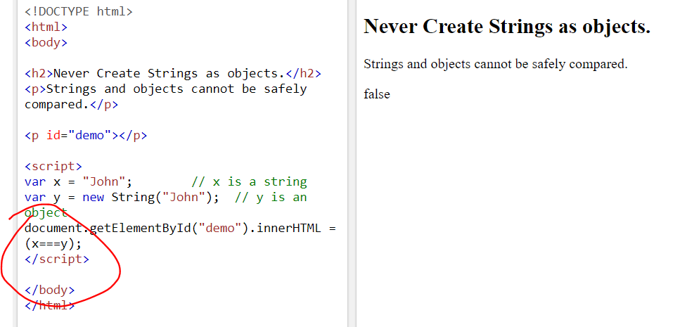

### Example

var x = "John";               
var y = new String("John");  
  
// (x === y) is false because x and y have different types (string and object)

[Try it Yourself »](https://www.w3schools.com/js/tryit.asp?filename=tryjs_string_object2)

Or even worse. Objects cannot be compared:

### Example

var x = new String("John");               
var y = new String("John");  
  
// (x == y) is false because x and y are different objects  
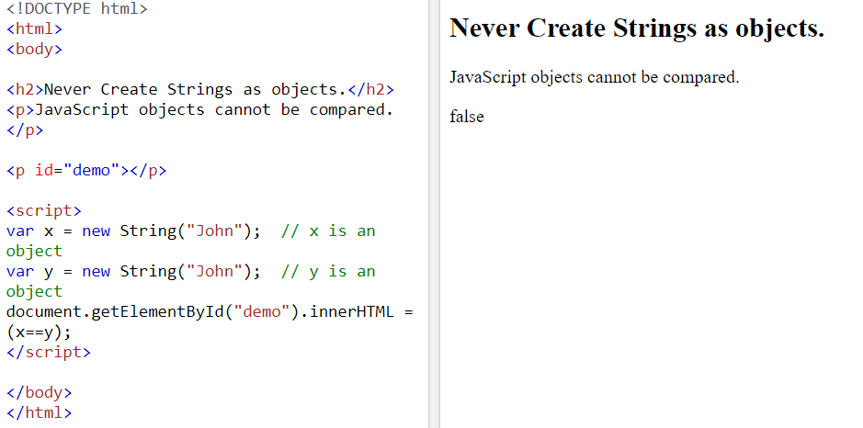

[Try it Yourself »](https://www.w3schools.com/js/tryit.asp?filename=tryjs_string_object3)

### Example

var x = new String("John");               
var y = new String("John");  
  
// (x === y) is false because x and y are different objects

[Try it Yourself »](https://www.w3schools.com/js/tryit.asp?filename=tryjs_string_object4)

Note the difference between (x==y) and (x===y).  
Comparing two JavaScript objects will **always** return false.

String methods help you to work with strings.

## String Methods and Properties

Primitive values, like "John Doe", cannot have properties or methods (because they are not objects).

But with JavaScript, methods and properties are also available to primitive values, because JavaScript treats primitive values as objects when executing methods and properties.

## String Length

The length property returns the length of a string:

### Example

var txt = "ABCDEFGHIJKLMNOPQRSTUVWXYZ";  
var sln = txt.length;

[Try it Yourself »](https://www.w3schools.com/js/tryit.asp?filename=tryjs_string_length)

## Finding a String in a String

The indexOf() method returns the index of (the position of) the first occurrence of a specified text in a string:

### Example

var str = "Please locate where 'locate' occurs!";  
var pos = str.indexOf("locate");

[Try it Yourself »](https://www.w3schools.com/js/tryit.asp?filename=tryjs_string_indexof)

JavaScript counts positions from zero.  
0 is the first position in a string, 1 is the second, 2 is the third ...

The lastIndexOf() method returns the index of the **last** occurrence of a specified text in a string:

### Example

var str = "Please locate where 'locate' occurs!";  
var pos = str.lastIndexOf("locate");

[Try it Yourself »](https://www.w3schools.com/js/tryit.asp?filename=tryjs_string_lastindexof)

Both indexOf(), and lastIndexOf() return -1 if the text is not found.

### Example

var str = "Please locate where 'locate' occurs!";  
var pos = str.lastIndexOf("John");

[Try it Yourself »](https://www.w3schools.com/js/tryit.asp?filename=tryjs_string_indexof_1)

Both methods accept a second parameter as the starting position for the search:

### Example

var str = "Please locate where 'locate' occurs!";  
var pos = str.indexOf("locate", 15);

[Try it Yourself »](https://www.w3schools.com/js/tryit.asp?filename=tryjs_string_indexof_2)

The lastIndexOf() methods searches backwards (from the end to the beginning), meaning: if the second parameter is 15, the search starts at position 15, and searches to the beginning of the string.

### Example

var str = "Please locate where 'locate' occurs!";  
var pos = str.lastIndexOf("locate", 15);

[Try it Yourself »](https://www.w3schools.com/js/tryit.asp?filename=tryjs_string_lastindexof_2)

## Searching for a String in a String

The search() method searches a string for a specified value and returns the position of the match:

### Example

var str = "Please locate where 'locate' occurs!";  
var pos = str.search("locate");

[Try it Yourself »](https://www.w3schools.com/js/tryit.asp?filename=tryjs_string_search_locate)

## Did You Notice?

The two methods, indexOf() and search(), are **equal?**

They accept the same arguments (parameters), and return the same value?

The two methods are **NOT** equal. These are the differences:

* The search() method cannot take a second start position argument.
* The indexOf() method cannot take powerful search values (regular expressions).

You will learn more about regular expressions in a later chapter.

## Extracting String Parts

There are 3 methods for extracting a part of a string:

* slice(start, end)
* substring(start, end)
* substr(start, length)

## The slice() Method

slice() extracts a part of a string and returns the extracted part in a new string.

The method takes 2 parameters: the start position, and the end position (end not included).

This example slices out a portion of a string from position 7 to position 12 (13-1):

### Example

var str = "Apple, Banana, Kiwi";  
var res = str.slice(7, 13);

The result of res will be:

Banana

[Try it Yourself »](https://www.w3schools.com/js/tryit.asp?filename=tryjs_string_slice)

Remember: JavaScript counts positions from zero. First position is 0.

If a parameter is negative, the position is counted from the end of the string.

This example slices out a portion of a string from position -12 to position -6:

### Example

var str = "Apple, Banana, Kiwi";  
var res = str.slice(-12, -6);

The result of res will be:

Banana

[Try it Yourself »](https://www.w3schools.com/js/tryit.asp?filename=tryjs_string_slice_negative)

If you omit the second parameter, the method will slice out the rest of the string:

### Example

var res = str.slice(7);

[Try it Yourself »](https://www.w3schools.com/js/tryit.asp?filename=tryjs_string_slice_rest)

or, counting from the end:

### Example

var res = str.slice(-12);

[Try it Yourself »](https://www.w3schools.com/js/tryit.asp?filename=tryjs_string_slice_rest_negative)

Negative positions do not work in Internet Explorer 8 and earlier.

## The substring() Method

substring() is similar to slice().

The difference is that substring() cannot accept negative indexes.

### Example

var str = "Apple, Banana, Kiwi";  
var res = str.substring(7, 13);

The result of res will be:

Banana

[Try it Yourself »](https://www.w3schools.com/js/tryit.asp?filename=tryjs_string_substring)

If you omit the second parameter, substring() will slice out the rest of the string.

## The substr() Method

substr() is similar to slice().

The difference is that the second parameter specifies the **length** of the extracted part.

### Example

var str = "Apple, Banana, Kiwi";  
var res = str.substr(7, 6);

The result of res will be:

Banana

[Try it Yourself »](https://www.w3schools.com/js/tryit.asp?filename=tryjs_string_substr)

If you omit the second parameter, substr() will slice out the rest of the string.

### Example

var str = "Apple, Banana, Kiwi";  
var res = str.substr(7);

The result of res will be:

Banana, Kiwi

[Try it Yourself »](https://www.w3schools.com/js/tryit.asp?filename=tryjs_string_substr1)

If the first parameter is negative, the position counts from the end of the string.

### Example

var str = "Apple, Banana, Kiwi";  
var res = str.substr(-4);

The result of res will be:

Kiwi

[Try it Yourself »](https://www.w3schools.com/js/tryit.asp?filename=tryjs_string_substr2)

## Replacing String Content

The replace() method replaces a specified value with another value in a string:

### Example

str = "Please visit Microsoft!";  
var n = str.replace("Microsoft", "W3Schools");

[Try it Yourself »](https://www.w3schools.com/js/tryit.asp?filename=tryjs_string_replace)

The replace() method does not change the string it is called on. It returns a new string.

By default, the replace() method replaces **only the first** match:

### Example

str = "Please visit Microsoft and Microsoft!";  
var n = str.replace("Microsoft", "W3Schools");

[Try it Yourself »](https://www.w3schools.com/js/tryit.asp?filename=tryjs_string_replace_first)

By default, the replace() method is case sensitive. Writing MICROSOFT (with upper-case) will not work:

### Example

str = "Please visit Microsoft!";  
var n = str.replace("MICROSOFT", "W3Schools");

[Try it Yourself »](https://www.w3schools.com/js/tryit.asp?filename=tryjs_string_replace_case)

To replace case insensitive, use a **regular expression** with an /i flag (insensitive):

### Example

str = "Please visit Microsoft!";  
var n = str.replace(/MICROSOFT/i, "W3Schools");

[Try it Yourself »](https://www.w3schools.com/js/tryit.asp?filename=tryjs_string_replace_insensitive)

Note that regular expressions are written without quotes.

To replace all matches, use a **regular expression** with a /g flag (global match):

### Example

str = "Please visit Microsoft and Microsoft!";  
var n = str.replace(/Microsoft/g, "W3Schools");

[Try it Yourself »](https://www.w3schools.com/js/tryit.asp?filename=tryjs_string_replace_global)

You will learn a lot more about regular expressions in the chapter [JavaScript Regular Expressions](https://www.w3schools.com/js/js_regexp.asp).

## Converting to Upper and Lower Case

A string is converted to upper case with toUpperCase():

### Example

var text1 = "Hello World!";       // String  
var text2 = text1.toUpperCase();  // text2 is text1 converted to upper

[Try it Yourself »](https://www.w3schools.com/js/tryit.asp?filename=tryjs_string_toupper)

A string is converted to lower case with toLowerCase():

### Example

var text1 = "Hello World!";       // String  
var text2 = text1.toLowerCase();  // text2 is text1 converted to lower

[Try it Yourself »](https://www.w3schools.com/js/tryit.asp?filename=tryjs_string_tolower)

## The concat() Method

concat() joins two or more strings:

### Example

var text1 = "Hello";  
var text2 = "World";  
var text3 = text1.concat(" ", text2);

[Try it Yourself »](https://www.w3schools.com/js/tryit.asp?filename=tryjs_string_concat)

The concat() method can be used instead of the plus operator. These two lines do the same:

### Example

var text = "Hello" + " " + "World!";  
var text = "Hello".concat(" ", "World!");

All string methods return a new string. They don't modify the original string.  
Formally said: Strings are immutable: Strings cannot be changed, only replaced.

## String.trim()

The trim() method removes whitespace from both sides of a string:

### Example

var str = "       Hello World!        ";  
alert(str.trim());

[Try it Yourself »](https://www.w3schools.com/js/tryit.asp?filename=tryjs_string_trim)

The trim() method is not supported in Internet Explorer 8 or lower.

If you need to support IE 8, you can use replace() with a regular expression instead:

### Example

var str = "       Hello World!        ";  
alert(str.replace(/^[\s\uFEFF\xA0]+|[\s\uFEFF\xA0]+$/g, ''));

[Try it Yourself »](https://www.w3schools.com/js/tryit.asp?filename=tryjs_string_trim_regexp)

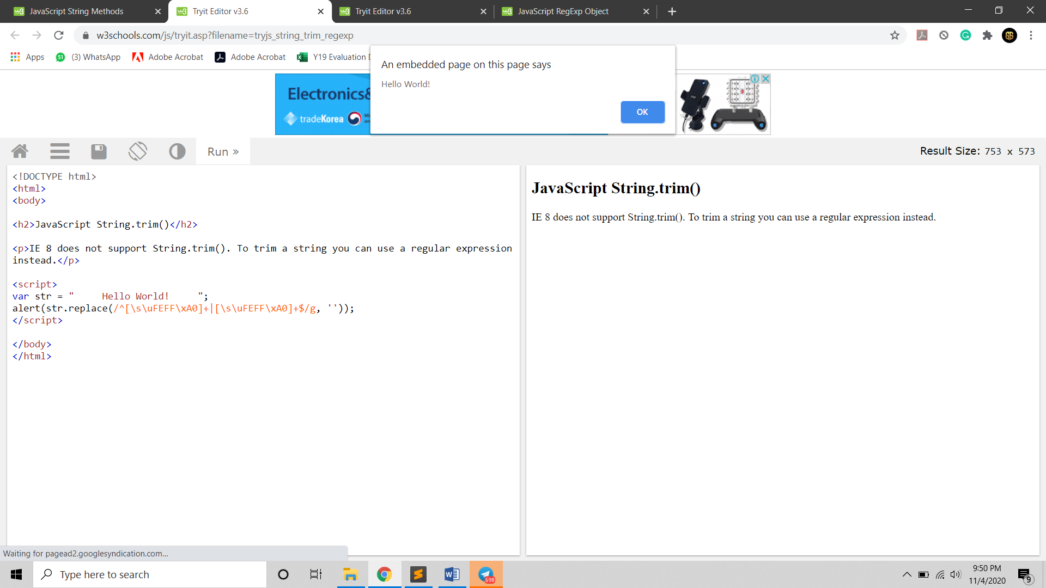

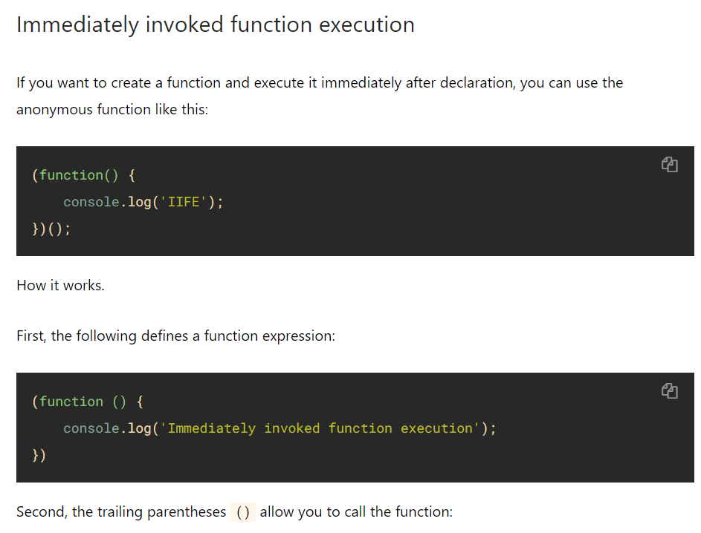

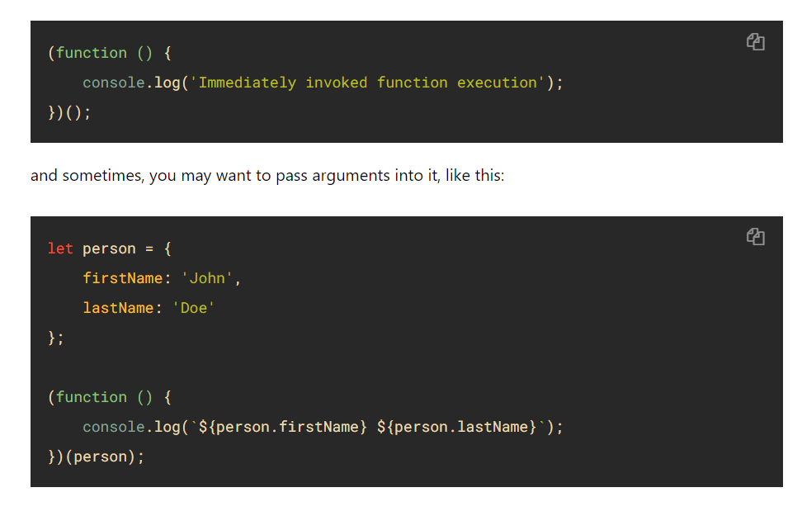

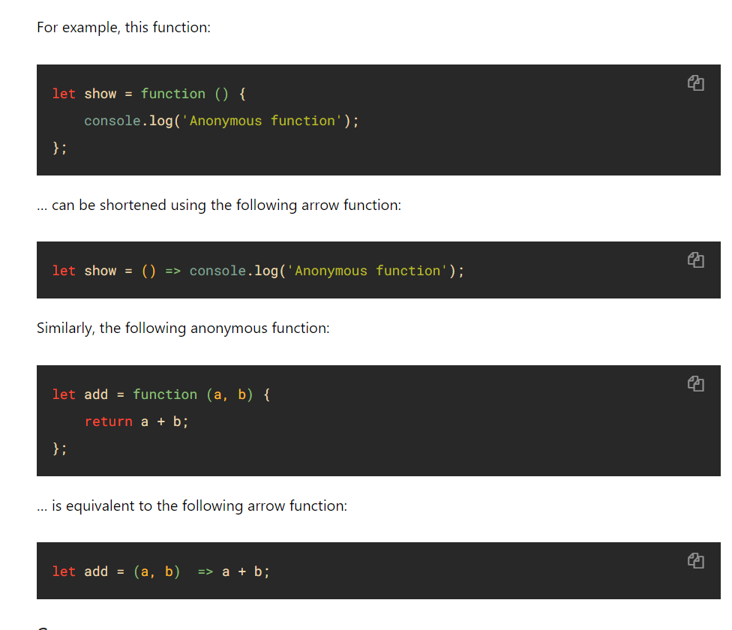

# **JavaScript String prototype Property**

[❮ JavaScript String Reference](https://www.w3schools.com/Jsref/jsref_obj_string.asp)

### Example

Use the prototype property to add a new property to all objects of a given type:

function employee(name, jobtitle, born) {  
  this.name = name;  
  this.jobtitle = jobtitle;  
  this.born = born;  
}  
employee.prototype.salary = 2000;  
  
var fred = new employee("Fred Flintstone", "Caveman", 1970);

[Try it Yourself »](https://www.w3schools.com/Jsref/tryit.asp?filename=tryjsref_prototype)

## Definition and Usage

The prototype property allows you to add new properties and methods to existing object types.

**Note:** Prototype is a global property which is available with almost all JavaScript objects.

## Browser Support

|  |  |  |  |  |  |
| --- | --- | --- | --- | --- | --- |
| Property |  |  |  |  |  |
| prototype | Yes | Yes | Yes | Yes | Yes |

## Syntax

object.prototype.name = value

## Technical Details

|  |  |
| --- | --- |
| **Return Value:** | A reference to the String.prototype object |
| **JavaScript Version:** | ECMAScript 1 |

[❮ JavaScript String Reference](https://www.w3schools.com/Jsref/jsref_obj_string.asp)

You can also use the replace solution above to add a trim function to the JavaScript String.prototype:

### Example

if (!String.prototype.trim) {  
  String.prototype.trim = function () {  
    return this.replace(/^[\s\uFEFF\xA0]+|[\s\uFEFF\xA0]+$/g, '');  
  };  
}  
var str = "       Hello World!        ";  
alert(str.trim());

[Try it Yourself »](https://www.w3schools.com/js/tryit.asp?filename=tryjs_string_trim_polyfill)

## Extracting String Characters

There are 3 methods for extracting string characters:

* charAt(position)
* charCodeAt(position)
* Property access [ ]

## The charAt() Method

The charAt() method returns the character at a specified index (position) in a string:

### Example

var str = "HELLO WORLD";  
str.charAt(0);            // returns H

[Try it Yourself »](https://www.w3schools.com/js/tryit.asp?filename=tryjs_string_charat)

## The charCodeAt() Method

The charCodeAt() method returns the unicode of the character at a specified index in a string:

The method returns a UTF-16 code (an integer between 0 and 65535).

### Example

var str = "HELLO WORLD";  
  
str.charCodeAt(0);         // returns 72

[Try it Yourself »](https://www.w3schools.com/js/tryit.asp?filename=tryjs_string_charcodeat)

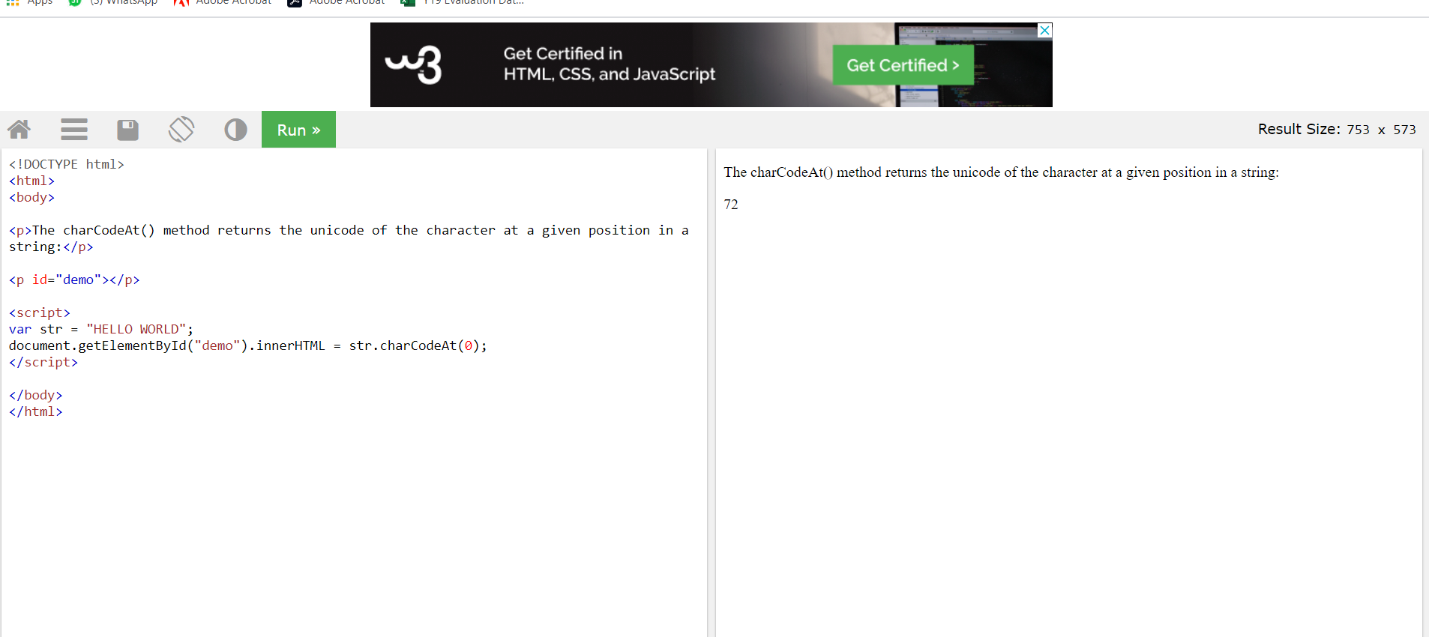

## Property Access

ECMAScript 5 (2009) allows property access [ ] on strings:

### Example

var str = "HELLO WORLD";  
str[0];                   // returns H

[Try it Yourself »](https://www.w3schools.com/js/tryit.asp?filename=tryjs_string_prop)

Property access might be a little **unpredictable:**

* It does not work in Internet Explorer 7 or earlier
* It makes strings look like arrays (but they are not)
* If no character is found, [ ] returns undefined, while charAt() returns an empty string.
* It is read only. str[0] = "A" gives no error (but does not work!)

### Example

var str = "HELLO WORLD";  
str[0] = "A";             **// Gives no error, but does not work**  
str[0];                   // returns H

[Try it Yourself »](https://www.w3schools.com/js/tryit.asp?filename=tryjs_string_prop2)

If you want to work with a string as an array, you can convert it to an array.

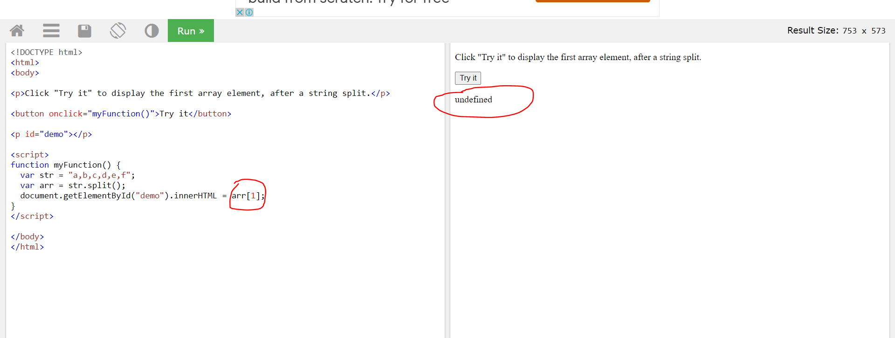

## Converting a String to an Array

A string can be converted to an array with the split() method:

### Example

var txt = "a,b,c,d,e";   // String  
txt.split(",");          // Split on commas  
txt.split(" ");          // Split on spaces  
txt.split("|");          // Split on pipe

[Try it Yourself »](https://www.w3schools.com/js/tryit.asp?filename=tryjs_string_split)

If the separator is omitted, the returned array will contain the whole string in index [0].

If the separator is "", the returned array will be an array of single characters:

### Example

var txt = "Hello";       // String  
txt.split("");           // Split in characters

[Try it Yourself »](https://www.w3schools.com/js/tryit.asp?filename=tryjs_string_split_char)

## Complete String Reference

For a complete reference, go to our [Complete JavaScript String Reference](https://www.w3schools.com/jsref/jsref_obj_string.asp).

The reference contains descriptions and examples of all string properties and methods.

# **JavaScript Numbers**

[❮ Previous](https://www.w3schools.com/js/js_string_methods.asp)[Next ❯](https://www.w3schools.com/js/js_number_methods.asp)

JavaScript has only one type of number. Numbers can be written with or without decimals.

### Example

var x = 3.14;    // A number with decimals  
var y = 3;       // A number without decimals

[Try it yourself »](https://www.w3schools.com/js/tryit.asp?filename=tryjs_numbers1)

Extra large or extra small numbers can be written with scientific (exponent) notation:

### Example

var x = 123e5;    // 12300000  
var y = 123e-5;   // 0.00123

[Try it yourself »](https://www.w3schools.com/js/tryit.asp?filename=tryjs_numbers2)

## JavaScript Numbers are Always 64-bit Floating Point

Unlike many other programming languages, JavaScript does not define different types of numbers, like integers, short, long, floating-point etc.

JavaScript numbers are always stored as double precision floating point numbers, following the international IEEE 754 standard.  
  
This format stores numbers in 64 bits, where the number (the fraction) is stored in bits 0 to 51, the exponent in bits 52 to 62, and the sign in bit 63:

|  |  |  |
| --- | --- | --- |
| **Value (aka Fraction/Mantissa)** | **Exponent** | **Sign** |
| 52 bits (0 - 51) | 11 bits (52 - 62) | 1 bit (63) |

## Precision

Integers (numbers without a period or exponent notation) are accurate up to 15 digits.

### Example

var x = 999999999999999;   // x will be 999999999999999  
var y = 9999999999999999;  // y will be 10000000000000000

[Try it Yourself »](https://www.w3schools.com/js/tryit.asp?filename=tryjs_numbers_inaccurate1)

The maximum number of decimals is 17, but floating point arithmetic is not always 100% accurate:

### Example

var x = 0.2 + 0.1;         // x will be 0.30000000000000004

[Try it yourself »](https://www.w3schools.com/js/tryit.asp?filename=tryjs_numbers_inaccurate2)

To solve the problem above, it helps to multiply and divide:

### Example

var x = (0.2 * 10 + 0.1 * 10) / 10;       // x will be 0.3

[Try it Yourself »](https://www.w3schools.com/js/tryit.asp?filename=tryjs_numbers_inaccurate3)

## Adding Numbers and Strings

WARNING !!

JavaScript uses the + operator for both addition and concatenation.

Numbers are added. Strings are concatenated.

If you add two numbers, the result will be a number:

### Example

var x = 10;  
var y = 20;  
var z = x + y;           // z will be 30 (a number)

[Try it Yourself »](https://www.w3schools.com/js/tryit.asp?filename=tryjs_numbers_add)

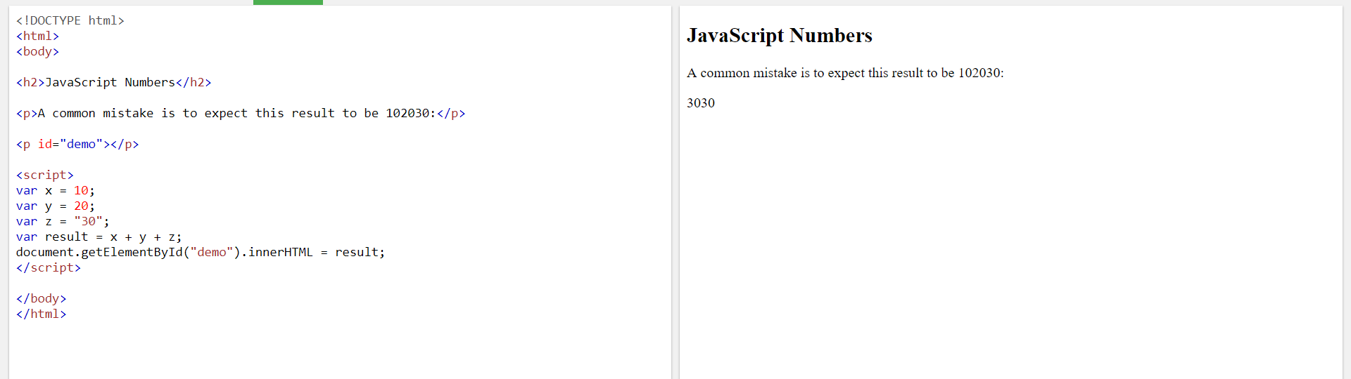

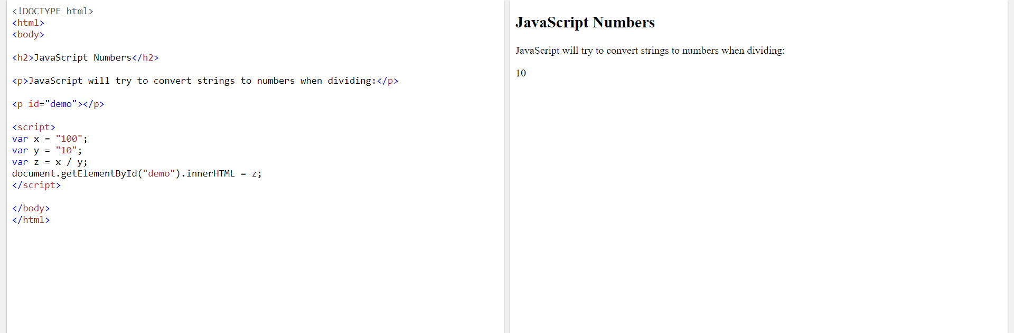

If you add two strings, the result will be a string concatenation:

### Example

var x = "10";  
var y = "20";  
var z = x + y;           // z will be 1020 (a string)

[Try it Yourself »](https://www.w3schools.com/js/tryit.asp?filename=tryjs_numbers_add_strings1)

If you add a number and a string, the result will be a string concatenation:

### Example

var x = 10;  
var y = "20";  
var z = x + y;           // z will be 1020 (a string)

[Try it Yourself »](https://www.w3schools.com/js/tryit.asp?filename=tryjs_numbers_add_strings2)

If you add a string and a number, the result will be a string concatenation:

### Example

var x = "10";  
var y = 20;  
var z = x + y;           // z will be 1020 (a string)

[Try it Yourself »](https://www.w3schools.com/js/tryit.asp?filename=tryjs_numbers_add_strings5)

A common mistake is to expect this result to be 30:

### Example

var x = 10;  
var y = 20;  
var z = "The result is: " + x + y;

[Try it Yourself »](https://www.w3schools.com/js/tryit.asp?filename=tryjs_numbers_add_strings3)

A common mistake is to expect this result to be 102030:

### Example

var x = 10;  
var y = 20;  
var z = "30";  
var result = x + y + z;

[Try it Yourself »](https://www.w3schools.com/js/tryit.asp?filename=tryjs_numbers_add_strings4)

The JavaScript interpreter works from left to right.

First 10 + 20 is added because x and y are both numbers.

Then 30 + "30" is concatenated because z is a string.

## Numeric Strings

JavaScript strings can have numeric content:

var x = 100;         // x is a number  
  
var y = "100";       // y is a string

JavaScript will try to convert strings to numbers in all numeric operations:

This will work:

var x = "100";  
var y = "10";  
var z = x / y;       // z will be 10

[Try it Yourself »](https://www.w3schools.com/js/tryit.asp?filename=tryjs_numbers_string1)

This will also work:

var x = "100";  
var y = "10";  
var z = x * y;       // z will be 1000

[Try it Yourself »](https://www.w3schools.com/js/tryit.asp?filename=tryjs_numbers_string2)

And this will work:

var x = "100";  
var y = "10";  
var z = x - y;       // z will be 90

[Try it Yourself »](https://www.w3schools.com/js/tryit.asp?filename=tryjs_numbers_string3)

But this will not work:

var x = "100";  
var y = "10";  
var z = x + y;       // z will not be 110 (It will be 10010)

[Try it Yourself »](https://www.w3schools.com/js/tryit.asp?filename=tryjs_numbers_string4)

In the last example JavaScript uses the + operator to concatenate the strings.

## NaN - Not a Number

NaN is a JavaScript reserved word indicating that a number is not a legal number.

Trying to do arithmetic with a non-numeric string will result in NaN (Not a Number):

### Example

var x = 100 / "Apple";  // x will be NaN (Not a Number)

[Try it Yourself »](https://www.w3schools.com/js/tryit.asp?filename=tryjs_numbers_divide_string)

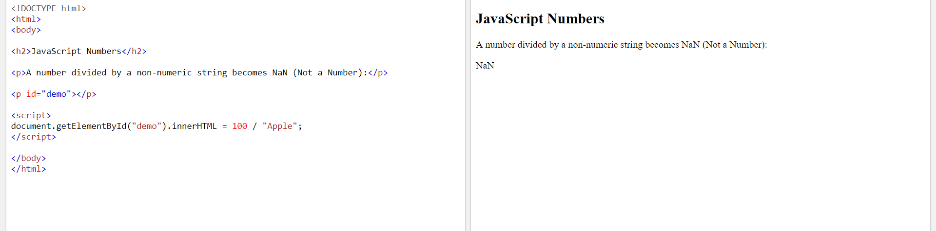

However, if the string contains a numeric value , the result will be a number:

### Example

var x = 100 / "10";     // x will be 10

[Try it Yourself »](https://www.w3schools.com/js/tryit.asp?filename=tryjs_numbers_divide_number)

You can use the global JavaScript function isNaN() to find out if a value is a number:

### Example

var x = 100 / "Apple";  
isNaN(x);               // returns true because x is Not a Number

[Try it Yourself »](https://www.w3schools.com/js/tryit.asp?filename=tryjs_numbers_isnan_true)

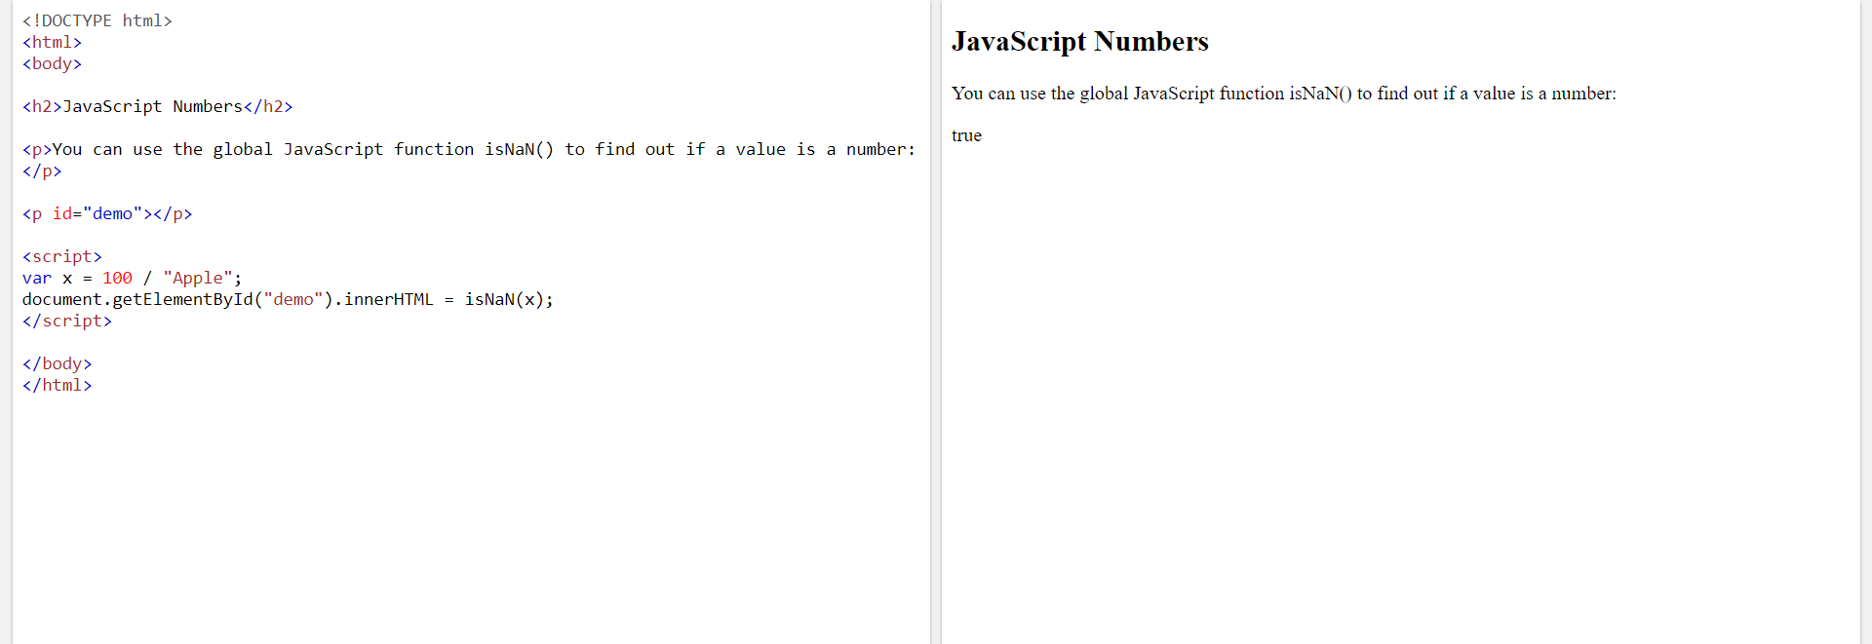

Watch out for NaN. If you use NaN in a mathematical operation, the result will also be NaN:

### Example

var x = NaN;  
var y = 5;  
var z = x + y;         // z will be NaN

[Try it Yourself »](https://www.w3schools.com/js/tryit.asp?filename=tryjs_numbers_nan_math)

Or the result might be a concatenation:

### Example

var x = NaN;  
var y = "5";  
var z = x + y;         // z will be NaN5

[Try it Yourself »](https://www.w3schools.com/js/tryit.asp?filename=tryjs_numbers_nan_concat)

NaN is a number: typeof NaN returns number:

### Example

typeof NaN;            // returns "number"

[Try it Yourself »](https://www.w3schools.com/js/tryit.asp?filename=tryjs_numbers_nan_typeof)

## Infinity

Infinity (or -Infinity) is the value JavaScript will return if you calculate a number outside the largest possible number.

### Example

var myNumber = 2;  
while (myNumber != Infinity) {   // Execute until Infinity  
  myNumber = myNumber * myNumber;  
}

[Try it yourself »](https://www.w3schools.com/js/tryit.asp?filename=tryjs_numbers_infinity)’

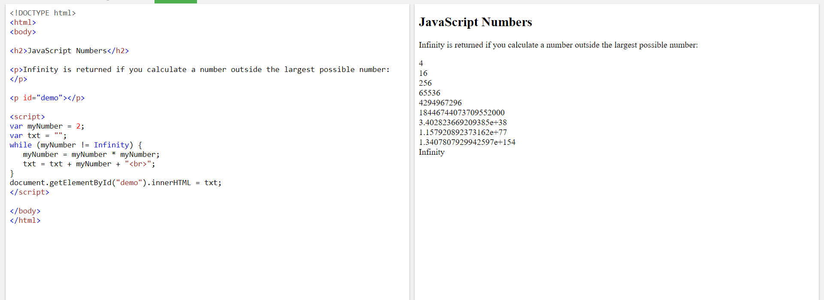

Division by 0 (zero) also generates Infinity:

### Example

var x =  2 / 0;       // x will be Infinity  
var y = -2 / 0;       // y will be -Infinity

[Try it Yourself »](https://www.w3schools.com/js/tryit.asp?filename=tryjs_numbers_infinity_zero)

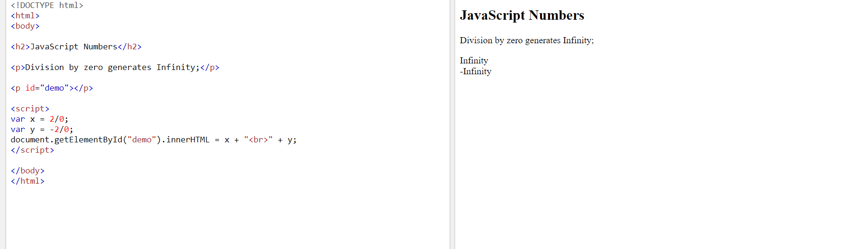

Infinity is a number: typeof Infinity returns number.

### Example

typeof Infinity;     // returns "number"

[Try it Yourself »](https://www.w3schools.com/js/tryit.asp?filename=tryjs_numbers_infinity_typeof)

## Hexadecimal

JavaScript interprets numeric constants as hexadecimal if they are preceded by 0x.

### Example

var x = 0xFF;        // x will be 255

[Try it Yourself »](https://www.w3schools.com/js/tryit.asp?filename=tryjs_numbers_hex)

Never write a number with a leading zero (like 07).  
Some JavaScript versions interpret numbers as octal if they are written with a leading zero.

By default, JavaScript displays numbers as **base 10** decimals.

But you can use the toString() method to output numbers from **base 2** to **base 36**.

Hexadecimal is **base 16**. Decimal is **base 10**. Octal is **base 8**. Binary is **base 2**.

### Example

var myNumber = 32;  
myNumber.toString(10);  // returns 32  
myNumber.toString(32);  // returns 10  
myNumber.toString(16);  // returns 20  
myNumber.toString(8);   // returns 40  
myNumber.toString(2);   // returns 100000

[Try it Yourself »](https://www.w3schools.com/js/tryit.asp?filename=tryjs_numbers_tostring)

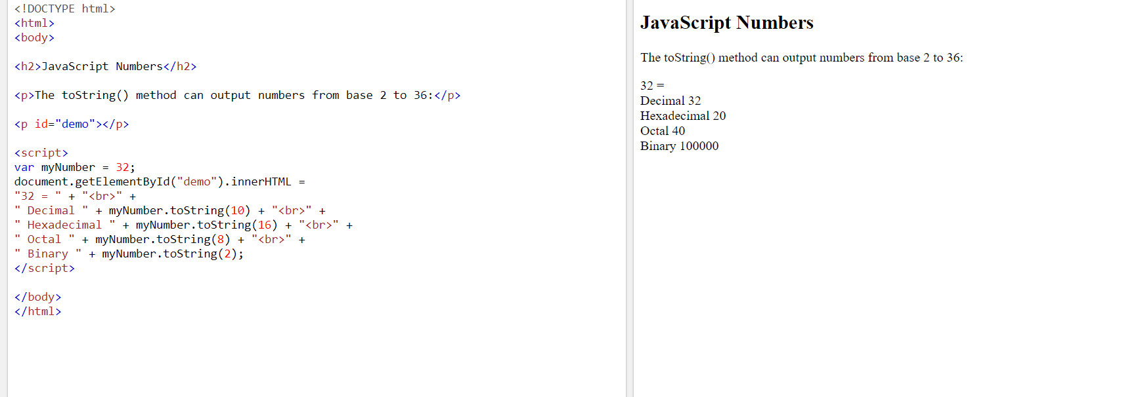

## Numbers Can be Objects

Normally JavaScript numbers are primitive values created from literals:

var x = 123;

But numbers can also be defined as objects with the keyword new:

var y = new Number(123);

### Example

var x = 123;  
var y = new Number(123);  
  
// typeof x returns number  
// typeof y returns object

[Try it yourself »](https://www.w3schools.com/js/tryit.asp?filename=tryjs_number_object)

Do not create Number objects. It slows down execution speed.  
The new keyword complicates the code. This can produce some unexpected results:

When using the == operator, equal numbers are equal:

### Example

var x = 500;               
var y = new Number(500);  
  
// (x == y) is true because x and y have equal values

[Try it Yourself »](https://www.w3schools.com/js/tryit.asp?filename=tryjs_number_object1)

When using the === operator, equal numbers are not equal, because the === operator expects equality in both type and value.

### Example

var x = 500;               
var y = new Number(500);  
  
// (x === y) is false because x and y have different types

[Try it Yourself »](https://www.w3schools.com/js/tryit.asp?filename=tryjs_number_object2)

Or even worse. Objects cannot be compared:

### Example

var x = new Number(500);               
var y = new Number(500);  
  
// (x == y) is false because objects cannot be compared

[Try it Yourself »](https://www.w3schools.com/js/tryit.asp?filename=tryjs_number_object3)

Note the difference between (x==y) and (x===y).  
Comparing two JavaScript objects will always return false.

# **JavaScript Number Methods**

[❮ Previous](https://www.w3schools.com/js/js_numbers.asp)[Next ❯](https://www.w3schools.com/js/js_arrays.asp)

Number methods help you work with numbers.

## Number Methods and Properties

Primitive values (like 3.14 or 2014), cannot have properties and methods (because they are not objects).

But with JavaScript, methods and properties are also available to primitive values, because JavaScript treats primitive values as objects when executing methods and properties.

## The toString() Method

The toString() method returns a number as a string.

All number methods can be used on any type of numbers (literals, variables, or expressions):

### Example

var x = 123;  
x.toString();            // returns 123 from variable x  
(123).toString();        // returns 123 from literal 123  
(100 + 23).toString();   // returns 123 from expression 100 + 23

[Try it Yourself »](https://www.w3schools.com/js/tryit.asp?filename=tryjs_number_tostring)

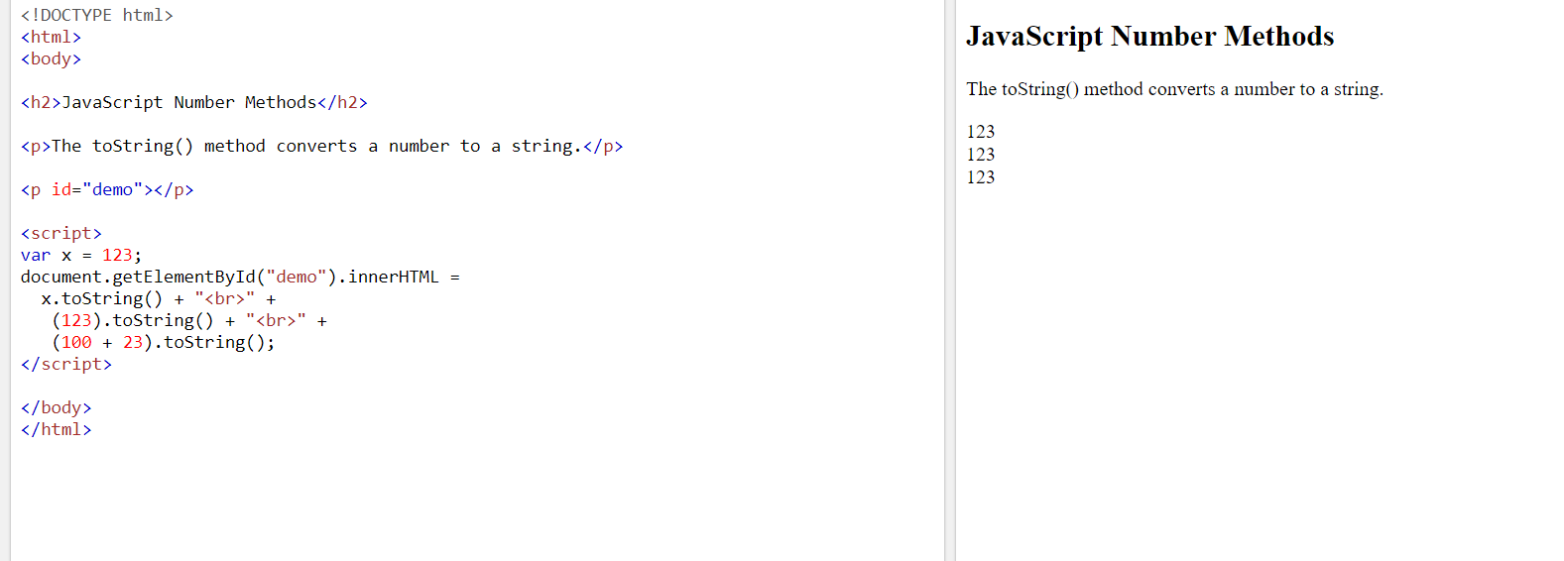

## The toExponential() Method

toExponential() returns a string, with a number rounded and written using exponential notation.

A parameter defines the number of characters behind the decimal point:

### Example

var x = 9.656;  
x.toExponential(2);     // returns 9.66e+0  
x.toExponential(4);     // returns 9.6560e+0  
x.toExponential(6);     // returns 9.656000e+0

[Try it yourself »](https://www.w3schools.com/js/tryit.asp?filename=tryjs_number_toexponential)

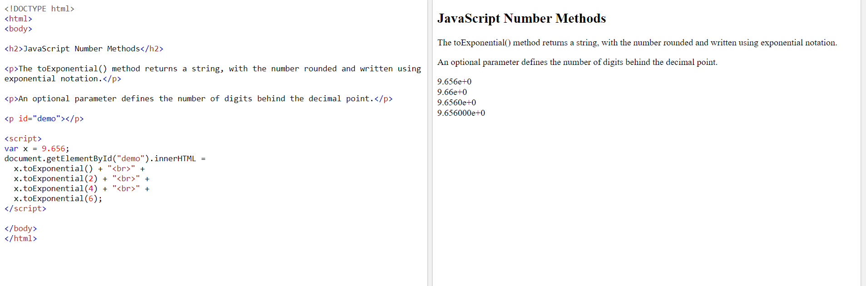

The parameter is optional. If you don't specify it, JavaScript will not round the number.

## The toFixed() Method

toFixed() returns a string, with the number written with a specified number of decimals:

### Example

var x = 9.656;  
x.toFixed(0);           // returns 10  
x.toFixed(2);           // returns 9.66  
x.toFixed(4);           // returns 9.6560  
x.toFixed(6);           // returns 9.656000

[Try it yourself »](https://www.w3schools.com/js/tryit.asp?filename=tryjs_number_tofixed)

toFixed(2) is perfect for working with money.

## The toPrecision() Method

toPrecision() returns a string, with a number written with a specified length:

### Example

var x = 9.656;  
x.toPrecision();        // returns 9.656  
x.toPrecision(2);       // returns 9.7  
x.toPrecision(4);       // returns 9.656  
x.toPrecision(6);       // returns 9.65600

[Try it Yourself »](https://www.w3schools.com/js/tryit.asp?filename=tryjs_number_toprecision)

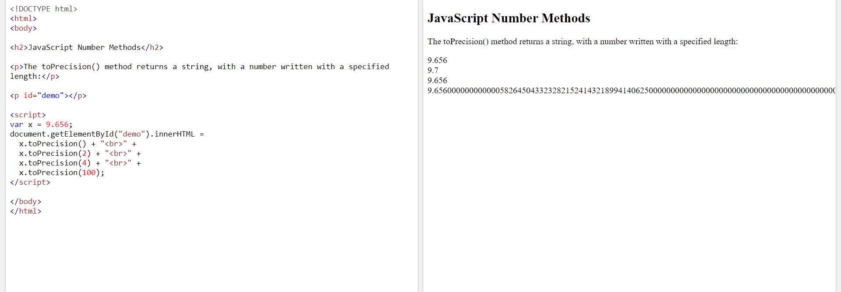

## The valueOf() Method

valueOf() returns a number as a number.

### Example

var x = 123;  
x.valueOf();            // returns 123 from variable x  
(123).valueOf();        // returns 123 from literal 123  
(100 + 23).valueOf();   // returns 123 from expression 100 + 23

[Try it Yourself »](https://www.w3schools.com/js/tryit.asp?filename=tryjs_number_valueof)

In JavaScript, a number can be a primitive value (typeof = number) or an object (typeof = object).

The valueOf() method is used internally in JavaScript to convert Number objects to primitive values.

There is no reason to use it in your code.

All JavaScript data types have a valueOf() and a toString() method.

## Converting Variables to Numbers

There are 3 JavaScript methods that can be used to convert variables to numbers:

* The Number() method
* The parseInt() method
* The parseFloat() method

These methods are not **number** methods, but **global** JavaScript methods.

## Global JavaScript Methods

JavaScript global methods can be used on all JavaScript data types.

These are the most relevant methods, when working with numbers:

|  |  |
| --- | --- |
| **Method** | **Description** |
| Number() | Returns a number, converted from its argument. |
| parseFloat() | Parses its argument and returns a floating point number |
| parseInt() | Parses its argument and returns an integer |

## The Number() Method

Number() can be used to convert JavaScript variables to numbers:

### Example

Number(true);          // returns 1  
Number(false);         // returns 0  
Number("10");          // returns 10  
Number("  10");        // returns 10  
Number("10  ");        // returns 10  
Number(" 10  ");       // returns 10  
Number("10.33");       // returns 10.33  
Number("10,33");       // returns NaN  
Number("10 33");       // returns NaN  
Number("John");        // returns NaN

[Try it Yourself »](https://www.w3schools.com/js/tryit.asp?filename=tryjs_global_number)

If the number cannot be converted, NaN (Not a Number) is returned.

## The Number() Method Used on Dates

Number() can also convert a date to a number:

### Example

Number(new Date("2017-09-30"));    // returns 1506729600000

[Try it Yourself »](https://www.w3schools.com/js/tryit.asp?filename=tryjs_global_number_date)

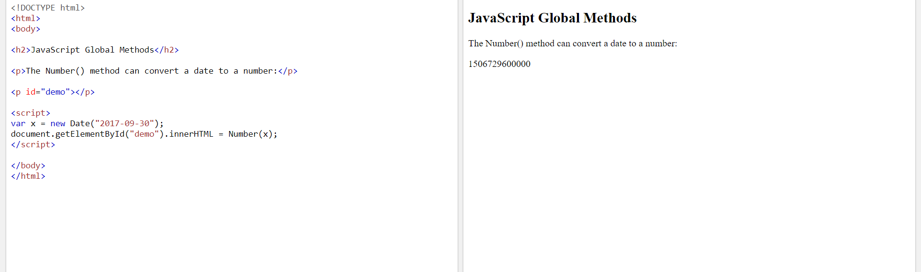

The Number() method above returns the number of milliseconds since 1.1.1970.

## The parseInt() Method

parseInt() parses a string and returns a whole number. Spaces are allowed. Only the first number is returned:

### Example

parseInt("10");         // returns 10  
parseInt("10.33");      // returns 10  
parseInt("10 20 30");   // returns 10  
parseInt("10 years");   // returns 10  
parseInt("years 10");   // returns NaN

[Try it yourself »](https://www.w3schools.com/js/tryit.asp?filename=tryjs_global_parseint)

If the number cannot be converted, NaN (Not a Number) is returned.

## The parseFloat() Method

parseFloat() parses a string and returns a number. Spaces are allowed. Only the first number is returned:

### Example

parseFloat("10");        // returns 10  
parseFloat("10.33");     // returns 10.33  
parseFloat("10 20 30");  // returns 10  
parseFloat("10 years");  // returns 10  
parseFloat("years 10");  // returns NaN

[Try it yourself »](https://www.w3schools.com/js/tryit.asp?filename=tryjs_global_parsefloat)

If the number cannot be converted, NaN (Not a Number) is returned.

## Number Properties

|  |  |
| --- | --- |
| **Property** | **Description** |
| MAX_VALUE | Returns the largest number possible in JavaScript |
| MIN_VALUE | Returns the smallest number possible in JavaScript |
| POSITIVE_INFINITY | Represents infinity (returned on overflow) |
| NEGATIVE_INFINITY | Represents negative infinity (returned on overflow) |
| NaN | Represents a "Not-a-Number" value |

## JavaScript MIN_VALUE and MAX_VALUE

MAX_VALUE returns the largest possible number in JavaScript.

### Example

var x = Number.MAX_VALUE;

[Try it yourself »](https://www.w3schools.com/js/tryit.asp?filename=tryjs_number_max)

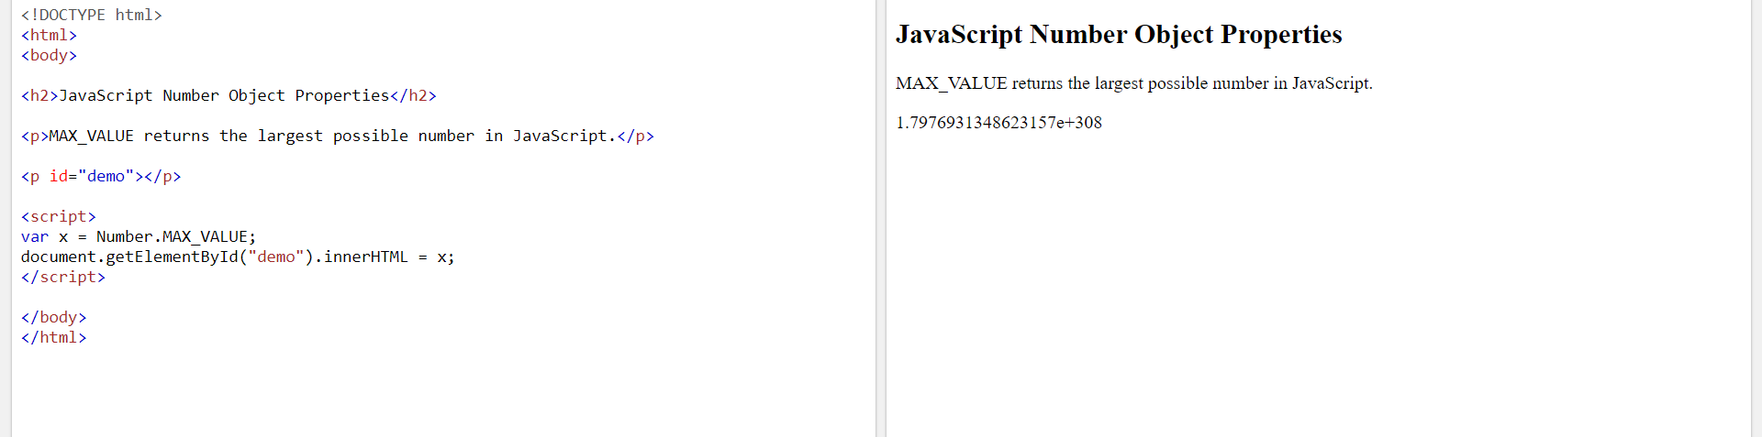

MIN_VALUE returns the lowest possible number in JavaScript.

### Example

var x = Number.MIN_VALUE;

[Try it yourself »](https://www.w3schools.com/js/tryit.asp?filename=tryjs_number_min)

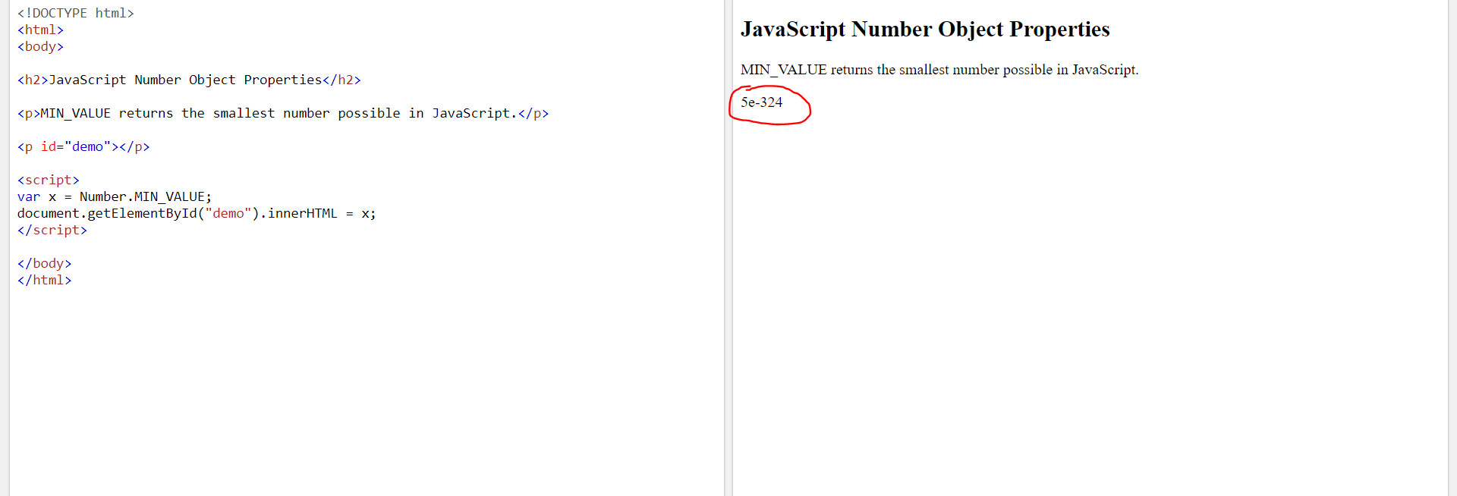

## JavaScript POSITIVE_INFINITY

### Example

var x = Number.POSITIVE_INFINITY;

[Try it yourself »](https://www.w3schools.com/js/tryit.asp?filename=tryjs_number_pos_infinity)

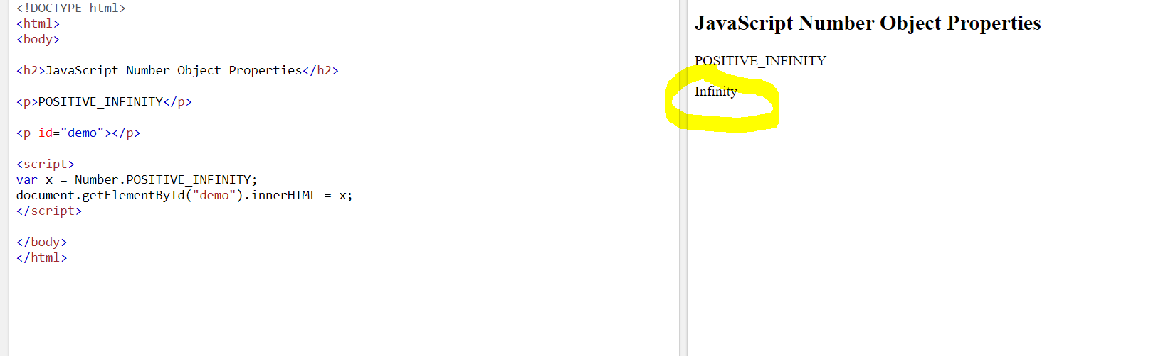

POSITIVE_INFINITY is returned on overflow:

### Example

var x = 1 / 0;

[Try it yourself »](https://www.w3schools.com/js/tryit.asp?filename=tryjs_number_pos_infinity2)

## JavaScript NEGATIVE_INFINITY

### Example

var x = Number.NEGATIVE_INFINITY;

[Try it yourself »](https://www.w3schools.com/js/tryit.asp?filename=tryjs_number_neg_infinity)

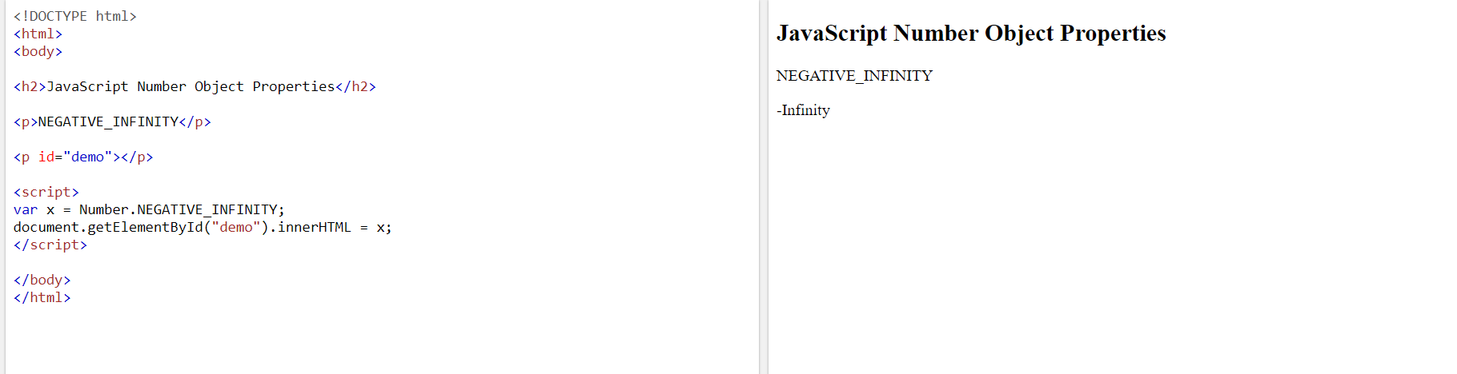

NEGATIVE_INFINITY is returned on overflow:

### Example

var x = -1 / 0;

[Try it yourself »](https://www.w3schools.com/js/tryit.asp?filename=tryjs_number_neg_infinity2)

## JavaScript NaN - Not a Number

### Example

var x = Number.NaN;

[Try it yourself »](https://www.w3schools.com/js/tryit.asp?filename=tryjs_number_nan)

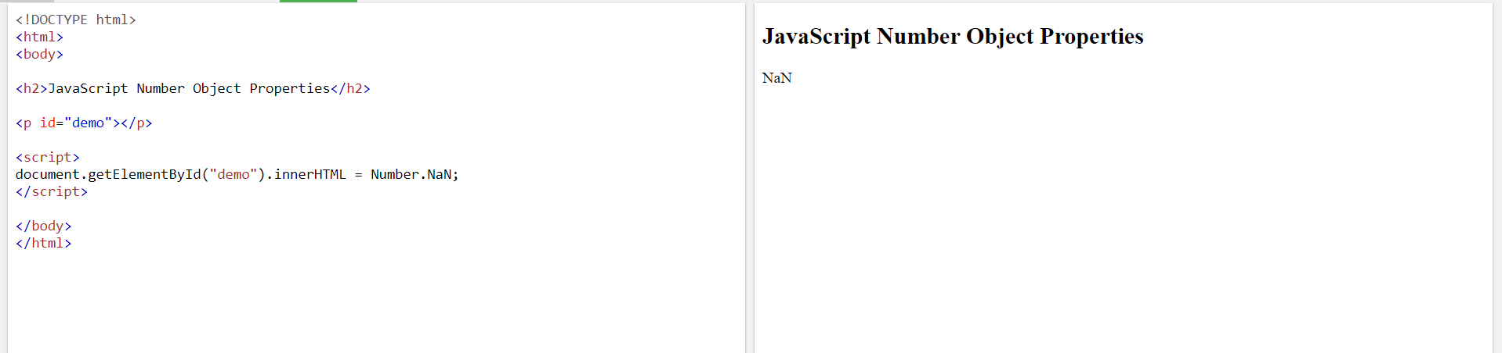

NaN is a JavaScript reserved word indicating that a number is not a legal number.

Trying to do arithmetic with a non-numeric string will result in NaN (Not a Number):

### Example

var x = 100 / "Apple";  // x will be NaN (Not a Number)

[Try it Yourself »](https://www.w3schools.com/js/tryit.asp?filename=tryjs_numbers_divide_string)

## Number Properties Cannot be Used on Variables

Number properties belongs to the JavaScript's number object wrapper called **Number**.

These properties can only be accessed as Number.MAX_VALUE.

Using myNumber.MAX_VALUE, where myNumber is a variable, expression, or value, will return undefined:

### Example

var x = 6;  
var y = x.MAX_VALUE;    // y becomes undefined

[Try it yourself »](https://www.w3schools.com/js/tryit.asp?filename=tryjs_number_max_undefined)

## Complete JavaScript Number Reference

For a complete reference, go to our [Complete JavaScript Number Reference](https://www.w3schools.com/jsref/jsref_obj_number.asp).

The reference contains descriptions and examples of all Number properties and methods.

# **JavaScript Arrays**

## Creating an Array

Using an array literal is the easiest way to create a JavaScript Array.

Syntax:

var array_name = [item1, item2, ...];

## Using the JavaScript Keyword new

The following example also creates an Array, and assigns values to it:

### Example

var cars = new Array("Saab", "Volvo", "BMW");

[Try it Yourself »](https://www.w3schools.com/js/tryit.asp?filename=tryjs_array_new)

The two examples above do exactly the same. There is no need to use new Array().  
For simplicity, readability and execution speed, use the first one (the array literal method).

## Access the Elements of an Array

You access an array element by referring to the **index number**.

This statement accesses the value of the first element in cars:

var name = cars[0];

### Example

var cars = ["Saab", "Volvo", "BMW"];  
document.getElementById("demo").innerHTML = cars[0];

[Try it Yourself »](https://www.w3schools.com/js/tryit.asp?filename=tryjs_array_element)

**Note:** Array indexes start with 0.

[0] is the first element. [1] is the second element.

## Changing an Array Element

This statement changes the value of the first element in cars:

cars[0] = "Opel";

### Example

var cars = ["Saab", "Volvo", "BMW"];  
cars[0] = "Opel";  
document.getElementById("demo").innerHTML = cars[0];

[Try it Yourself »](https://www.w3schools.com/js/tryit.asp?filename=tryjs_array_element_change)

## Access the Full Array

With JavaScript, the full array can be accessed by referring to the array name:

### Example

var cars = ["Saab", "Volvo", "BMW"];  
document.getElementById("demo").innerHTML = cars;

[Try it Yourself »](https://www.w3schools.com/js/tryit.asp?filename=tryjs_array_full)

## Arrays are Objects

Arrays are a special type of objects. The typeof operator in JavaScript returns "object" for arrays.

But, JavaScript arrays are best described as arrays.

Arrays use **numbers** to access its "elements". In this example, person[0] returns John:

### Array:

var person = ["John", "Doe", 46];

[Try it Yourself »](https://www.w3schools.com/js/tryit.asp?filename=tryjs_array_array)

Objects use **names** to access its "members". In this example, person.firstName returns John:

### Object:

var person = {firstName:"John", lastName:"Doe", age:46};

[Try it Yourself »](https://www.w3schools.com/js/tryit.asp?filename=tryjs_array_object)

## Array Elements Can Be Objects

JavaScript variables can be objects. Arrays are special kinds of objects.

Because of this, you can have variables of different types in the same Array.

You can have objects in an Array. You can have functions in an Array. You can have arrays in an Array:

myArray[0] = Date.now;  
myArray[1] = myFunction;  
myArray[2] = myCars;

## Array Properties and Methods

The real strength of JavaScript arrays are the built-in array properties and methods:

### Examples

var x = cars.length;   // The length property returns the number of elements  
var y = cars.sort();   // The sort() method sorts arrays

Array methods are covered in the next chapters.

## The length Property

The length property of an array returns the length of an array (the number of array elements).

### Example

var fruits = ["Banana", "Orange", "Apple", "Mango"];  
fruits.length;   // the length of fruits is 4

[Try it Yourself »](https://www.w3schools.com/js/tryit.asp?filename=tryjs_array_length)

The length property is always one more than the highest array index.

## Accessing the First Array Element

### Example

fruits = ["Banana", "Orange", "Apple", "Mango"];  
var first = fruits[0];

[Try it Yourself »](https://www.w3schools.com/js/tryit.asp?filename=tryjs_array_first)

## Accessing the Last Array Element

### Example

fruits = ["Banana", "Orange", "Apple", "Mango"];  
var last = fruits[fruits.length - 1];

[Try it Yourself »](https://www.w3schools.com/js/tryit.asp?filename=tryjs_array_last)

## Looping Array Elements

The safest way to loop through an array, is using a for loop:

### Example

var fruits, text, fLen, i;  
fruits = ["Banana", "Orange", "Apple", "Mango"];  
fLen = fruits.length;  
  
text = "<ul>";  
for (i = 0; i < fLen; i++) {  
  text += "<li>" + fruits[i] + "</li>";  
}  
text += "</ul>";

[Try it Yourself »](https://www.w3schools.com/js/tryit.asp?filename=tryjs_array_loop)

You can also use the Array.forEach() function:

### Example

var fruits, text;  
fruits = ["Banana", "Orange", "Apple", "Mango"];  
  
text = "<ul>";  
fruits.forEach(myFunction);  
text += "</ul>";  
  
function myFunction(value) {  
  text += "<li>" + value + "</li>";  
}

[Try it Yourself »](https://www.w3schools.com/js/tryit.asp?filename=tryjs_array_loop_foreach)

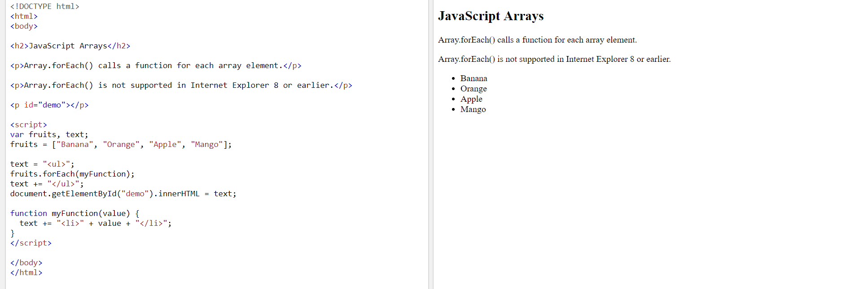

## Adding Array Elements

The easiest way to add a new element to an array is using the push() method:

### Example

var fruits = ["Banana", "Orange", "Apple", "Mango"];  
fruits.push("Lemon");    // adds a new element (Lemon) to fruits

[Try it Yourself »](https://www.w3schools.com/js/tryit.asp?filename=tryjs_array_add_push)

New element can also be added to an array using the length property:

### Example

var fruits = ["Banana", "Orange", "Apple", "Mango"];  
fruits[fruits.length] = "Lemon";    // adds a new element (Lemon) to fruits

[Try it Yourself »](https://www.w3schools.com/js/tryit.asp?filename=tryjs_array_add)

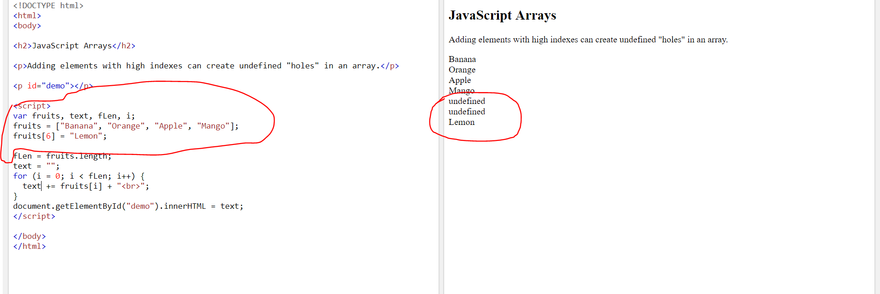

**WARNING !**

Adding elements with high indexes can create undefined "holes" in an array:

### Example

var fruits = ["Banana", "Orange", "Apple", "Mango"];  
fruits[6] = "Lemon";    // adds a new element (Lemon) to fruits

[Try it Yourself »](https://www.w3schools.com/js/tryit.asp?filename=tryjs_array_holes)

## Associative Arrays

Many programming languages support arrays with named indexes.

Arrays with named indexes are called associative arrays (or hashes).

JavaScript does **not** support arrays with named indexes.

In JavaScript, **arrays** always use **numbered indexes**.

### Example

var person = [];  
person[0] = "John";  
person[1] = "Doe";  
person[2] = 46;  
var x = person.length;     // person.length will return 3  
var y = person[0];         // person[0] will return "John"

[Try it Yourself »](https://www.w3schools.com/js/tryit.asp?filename=tryjs_array_associative_1)

**WARNING !!**  
If you use named indexes, JavaScript will redefine the array to a standard object.  
After that, some array methods and properties will produce **incorrect results**.

### Example:

var person = [];  
person["firstName"] = "John";  
person["lastName"] = "Doe";  
person["age"] = 46;  
var x = person.length;     // person.length will return 0  
var y = person[0];         // person[0] will return undefined

[Try it Yourself »](https://www.w3schools.com/js/tryit.asp?filename=tryjs_array_associative_2)

## The Difference Between Arrays and Objects

In JavaScript, **arrays** use **numbered indexes**.

In JavaScript, **objects** use **named indexes**.

Arrays are a special kind of objects, with numbered indexes.

## When to Use Arrays. When to use Objects.

* JavaScript does not support associative arrays.
* You should use **objects** when you want the element names to be **strings (text)**.
* You should use **arrays** when you want the element names to be **numbers**.

## Avoid new Array()

There is no need to use the JavaScript's built-in array constructor new Array().

**Use [] instead.**

These two different statements both create a new empty array named points:

var points = new Array();     // Bad  
var points = [];              // Good

These two different statements both create a new array containing 6 numbers:

var points = new Array(40, 100, 1, 5, 25, 10); // Bad  
var points = [40, 100, 1, 5, 25, 10];          // Good

[Try it Yourself »](https://www.w3schools.com/js/tryit.asp?filename=tryjs_array_literal)

The new keyword only complicates the code. It can also produce some unexpected results:

var points = new Array(40, 100);  // Creates an array with two elements (40 and 100)

What if I remove one of the elements?

var points = new Array(40);  // Creates an array with 40 undefined elements !!!!!

[Try it Yourself »](https://www.w3schools.com/js/tryit.asp?filename=tryjs_array_new_error)

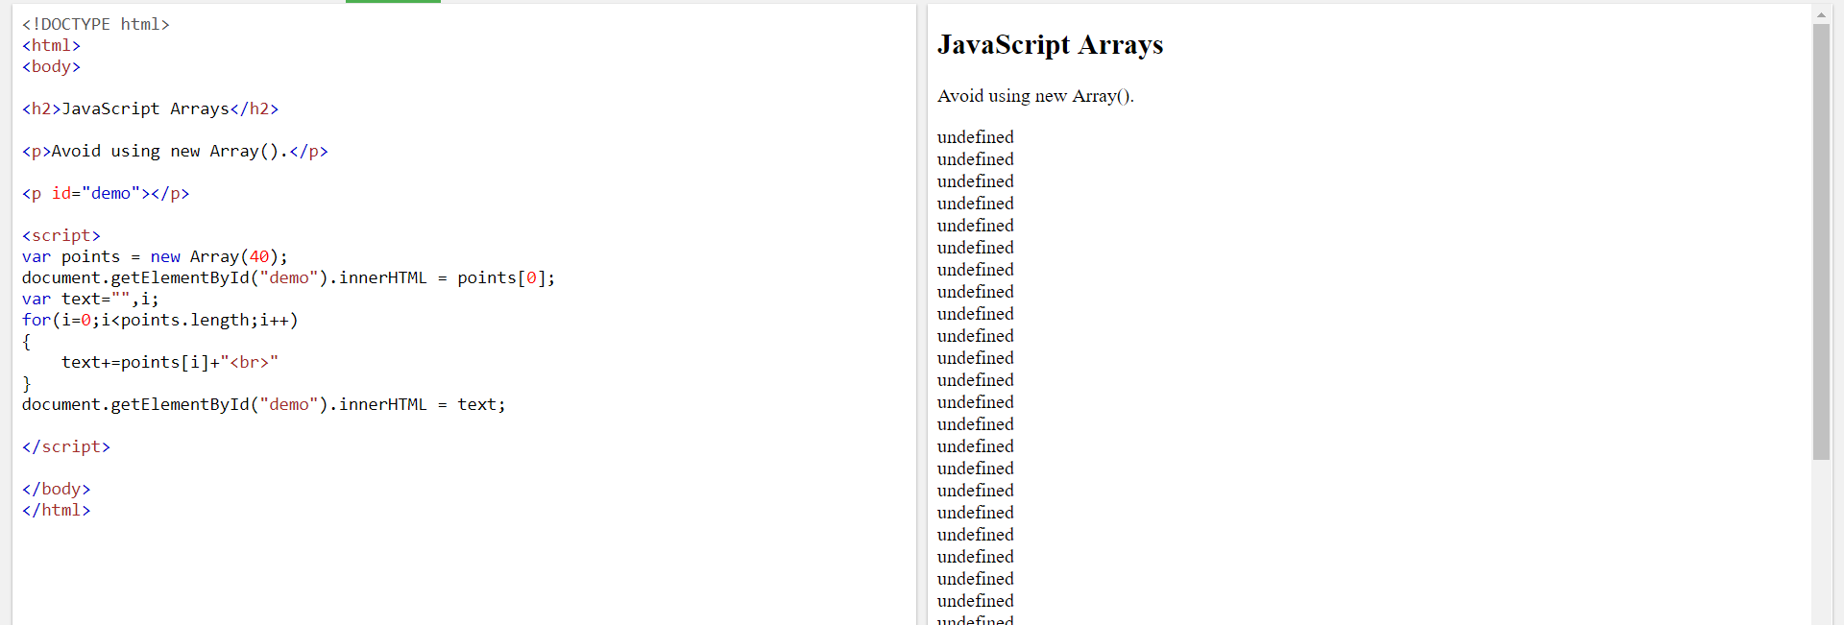

## How to Recognize an Array

A common question is: How do I know if a variable is an array?

The problem is that the JavaScript operator typeof returns "object":

var fruits = ["Banana", "Orange", "Apple", "Mango"];  
  
typeof fruits;    // returns object

[Try it Yourself »](https://www.w3schools.com/js/tryit.asp?filename=tryjs_array_typeof)

The typeof operator returns object because a JavaScript array is an object.

### Solution 1:

To solve this problem ECMAScript 5 defines a new method Array.isArray():

Array.isArray(fruits);   // returns true

[Try it Yourself »](https://www.w3schools.com/js/tryit.asp?filename=tryjs_array_isarray_method)

The problem with this solution is that ECMAScript 5 is **not supported in older browsers**.

### Solution 2:

To solve this problem you can create your own isArray() function:

function isArray(x) {  
  return x.constructor.toString().indexOf("Array") > -1;  
}

[Try it Yourself »](https://www.w3schools.com/js/tryit.asp?filename=tryjs_array_isarray)

The function above always returns true if the argument is an array.

Or more precisely: it returns true if the object prototype contains the word "Array".

### Solution 3:

The instanceof operator returns true if an object is created by a given constructor:

var fruits = ["Banana", "Orange", "Apple", "Mango"];  
  
fruits instanceof Array;   // returns true

[Try it Yourself »](https://www.w3schools.com/js/tryit.asp?filename=tryjs_array_instanceof)

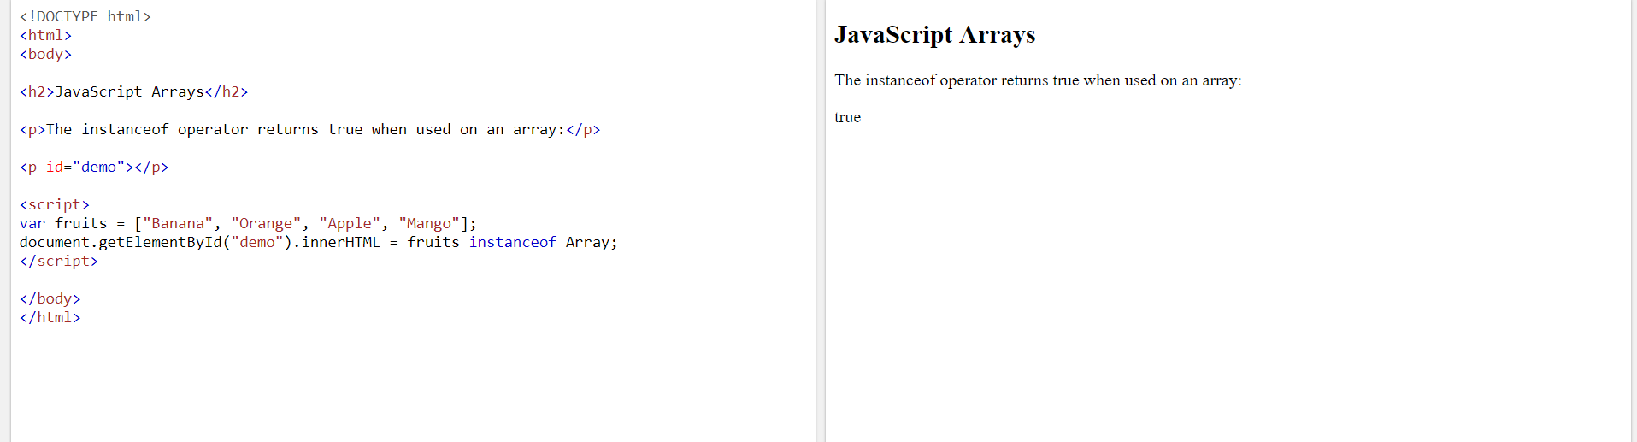

# **JavaScript Array Methods**

[❮ Previous](https://www.w3schools.com/js/js_arrays.asp)[Next ❯](https://www.w3schools.com/js/js_array_sort.asp)

## Converting Arrays to Strings

The JavaScript method toString() converts an array to a string of (comma separated) array values.

### Example

var fruits = ["Banana", "Orange", "Apple", "Mango"];  
document.getElementById("demo").innerHTML = fruits.toString();

Result:

Banana,Orange,Apple,Mango

[Try it Yourself »](https://www.w3schools.com/js/tryit.asp?filename=tryjs_array_tostring)

The join() method also joins all array elements into a string.

It behaves just like toString(), but in addition you can specify the separator:

### Example

var fruits = ["Banana", "Orange", "Apple", "Mango"];  
document.getElementById("demo").innerHTML = fruits.join(" * ");

Result:

Banana * Orange * Apple * Mango

[Try it Yourself »](https://www.w3schools.com/js/tryit.asp?filename=tryjs_array_join)

## Popping and Pushing

When you work with arrays, it is easy to remove elements and add new elements.

This is what popping and pushing is:

Popping items **out** of an array, or pushing items **into** an array.

## Popping

The pop() method removes the last element from an array:

### Example

var fruits = ["Banana", "Orange", "Apple", "Mango"];  
fruits.pop();              // Removes the last element ("Mango") from fruits

[Try it Yourself »](https://www.w3schools.com/js/tryit.asp?filename=tryjs_array_pop)

The pop() method returns the value that was "popped out":

### Example

var fruits = ["Banana", "Orange", "Apple", "Mango"];  
var x = fruits.pop();      // the value of x is "Mango"

[Try it Yourself »](https://www.w3schools.com/js/tryit.asp?filename=tryjs_array_pop_out)

## Pushing

The push() method adds a new element to an array (at the end):

### Example

var fruits = ["Banana", "Orange", "Apple", "Mango"];  
fruits.push("Kiwi");       //  Adds a new element ("Kiwi") to fruits

[Try it Yourself »](https://www.w3schools.com/js/tryit.asp?filename=tryjs_array_push)

The push() method returns the new array length:

### Example

var fruits = ["Banana", "Orange", "Apple", "Mango"];  
var x = fruits.push("Kiwi");   //  the value of x is 5

[Try it Yourself »](https://www.w3schools.com/js/tryit.asp?filename=tryjs_array_push_length)

## Shifting Elements

Shifting is equivalent to popping, working on the first element instead of the last.

The shift() method removes the first array element and "shifts" all other elements to a lower index.

### Example

var fruits = ["Banana", "Orange", "Apple", "Mango"];  
fruits.shift();            // Removes the first element "Banana" from fruits

[Try it Yourself »](https://www.w3schools.com/js/tryit.asp?filename=tryjs_array_shift)

The shift() method returns the string that was "shifted out":

### Example

var fruits = ["Banana", "Orange", "Apple", "Mango"];  
var x = fruits.shift();    // the value of x is "Banana"

[Try it Yourself »](https://www.w3schools.com/js/tryit.asp?filename=tryjs_array_shift_return)

The unshift() method adds a new element to an array (at the beginning), and "unshifts" older elements:

### Example

var fruits = ["Banana", "Orange", "Apple", "Mango"];  
fruits.unshift("Lemon");    // Adds a new element "Lemon" to fruits

[Try it Yourself »](https://www.w3schools.com/js/tryit.asp?filename=tryjs_array_unshift)

The unshift() method returns the new array length.

### Example

var fruits = ["Banana", "Orange", "Apple", "Mango"];  
fruits.unshift("Lemon");    // Returns 5

[Try it Yourself »](https://www.w3schools.com/js/tryit.asp?filename=tryjs_array_unshift_return)

## Changing Elements

Array elements are accessed using their **index number**:

Array **indexes** start with 0. [0] is the first array element, [1] is the second, [2] is the third ...

### Example

var fruits = ["Banana", "Orange", "Apple", "Mango"];  
fruits[0] = "Kiwi";        // Changes the first element of fruits to "Kiwi"

[Try it Yourself »](https://www.w3schools.com/js/tryit.asp?filename=tryjs_array_change)

The length property provides an easy way to append a new element to an array:

### Example

var fruits = ["Banana", "Orange", "Apple", "Mango"];  
fruits[fruits.length] = "Kiwi";          // Appends "Kiwi" to fruits

[Try it Yourself »](https://www.w3schools.com/js/tryit.asp?filename=tryjs_array_change_add)

## Deleting Elements

Since JavaScript arrays are objects, elements can be deleted by using the JavaScript operator delete:

### Example

var fruits = ["Banana", "Orange", "Apple", "Mango"];  
delete fruits[0];           // Changes the first element in fruits to **undefined**

[Try it Yourself »](https://www.w3schools.com/js/tryit.asp?filename=tryjs_array_delete)

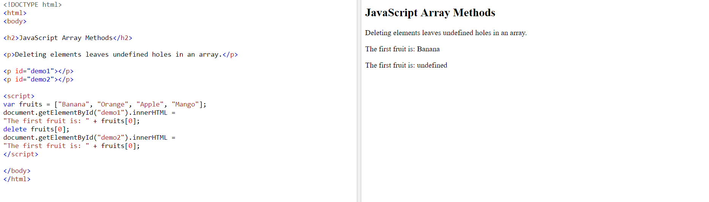

Using **delete** may leave undefined holes in the array. Use pop() or shift() instead.

## Splicing an Array

The splice() method can be used to add new items to an array:

### Example

var fruits = ["Banana", "Orange", "Apple", "Mango"];  
fruits.splice(2, 0, "Lemon", "Kiwi");

[Try it Yourself »](https://www.w3schools.com/js/tryit.asp?filename=tryjs_array_splice)

The first parameter (2) defines the position **where** new elements should be **added** (spliced in).

The second parameter (0) defines **how many** elements should be **removed**.

The rest of the parameters ("Lemon" , "Kiwi") define the new elements to be **added**.

The splice() method returns an array with the deleted items:

### Example

var fruits = ["Banana", "Orange", "Apple", "Mango"];  
fruits.splice(2, 2, "Lemon", "Kiwi");

[Try it Yourself »](https://www.w3schools.com/js/tryit.asp?filename=tryjs_array_splice_return)

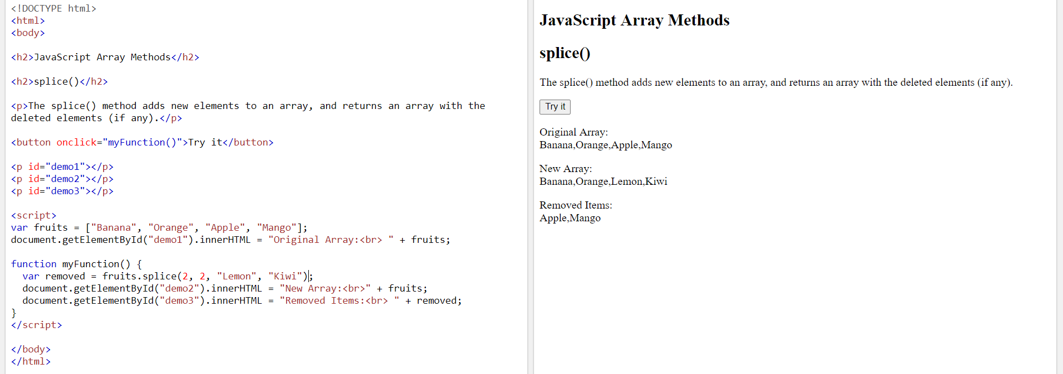

## Using splice() to Remove Elements

With clever parameter setting, you can use splice() to remove elements without leaving "holes" in the array:

### Example

var fruits = ["Banana", "Orange", "Apple", "Mango"];  
fruits.splice(0, 1);        // Removes the first element of fruits

[Try it Yourself »](https://www.w3schools.com/js/tryit.asp?filename=tryjs_array_remove)

The first parameter (0) defines the position where new elements should be **added** (spliced in).

The second parameter (1) defines **how many** elements should be **removed**.

The rest of the parameters are omitted. No new elements will be added.

## Merging (Concatenating) Arrays

The concat() method creates a new array by merging (concatenating) existing arrays:

### Example (Merging Two Arrays)

var myGirls = ["Cecilie", "Lone"];  
var myBoys = ["Emil", "Tobias", "Linus"];  
var myChildren = myGirls.concat(myBoys);   // Concatenates (joins) myGirls and myBoys

[Try it Yourself »](https://www.w3schools.com/js/tryit.asp?filename=tryjs_array_concat)

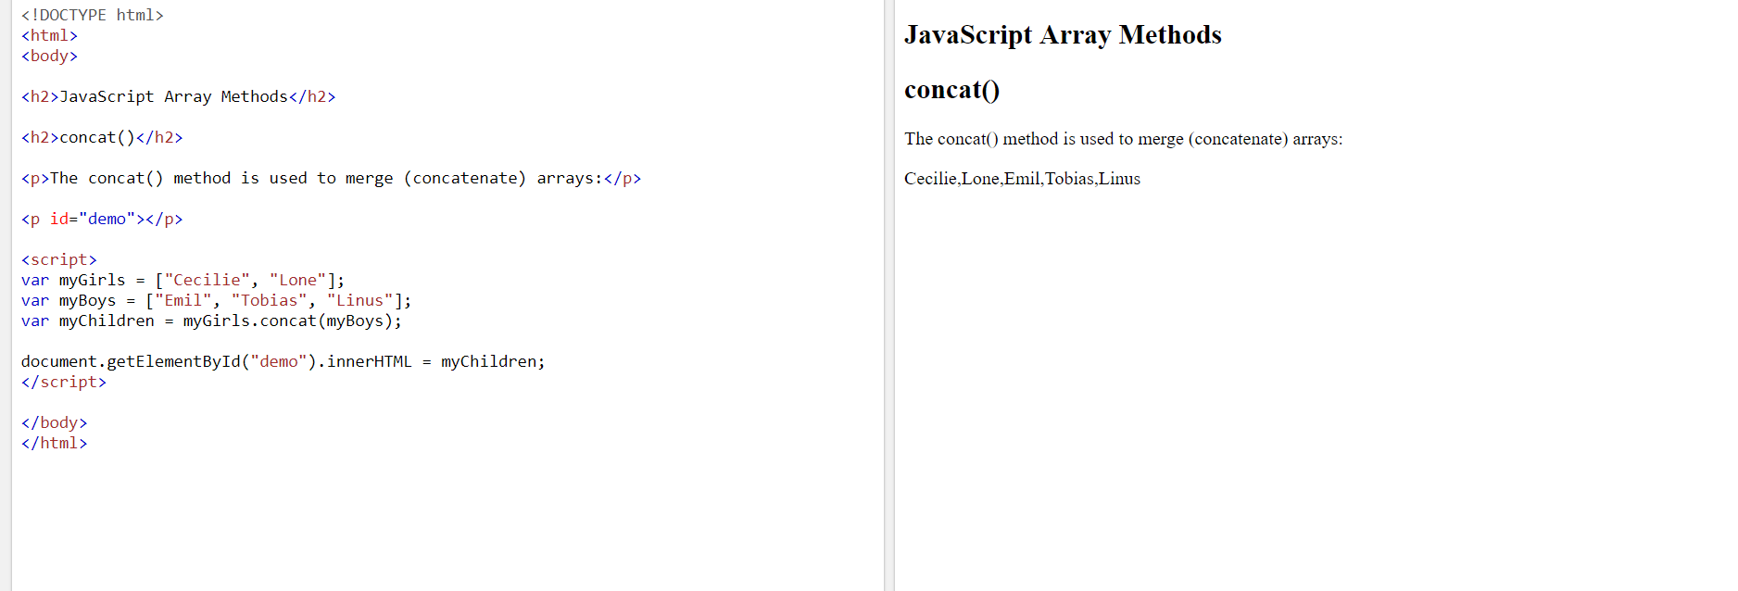

The concat() method does not change the existing arrays. It always returns a new array.

The concat() method can take any number of array arguments:

### Example (Merging Three Arrays)

var arr1 = ["Cecilie", "Lone"];  
var arr2 = ["Emil", "Tobias", "Linus"];  
var arr3 = ["Robin", "Morgan"];  
var myChildren = arr1.concat(arr2, arr3);   // Concatenates arr1 with arr2 and arr3

[Try it Yourself »](https://www.w3schools.com/js/tryit.asp?filename=tryjs_array_concat2)

The concat() method can also take strings as arguments:

### Example (Merging an Array with Values)

var arr1 = ["Emil", "Tobias", "Linus"];  
var myChildren = arr1.concat("Peter");

[Try it Yourself »](https://www.w3schools.com/js/tryit.asp?filename=tryjs_array_concat3)

## Slicing an Array

The slice() method slices out a piece of an array into a new array.

This example slices out a part of an array starting from array element 1 ("Orange"):

### Example

var fruits = ["Banana", "Orange", "Lemon", "Apple", "Mango"];  
var citrus = fruits.slice(1);

[Try it Yourself »](https://www.w3schools.com/js/tryit.asp?filename=tryjs_array_slice1)

The slice() method creates a new array. It does not remove any elements from the source array.

This example slices out a part of an array starting from array element 3 ("Apple"):

### Example

var fruits = ["Banana", "Orange", "Lemon", "Apple", "Mango"];  
var citrus = fruits.slice(3);

[Try it Yourself »](https://www.w3schools.com/js/tryit.asp?filename=tryjs_array_slice3)

The slice() method can take two arguments like slice(1, 3).

The method then selects elements from the start argument, and up to (but not including) the end argument.

### Example

var fruits = ["Banana", "Orange", "Lemon", "Apple", "Mango"];  
var citrus = fruits.slice(1, 3);

[Try it Yourself »](https://www.w3schools.com/js/tryit.asp?filename=tryjs_array_slice)

If the end argument is omitted, like in the first examples, the slice() method slices out the rest of the array.

### Example

var fruits = ["Banana", "Orange", "Lemon", "Apple", "Mango"];  
var citrus = fruits.slice(2);

[Try it Yourself »](https://www.w3schools.com/js/tryit.asp?filename=tryjs_array_slice2)

## Automatic toString()

JavaScript automatically converts an array to a comma separated string when a primitive value is expected.

This is always the case when you try to output an array.

These two examples will produce the same result:

### Example

var fruits = ["Banana", "Orange", "Apple", "Mango"];  
document.getElementById("demo").innerHTML = fruits.toString();

[Try it Yourself »](https://www.w3schools.com/js/tryit.asp?filename=tryjs_array_tostring)

### Example

var fruits = ["Banana", "Orange", "Apple", "Mango"];  
document.getElementById("demo").innerHTML = fruits;

[Try it Yourself »](https://www.w3schools.com/js/tryit.asp?filename=tryjs_array_automatic)

All JavaScript objects have a toString() method.

## Finding Max and Min Values in an Array

There are no built-in functions for finding the highest or lowest value in a JavaScript array.

You will learn how you solve this problem in the next chapter of this tutorial.

## Sorting Arrays

Sorting arrays are covered in the next chapter of this tutorial.

## Complete Array Reference

For a complete reference, go to our [Complete JavaScript Array Reference](https://www.w3schools.com/jsref/jsref_obj_array.asp).

The reference contains descriptions and examples of all Array properties and methods.

# **JavaScript Sorting Arrays**

[❮ Previous](https://www.w3schools.com/js/js_array_methods.asp)[Next ❯](https://www.w3schools.com/js/js_array_iteration.asp)

## Sorting an Array

The sort() method sorts an array alphabetically:

### Example

var fruits = ["Banana", "Orange", "Apple", "Mango"];  
fruits.sort();        // Sorts the elements of fruits

[Try it Yourself »](https://www.w3schools.com/js/tryit.asp?filename=tryjs_array_sort)

## Reversing an Array

The reverse() method reverses the elements in an array.

You can use it to sort an array in descending order:

### Example

var fruits = ["Banana", "Orange", "Apple", "Mango"];  
fruits.sort();        // First sort the elements of fruits  
fruits.reverse();     // Then reverse the order of the elements

[Try it Yourself »](https://www.w3schools.com/js/tryit.asp?filename=tryjs_array_sort_reverse)

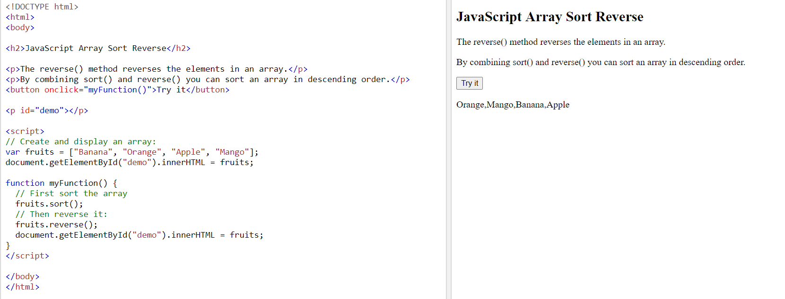

## Numeric Sort

By default, the sort() function sorts values as **strings**.

This works well for strings ("Apple" comes before "Banana").

However, if numbers are sorted as strings, "25" is bigger than "100", because "2" is bigger than "1".

Because of this, the sort() method will produce incorrect result when sorting numbers.

You can fix this by providing a **compare function**:

### Example

var points = [40, 100, 1, 5, 25, 10];  
points.sort(function(a, b){return a - b});

[Try it Yourself »](https://www.w3schools.com/js/tryit.asp?filename=tryjs_array_sort2)

Use the same trick to sort an array descending:

### Example

var points = [40, 100, 1, 5, 25, 10];  
points.sort(function(a, b){return b - a});

[Try it Yourself »](https://www.w3schools.com/js/tryit.asp?filename=tryjs_array_sort3)

## The Compare Function

The purpose of the compare function is to define an alternative sort order.

The compare function should return a negative, zero, or positive value, depending on the arguments:

function(a, b){return a - b}

When the sort() function compares two values, it sends the values to the compare function, and sorts the values according to the returned (negative, zero, positive) value.

If the result is negative a is sorted before b.

If the result is positive b is sorted before a.

If the result is 0 no changes are done with the sort order of the two values.

**Example:**

The compare function compares all the values in the array, two values at a time (a, b).

When comparing 40 and 100, the sort() method calls the compare function(40, 100).

The function calculates 40 - 100 (a - b), and since the result is negative (-60),  the sort function will sort 40 as a value lower than 100.

You can use this code snippet to experiment with numerically and alphabetically sorting:

<button onclick="myFunction1()">Sort Alphabetically</button>  
<button onclick="myFunction2()">Sort Numerically</button>  
  
<p id="demo"></p>  
  
<script>  
var points = [40, 100, 1, 5, 25, 10];  
document.getElementById("demo").innerHTML = points;  
  
function myFunction1() {  
  points.sort();  
  document.getElementById("demo").innerHTML = points;  
}  
  
function myFunction2() {  
  points.sort(function(a, b){return a - b});  
  document.getElementById("demo").innerHTML = points;  
}  
</script>

[Try it Yourself »](https://www.w3schools.com/js/tryit.asp?filename=tryjs_array_sort_alpha)

## Sorting an Array in Random Order

### Example

var points = [40, 100, 1, 5, 25, 10];  
points.sort(function(a, b){return 0.5 - Math.random()});

[Try it Yourself »](https://www.w3schools.com/js/tryit.asp?filename=tryjs_array_sort_random)

## The Fisher Yates Method

The above example, array.sort(), is not accurate, it will favor some numbers over the others.

The most popular correct method, is called the Fisher Yates shuffle, and was introduced in data science as early as 1938!

In JavaScript the method can be translated to this:

### Example

var points = [40, 100, 1, 5, 25, 10];  
  
for (i = points.length -1; i > 0; i--) {  
  j = Math.floor(Math.random() * i)  
  k = points[i]  
  points[i] = points[j]  
  points[j] = k  
}

[Try it Yourself »](https://www.w3schools.com/js/tryit.asp?filename=tryjs_array_sort_random2)

## Find the Highest (or Lowest) Array Value

There are no built-in functions for finding the max or min value in an array.

However, after you have sorted an array, you can use the index to obtain the highest and lowest values.

Sorting ascending:

### Example

var points = [40, 100, 1, 5, 25, 10];  
points.sort(function(a, b){return a - b});  
// now points[0] contains the lowest value  
// and points[points.length-1] contains the highest value

[Try it Yourself »](https://www.w3schools.com/js/tryit.asp?filename=tryjs_array_sort_low)

Sorting descending:

### Example

var points = [40, 100, 1, 5, 25, 10];  
points.sort(function(a, b){return b - a});  
// now points[0] contains the highest value  
// and points[points.length-1] contains the lowest value

[Try it Yourself »](https://www.w3schools.com/js/tryit.asp?filename=tryjs_array_sort_high)

Sorting a whole array is a very inefficient method if you only want to find the highest (or lowest) value.

## Using Math.max() on an Array

You can use Math.max.apply to find the highest number in an array:

### Example

function myArrayMax(arr) {  
  return Math.max.apply(null, arr);  
}

[Try it Yourself »](https://www.w3schools.com/js/tryit.asp?filename=tryjs_array_sort_math_max)

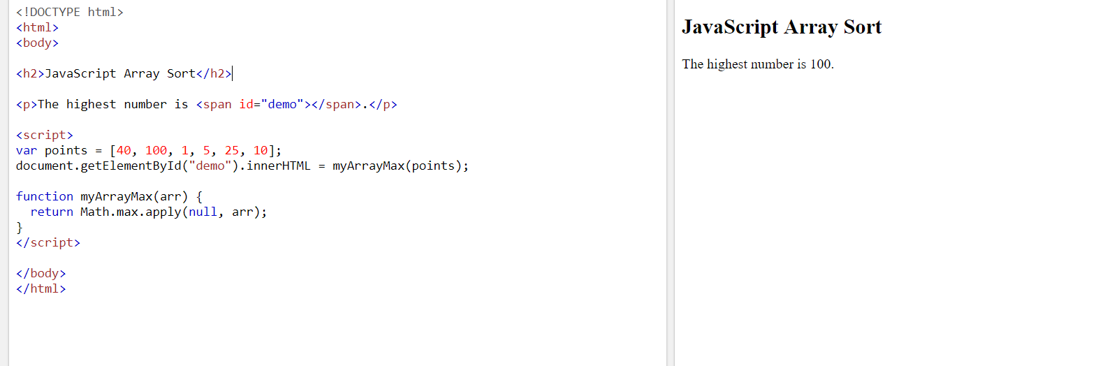

Math.max.apply(null, [1, 2, 3]) is equivalent to Math.max(1, 2, 3).

## Using Math.min() on an Array

You can use Math.min.apply to find the lowest number in an array:

### Example

function myArrayMin(arr) {  
  return Math.min.apply(null, arr);  
}

[Try it Yourself »](https://www.w3schools.com/js/tryit.asp?filename=tryjs_array_sort_math_min)

Math.min.apply(null, [1, 2, 3]) is equivalent to Math.min(1, 2, 3).

## My Min / Max JavaScript Methods

The fastest solution is to use a "home made" method.

This function loops through an array comparing each value with the highest value found:

### Example (Find Max)

function myArrayMax(arr) {  
  var len = arr.length;  
  var max = -Infinity;  
  while (len--) {  
    if (arr[len] > max) {  
      max = arr[len];  
    }  
  }  
  return max;  
}

[Try it Yourself »](https://www.w3schools.com/js/tryit.asp?filename=tryjs_array_sort_max)

This function loops through an array comparing each value with the lowest value found:

### Example (Find Min)

function myArrayMin(arr) {  
  var len = arr.length;  
  var min = Infinity;  
  while (len--) {  
    if (arr[len] < min) {  
      min = arr[len];  
    }  
  }  
  return min;  
}

[Try it Yourself »](https://www.w3schools.com/js/tryit.asp?filename=tryjs_array_sort_min)

## Sorting Object Arrays

JavaScript arrays often contain objects:

### Example

var cars = [  
  {type:"Volvo", year:2016},  
  {type:"Saab", year:2001},  
  {type:"BMW", year:2010}  
];

Even if objects have properties of different data types, the sort() method can be used to sort the array.

The solution is to write a compare function to compare the property values:

### Example

cars.sort(function(a, b){return a.year - b.year});

[Try it Yourself »](https://www.w3schools.com/js/tryit.asp?filename=tryjs_array_sort_object1)

Comparing string properties is a little more complex:

### Example

cars.sort(function(a, b){  
  var x = a.type.toLowerCase();  
  var y = b.type.toLowerCase();  
  if (x < y) {return -1;}  
  if (x > y) {return 1;}  
  return 0;  
});