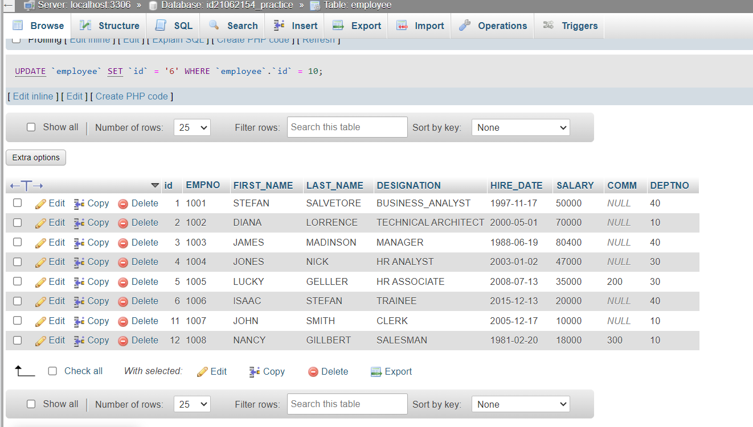

CREATE TABLE my_company(id int PRIMARY KEY AUTO_INCREMENT);

ALTER TABLE my_company ADD (EMPNO int , FIRST_NAME varchar(50) , LAST_NAME varchar(50) , DESIGNATION varchar(50) , HIRE_DATE date , SALARY varchar(50) , COMM varchar(50) , DEPTNO varchar(50));

INSERT INTO employee(EMPNO,FIRST_NAME,LAST_NAME,DESIGNATION,HIRE_DATE,SALARY,COMM,DEPTNO) VALUES ('1008','NANCY','GILLBERT','SALESMAN','1981-02-20','18000','300','10')