UoG-Faculty of CS & IT


Spring 2011

Digital Logic Design CS-151

Sequential Networks
„ Have clock and state
„ Present state depends not only on the current input, but also on all previous inputs (history)
„ Future state depends on the current input and state
X = x1 x2... xn
Q = Q1 Q2... Qk
Z = z1 z2... zm
x1 z1
x2 Q z2

xn

Z ( t ) =

F ( X

( t ),

Q ( t ))
z Flip-flops are
m commonly used as
storage devices:

Q ( t + ) =
G ( X
( t ),
Q ( t ))
D-FF, JK-FF, T-FF

Clocked D Flip-Flop with Rising-edge Trigger

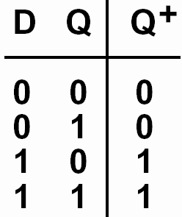

Next state

The next state in response to the rising edge of the clock is equal to the D input before the rising edge
Clocked JK Flip-Flop

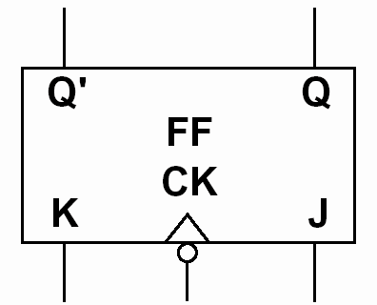
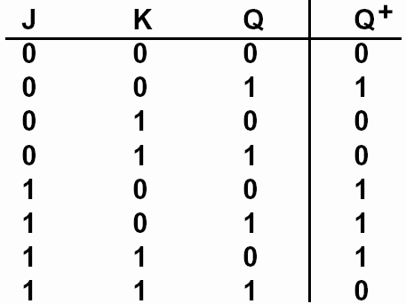

Next state
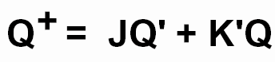

JK = 00 => no state change occurs
JK = 10 => the flip-flop is set to 1, independent of the current state
JK = 01 => the flip-flop is always reset to 0
JK = 11 => the flip-flop changes the state Q+ = Q’
Clocked JK Flip-Flop

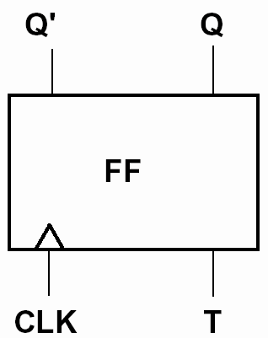

Next state
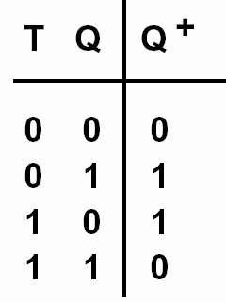

T = 1 => the flip-flop changes the state Q+ = Q’ T = 0 => no state change
S-R Latch

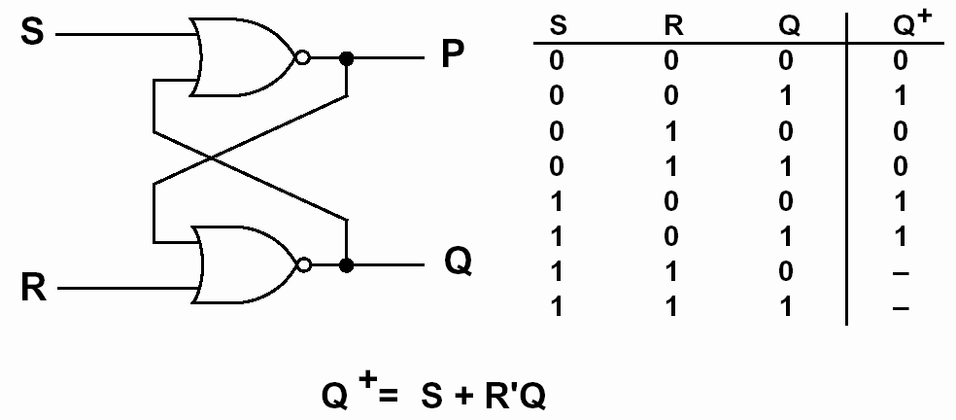
Transparent D Latch

