**QUIZ**

19010819-021

Nabeel Yousaf

MSc Computer Science

DCN

Dated : 30-June-2020

Class **C IP** Address : 200.10.20.0/24

|  |  |
| --- | --- |
| Network | Number of Hosts required. |
| Network-1 | 32 |
| Network-2 | 14 |
| Network-3 | 60 |
| Network-4 | 2 |
| Network-5 | 2 |
| Network-6 | 2 |

|  |  |  |  |  |  |  |  |  |
| --- | --- | --- | --- | --- | --- | --- | --- | --- |
| **Name** | **Hosts Needed** | **Hosts Available** | **Unused Hosts** | **Network Address** | **Slash** | **Mask** | **Usable Range** | **Broadcast** |
| Network-3 | 60 | 62 | 2 | 200.10.20.0 | /26 | 255.255.255.192 | 200.10.20.1 - 200.10.20.62 | 200.10.20.63 |
| Network-1 | 32 | 62 | 30 | 200.10.20.64 | /26 | 255.255.255.224 | 200.10.20.65 - 200.10.20.126 | 200.10.20.127 |
| Network-2 | 14 | 14 | 0 | 200.10.20.128 | /28 | 255.255.255.240 | 200.10.20.129 - 200.10.20.142 | 200.10.20.143 |
| Network-4 | 2 | 2 | 0 | 200.10.20.144 | /30 | 255.255.255.252 | 200.10.20.145 - 200.10.20.146 | 200.10.20.147 |
| Network-5 | 2 | 2 | 0 | 200.10.20.148 | /30 | 255.255.255.252 | 200.10.20.149 - 200.10.20.150 | 200.10.20.151 |
| Network-6 | 2 | 2 | 0 | 200.10.20.152 | /30 | 255.255.255.252 | 200.10.20.153 - 200.10.20.154 | 200.10.20.155 |

**ROUTER 1:**

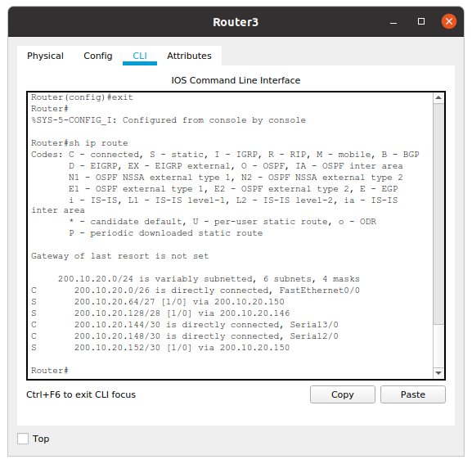

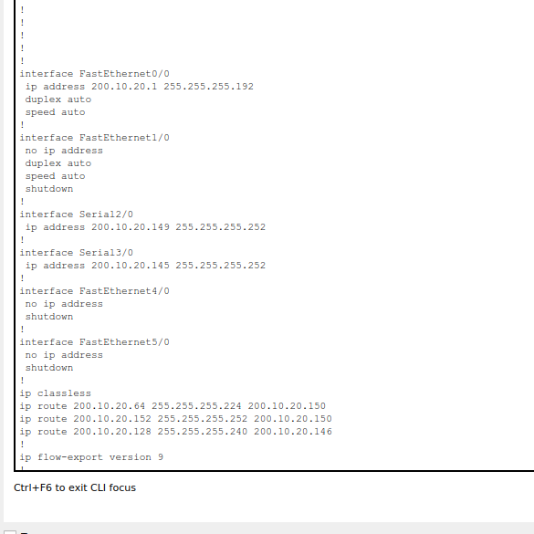

**Router 2**

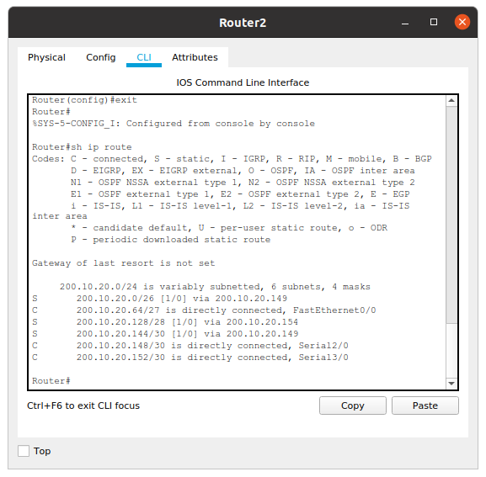

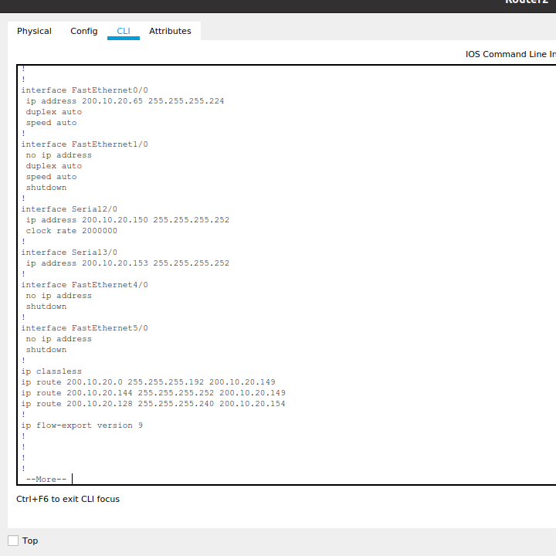

**Router 3:**

