**Name**

YoungCareer

**Prerequisites**

For open this website you only need laptop/smartphone and installed browser.

**Description**

Website of telegram channel where posting job vacancies and internships for juniors. Using this website, you can gain new information every day. There we have parts about internships, job vacancies and articles. Also, users can contact us for ask some important questions and send their resumes to checking.

**Installation**

Use the package manager [pip](https://pip.pypa.io/en/stable/) to install foobar.

pip install websiteYC

**Built with**

Laravel, php, html, css

**Roadmap**

In future it would be used for searching vacancies, internships and useful articles which would help juniors to easily find job in Kz and foreign countries.

**Contributes**

Pull requests are welcome. For major changes, please open an issue first to discuss what you would like to change.

Please make sure to update tests as appropriate.

**Author**

Aruzhan Kabulova



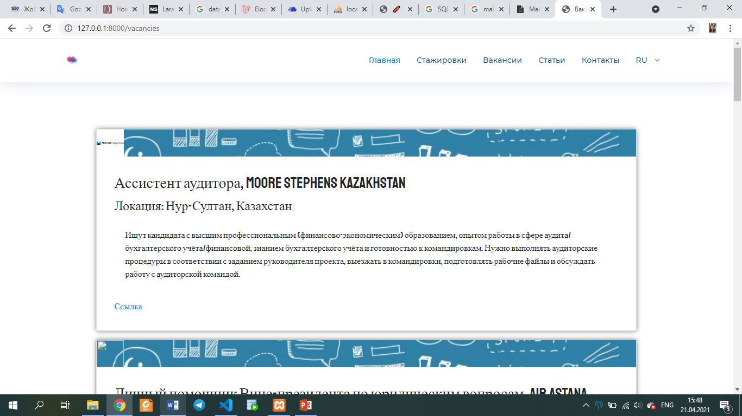

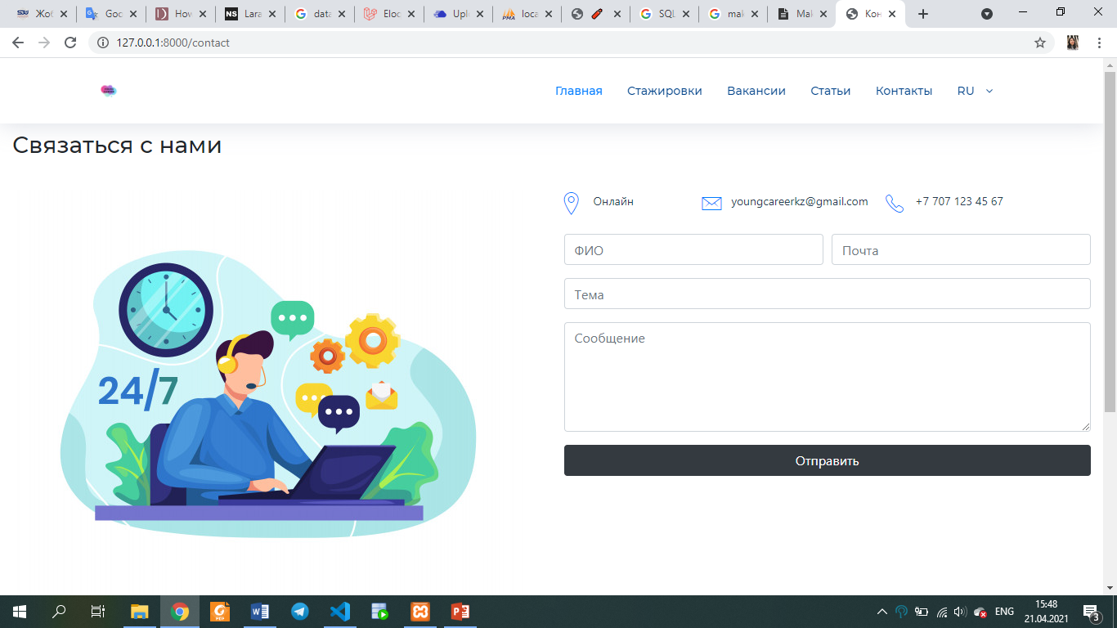

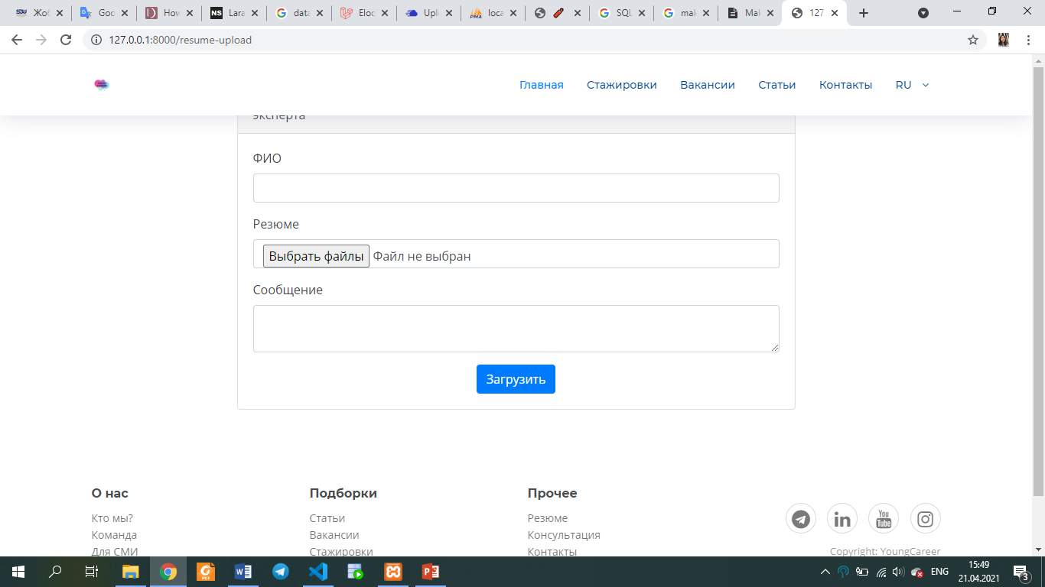

ERD diagram (many-to-many relation)

