网络层
1.
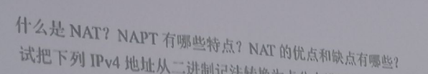
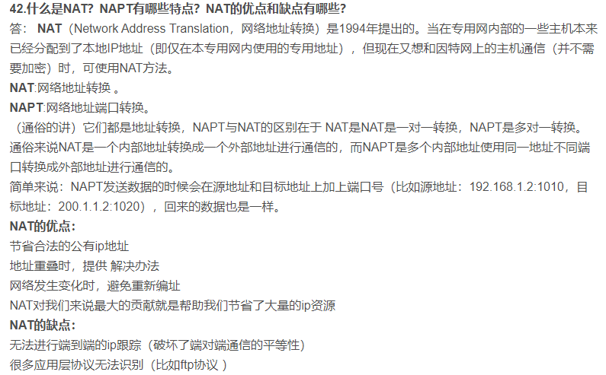

2.
https://www.nowcoder.com/questionTerminal/23632fc3a22f4757a9fe35ba2c6e168a
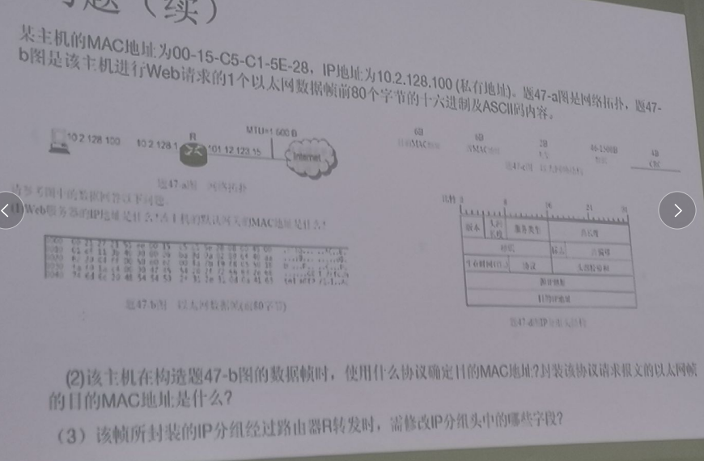
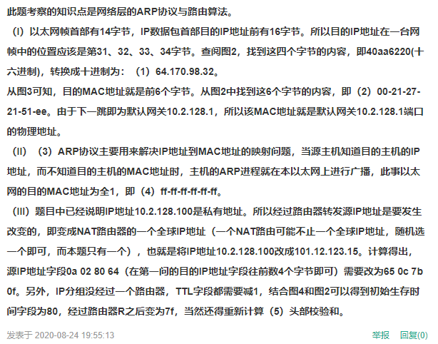
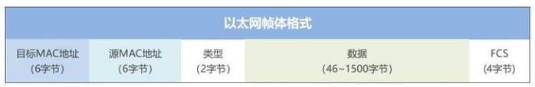

3.https://kaoyan.koolearn.com/20210711/1456563.html
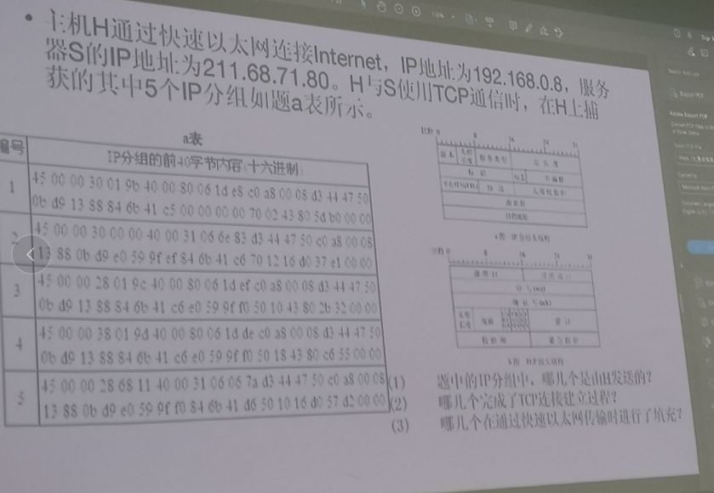
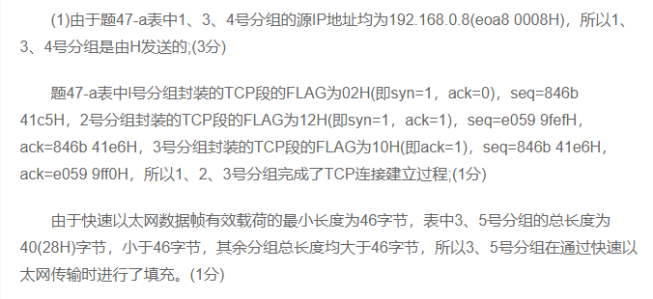

4.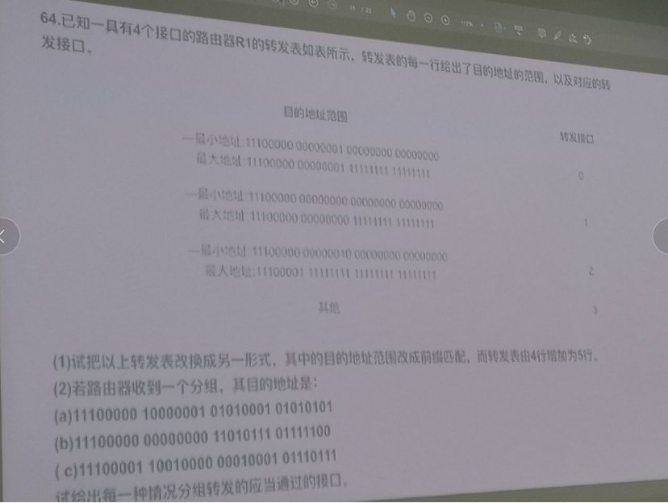
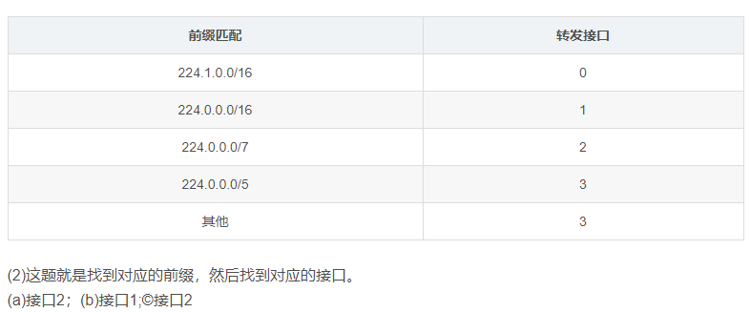

运输层
1.
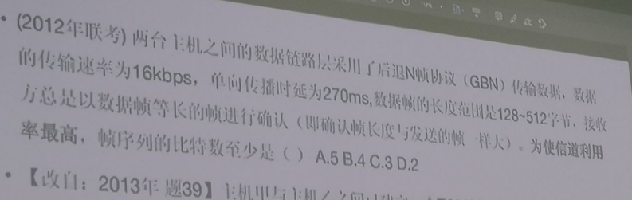
https://www.nowcoder.com/questionTerminal/0405663ab15c4b74be6aec946542a28c
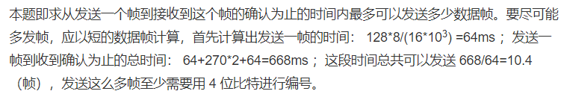

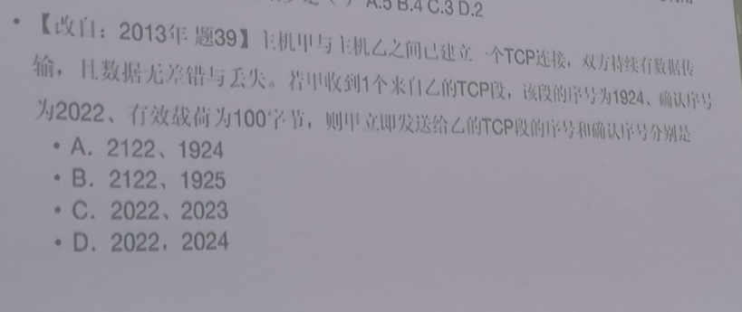
D

3.
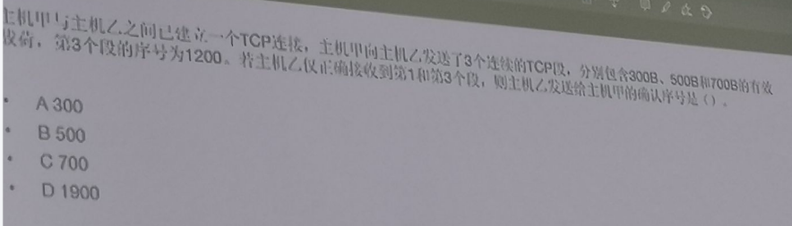
C

4.
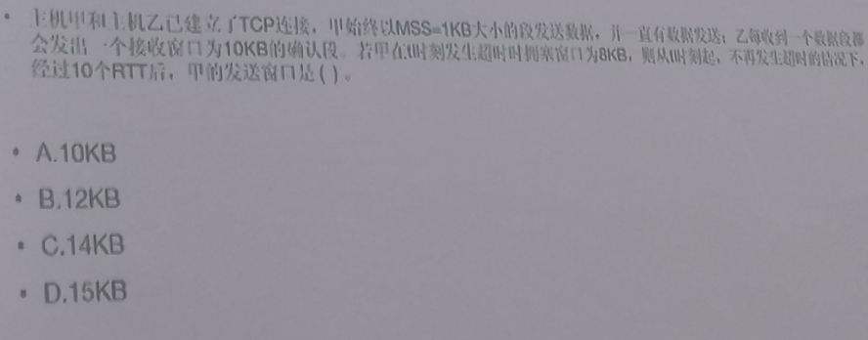
A

应用层
1.
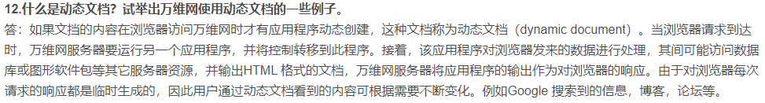

2.

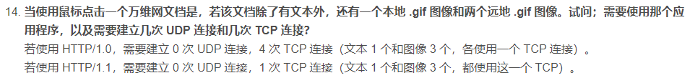

3.
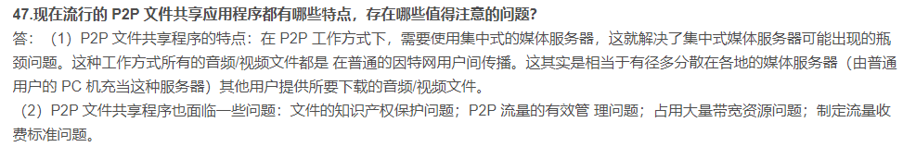
不需要

4.
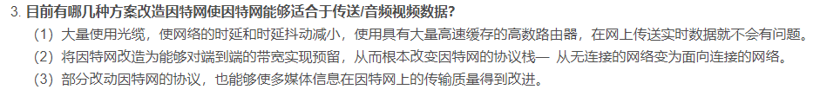

5.


