**Programming Assignment 1**

**Bilinear Interpolation**：One of the main tasks in image and video processing is image resizing. There are many methods for performing this task, but bilinear interpolation is very common among them. Linear interpolation is very common in 1D signals to estimate the values between two known values. In Figure 1, the value for queried coordinate (q) is linearly interpolated by values at coordinates 1 and 2.

𝑞=(1.25−1)1+(2−1.25)3=0.25+2.25=2.5

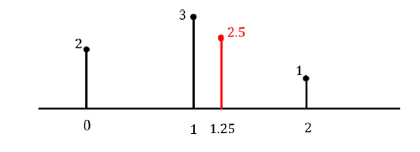

Figure 1. Linear interpolation in 1D

Bilinear interpolation is its extension in 2D that used for image resizing. Suppose we want to resize a 4x4 image into a 6x6 image. As illustrated in Figure 2, the four corner pixels are aligned and the rest of pixels are linearly distributed.

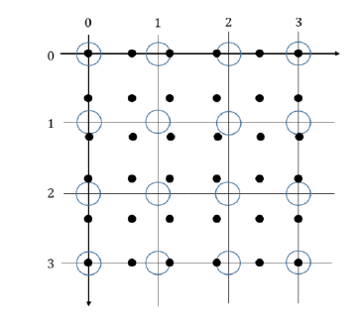

Figure 2. Resizing a 4x4 image to 6x6. The original pixels are blue circles and the query pixels are black dots.

As it is depicted in Figure 2, there are three types of query points

a. The query points that are aligned exactly at the original points (e.g. the four corner points). For this category, you can simply assign the original value to the queried value.

b. The query points that are aligned at the square’s horizontal or vertical edges. To find the values for these points, use the 1D linear interpolation method that is explained earlier.

𝑣𝑞=(𝑥𝑞−𝑥1)𝑣2+(𝑥2−𝑥𝑞)𝑣1

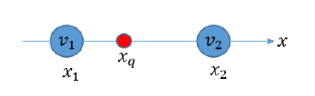

Figure 3. Linear interpolation when the query point is at the edge

c. The query points that are inside the square. We can find the value for the query points using twice linear interpolation. First, we find the values for green points at the edges (horizontal or vertical), and then interpolate between the green point to find the value for the queried point (red).

𝑣𝑞=(1−𝑎)(1−𝑏)𝑣1+𝑎(1−𝑏)𝑣2+(1−𝑎)𝑏𝑣3+𝑎𝑏𝑣4

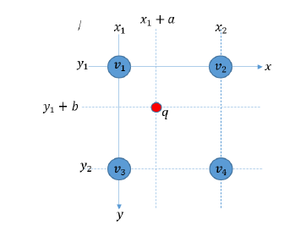

Figure 4. Bilinear interpolation of query point

Write a function “imresize” that gets the *original image*, *original size*, and *target size* as input and returns the output image at the target size using bilinear interpolation. Apply the imresize to one of the test images (256x256) to scale them to 1.5 and 0.75 (384x384 and 192x192 respectively).

**提交报告内容：**包括实现原理，程序输入与输出图像对比，结果分析，及代码。编程语言不限。