[http://curl.haxx.se/download.html](http://curl.haxx.se/download.html" \t "_blank)

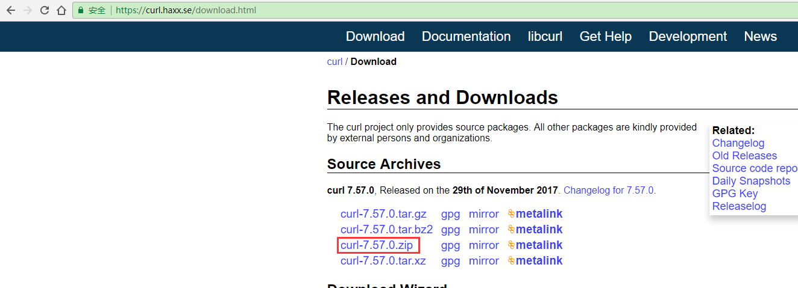

下载并配置mingw64环境

编译：

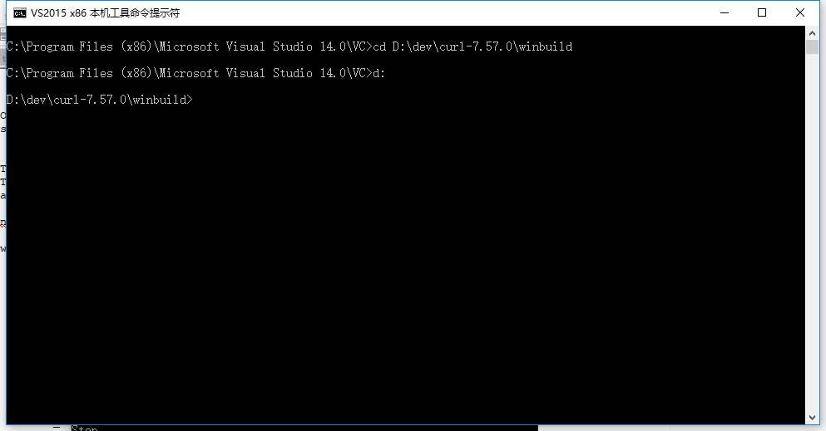

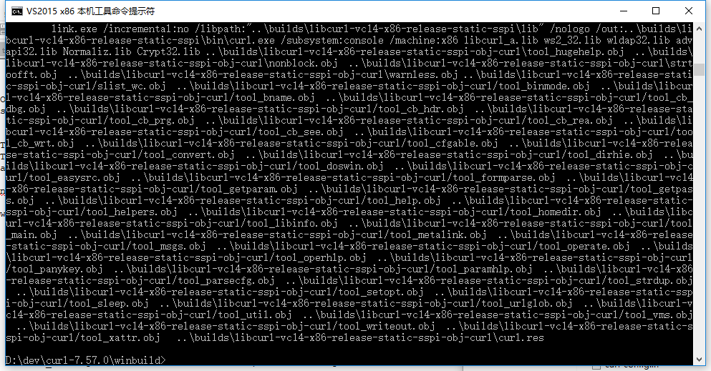

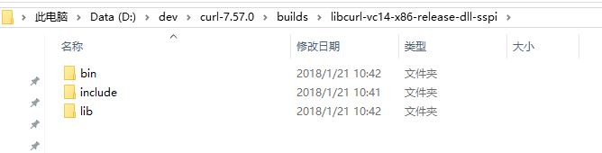

nmake /f Makefile.vc mode=static VC=14

nmake /f Makefile.vc mode=static VC=14 ENABLE\_WINSSL=false ENABLE\_IPV6=false MACHINE=x86

C:\Program Files (x86)\Microsoft Visual Studio 14.0\VC\bin\nmake /f Makefile.vc mode=14

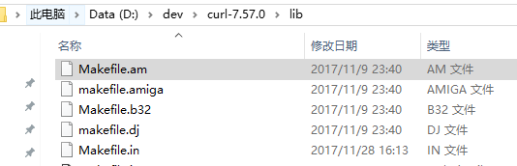

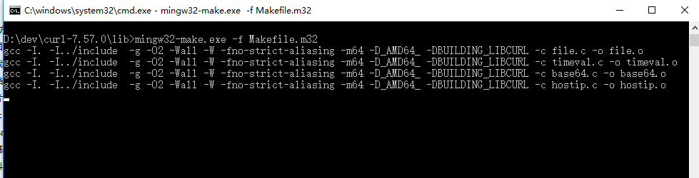

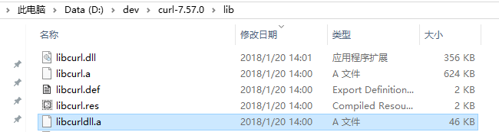

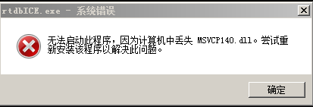

缺少vc运行环境

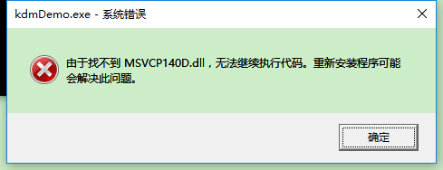

程序是Debug模式运行，Release版本正常

#include "./lib/curl.h"