**Elasticsearch API使用**

<https://www.elastic.co/guide/en/elasticsearch/reference/current/docs.html>

# Docker Elasticsearch安装

sudo docker run \

--name my-elasticsearch \

-d --restart=unless-stopped \

-v "/home/oge/elasticsearch/data":/usr/share/elasticsearch/data \

-p 9200:9200 \

elasticsearch:5.5.0

-v "/home/oge/elasticsearch/config":/usr/share/elasticsearch/config \

# Docker kibana安装

docker run \

--name kibana \

-d --restart=unless-stopped \

--link my-elasticsearch:elasticsearch \

-p 5601:5601 \

-d kibana:5.5.0

# 创建索引

postman put http://127.0.0.1:9200/oge_data

curl -XPUT http://127.0.0.1:9200/oge_data

curl --request PUT http://127.0.0.1:9200/oge_data

PUT oge_data/data/1

{

    "user" : "yao",

    "post_date" : "2017-07-20T14:12:12",

    "message" : "trying out Elasticsearch"

}

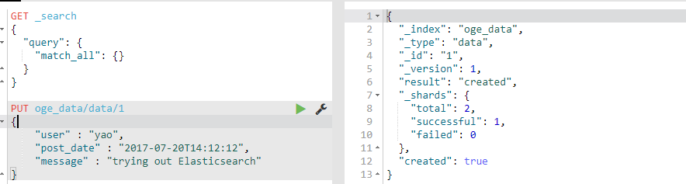

添加索引并配置

PUT /fengji

{

"settings": {

"number_of_replicas": 0,

"refresh_interval": "15s",

"number_of_shards": 3

},

"mappings": {

"poc": {

"properties": {

"datetime": {

"type": "date"

},

"tag": {

"type": "text",

"fielddata": "true"

}

}

}

}

}

增加文档

# 删除索引

curl -XDELETE http://127.0.0.1:9200/logstash-* //删除所有以logstash-开始的索引

{

  "acknowledged": true

}

# kibana

地址：127.0.0.1:5601

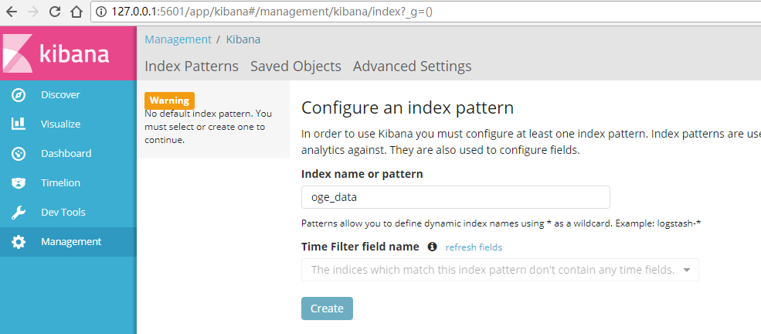

# 文档操作

## 增加文档

增加数据到索引中，使之能够进行搜索，文档的格式是JSON格式

PUT oge_data/data/1

{

  "tag": "KKS1",

  "datetime": 1,

  "value": 12.21

}

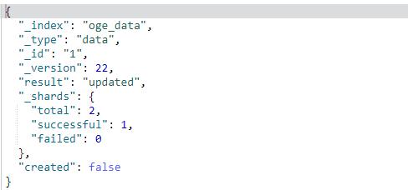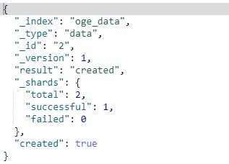

**注意1：**

oge_data/data/1 中的1为id，如果id存在，则为更新数据，即created : false。不存在，则created : true，可以使用自动创建id逻辑，将put改为post，路径为oge_data/data

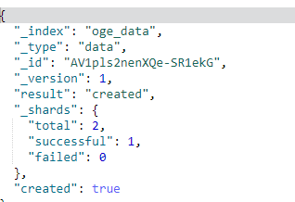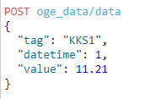

## 查询文档

### [不带参数] GET /oge_data/data/_search

### [带参数] GET /fengji/poc/_search

{

"query": {

"match": {

"tag": "YN001WF0MZA00MA001ZZ00B2DC002AA05"

}

}

}

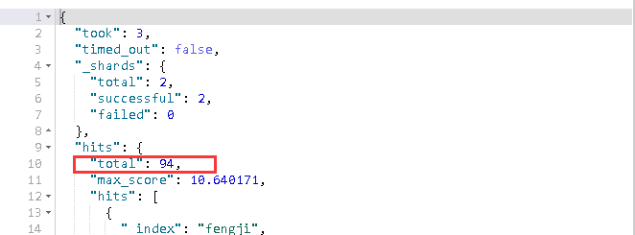

### GET oge_data/data/_mget

{

  "docs": [

    {

      "_id": "1"

    },

    {

      "_id": "2"

    }

  ]

}

### GET oge_data/data/_mget

{

  "ids" : ["1", "2"]

}

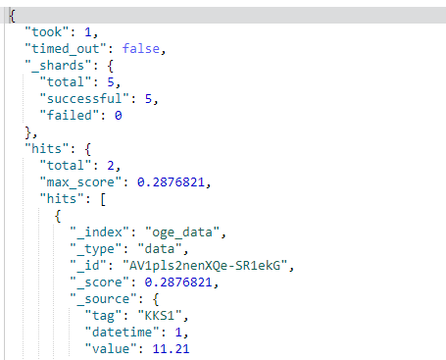

### 分页

GET oge_data/precent/_search

{

"from" : 0, "size" : 50,

"query": {

"match": {

"tag": "YN001WF1MVB00MB025ZZ01B2KF003AA05"

}

}

}

### 排序

GET _search

{

  "query": {

    "match_all": {}

  },

  "sort": [

    {

      "datetime": {

        "order": "desc"

      }

    }

  ]

}

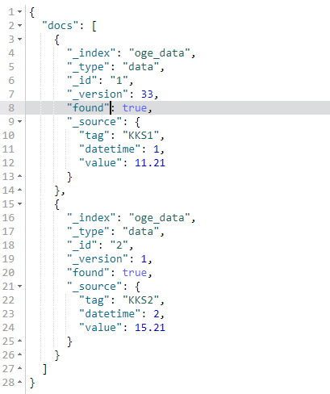

## 删除文档（之前录入一个错误的类型）

### 根据id删除

DELETE oge_data/dada/1

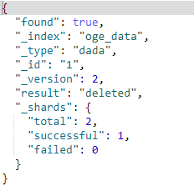

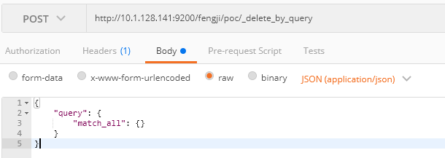

### 根据查询条件删除_delete_by_query

POST /fengji/poc/_delete_by_query

{

"query": {

"match_all": {}

}

}

# dejavu插件

dejavu : <https://github.com/appbaseio/dejaVu>

cnpm install

cnpm install bower

bower install

npm start (open dejavu in the browser on [http://localhost:1358](http://localhost:1358/live))

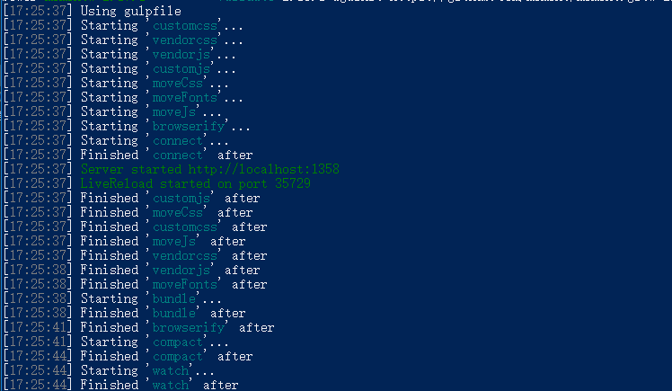

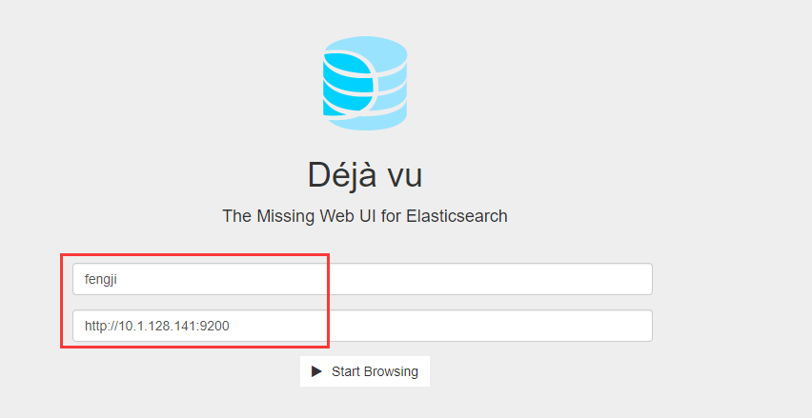

或者chrome安装插件，直接可以使用

