《数据库概论》实验一：用SQL进行数据操作 实验报告

姓名 傅小龙 学号 191220029 联系方式 1830970417(QQ)

实验环境

操作系统: Windows 10 (19042.1288)

Mysql Workbench 8.0 CE

mysql-8.0.19-winx64

实验过程

任务1：

-- ___________________________________________________________________

-- BEGIN Q1

select count(*) speciesCount

from Species

where description like '%this%';

-- END Q1

-- ___________________________________________________________________

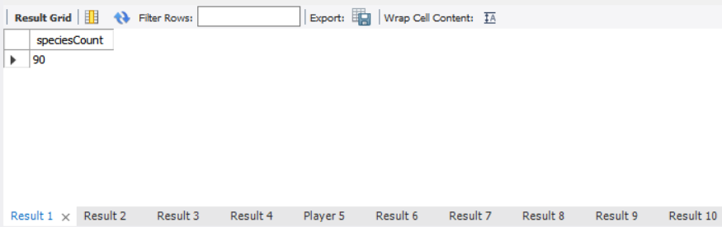

任务2：

-- ___________________________________________________________________

-- BEGIN Q2

select Player.username, SUM(Phonemon.power)totalPhonemonPower

from Player, Phonemon

where (username = 'Cook' OR username = 'Hughes') and Player.id = Phonemon.player

group by username;

-- END Q2

-- ___________________________________________________________________

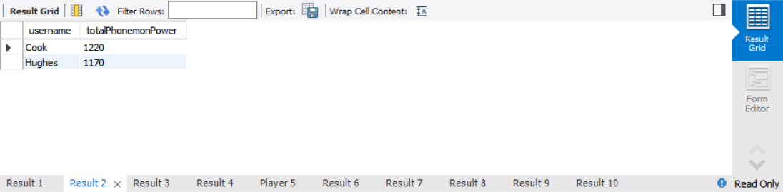

任务3：

-- ___________________________________________________________________

-- BEGIN Q3

select title, count(Player.id) numberOfPlayers

from Player, Team

where Player.team = Team.id

group by Team.id

order by count(Player.id) desc;

-- END Q3

-- ___________________________________________________________________

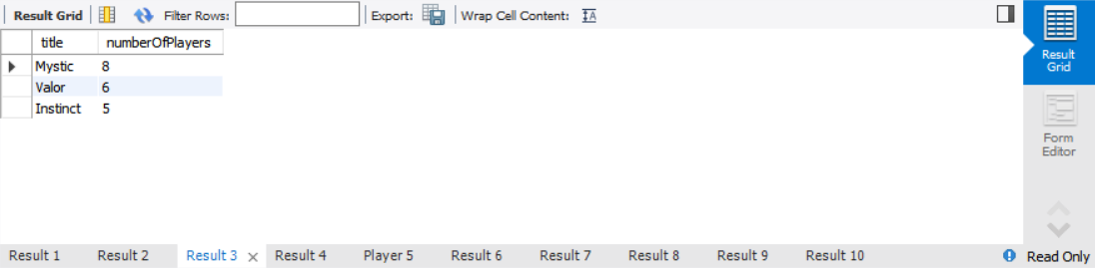

任务4：

-- ___________________________________________________________________

-- BEGIN Q4

select Species.id idSpecies, Species.title

from Species, Type

where Type.title = 'grass' AND (type1 = Type.id OR type2 = Type.id);

-- END Q4

-- ___________________________________________________________________

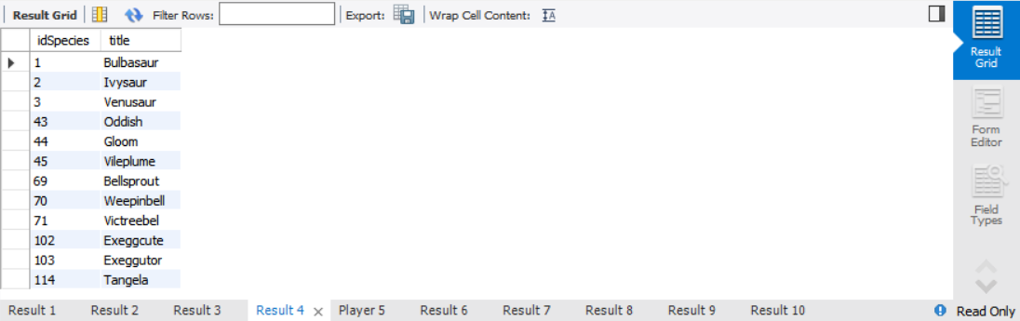

任务5：

-- ___________________________________________________________________

-- BEGIN Q5

select id idPlayer, username

from Player

where Player.id not in

(

select Player.id

from Player, Item, Purchase

where Player.id = Purchase.player and Purchase.item = Item.id and Item.type = 'F'

);

-- END Q5

-- ___________________________________________________________________

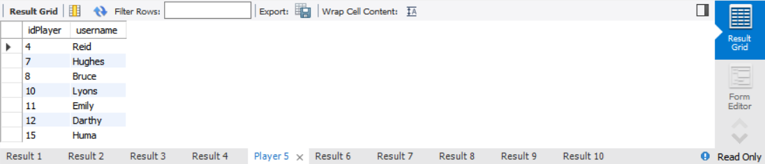

任务6：

-- ___________________________________________________________________

-- BEGIN Q6

select Player.level,

sum(Purchase.quantity * Item.price) totalAmountSpentByAllPlayersAtLevel

from Player, Purchase, Item

where Player.id = Purchase.player and Item.id = Purchase.item

group by level

order by Player.level desc;

-- END Q6

-- ___________________________________________________________________

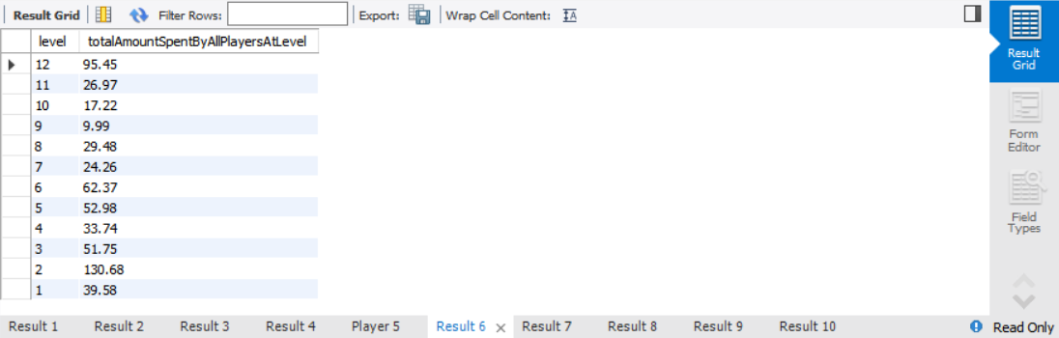

任务7：

-- ___________________________________________________________________

-- BEGIN Q7

select purchase.item, item.title, count(purchase.item) numTimesPurchased

from purchase, item

where purchase.item = item.id

group by purchase.item

having numTimesPurchased >= all(

select count(purchase.item)

from purchase

group by purchase.item

);

-- END Q7

-- ___________________________________________________________________

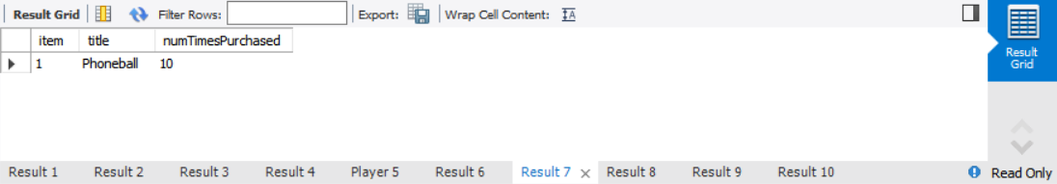

任务8：

-- ___________________________________________________________________

-- BEGIN Q8

select Player.id, Player.username,

count(distinct Item.id) numberDistinctFoodItemsPurchased

from Player, Purchase, Item

where Player.id = Purchase.player and Purchase.item = Item.id and Item.type = 'F'

group by Player.id

having numberDistinctFoodItemsPurchased = (select count(*) from food);

-- END Q8

-- ___________________________________________________________________

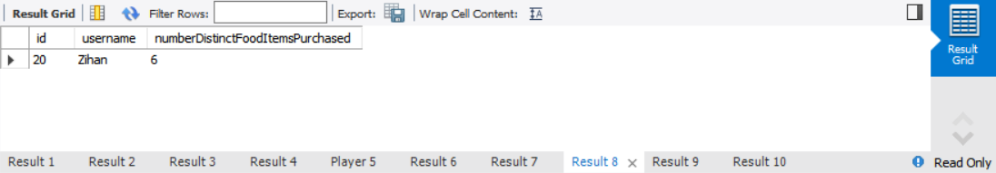

任务9：

-- ___________________________________________________________________

-- BEGIN Q9

select count(*) numberOfPhonemonPairs, distanceX

from

(

select t1.id id1, t2.id id2, round(sqrt(power((t1.latitude - t2.latitude), 2) + power((t1.longitude - t2.longitude), 2)) * 100, 3) distanceX

from Phonemon t1, Phonemon t2

where t1.id < t2.id

) as t

where distanceX <=

(

select round(min(sqrt(power((t1.latitude - t2.latitude), 2) + power((t1.longitude - t2.longitude), 2)) * 100), 3)

from Phonemon t1, Phonemon t2

where t1.id < t2.id

)

group by distanceX;

-- END Q9

-- ___________________________________________________________________

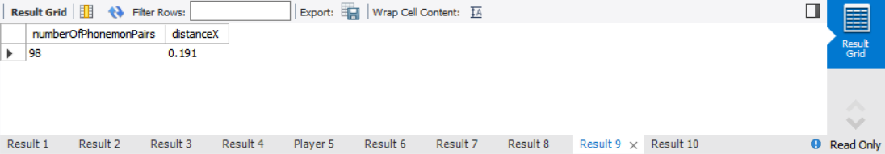

任务10：

-- ___________________________________________________________________

-- BEGIN Q10

select t.username, t.typeTitle

from

(

select player.username username, type.title typeTitle, type.id

from player, phonemon, species, type

where player.id = phonemon.player and phonemon.species = species.id and (species.type1 = type.id or species.type2 = type.id)

group by player.id, type.id

having count(distinct species.id) = (

select count(*) from Species where Species.type1 = type.id or Species.type2 = type.id

)

)as t

-- END Q10

-- ___________________________________________________________________

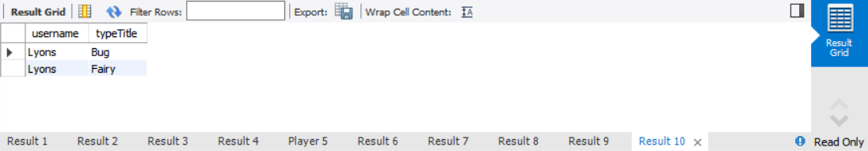

实验中遇到的困难及解决办法

本次实验中较为困难的部分在于编写出形式简单且易于理解的mysql语句。

例如任务8：找到可获取的食物的数量，和购买所有种类食物至少各一次的玩家。在实验时最初的想法是先找出购买所有种类食物各一次的玩家id, 然后再根据找出的id在Player, Purchase, Item, Food的联结表中进行统计，给出查询结果。其实现如下：

select playerId, username, num numberDistinctFoodItemsPurchased

from

(select Player.id playerID, Player.username username, count(Purchase.quantity) num

from Player, Purchase, Item, Food

where Player.id = Purchase.player and Purchase.item = Item.id and Item.id = Food.id

group by Player.id, Purchase.item) as t

where playerID in (

select t.id from

(select Player.id id, Purchase.item item

from Player, Purchase

where Player.id = Purchase.player

group by Player.id, Purchase.item) as t

group by t.id

having count(item) = (select count(*) from Food)

)

group by playerId;

实际上，可以直接通过在Player, Purchase, Item的联结表中用count(distinct Item.id)得到玩家购买的不同商品的数量，然后通过numberDistinctFoodItemsPurchased = (select count(*) from food) 判断该数量是否和所有食品的种类数相同。简化后的查询语句如下：

select Player.id, Player.username, count(distinct Item.id) numberDistinctFoodItemsPurchased

from Player, Purchase, Item

where Player.id = Purchase.player and Purchase.item = Item.id and Item.type = 'F'

group by Player.id

having numberDistinctFoodItemsPurchased = (select count(*) from food);

让语句变得简单易懂的关键在于尽可能多地利用单次查询可以得到的信息，合理高效地使用统计方法。