使用Ruby的交互开发环境irb进行实验，并参考课上PPT，画出该语言的对象模型图。

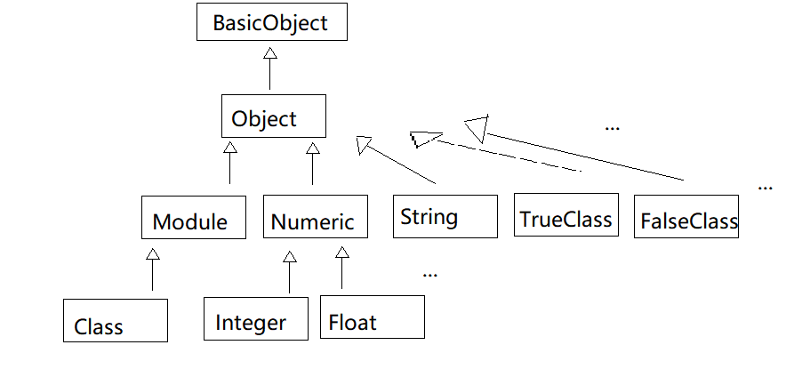

Ruby执行记录：

irb(main):025:0> Module.superclass

=> Object

irb(main):026:0> Object.superclass

=> BasicObject

irb(main):027:0> BasicObject.superclass

=> nil

irb(main):028:0>

irb(main):029:0> Integer.superclass

=> Numeric

irb(main):030:0> Numeric.superclass

=> Object

irb(main):031:0> Class.superclass

=> Module

irb(main):032:0> TrueClass.superclass

=> Object

irb(main):033:0> FalseClass.superclass

=> Object

irb(main):034:0> Fixnum.superclass

=> Numeric

irb(main):035:0> Numeric.superclass

=> Object

irb(main):036:0> Float.superclass

=> Numeric

irb(main):037:0> Integer.superclass

=> Numeric

irb(main):038:0> String.superclass

=> Object

irb(main):039:0> Numeric.subclasses

=> [Date::Infinity, Complex, Rational, Float, Integer]

irb(main):040:0> Class.subclasses

=> []

irb(main):041:0> Object.subclasses

=>

[RDoc::Markup::RegexpHandling,

RDoc::Markup::HardBreak,

RDoc::Markup::AttrSpan,

RDoc::Markup::Attributes,

RDoc::Markup::AttributeManager,

RDoc::Options,

RDoc::Comment,

RDoc::Markup::ListItem,

RDoc::Markup::List,

RDoc::Markup::BlankLine,

RDoc::Markup::Raw,

RDoc::Markup::Document,

RDoc::Store,

RDoc::Generator::POT::POEntry,

RDoc::Generator::POT::PO,

RDoc::Generator::POT::MessageExtractor,

RDoc::Generator::POT,

RDoc::Generator::RI,

RDoc::Generator::Darkfish,

RDoc::Context::Section,

RDoc::CodeObject,

RDoc::Markup::PreProcess,

RDoc::Markup::Parser::MyStringScanner,

RDoc::Markup::Parser,

RDoc::RD,

RDoc::Markdown::Literals::RuleInfo,

RDoc::Markdown::Literals::MemoEntry,

RDoc::Markdown::Literals,

RDoc::Markup::Formatter,

RDoc::Markup,

RDoc::Markdown::RuleInfo,

RDoc::Markdown::MemoEntry,

RDoc::Markdown,

ERB::Compiler::Buffer,

StringScanner,

ERB::Compiler::Scanner,

ERB::Compiler::PercentLine,

ERB::Compiler,

ERB,

CGI,

RDoc::RDoc,

Date,

Pathname,

RDoc::RI::Driver,

OptionParser::List,

OptionParser::Switch,

OptionParser,

PrettyPrint::SingleLine,

PrettyPrint::GroupQueue,

PrettyPrint::Group,

PrettyPrint::Breakable,

PrettyPrint::Text,

PrettyPrint,

IRB::Irb,

#<Class:0x05546500>::RubyModel,

#<Class:0x05546500>::Canvas,

#<Class:0x05546500>::Vec,

IRB::Color::SymbolState,

IRB::Locale,

IRB::Context,

IRB::OutputMethod,

IRB::InputMethod,

RDoc::I18n::Text,

RubyLex,

IRB::Inspector,

IRB::WorkSpace,

Reline::Windows::KeyEventRecord,

Reline::Windows::Win32API,

Reline::Windows,

Reline::GeneralIO,

Reline::Core,

Fiddle::CompositeHandler,

Fiddle::CUnion,

Fiddle::CStruct,

Fiddle::Packer,

Fiddle::MemoryView,

Fiddle::Pinned,

Fiddle::Pointer,

Fiddle::Handle,

Fiddle::Closure,

Fiddle::Function,

Reline::LineEditor::Dialog,

Reline::LineEditor::DialogProcScope,

Reline::LineEditor,

Tempfile::Remover,

FileUtils::Entry_,

Reline::Unicode::EastAsianWidth,

Reline::Unicode,

Reline::KillRing::RingBuffer,

Reline::KillRing,

Reline::KeyStroke,

Reline::KeyActor::Base,

Reline::Config,

IO::ConsoleMode,

Ripper::Filter,

Ripper::TokenPattern::MatchData,

Ripper::TokenPattern,

Ripper::Lexer::Elem,

Ripper::Lexer::State,

Ripper,

Set,

Gem::Source,

Gem::Resolver::Specification,

Gem::Resolver::Set,

Gem::Resolver::Stats,

Gem::Resolver::RequirementList,

Gem::Resolver::DependencyRequest,

Gem::Resolver::Conflict,

Gem::Resolver::ActivationRequest,

Gem::Resolver,

Gem::Resolver::Molinillo::Resolver::Resolution,

Gem::Resolver::Molinillo::Resolver,

Gem::Resolver::Molinillo::DependencyGraph,

Gem::Resolver::Molinillo::DependencyGraph::Vertex,

Gem::Resolver::Molinillo::DependencyGraph::Log,

Gem::Resolver::Molinillo::DependencyGraph::Action,

Gem::RequestSet::Lockfile::Tokenizer,

Gem::RequestSet::Lockfile::Parser,

Gem::RequestSet::Lockfile,

Gem::RequestSet::GemDependencyAPI,

Gem::RequestSet,

DidYouMean::DeprecatedMapping,

DidYouMean::Formatter,

DidYouMean::PatternKeyNameChecker,

DidYouMean::RequirePathChecker,

DidYouMean::TreeSpellChecker,

DidYouMean::NullChecker,

DidYouMean::KeyErrorChecker,

DidYouMean::MethodNameChecker,

DidYouMean::VariableNameChecker,

DidYouMean::ClassNameChecker,

DidYouMean::SpellChecker,

ErrorHighlight::DefaultFormatter,

ErrorHighlight::Spotter,

Gem::PathSupport,

MonitorMixin::ConditionVariable,

Monitor,

Gem::Dependency,

RubyInstaller::Runtime::DllDirectory,

RubyInstaller::Runtime::Msys2Installation,

Gem::List,

Gem::Requirement,

Gem::Version,

Gem::Platform,

Gem::StubSpecification::StubLine,

Gem::BasicSpecification,

Gem::UnknownCommandSpellChecker,

Gem::ErrorReason,

RubyVM::AbstractSyntaxTree::Node,

TracePoint,

Complex::compatible,

Rational::compatible,

Fiber,

Process::Status,

Thread::ConditionVariable,

Thread::Queue,

Thread::Mutex,

ThreadGroup,

RubyVM::InstructionSequence,

Thread::Backtrace::Location,

Thread::Backtrace,

Thread,

RubyVM,

Ractor,

Enumerator::Producer,

Enumerator::Yielder,

Enumerator::Generator,

Enumerator,

ObjectSpace::WeakMap,

Binding,

UnboundMethod,

Method,

Proc,

Random::Base,

Time::tm,

Time,

Dir,

IO::Buffer,

File::Stat,

ARGF.class,

IO,

Range,

Encoding::Converter,

MatchData,

Regexp,

Struct,

Hash,

Array,

Numeric,

NameError::message,

Exception,

Symbol,

String,

Encoding,

FalseClass,

TrueClass,

NilClass,

Module]

irb(main):042:0> BasicObject.subclasses

=> [Delegator, Ractor::MovedObject, Object]

irb(main):043:0> String.subclasses

=> [DidYouMean::ClassNameChecker::ClassName, Warning::buffer]

irb(main):044:0>