以下请求前缀注意替换

1.首页
- 登录接口
请求:POST && GET
URL:127.0.0.1/ark/login.do
参数 | 说明 | 类型
loginname | 账号 | String
password | 密码 | String
返回json格式:
{
"success": true,
"message": "登陆成功",
"data": {
"orgId": "c550f192-ba28-4775-96ba-3a0c45c4f793",
"orgLevelCode": "001003"
}
}

返回参数说明:
参数 | 说明 | 类型
orgId | 登录人部门
orgLevelCode | 部门层级编码

- 首页-通知公告
请求:POST && GET
URL:127.0.0.1/jsxlplat/defaultpage/datastatics/getInformAndNoticeList.do
参数 | 说明 | 类型

返回json格式:
[
{
"mainTitle": "暖心！重庆建军人一站式服务体系",
"article": "让军人成为全社会尊崇的职业是承诺，更是行动1。近来，各地纷纷采取探索创新工作机制......\n让军人成为全社会尊崇的职业是承诺，更是行动2。近来，各地纷纷采取探索创新工作机制......\n让军人成为全社会尊崇的职业是承诺，更是行动3。近来，各地纷纷采取探索创新工作机制......\n让军人成为全社会尊崇的职业是承诺，更是行动4",
"startTime": "2019-04-25",
"rownum": 1
},
{
"mainTitle": "13名民企科技专家进入火箭军",
"article": "今日，一批民企技术人员组成两制创新团队，对接火箭武器装备关键技术需求公关。牵头组织......",
"startTime": "2019-04-25",
"rownum": 2
}
]
返回参数说明:
参数 | 说明 | 类型
mainTitle | 标题
article | 内容
startTime | 发布时间
rownum | 排序

- 首页-战备值班
请求:POST && GET
URL:127.0.0.1/jsxlplat/defaultpage/datastatics/showDutyManage.do
参数 | 说明 | 类型
orgId | 部门ID
orgLevelCode | 部门层级编码
返回json格式:
{
"dutyHeadName": "马老鸨",
"dutyPersonnelName": "团机关",
"dutyCarName": "苏A123471",
"remark": "测试",
"dutyPhone": "13770000000",
"headTelphoneNum": "13211890960",
"headPicPath": "/upload/user/0044bfbe-2417-4a23-bf96-05b51fe98d6d.jpg",
"personnelTelphoneNum": "",
"personnelPicPath": "/upload/user/d550af76-43a2-4b0e-ab2a-eb3aaa7109ed.jpg",
"carTypeNum": "别克",
"driver": "王某某",
"driverTelephoneNum": "13875444444"
}
{
"dutyHeadName" : "",//值班首长
"remark" : "",//值班信息
"dutyCarName" : "",//车牌
"orgName" : "",//值班分队
"dutyPersonnelName" : "",//值班员
"driverTelephoneNum" : "",//司机电话
"headPicPath" : "",//值班首长照片
"dutyPhone" : "",//值班电话
"headTelphoneNum" : "",//值班首长电话
"carTypeNum" : "",//值班车辆
"driver" : "",//司机
"personnelTelphoneNum" : "",//值班员电话
"personnelPicPath" : ""//值班员照片
}
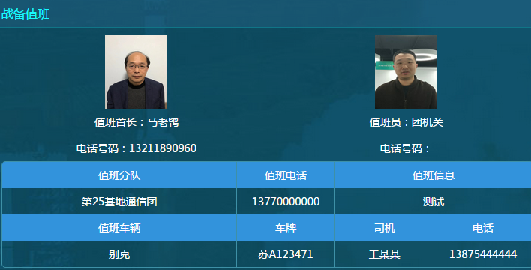
- 首页-今日工作
请求:POST && GET
URL:127.0.0.1/secplat/pagePlanRemind/getPlanWeekCount.do?isCurrentDay=02
参数 | 说明 | 类型
isCurrentDay | 02 | String
返回json格式:
{
"objectList": [
{
"id": "d570fcd1-a140-4c4a-b7b7-f4cf019dbf17",
"timeName": "早操",
"content": "无",
"trainContent": "机动"
},
{
"id": "f40770e8-c791-4380-92a4-53623d6284b6",
"timeName": "上午",
"content": "无",
"trainContent": "机动"
},
{
"id": "69e6b6b9-566b-423b-9aae-2e84175270cd",
"timeName": "下午",
"content": "无",
"trainContent": "机动"
},
{
"id": "2e6b18b5-d4c0-4c33-86e6-478004fc1bbd",
"timeName": "111",
"content": "无",
"trainContent": "机动"
}
]
}
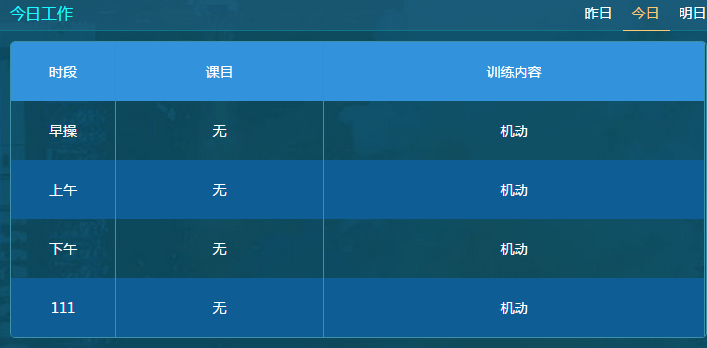

- 首页-训练进度
请求:POST && GET
URL:127.0.0.1/jsxlplat/defaultpage/datastatics/trainScheduleContrast.do
参数 | 说明 | 类型
type | quarter 季度  month 月  year 年

返回json格式:
[
[{"real":2.33,"plan":75.0,"name":"专业训练","avg":3.1},
{"real":0.29,"plan":356.0,"name":"技能训练","avg":0.08},
{"real":0.49,"plan":355.0,"name":"队列训练","avg":0.14},
{"real":0.25,"plan":11.0,"name":"共同训练","avg":2.27}]
]
图例:
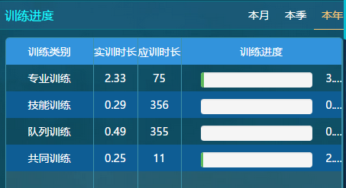

2.战备工作

- 战备工作-部门导航
请求:POST && GET
URL:127.0.0.1/secplat/sys/organization/getOrgTreePublic.do
参数 | 说明 | 类型
code | org.queryOrganization | HttpServletRequest
返回json格式:
{
"icon": null,
"text": ".",
"sortOrder": 1000,
"entrySet": null,
"referenceTreeId": null,
"children": [
{
"orgType": "5",
"createTime": 1522304649000,
"referenceTreeId": null,
"children": [
{
"orgType": "4",
"createTime": 1522636235000,
"referenceTreeId": null,
"children": [
{
"orgType": "4",
"createTime": 1522636254000,
"referenceTreeId": null,
"children": [],
"modifior": "developer",
"leaf": true,
"telphone": null,
"creator": "developer",
"id": "b85859d8-1c73-4a0c-832d-425c7237f5b0",
"parentId": "40cc3bcb-5479-4c55-9063-76dd7a45ccf4",
"modifyName": "developer",
"orgCode": null,
"name": "作训科",
"leader": null,
"value": "b85859d8-1c73-4a0c-832d-425c7237f5b0",
"nodeType": "OrgOrganization",
"modifyTime": 1524894422000,
"simpleName": "作训科",
"icon": "/pro_icons/plat/tree/deptTree.png",
"text": "作训科",
"fax": null,
"weburl": null,
"sortOrder": 1000,
"isUse": 1,
"zipcode": null,
"levelCode": "001001001",
"code": "ZXK",
"recordSort": 3,
"creatorName": "developer",
"address": null,
"email": null,
"attributes": {},
"fldtag": null,
"orgLevel": 3
},
参数 | 说明 | 类型
name | 部门名称 | String
levelCode | 部门层级编码
parentId | 父节点ID

- 战备工作-通信值勤
第一步:
获取本月有几周
请求:POST && GET
URL:127.0.0.1/jsxlpost/dutymanagement/postWatch/zbPostDuty/getWeekByMonth.do
参数 | 说明 | 类型
planYear | 2020
planMonth | 03
返回json格式:
[
{
"value": "第1周(2020-02-24 ~ 2020-03-01)",
"key": 1
},
{
"value": "第2周(2020-03-02 ~ 2020-03-08)",
"key": 2
},
{
"value": "第3周(2020-03-09 ~ 2020-03-15)",
"key": 3
},
{
"value": "第4周(2020-03-16 ~ 2020-03-22)",
"key": 4
},
{
"value": "第5周(2020-03-23 ~ 2020-03-29)",
"key": 5
},
{
"value": "第6周(2020-03-30 ~ 2020-04-05)",
"key": 6
}
]

第二步:
获取周值班数据
请求:POST && GET
URL:127.0.0.1/jsxlpost/dutymanagement/postWatch/zbPostDuty/getSrTecResultData.do
参数 | 说明 | 类型
orgId | 首次默认登录人orgId | String
week | 第一步中获取的值,传value
dutyType | 01
返回json格式:
[
{
"id": "1fb7761a-f99a-41d9-b035-43e4dbe09612",
"name": "一连",
"post": "电源岗位",
"dutyDay": "星期一(2020-03-23)",
"dutyTime": "上午",
"leaderName": null,
"dutyNames": null
},
{
"id": "5ae2bff2-a263-4f5b-98c5-dc48ad78826b",
"name": "一连",
"post": "电源岗位",
"dutyDay": "星期一(2020-03-23)",
"dutyTime": "下午",
"leaderName": null,
"dutyNames": null
},
{
"id": "a5c61929-18a2-4eea-87f7-89ce837b27e6",
"name": "一连",
"post": "电源岗位",
"dutyDay": "星期一(2020-03-23)",
"dutyTime": "晚上",
"leaderName": null,
"dutyNames": null
},
{
"id": "872e1683-986e-4dd2-9cbd-e806216d4bbf",
"name": "一连",
"post": "电源岗位",
"dutyDay": "星期二(2020-03-24)",
"dutyTime": "上午",
"leaderName": "点名点测试人员2",
"dutyNames": "毛所属,李xx,王某某"
},
{
"id": "054bf71a-5d7a-4bc0-b6c1-fa09d325c2c1",
"name": "一连",
"post": "电源岗位",
"dutyDay": "星期二(2020-03-24)",
"dutyTime": "下午",
"leaderName": null,
"dutyNames": null
},
{
"id": "ccb30953-e54e-4cc0-92f2-fd6669a78111",
"name": "一连",
"post": "电源岗位",
"dutyDay": "星期二(2020-03-24)",
"dutyTime": "晚上",
"leaderName": null,
"dutyNames": null
},
{
"id": "0af48549-eb93-4d6d-aed7-c48733efb2ea",
"name": "一连",
"post": "电源岗位",
"dutyDay": "星期三(2020-03-25)",
"dutyTime": "上午",
"leaderName": null,
"dutyNames": null
},
{
"id": "d05e6f59-7a05-4391-840a-dcfa6d7230d4",
"name": "一连",
"post": "电源岗位",
"dutyDay": "星期三(2020-03-25)",
"dutyTime": "下午",
"leaderName": null,
"dutyNames": null
},
{
"id": "52044a32-c06d-4bb5-956a-1beca24a266b",
"name": "一连",
"post": "电源岗位",
"dutyDay": "星期三(2020-03-25)",
"dutyTime": "晚上",
"leaderName": null,
"dutyNames": null
},
{
"id": "8bbbe4b8-ad49-48db-a2c0-e0fcde829e9d",
"name": "一连",
"post": "电源岗位",
"dutyDay": "星期四(2020-03-26)",
"dutyTime": "上午",
"leaderName": null,
"dutyNames": null
},
{
"id": "3862e600-0f01-40ad-a155-3cf1a78d0f56",
"name": "一连",
"post": "电源岗位",
"dutyDay": "星期四(2020-03-26)",
"dutyTime": "下午",
"leaderName": null,
"dutyNames": null
},
{
"id": "0efd9b7f-cae4-4585-bf15-6232b5b0ccee",
"name": "一连",
"post": "电源岗位",
"dutyDay": "星期四(2020-03-26)",
"dutyTime": "晚上",
"leaderName": "测试人员3",
"dutyNames": "马老鸨"
},
{
"id": "1f274ff5-fe0b-41e0-8c95-da5a57942afe",
"name": "一连",
"post": "电源岗位",
"dutyDay": "星期五(2020-03-27)",
"dutyTime": "上午",
"leaderName": null,
"dutyNames": null
},
{
"id": "3719920e-c9f8-4864-9767-961cb3e4a7a1",
"name": "一连",
"post": "电源岗位",
"dutyDay": "星期五(2020-03-27)",
"dutyTime": "下午",
"leaderName": null,
"dutyNames": null
},
{
"id": "ad0fa700-33bb-4dac-922c-21ec59717336",
"name": "一连",
"post": "电源岗位",
"dutyDay": "星期五(2020-03-27)",
"dutyTime": "晚上",
"leaderName": null,
"dutyNames": null
},
{
"id": "5f224b99-9354-48c9-b8e2-0424b90a430f",
"name": "一连",
"post": "电源岗位",
"dutyDay": "星期六(2020-03-28)",
"dutyTime": "上午",
"leaderName": null,
"dutyNames": null
},
{
"id": "7eaa9263-6892-4e43-9078-8461ef8111f5",
"name": "一连",
"post": "电源岗位",
"dutyDay": "星期六(2020-03-28)",
"dutyTime": "下午",
"leaderName": null,
"dutyNames": null
},
{
"id": "4f65fc5d-b92b-4f8e-8440-9b5cfe04046b",
"name": "一连",
"post": "电源岗位",
"dutyDay": "星期六(2020-03-28)",
"dutyTime": "晚上",
"leaderName": null,
"dutyNames": null
},
{
"id": "1323149d-8475-45a2-b298-7653e536468e",
"name": "一连",
"post": "电源岗位",
"dutyDay": "星期日(2020-03-29)",
"dutyTime": "上午",
"leaderName": null,
"dutyNames": null
},
{
"id": "1817c005-1f7e-431f-a0b4-91cdc0d62b93",
"name": "一连",
"post": "电源岗位",
"dutyDay": "星期日(2020-03-29)",
"dutyTime": "下午",
"leaderName": null,
"dutyNames": null
},
{
"id": "0fbba08d-90f8-4162-b62c-8e93e2f7481b",
"name": "一连",
"post": "电源岗位",
"dutyDay": "星期日(2020-03-29)",
"dutyTime": "晚上",
"leaderName": null,
"dutyNames": null
}
]

PC效果:
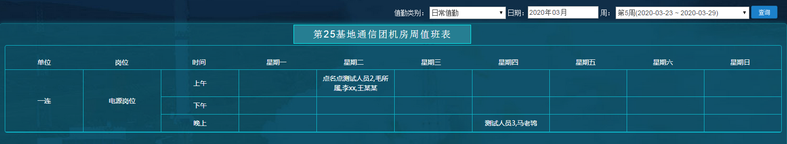

安卓效果:参考如下效果
默认当月数据,中间查询条件,可以切换周
最下面数据可以参考PC展示
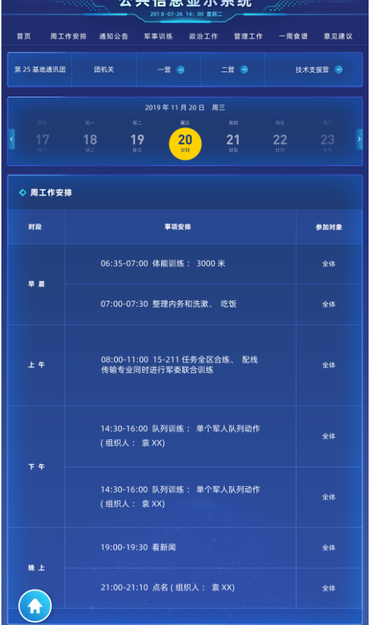

3.思想政治工作
- 政治工作-党委结构图
请求:POST && GET
URL:127.0.0.1/zzgz/zzgzMngOrgCons/zzgzMngOrgBuild/zzorg/listTree.do
参数 | 说明 | 类型
parentId
返回json格式:
{
"children": [
{
"orgType": "03",
"createTime": 1585538896000,
"children": [],
"referenceTreeId": null,
"modifior": "developer",
"leaf": true,
"creator": "developer",
"orgId": null,
"id": "13fd8d7b-c120-4d98-b035-089f88e34080",
"parentId": "root",
"modifyName": "developer",
"value": "13fd8d7b-c120-4d98-b035-089f88e34080",
"nodeType": "ZzOrg",
"modifyTime": 1585538901000,
"icon": "/pro_icons/plat/tree/deptTree.png",
"text": "军人委员会",
"isUse": 1,
"sortOrder": 1000,
"editPersonName": null,
"orgTitle": "军人委员会",
"editPersonId": null,
"recordSort": 3,
"creatorName": "developer",
"attributes": {},
"fldtag": null
},
{
"orgType": "01",
"createTime": 1585292399000,
"children": [],
"referenceTreeId": null,
"modifior": "developer",
"leaf": true,
"creator": "developer",
"orgId": null,
"id": "87948950-3961-4f07-8139-74ddf25b9bc5",
"parentId": "root",
"modifyName": "developer",
"value": "87948950-3961-4f07-8139-74ddf25b9bc5",
"nodeType": "ZzOrg",
"modifyTime": 1585292399000,
"icon": "/pro_icons/plat/tree/deptTree.png",
"text": "团支部",
"isUse": 1,
"sortOrder": 1000,
"editPersonName": null,
"orgTitle": "团支部",
"editPersonId": null,
"recordSort": 2,
"creatorName": "developer",
"attributes": {},
"fldtag": null
},
{
"orgType": "02",
"createTime": 1585292361000,
"children": [
{
"createTime": 1585292383000,
"icon": "/pro_icons/plat/tree/deptTree.png",
"text": "分部2",
"sortOrder": 1000,
"isUse": 1,
"levelCode": null,
"referenceTreeId": null,
"children": [],
"modifior": "developer",
"leaf": true,
"recordSort": 2,
"creator": "developer",
"id": "ed319353-809e-4a94-8683-77f96e8d29ed",
"orgId": null,
"parentId": "20e75e27-e8e8-442f-bade-c00f0430c660",
"creatorName": "developer",
"modifyName": "developer",
"value": "ed319353-809e-4a94-8683-77f96e8d29ed",
"attributes": {},
"fldtag": null,
"nodeType": "ZzOrgMember",
"modifyTime": 1585292383000,
"memberTitle": "分部2",
"parId": "20e75e27-e8e8-442f-bade-c00f0430c660"
},
{
"createTime": 1585292373000,
"icon": "/pro_icons/plat/tree/deptTree.png",
"text": "分部1",
"sortOrder": 1000,
"isUse": 1,
"levelCode": null,
"referenceTreeId": null,
"children": [
{
"createTime": 1585292409000,
"icon": "/pro_icons/plat/tree/deptTree.png",
"text": "分部11",
"sortOrder": 1000,
"isUse": 1,
"levelCode": null,
"referenceTreeId": null,
"children": [],
"modifior": "developer",
"leaf": true,
"recordSort": 3,
"creator": "developer",
"id": "cd9275e9-5237-435a-bea2-c2b79cbcf580",
"orgId": null,
"parentId": "73f40707-9e1c-4a0f-9782-c38fbf6f937c",
"creatorName": "developer",
"modifyName": "developer",
"value": "cd9275e9-5237-435a-bea2-c2b79cbcf580",
"attributes": {},
"fldtag": null,
"nodeType": "ZzOrgMember",
"modifyTime": 1585292409000,
"memberTitle": "分部11",
"parId": "73f40707-9e1c-4a0f-9782-c38fbf6f937c"
}
],
"modifior": "developer",
"leaf": false,
"recordSort": 1,
"creator": "developer",
"id": "73f40707-9e1c-4a0f-9782-c38fbf6f937c",
"orgId": null,
"parentId": "20e75e27-e8e8-442f-bade-c00f0430c660",
"creatorName": "developer",
"modifyName": "developer",
"value": "73f40707-9e1c-4a0f-9782-c38fbf6f937c",
"attributes": {},
"fldtag": null,
"nodeType": "ZzOrgMember",
"modifyTime": 1585292373000,
"memberTitle": "分部1",
"parId": "20e75e27-e8e8-442f-bade-c00f0430c660"
}
],
"referenceTreeId": null,
"modifior": "developer",
"leaf": false,
"creator": "developer",
"orgId": null,
"id": "20e75e27-e8e8-442f-bade-c00f0430c660",
"parentId": "root",
"modifyName": "developer",
"value": "20e75e27-e8e8-442f-bade-c00f0430c660",
"nodeType": "ZzOrg",
"modifyTime": 1585292361000,
"icon": "/pro_icons/plat/tree/deptTree.png",
"text": "党支部",
"isUse": 1,
"sortOrder": 1000,
"editPersonName": null,
"orgTitle": "党支部",
"editPersonId": null,
"recordSort": 1,
"creatorName": "developer",
"attributes": {},
"fldtag": null
}
]
}
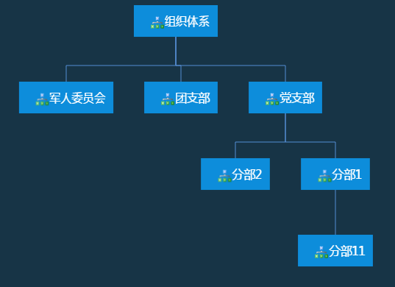
- 政治工作-月教育计划
请求:POST && GET
URL:127.0.0.1/armyplat/fl/queryIndex/getMonthEduRecordList.do
参数 | 说明 | 类型
yearMonth | 2020-03 | String
返回json格式:
{"objectList":[{"week":"01","eduName":"主题教育,思想教育"},{"week":"02","eduName":"思想教育,心理卫生教育"},{"week":"03","eduName":"安全教育"},{"week":"04","eduName":"安全教育"},{"eduName":"无","week":"05"}]}
参数 | 说明 | 类型
week | 01 第一周  02 第二周  03 第三周  04 第四周  05 第五周 | String
eduName | 教育类型

- 政治工作-教育类型次数统计饼图
请求:POST && GET
URL:127.0.0.1/armyplat/fl/queryIndex/getEduTypeCountChar.do
参数 | 说明 | 类型
queryType | 01 本月  02 本季  03 本年 | String
返回json格式:
{
"success": true,
"message": "",
"data": "[[\"思想教育\",1],[\"保密教育\",1]]"
}
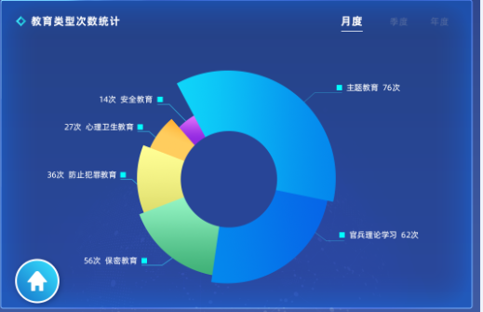

- 政治工作-会议类型
请求:POST && GET
URL:127.0.0.1 /zzgz/zzgzMngOrgCons/zzgzMngMeet/zzorgmeeting/listMeetType.do
请求参数 | 说明 | 类型
meetingTimeStart | 开始时间(yyyy-MM) | String
meetingTimeEnd | 结束时间(yyyy-MM) | String

返回json格式:
{
"objectList": [
{
"01": 2,
"02": 2,
"03": 1,
"04": 1,
"sum": 6,
"rn": 1
}
],
"success": true,
"rowCount": 1,
"start": 0,
"limit": 20
}

返回参数说明:
参数 | 说明 | 类型
01 | 党支部会议
02 | 团支部会议
03 | 军人委员会议
04 | 党委中心组学习会议
sum

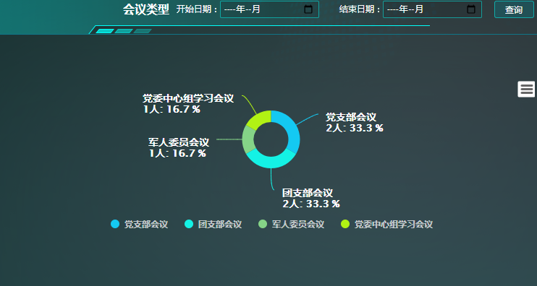

军事训练
- 参训时长
请求:POST && GET
URL:127.0.0.1/jsxlplat/defaultpage/datastatics/showTrainTimeByType.do
参数 | 说明 | 类型
type | quarter 季度  month 月  year 年
返回json格式:

[["专业训练",2.33],["技能训练",0.29],["队列训练",0.49],["共同训练",0.25]]

图例:
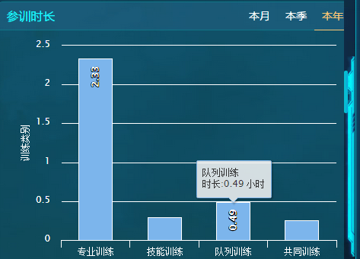

- 岗位分布
请求:POST && GET
URL:127.0.0.1/jsxlplat/defaultpage/datastatics/showPostList.do
参数 | 说明 | 类型
orgId |  | String
返回json格式:
[
{"name":"岗位1",
"postName":"试",
"gq":0,
"cj":0,
"zj":0,
"gj":0,
"zs":0},
{"id":"0aac5bb7-839a-414f-bd8a-6dab8b06a77e","name":"名称","recordSort":1,"postName":"名称","gq":0,"cj":0,"zj":0,"gj":0,"zs":0}]

返回参数说明:
参数 | 说明 | 类型
postName | 岗位名称
zs | 总数
gc | 岗前
cj | 初级
zj | 中级
gj | 高级



- 参训率
请求:POST && GET
URL:127.0.0.1/jsxlplat/defaultpage/datastatics/showTrainRateByOrg.do//
URL:127.0.0.1/jsxlplat/defaultpage/datastatics/showTrainRateByOneMonth.do
URL:jsxlplat/defaultpage/datastatics/showTrainRateByRecentYear.do

[["03-30","03-31","04-01","04-02","04-03","04-04","04-05"],[{"name":"通信团","data":[0.0,0.0,0.0,0.0,0.0,0.0,0.0]},{"name":"团机关","data":[0.0,0.0,0.0,0.0,0.0,0.0,0.0]},{"name":"一营","data":[0.0,0.0,0.0,0.0,0.0,0.0,0.0]},{"name":"一营营部","data":[0.0,0.0,0.0,0.0,0.0,0.0,0.0]},{"name":"一营一连","data":[0.0,0.0,0.0,0.0,0.0,0.0,0.0]},{"name":"一营二连","data":[0.0,0.0,0.0,0.0,0.0,0.0,0.0]},{"name":"二营","data":[0.0,0.0,0.0,0.0,0.0,0.0,0.0]},{"name":"二营营部","data":[0.0,0.0,0.0,0.0,0.0,0.0,0.0]},{"name":"二营三连","data":[0.0,0.0,0.0,0.0,0.0,0.0,0.0]},{"name":"二营四连","data":[0.0,0.0,0.0,0.0,0.0,0.0,0.0]},{"name":"技术支援营","data":[0.0,0.0,0.0,0.0,0.0,0.0,0.0]},{"name":"勤务连","data":[0.0,0.0,0.0,0.0,0.0,0.0,0.0]},{"name":"test连","data":[0.0,0.0,0.0,0.0,0.0,0.0,0.0]}]]
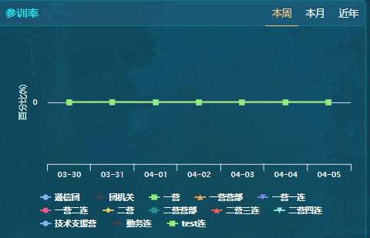

- 成绩考核
请求:POST && GET
URL:127.0.0.1 /jsxlplat/trainAssessIndex/trainAssess/getAssessRecord.do
参数 | 说明 | 类型
orgId | 部门ID | String
返回json格式:
{
"pageSet": {
"startPage": 1,
"lastPage": 1,
"nowPage": 1,
"nextPage": 2,
"endPage": 2,
"totalPage": 2,
"pageCount": 10,
"totalCount": 0
},
"objectList": [
{
"name": "一连",
"id": "b032357e-c6d1-4be4-a053-6837591f8ec5",
"examName": "33",
"examTimeStr": "2021-02-22",
"content": "光传输设备基本原理",
"yxl": "0%",
"lhl": "0%",
"jgl": "100%",
"bjgl": "0%"
}
]
}
返回参数说明:
参数 | 说明 | 类型
Name | 单位 | String
examName | 考核名称 | String
content | 考核内容 | String
examTimeStr | 时间 | String
yxl | 优秀率 | String
lhl | 良好率 | String
Jgl | 及格率 | String
bjgl | 不及格率 | String
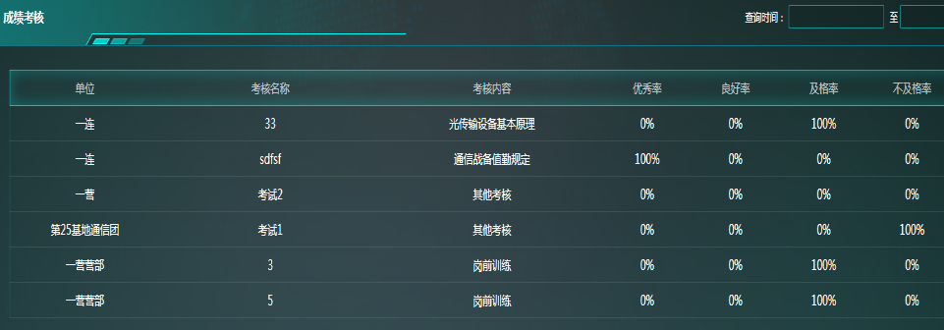

- 学习情况展示
请求:POST && GET
URL:127.0.0.1/jsxlpost/mpeLearningManagement/listByOrgId.do
参数 | 说明 | 类型
orgId | 部门ID | String
返回json格式:
{
"success": true,
"message": "加载成功",
"data": [
{
"num": 20,
"name": "成员总数"
},
{
"num": 17,
"name": "选课人次"
},
{
"num": 20,
"name": "进度人次"
},
{
"num": 16,
"name": "参考人次"
},
{
"num": 16,
"name": "合格人次"
}
]
}
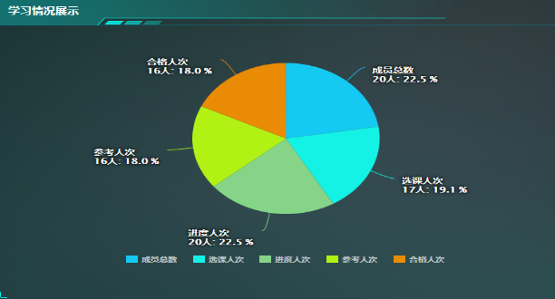
- 选课情况展示
请求:POST && GET
URL:127.0.0.1 /jsxlpost/mpeCourseManagement/showListIndexChart.do
参数 | 说明 | 类型
orgId | 部门ID | String
返回json格式:
[
[
{
"name": "一营",
"data": [
0,
0,
0
]
},
{
"name": "一营营部",
"data": [
0,
0,
0
]
},
{
"name": "一连",
"data": [
0,
0,
0
]
},
{
"name": "二连",
"data": [
0,
0,
0
]
}
]
]

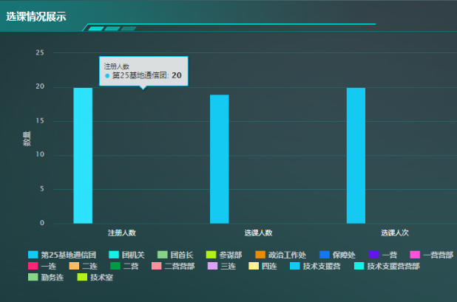

- 结业情况展示
请求:POST && GET
URL:127.0.0.1/jsxlpost/mpeGraduationGrades/listByOrgId.do
参数 | 说明 | 类型
orgId | 部门ID | String

返回json格式:
{
"success": true,
"message": "加载成功",
"data": [
{
"num": 5,
"name": "参考课程数"
},
{
"num": 3,
"name": "合格课程数"
},
{
"num": 1,
"name": "良好课程数"
},
{
"num": 1,
"name": "优秀课程数"
}
]
}
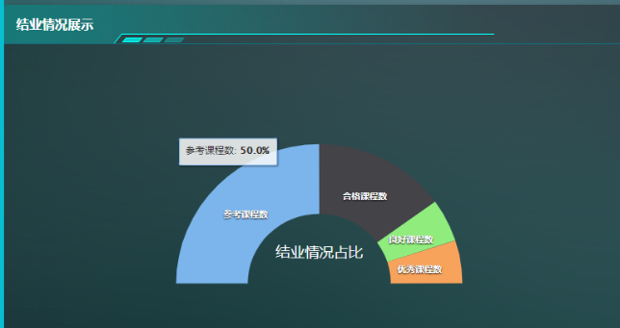

5.日常管理
- 日常管理-人员在位率柱状图
请求:POST && GET
URL:127.0.0.1/jsxlplat/trainPlanIndex/trainPlan/perReignCount.do
参数 | 说明 | 类型
orgId | 部门ID | String
orgLevelCode | 部门层级编码
返回json格式:
{
"success": true,
"message": "",
"data": [
[
24,
4,
1,
14,
11,
1,
1,
3,
1,
1,
1,
2
],
[
100,
100,
100,
100,
100,
100,
100,
100,
100,
100,
100,
100
],
[
"第25基地通信团",
"团机关",
"参谋部",
"一营",
"一营营部",
"一连",
"二连",
"二营",
"二营营部",
"三连",
"四连",
"技术支援营"
]
]
}

- 日常管理-人员在位数/在位率
请求:POST && GET
URL:127.0.0.1/jsxlplat/trainPlanIndex/trainPlan/getTodayReginNum.do
参数 | 说明 | 类型
orgId | 部门ID | String
orgLevelCode | 部门层级编码
返回json格式:
{
"success": true,
"message": "",
"data": "24 / 100%"
}

- 日常管理-车辆在位/不在位列表
请求:POST && GET
URL:127.0.0.1/secplat/carmanager/carinout/getCarList.do
参数 | 说明 | 类型
orgId | 部门ID | String
orgLevelCode | 部门层级编码
返回json格式:
{
"reignListMap": [//在位车辆列表
{
"carNumber": "苏A123457",
"recordSort": 2
},
{
"carNumber": "苏A123459",
"recordSort": 4
},
{
"carNumber": "苏A123460",
"recordSort": 5
},
{
"carNumber": "苏A123461",
"recordSort": 6
},
{
"carNumber": "苏A123462",
"recordSort": 7
},
{
"carNumber": "苏A123463",
"recordSort": 8
},
{
"carNumber": "苏A123464",
"recordSort": 9
},
{
"carNumber": "苏A123465",
"recordSort": 10
},
{
"carNumber": "苏A123466",
"recordSort": 11
},
{
"carNumber": "苏A123467",
"recordSort": 12
},
{
"carNumber": "苏A123468",
"recordSort": 13
},
{
"carNumber": "苏A123469",
"recordSort": 14
},
{
"carNumber": "苏A123470",
"recordSort": 15
},
{
"carNumber": "苏A123471",
"recordSort": 16
},
{
"carNumber": "苏A123472",
"recordSort": 17
},
{
"carNumber": "苏A123473",
"recordSort": 18
},
{
"carNumber": "苏A123474",
"recordSort": 19
},
{
"carNumber": "苏A123475",
"recordSort": 20
},
{
"carNumber": "苏A123476",
"recordSort": 21
},
{
"carNumber": "苏A123477",
"recordSort": 22
},
{
"carNumber": "苏A123478",
"recordSort": 23
},
{
"carNumber": "苏A123479",
"recordSort": 24
},
{
"carNumber": "苏A123480",
"recordSort": 25
},
{
"carNumber": "苏A123481",
"recordSort": 26
},
{
"carNumber": "苏A123482",
"recordSort": 27
},
{
"carNumber": "苏A123483",
"recordSort": 28
},
{
"carNumber": "苏A123485",
"recordSort": 30
},
{
"carNumber": "苏A123486",
"recordSort": 31
}
],
"unReignListMap": [//不在位车辆列表
{
"carNumber": "苏A123456",
"recordSort": 1
}
]
}

- 日常管理-车辆在位数/外出数
请求:POST && GET
URL:127.0.0.1/jsxlplat/trainPlanIndex/trainPlan/getPublicCarChangeRecord.do
参数 | 说明 | 类型
orgId | 部门ID | String
orgLevelCode | 部门层级编码
返回json格式:
{
"success": true,
"message": "成功",
"data": [
{
"inCar": 28,
"outCar": 1
}
]
}

- 日常管理-家属房入住情况
请求:POST && GET
URL:127.0.0.1/armyplat/fl/queryIndex/getTempHomeInfo.do
参数 | 说明 | 类型
返回json格式:
{
"success": true,
"message": "",
"data": {
"noEmptyHouse": 2,//已住户数
"emptyHouse": 11//空房户数
}
}
- 日常管理-今日访客情况
请求:POST && GET
URL:127.0.0.1/jsxlplat/trainPlanIndex/trainPlan/getVisitRecord.do
参数 | 说明 | 类型
返回json格式:
{
"success": true,
"message": "成功",
"data": {
"todayVisit": 0,//今日访客
"outVisit": 0,//进入次数
"inVisit": 0//离开次数
}
}
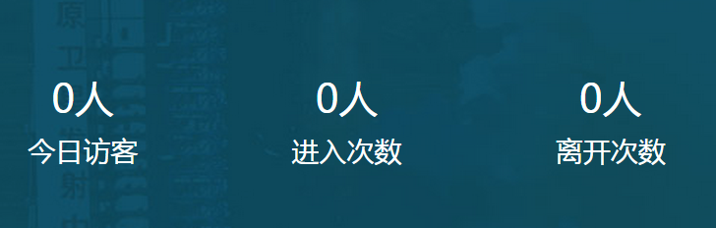

- 当日卫生值班
请求:POST && GET
URL:127.0.0.1/jsxlpost/dutymanagement/medicalOnDuty/lsPostDutyPerson/listTodayDutySituation.do
参数 | 说明 | 类型
orgId |  | String
返回json格式:
{
"leaderId": "44d53360-789a-4e38-973c-250e9caac985",
"leaderName": "张三1",
"dutyIds": "e6c307d8-211f-497e-bea2-106df541b129",
"dutyNames": "李四1",
"leaderTelphoneNum": "",
"leaderPicPath": "/upload/user/acd43488-4cfb-4f26-973b-73bd8c25b2fb.jpg",
"personnelTelphoneNum": "",
"personnelPicPath": "/upload/user/8303ffd9-34d4-4413-a563-01c3bf02d1c5.jpg"
}
返回参数
参数 | 说明 | 类型
leaderName | 医生姓名 | String
leaderTelphoneNum | 医生电话 | String
leaderPicPath | 医生照片 | String
dutyNames | 卫生员姓名 | String
personnelTelphoneNum | 卫生员电话 | String
personnelPicPath | 卫生员照片 | String
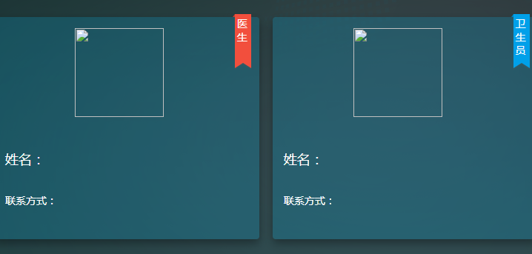

- 年度外诊态势
请求:POST && GET
URL:127.0.0.1/armyplat/fl/drugManage/dianosisManage/lsdiagnosismanage/listDiagnosisManage.do
参数 | 说明 | 类型
beginTime | 开始时间（2020-08-01） | String
endTime | 结束时间 | String
levelCode | 部门levelCode（001） | String
返回json格式:
{
"objectList": [
{
"count": 1,
"name": "一营",
"levelCode": "001003",
"rn": 1
}
],
"success": true,
"rowCount": 1,
"start": 0,
"limit": 20
}
返回参数
参数 | 说明 | 类型
count | 外诊数量 | String
name | 单位名称 | String
levelCode | 单位levelCode | String

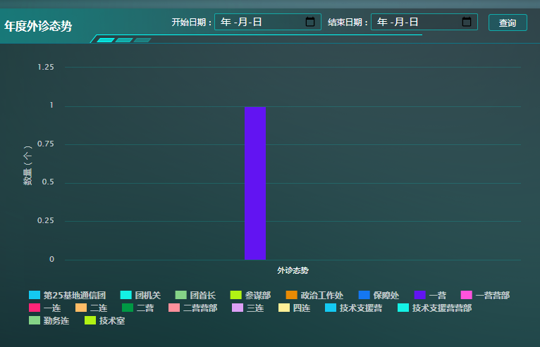

- 疗养态势
请求:POST && GET
URL:127.0.0.1/armyplat/fl/drugManage/recuperateManage/lsrecuperatemanage//listLsrecuperateManage.do
参数 | 说明 | 类型
beginTime | 开始时间（2020-08-01） | String
endTime | 结束时间 | String
levelCode | 部门levelCode（001） | String
返回json格式:
{
"objectList": [
{
"count": 1,
"name": "政治工作处",
"levelCode": "001002003",
"rn": 1
},
{
"count": 1,
"name": "一营营部",
"levelCode": "001003001",
"rn": 2
}
],
"success": true,
"rowCount": 2,
"start": 0,
"limit": 20
}
返回参数
参数 | 说明 | 类型
count | 疗养数量 | String
name | 单位名称 | String
levelCode | 单位levelCode | String

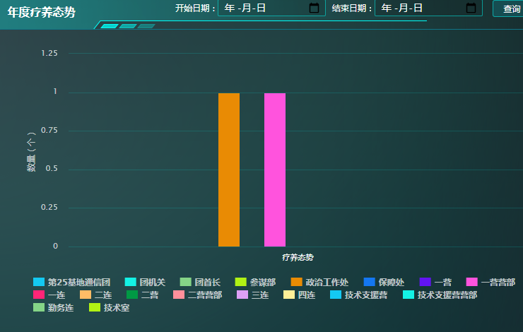

6.工作计划
- 工作计划-每日工作
请求:POST && GET
URL:127.0.0.1/armyplat/fl/queryIndex/getThisWeekWorkInfo.do
参数 | 说明 | 类型
orgId | 默认当前登录人部门ID
queryDate | 2020-03-30
返回json格式:
[
{
"id": "d570fcd1-a140-4c4a-b7b7-f4cf019dbf17",
"timeName": "早操",
"content": "写日报",
"trainContent": "3"
},
{
"id": "f40770e8-c791-4380-92a4-53623d6284b6",
"timeName": "上午",
"content": "无",
"trainContent": "机动"
},
{
"id": "69e6b6b9-566b-423b-9aae-2e84175270cd",
"timeName": "下午",
"content": "无",
"trainContent": "机动"
},
{
"id": "2e6b18b5-d4c0-4c33-86e6-478004fc1bbd",
"timeName": "111",
"content": "无",
"trainContent": "机动"
}
]
参考界面:
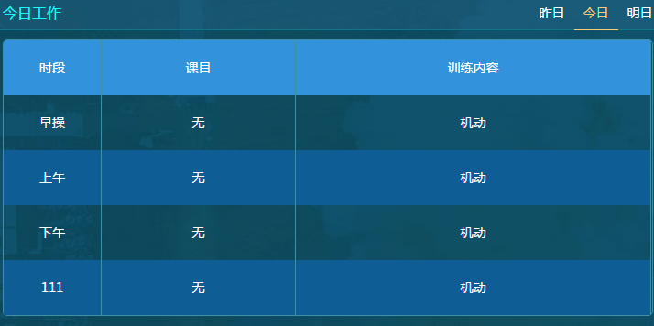

7.本周食谱
- 本周食谱
请求:POST && GET
URL:127.0.0.1/armyplat/fl/queryIndex/getThisWeekFoodMenu.do
参数 | 说明 | 类型
orgId | 默认当前登录人部门ID

返回json格式:
[
{
"breakfast": "红烧肉",
"lunch": "红烧肉",
"dinner": "红烧肉",
"makeDateStr": "03-30"
},
{
"makeDateStr": "03-31",
"dinner": "无",
"breakfast": "无",
"lunch": "无"
},
{
"breakfast": "红烧肉",
"lunch": "苹果",
"dinner": "青菜",
"makeDateStr": "04-01"
},
{
"makeDateStr": "04-02",
"dinner": "无",
"breakfast": "无",
"lunch": "无"
},
{
"breakfast": "红烧肉",
"lunch": "青菜",
"dinner": "苹果",
"makeDateStr": "04-03"
},
{
"makeDateStr": "04-04",
"dinner": "无",
"breakfast": "无",
"lunch": "无"
},
{
"breakfast": "1",
"lunch": "2",
"dinner": "3",
"makeDateStr": "04-05"
}
]

8.通知公告
- 通知公告列表-分页
请求:POST && GET
URL:127.0.0.1/armyplat/fl/queryIndex/getNoticePage.do
参数 | 说明 | 类型
start | 默认传0,下一页传20

返回json格式:
{
"objectList": [
{
"id": "12",
"mainTitle": "13名民企科技专家进入火箭军",
"article": "今日，一批民企技术人员组成两制创新团队，对接火箭武器装备关键技术需求公关。牵头组织......",
"startTimeStr": "2019-04-25",
"rn": 1
},
{
"id": "2",
"mainTitle": "13名民企科技专家进入火箭军",
"article": "今日，一批民企技术人员组成两制创新团队，对接火箭武器装备关键技术需求公关。牵头组织......",
"startTimeStr": "2019-04-25",
"rn": 3
}
],
"success": true,
"rowCount": 30,//总数
"start": 0,//从第几个开始
"limit": 20//每页显示个数
}

- 通知公告列表-详情
请求:POST && GET
URL:127.0.0.1/jsxlplat/commonupload/list.do
参数 | 说明 | 类型
pTableId | 通知公告的id

返回json格式:
{
"objectList": [
{
"id": "ab730411-6219-4459-9656-1ba8ad1a64ba",
"path": "upload/informnoticefilegrid/",把path跟filename拼起来,就是正确url
"filename": "facepad Socket接口文档v3.4.pdf"

},
{
"id": "b678d272-e7a2-438c-81fc-b5d3da0174b7",
"title": "facepad Socket接口文档v3.4.pdf",
"path": "upload/informnoticefilegrid/",
"filename": "facepad Socket接口文档v3.4.pdf",
"rn": 2
}
],
"success": true,
"rowCount": 2,
"start": 0,
"limit": 20
}

9.建言建议
- 建言建议-获取意见类型字典
请求:POST && GET
URL:127.0.0.1/ark/plat/sysset/category/list_category_value2.do
参数 | 说明 | 类型
categoryCode | BwSuggestType
返回json格式:

[
{
"code": "01",//编码
"name": "军事",//显示内容
"categoryId": "31f300ca-895f-4515-85ff-d7c017cb87eb",
"id": "1e982e18-54a4-4473-947e-d48fcb7203b9",
"createTime": 1584092046000,
"creator": "developer",
"creatorName": "developer",
"modifyTime": 1584092046000,
"modifior": "developer",
"modifyName": "developer",
"isUse": 1,
"recordSort": 4688
},
{
"code": "02",
"name": "政工",
"categoryId": "31f300ca-895f-4515-85ff-d7c017cb87eb",
"id": "59496efe-d1ea-4cf7-b31f-ac56584beae3",
"createTime": 1584092046000,
"creator": "developer",
"creatorName": "developer",
"modifyTime": 1584092046000,
"modifior": "developer",
"modifyName": "developer",
"isUse": 1,
"recordSort": 4689
},

]

- 建言建议-保存意见
请求:POST && GET
URL:127.0.0.1/secplat/basework/suggestbox/save.do
参数 | 说明 | 类型
suggestType | 字典:意见类型BwSuggestType
suggest | 意见内容
返回json格式:
{
"success": true,
"message": "保存成功",
"data": {
"suggestType": "02",
"suggestTime": 1585727375940,
"suggest": "123123",
"id": "be330a7d-474b-4b6d-9df7-e676d93c56d5",
"createTime": 1585727375941,
"creator": "developer",
"creatorName": "developer",
"modifyTime": 1585727375941,
"modifior": "developer",
"modifyName": "developer",
"isUse": 1,
"recordSort": 1
}
}

- 建言建议-获取意见列表-分页
请求:POST && GET
URL:127.0.0.1/armyplat/fl/queryIndex/getSuggestPage.do
参数 | 说明 | 类型
suggestType | 字典:意见类型BwSuggestType
Start | 默认传0,下一页传20
返回json格式:
{
"objectList": [
{
"suggest": "123123",
" suggestTypeStr": "政工",
"suggestTimeStr": "2020-04-01",
"rn": 1
}
],
"success": true,
"rowCount": 1,
"start": 0,
"limit": 20
}

