The Showmen

Combined Gantt Chart

Ryan Enshaie

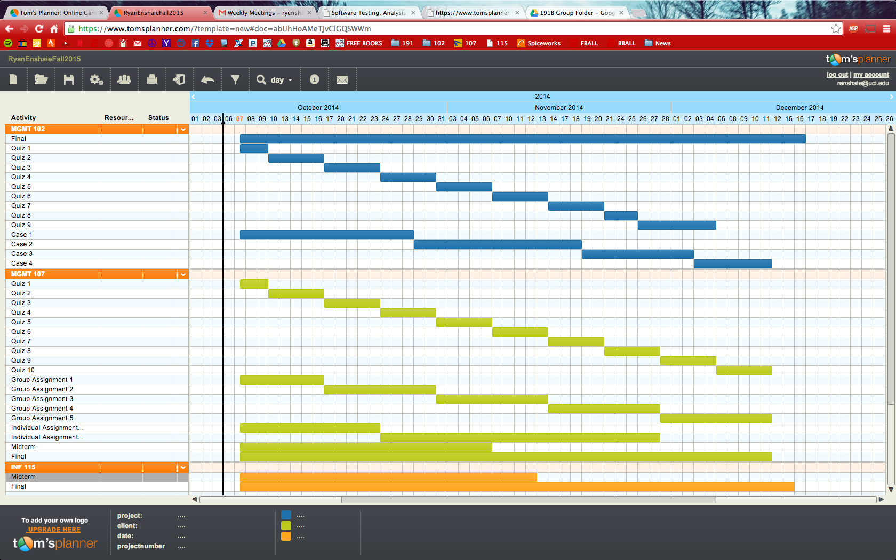

Damon Wong

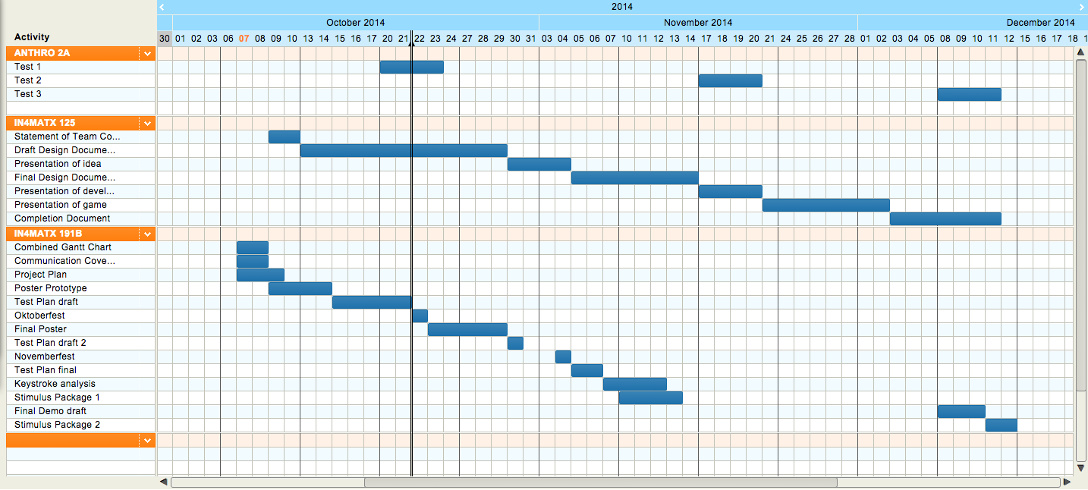

Byung Kim

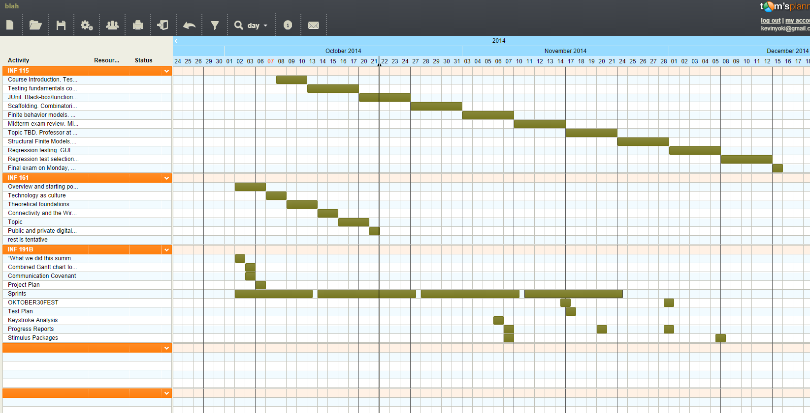

Antonio Montalvo

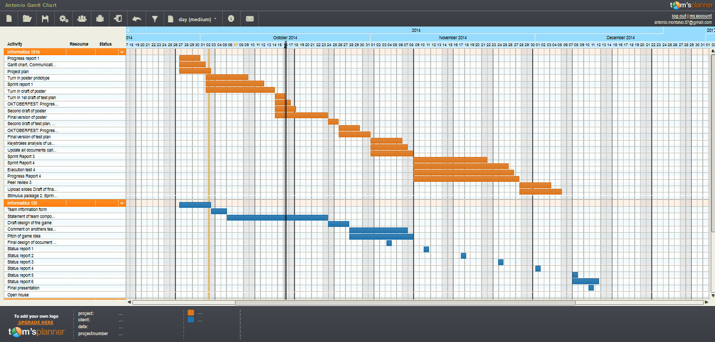

Adam Yee

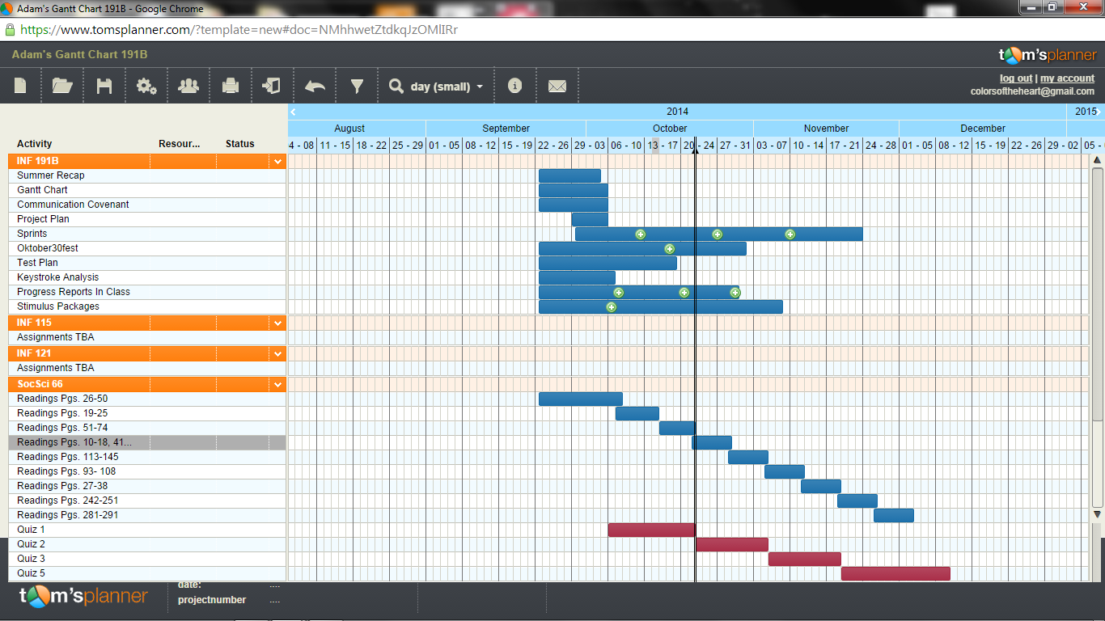

Project Plan Implications

After catching up as a group, our project plan is very up in the air as of right now. We have discussed with our sponsor the goals for this quarter, and they are very high-level. We plan on taking over the Learning Paths project started by Austin, and developing it to hopefully integrate into the existing Showbiz U website. Our first steps are to review all of Austin’s documentation, and provide the sponsor with our plans for how we want to contribute. The three tiers that are available to take over the UI/UX front-end, the algorithmic logic, and the back-end database. Our actual Project Plan will be heavily dependent on what we, as a group and as individuals, choose to pursue.