计算机与电子信息学院/人工智能学院

《计算机操作系统实验》
课程实验报告

实验名称： 连续存储空间管理模拟
专 业： 计算机科学与技术
姓 名： 成文涛
学 号： 19200312

实验问题描述
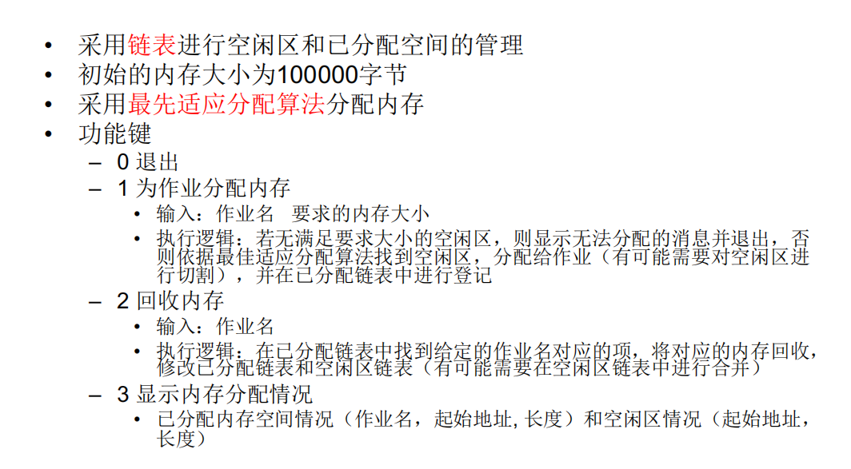
图1

实验原理

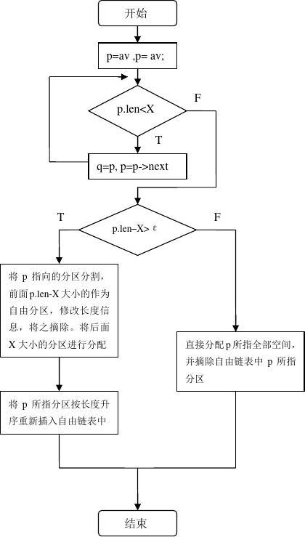
图2 流程图
- #include<iostream>
- #include<cstdlib>
- #include<cstdio>
- #include<algorithm>
- #include<cmath>
- #include<map>
- #include<stack>
- #include<queue>
- #include<ctime>
- #include<cstring>
- #include<vector>
- #define ll long long
- using namespace std;

- void allocate();void recycle();void display();

- struct AllocatedSpace
- {
- int start_address;
- int length;
- char job;
- struct AllocatedSpace *next;

- AllocatedSpace(){}
- AllocatedSpace(int start_address,int length,char job){
- this->start_address=start_address;
- this->length=length;
- this->job=job;
- this->next=NULL;
- }
- };

- struct FreeSpace{
- int start_address;
- int length;
- struct FreeSpace *next;
- FreeSpace(){}
- FreeSpace(int start_address,int length){
- this->start_address=start_address;
- this->length=length;
- this->next=NULL;
- }
- };

- FreeSpace* free_head;
- AllocatedSpace* allocated_head;

- void init()
- {
- free_head=new FreeSpace();
- allocated_head=new AllocatedSpace();
- FreeSpace *tmp=new FreeSpace();

- tmp->length=100000;
- tmp->start_address=0;
- tmp->next=NULL;
- free_head->next=tmp;

- allocated_head->next=NULL;
- }

- void table()
- {
- cout<<"0:退出"<<endl<<"1:分配"<<endl<<"2:回收"<<endl<<"3:显示"<<endl;
- int choice;
- cin>>choice;
- switch(choice)
- {
- case 0:
- exit(1);
- recycle();
- break;
- case 1:
- allocate();
- break;
- case 2:
- recycle();
- break;
- case 3:
- display();
- break;
- default:
- break;
- }

- }

- void allocate()
- {
- char job;
- int require_length;
- cout<<"输入作业名："<<endl;
- cin>>job;
- cout<<"输入要求内存大小："<<endl;
- cin>>require_length;

- FreeSpace *tmp=free_head->next;
- FreeSpace *pretmp=NULL;
- bool flag=0;
- while(tmp!=NULL)
- {
- if(tmp->length>=require_length)
- {
- flag=1;
- AllocatedSpace* allocated_tmp=allocated_head;
- while(allocated_tmp->next!=NULL)
- allocated_tmp=allocated_tmp->next;
- AllocatedSpace* newallocated=new AllocatedSpace(tmp->start_address,require_length,job);
- allocated_tmp->next=newallocated;

- tmp->length=tmp->length-require_length;
- tmp->start_address+=require_length;
- break;
- }
- else
- {
- pretmp=tmp;
- tmp=tmp->next;
- }
- }
- if(!flag) {cout<<"内存不足，无法分配"<<endl;};
- }

- void integrate()
- {
- FreeSpace* tmp1=free_head->next;
- if(tmp1==NULL||tmp1->next==NULL)
- return ;
- while(tmp1!=NULL&&tmp1->next!=NULL)
- {
- cout<<"breakpoint 1"<<endl;
- FreeSpace* tmp2=tmp1->next;
- FreeSpace* pretmp2=tmp1;
- cout<<"breakpoint 2"<<endl;
- while(tmp2!=NULL)
- {
- cout<<"breakpoint 3"<<endl;
- if((tmp1->start_address+tmp1->length)==tmp2->start_address)
- {
- tmp1->length+=tmp2->length;
- pretmp2->next=tmp2->next;
- }
- pretmp2=tmp2;
- tmp2=tmp2->next;
- }
- tmp1=tmp1->next;
- }
- }

- void SORT()
- {
- if(free_head->next==NULL||free_head->next->next==NULL)
- return;
- FreeSpace* tmp1=free_head->next;
- while(tmp1!=NULL)
- {
- FreeSpace* tmp2=tmp1->next;
- while(tmp2!=NULL)
- {
- if(tmp1->length>tmp2->length)
- {
- int addtmp=tmp1->start_address;
- int lentmp=tmp1->length;
- tmp1->length=tmp2->length;
- tmp1->start_address=tmp2->start_address;
- tmp2->length=lentmp;
- tmp2->start_address=addtmp;
- }
- tmp2=tmp2->next;
- }
- tmp1=tmp1->next;
- }
- }

- void recycle()
- {
- char job;
- cout<<"输入作业名："<<endl;
- cin>>job;
- AllocatedSpace* tmp1=allocated_head;

- while(tmp1->next!=NULL&&tmp1->next->job!=job)
- tmp1=tmp1->next;

- FreeSpace* tmp2=free_head;
- while(tmp2->next!=NULL)
- tmp2=tmp2->next;

- if(tmp1->next->job==job)
- {
- tmp2->next=new FreeSpace(tmp1->next->start_address,tmp1->next->length) ;
- AllocatedSpace* trash=tmp1->next;
- if(tmp1->next->next!=NULL)
- tmp1->next=tmp1->next->next;
- else
- tmp1->next=NULL;
- delete(trash);
- integrate();
- SORT();
- }
- else
- {
- cout<<"不存在这个任务"<<endl;
- }
- }

- void display()
- {
- AllocatedSpace* tmp1=allocated_head->next;
- FreeSpace* tmp2=free_head->next;
- cout<<"*****内存分配情况******"<<endl;
- while(tmp1!=NULL)
- {
- cout<<"作业名："<<tmp1->job<<"起始地址："<<tmp1->start_address<<"长度：" <<tmp1->length<<endl;
- tmp1=tmp1->next;
- }
- cout<<"************************"<<endl;
- cout<<"*****空闲区情况******"<<endl;
- while(tmp2!=NULL)
- {
- cout<<"起始地址："<<tmp2->start_address<<"长度：" <<tmp2->length<<endl;
- tmp2=tmp2->next;
- }
- cout<<"************************"<<endl;
- }

- int main()
- {
- init();
- while(1)
- table();

心得体会
空闲区的合并一开始写错了：错误思路是：先判断左边能否合并，再判断右边能否合并。
其实不同这样，排好序后一定是左边合并右边。

第二次错误是：要多用双指针来遍历，这样会使得代码简洁且快速。最好把头指针设为空，方便遍历时的条件判断。

空闲区的分割比较好写，但是空闲区的合并比较麻烦，在给出的样例上似乎是可以合并的，但是我自己测试的时候似乎是有些问题的，就是没有合并完全。
我猜测是 空闲区的从小到大的排序算法写错了，从而导致了合并算法的错误。
排序算法错误结果如下：
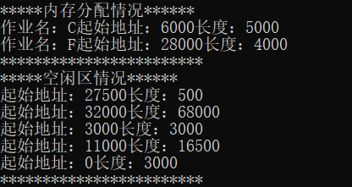
图3
冒泡排序有一行的位置放错了，导致了整个的逻辑错误，还是很可惜的。

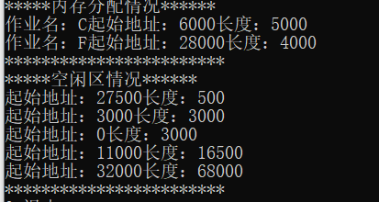
图4

