**DAY 1 - TIMECOMPLEXITY PROGRAM**

**PROGRAM 1**

#include<stdio.h>

void function(int min);

int main(){

int n;

scanf("%d",&n);

function(n);

return 0;

}

void function(int n){

int count=0;

int i=1,s=1;

count++;

count++;

while(s<=n){

count++;

i++;

count++;

s+=i;

count++;

}

count++;

printf("%d",count);

}

**OUTPUT:**

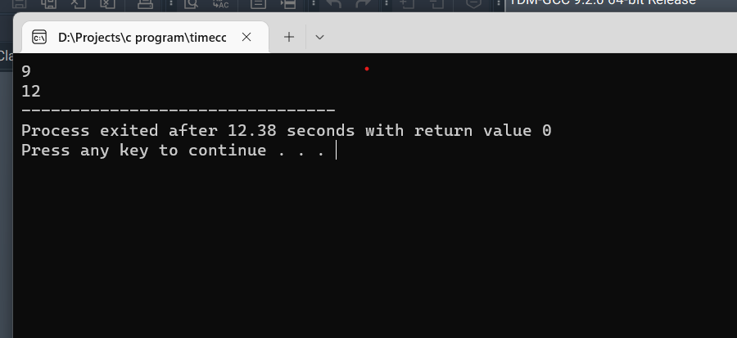

**PROGRAM 2**

#include<stdio.h>

void function(int min);

int main(){

int n;

scanf("%d",&n);

function(n);

return 0;

}

void function(int n){

int count=0;

if(n==1){

count++;

count++;

}

else{

count++;

for(int i=1;i<=n;i++){

count++;

for(int j=1;j<=n;j++){

count++;

count++;

count++;

count++;

break;

}

}

}count++;

printf("%d",count);

}

**OUTPUT:**

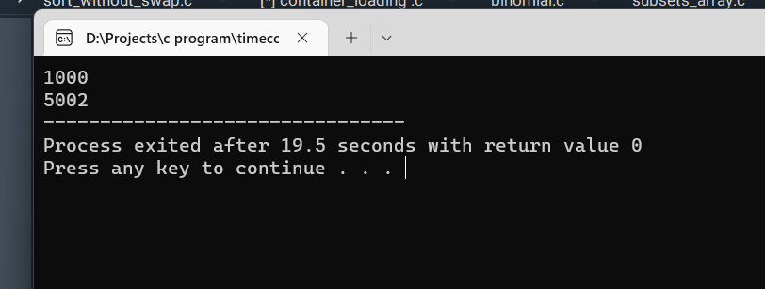

**PROGRAM 3**

#include<stdio.h>

int factor(int n);

int count=0;

int main(){

int n;

scanf("%d",&n);

factor(n);

printf("%d",count);

return 0;

}

int factor(int n){

int i;

count++;

for(i=1;i<=n;i++){

count++;

if(n%i==0){

//print present here

}count++;

}

count++;

return 0;

}

**OUTPUT:**

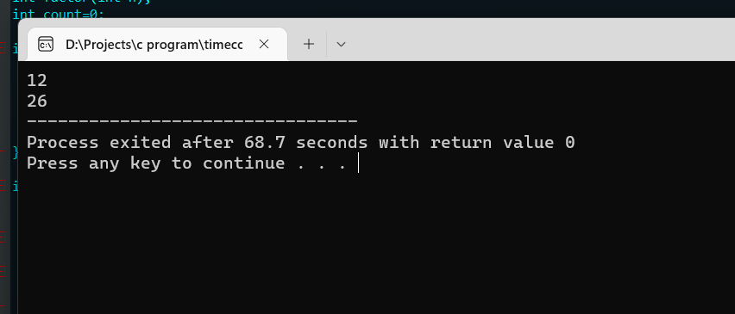

**PROGRAM 4**

#include<stdio.h>

void function(int n);

int main(){

int n;

scanf("%d",&n);

function(n);

return 0;

}

void function(int n){

int count=0;

int c=0;

count++;

for(int i=n/2;i<n;i++){

count++;

for(int j=1;j<n;j=2*j){

count++;

for(int k=1;k<n;k=k*2){

count++;

c++;

count++;

}count++;

}count++;

}count++;

printf("%d",count);

}

**OUTPUT**

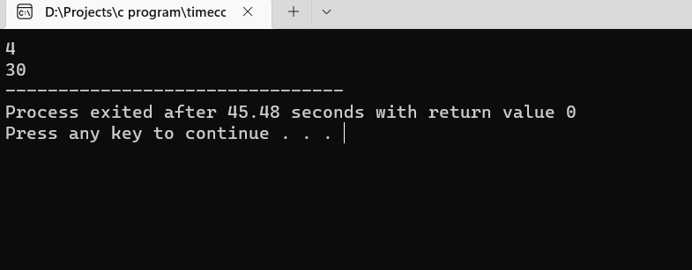

**PROGRAM 5**

#include<stdio.h>

void reverse(int n);

int main(){

int n;

scanf("%d",&n);

reverse(n);

return 0;

}

void reverse(int n){

int count =0;

int rev=0,remainder;

count++;

while(n!=0){

count++;

remainder=n%10;

count++;

rev=rev*10+remainder;

count++;

n=n/10;

count++;

}

count++;

count++; //print

printf("%d",count);

}

**OUTPUT:**

