Subject Code : CSA0540

Subject Name: DBMS (Database for Mobile Systems)

Reg.no : 192125120L

Name : S.Dinakar

Department: ai&ml(2ndyear)

Ex.no = 1

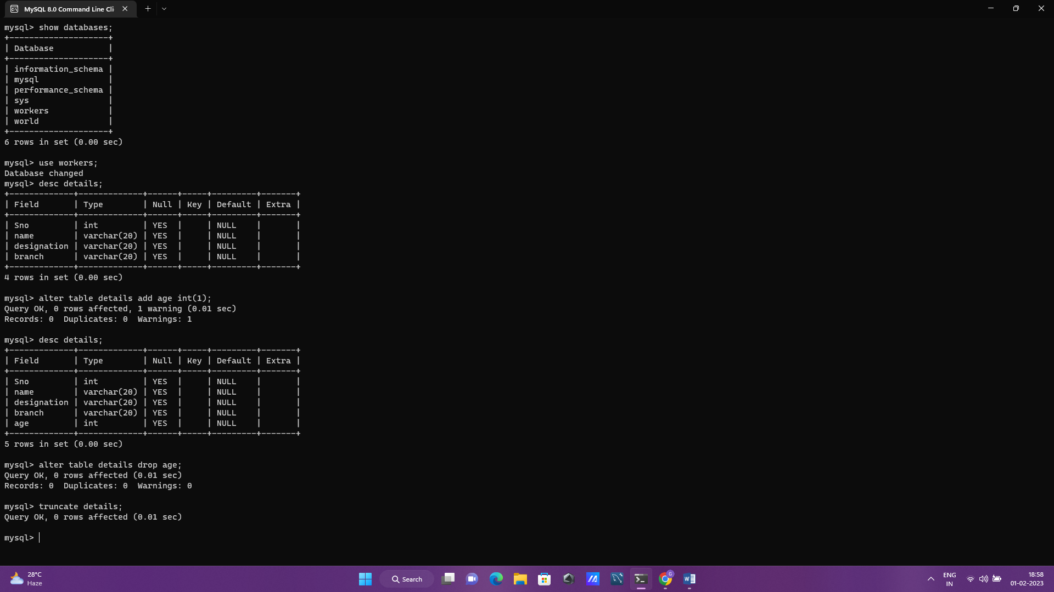

Ex.no = 2 Insert , select , update , delete function 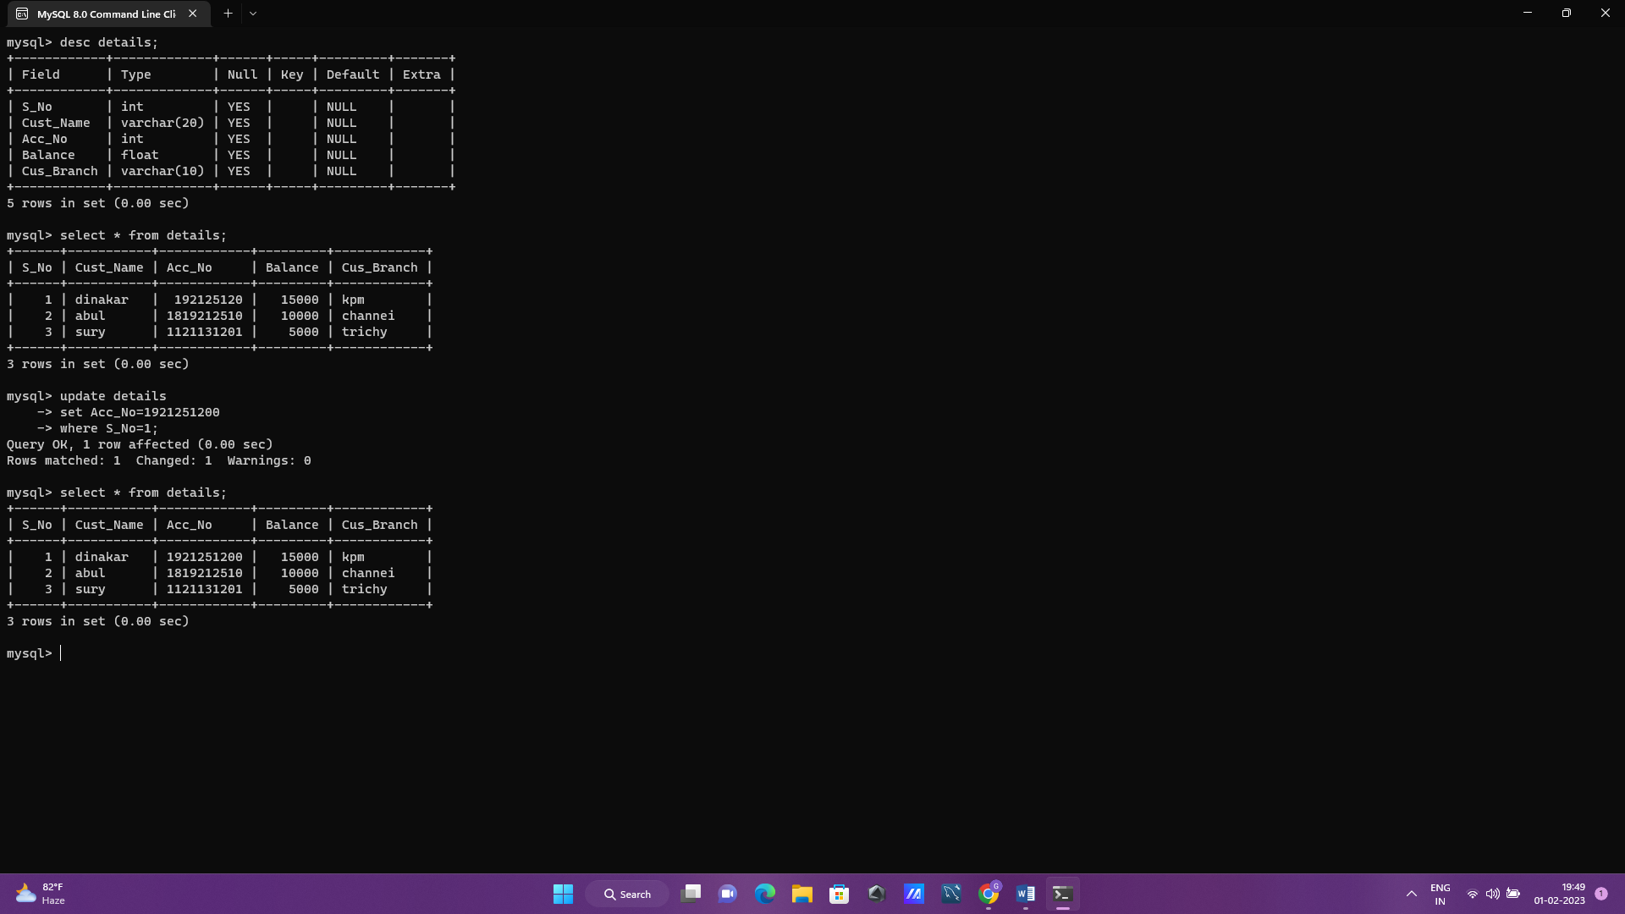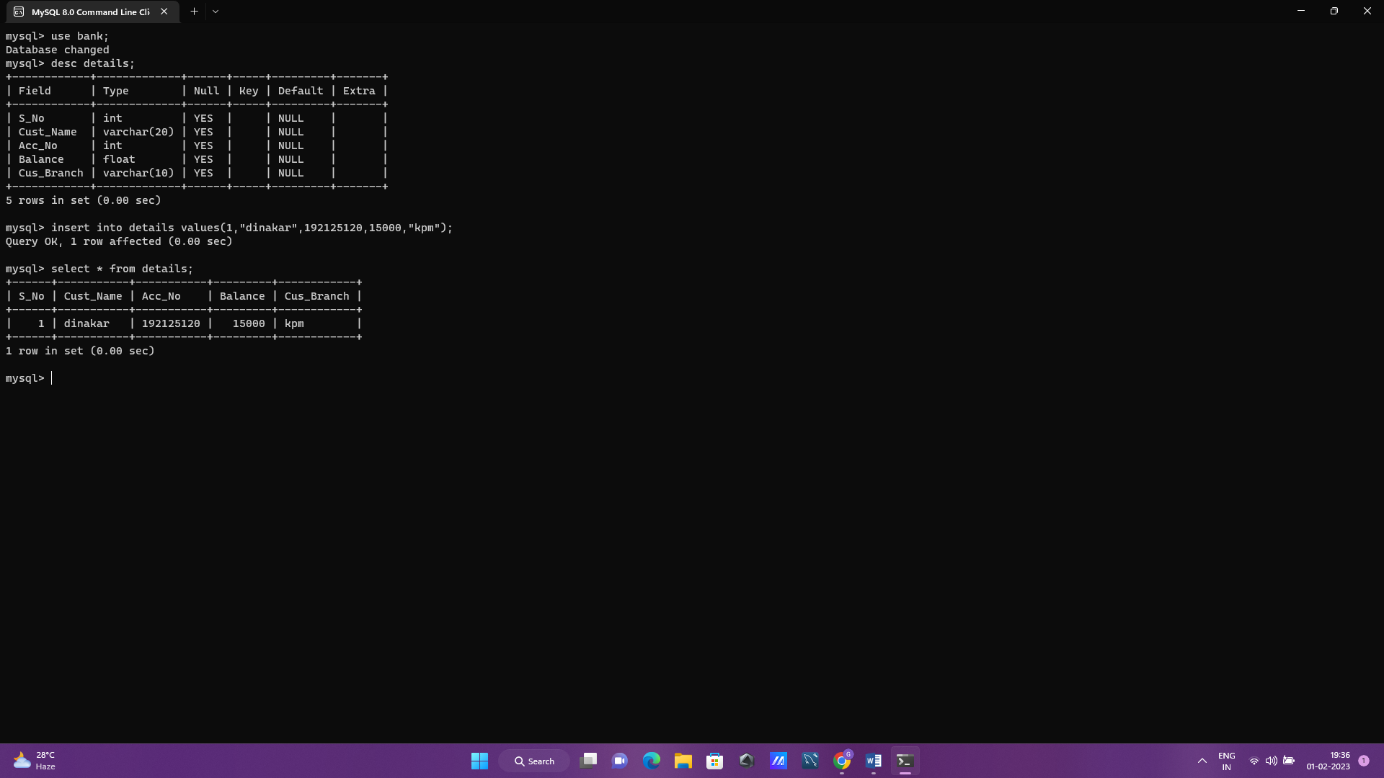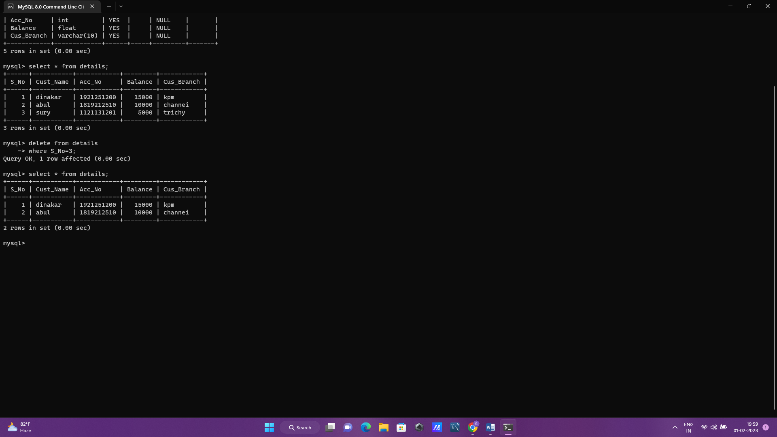

Ex=3 primary,foreign key,unique,check

