**SET1**

**Code1**

kelvin_to_celsius <- function(kelvin_temp) {

celsius_temp <- kelvin_temp - 273.15

return(celsius_temp)

}

values <- c(90, 50, 70, 80, 70, 60, 20, 30, 80, 90, 20)

mean_value <- mean(values)

median_value <- median(values)

mode_value <- names(table(values))[table(values) == max(table(values))]

print(mean_value)

print(median_value)

print(mode_value)

values <- c(90, 50, 70, 80, 70, 60, 20, 30, 80, 90, 20)

sorted_values <- sort(values, decreasing = TRUE)

second_highest <- sorted_values[2]

third_lowest <- sorted_values[length(unique(sorted_values)) - 2]

print(second_highest)

print(third_lowest)

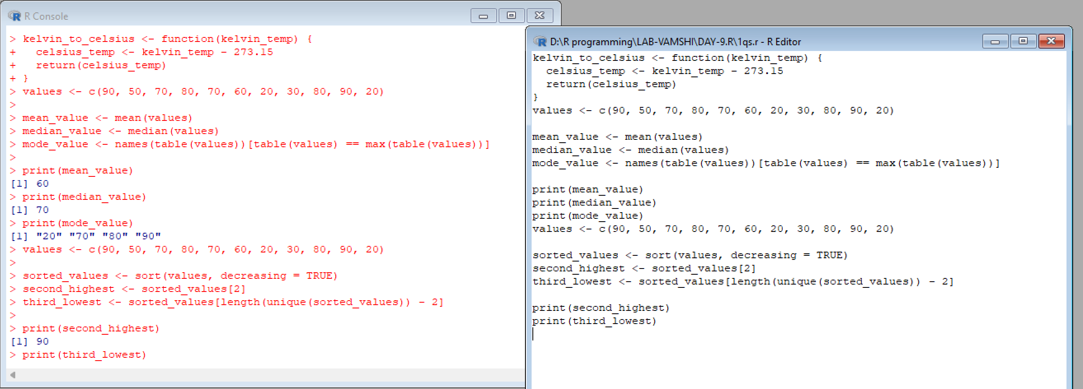

**Code2**

# Load the airquality dataset

data(airquality)

# i. Compute the mean temperature (without using built-in function)

mean_temperature <- sum(airquality$Temp) / length(airquality$Temp)

print(mean_temperature)

# ii. Extract the first five rows from airquality

first_five_rows <- airquality[1:5, ]

print(first_five_rows)

# iii. Extract all columns from airquality except Temp and Wind

subset_airquality <- airquality[, !(names(airquality) %in% c("Temp", "Wind"))]

print(subset_airquality)

# iv. Find the coldest day during the period

coldest_day <- airquality$Day[which.min(airquality$Temp)]

print(coldest_day)

# v. Count the number of days with wind speed greater than 17 mph

wind_speed_gt_17 <- sum(airquality$Wind > 17)

print(wind_speed_gt_17)

**output**

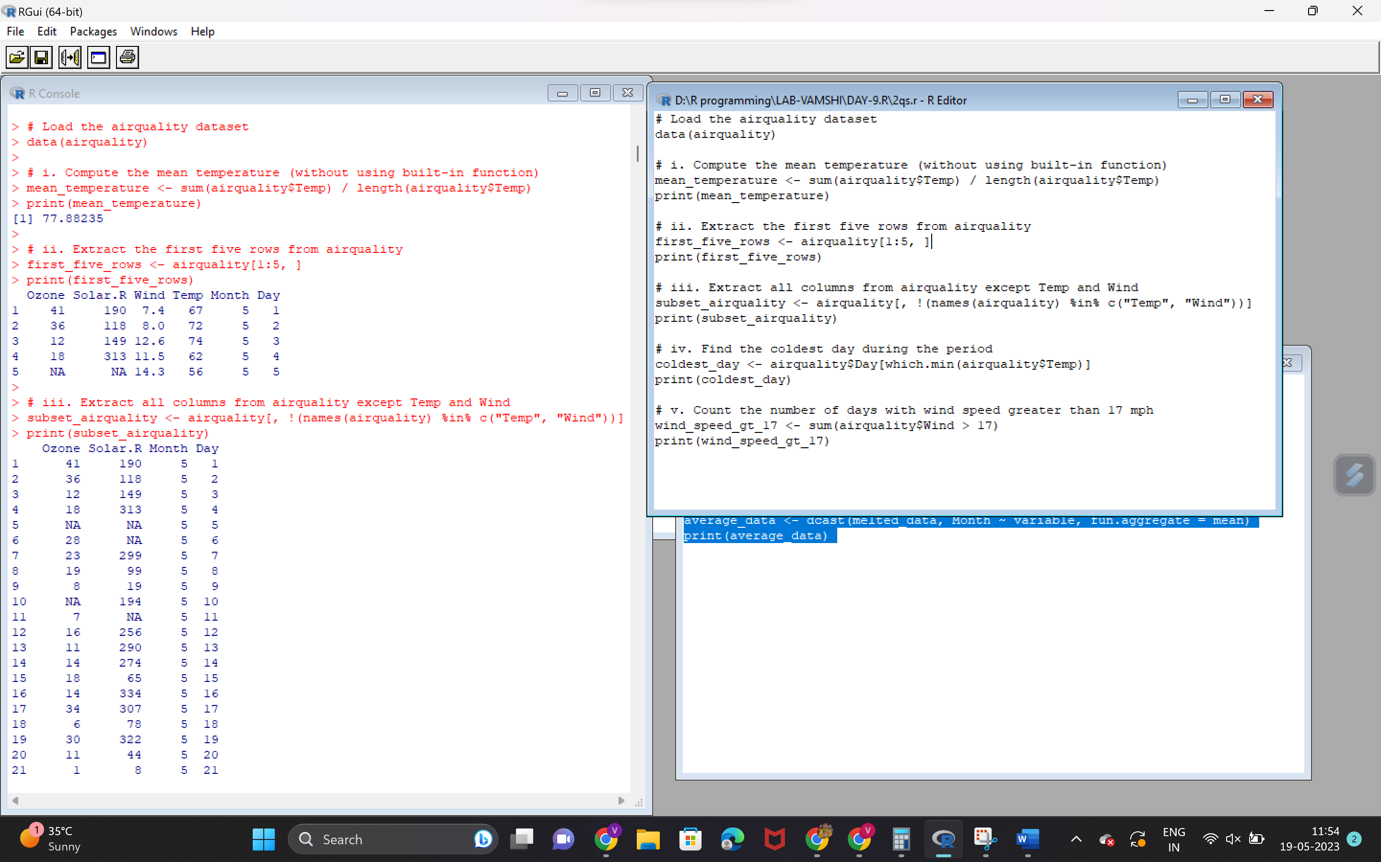

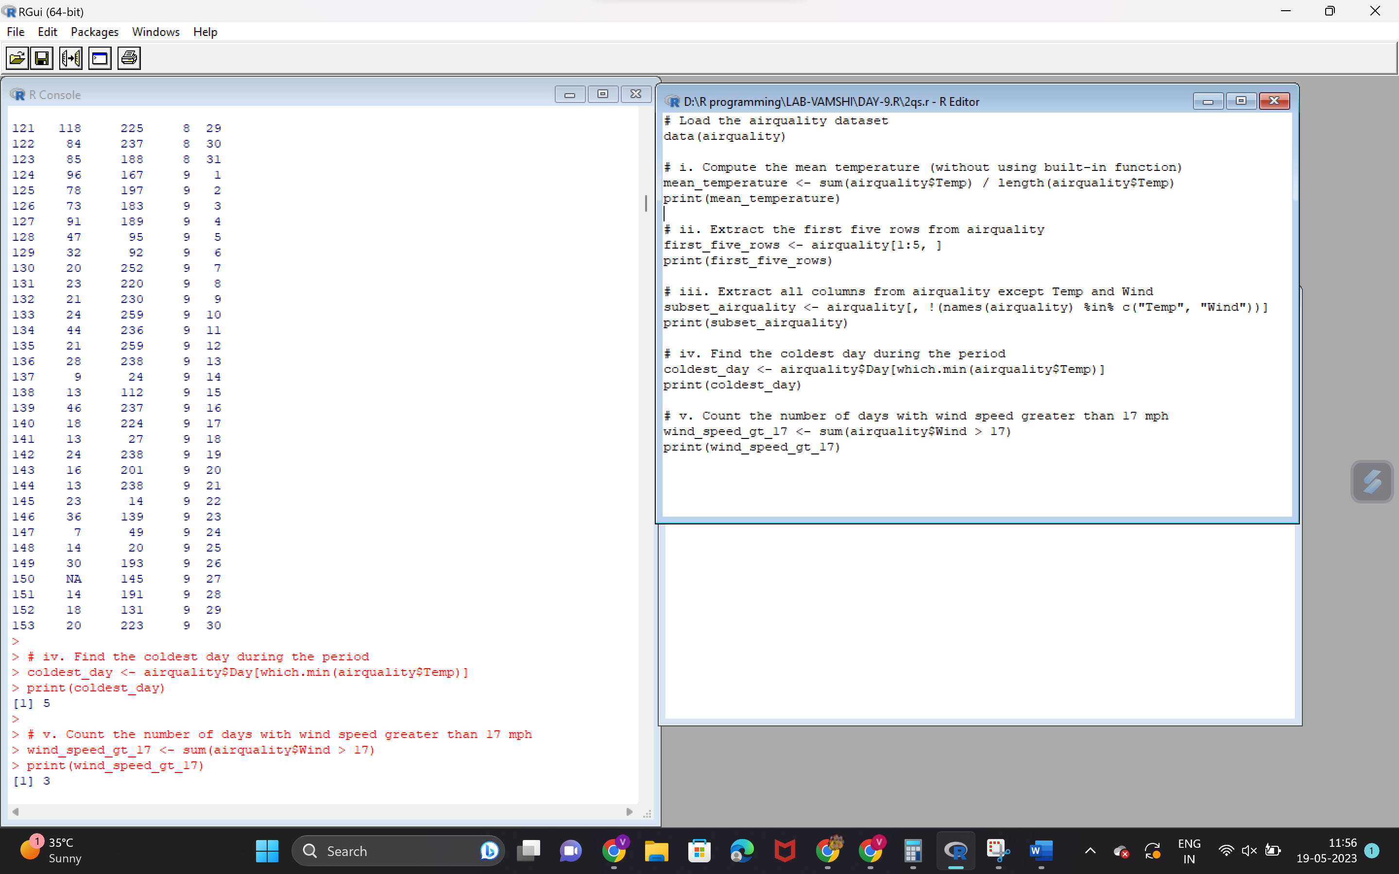

**Code3**

summary(airquality)

library(reshape2)

melted_data <- melt(airquality)

print(melted_data)

melted_data <- melt(airquality, id.vars = c("Month", "Day"))

print(melted_data)

casted_data <- dcast(melted_data, Month + Day ~ variable)

print(casted_data)

average_data <- dcast(melted_data, Month ~ variable, fun.aggregate = mean)

print(average_data)

**output**

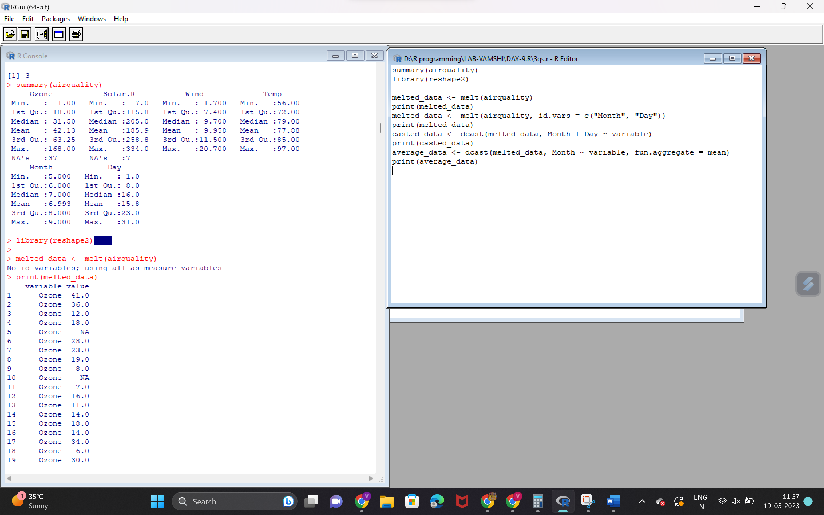

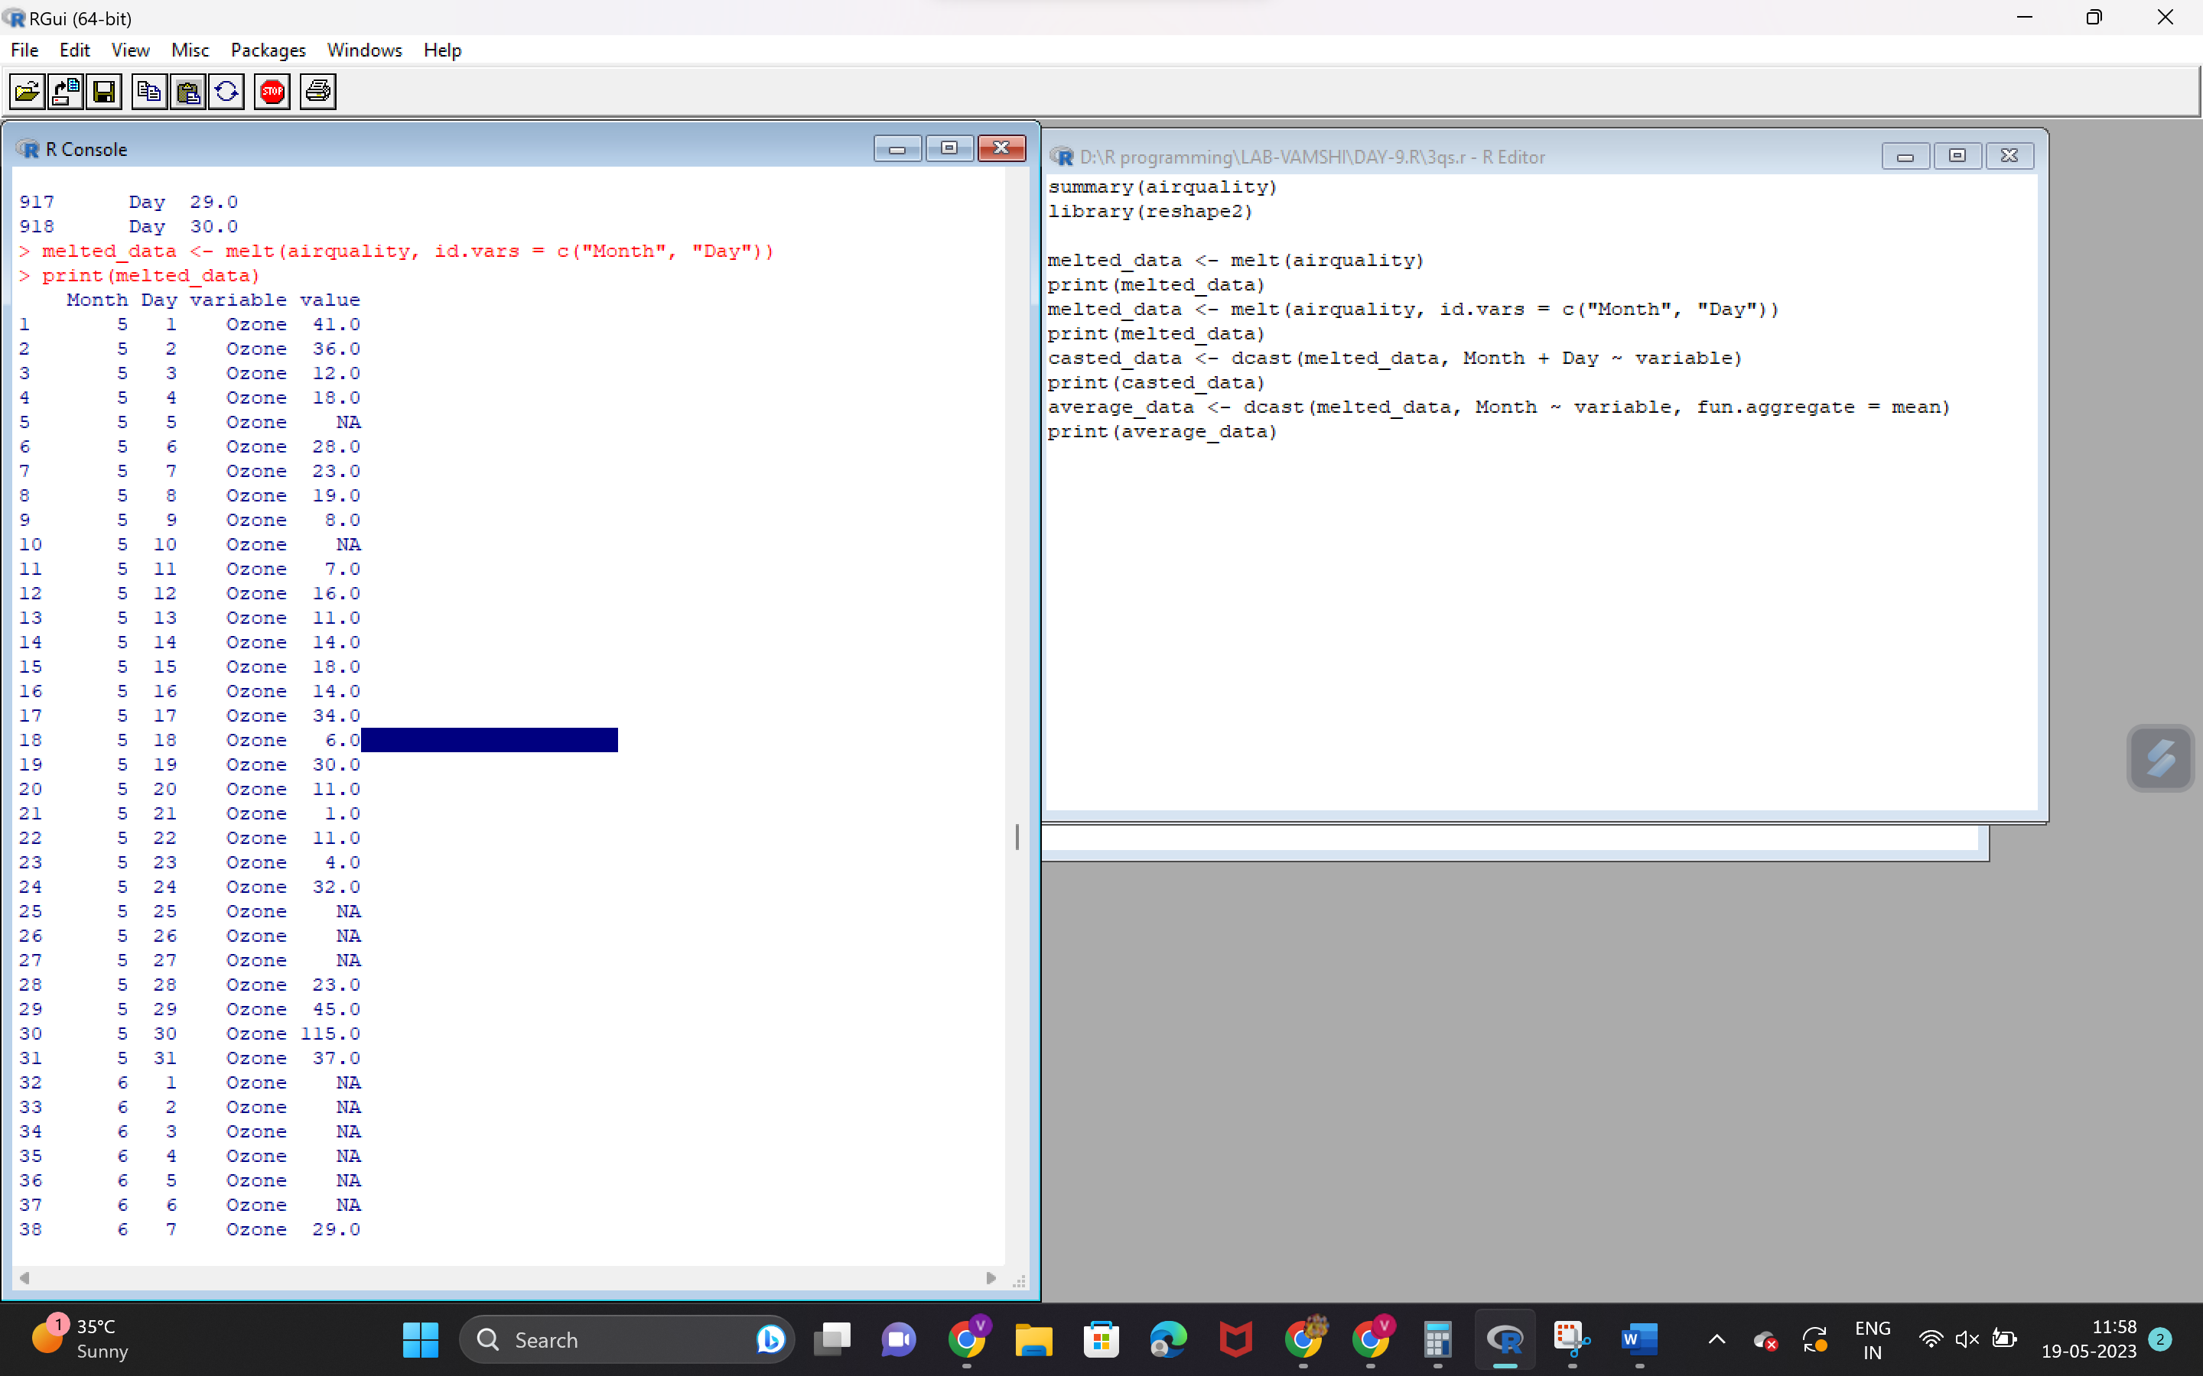

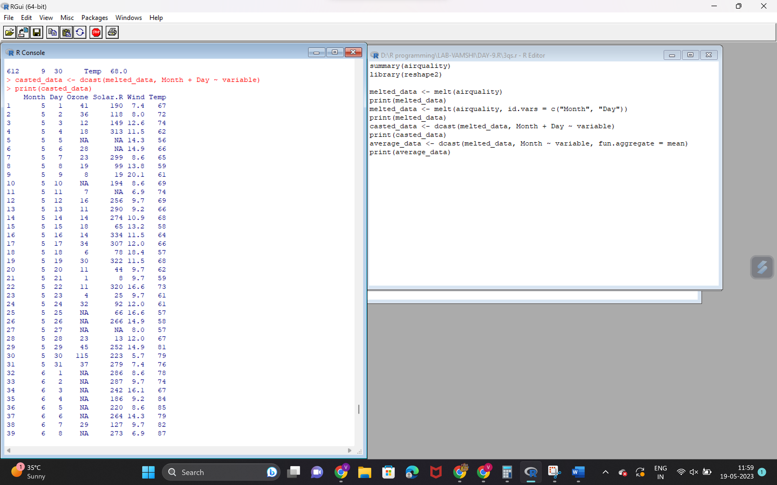

**Code4**

# Check for missing values in the dataset

missing_values <- sum(is.na(airquality))

missing_percentage <- missing_values / nrow(airquality) * 100

# If missing values are less than 10%, drop them. Otherwise, replace with mean.

if (missing_percentage < 10) {

airquality <- na.omit(airquality)

} else {

airquality[is.na(airquality)] <- mean(airquality, na.rm = TRUE)

}

# Fit linear regression model

model <- lm(Ozone ~ Solar.R, data = airquality)

# Print model summary

summary(model)

# Plot scatter plot

plot(airquality$Solar.R, airquality$Ozone, xlab = "Solar.R", ylab = "Ozone", main = "Scatter Plot")

# Add regression line

abline(model, col = "red")

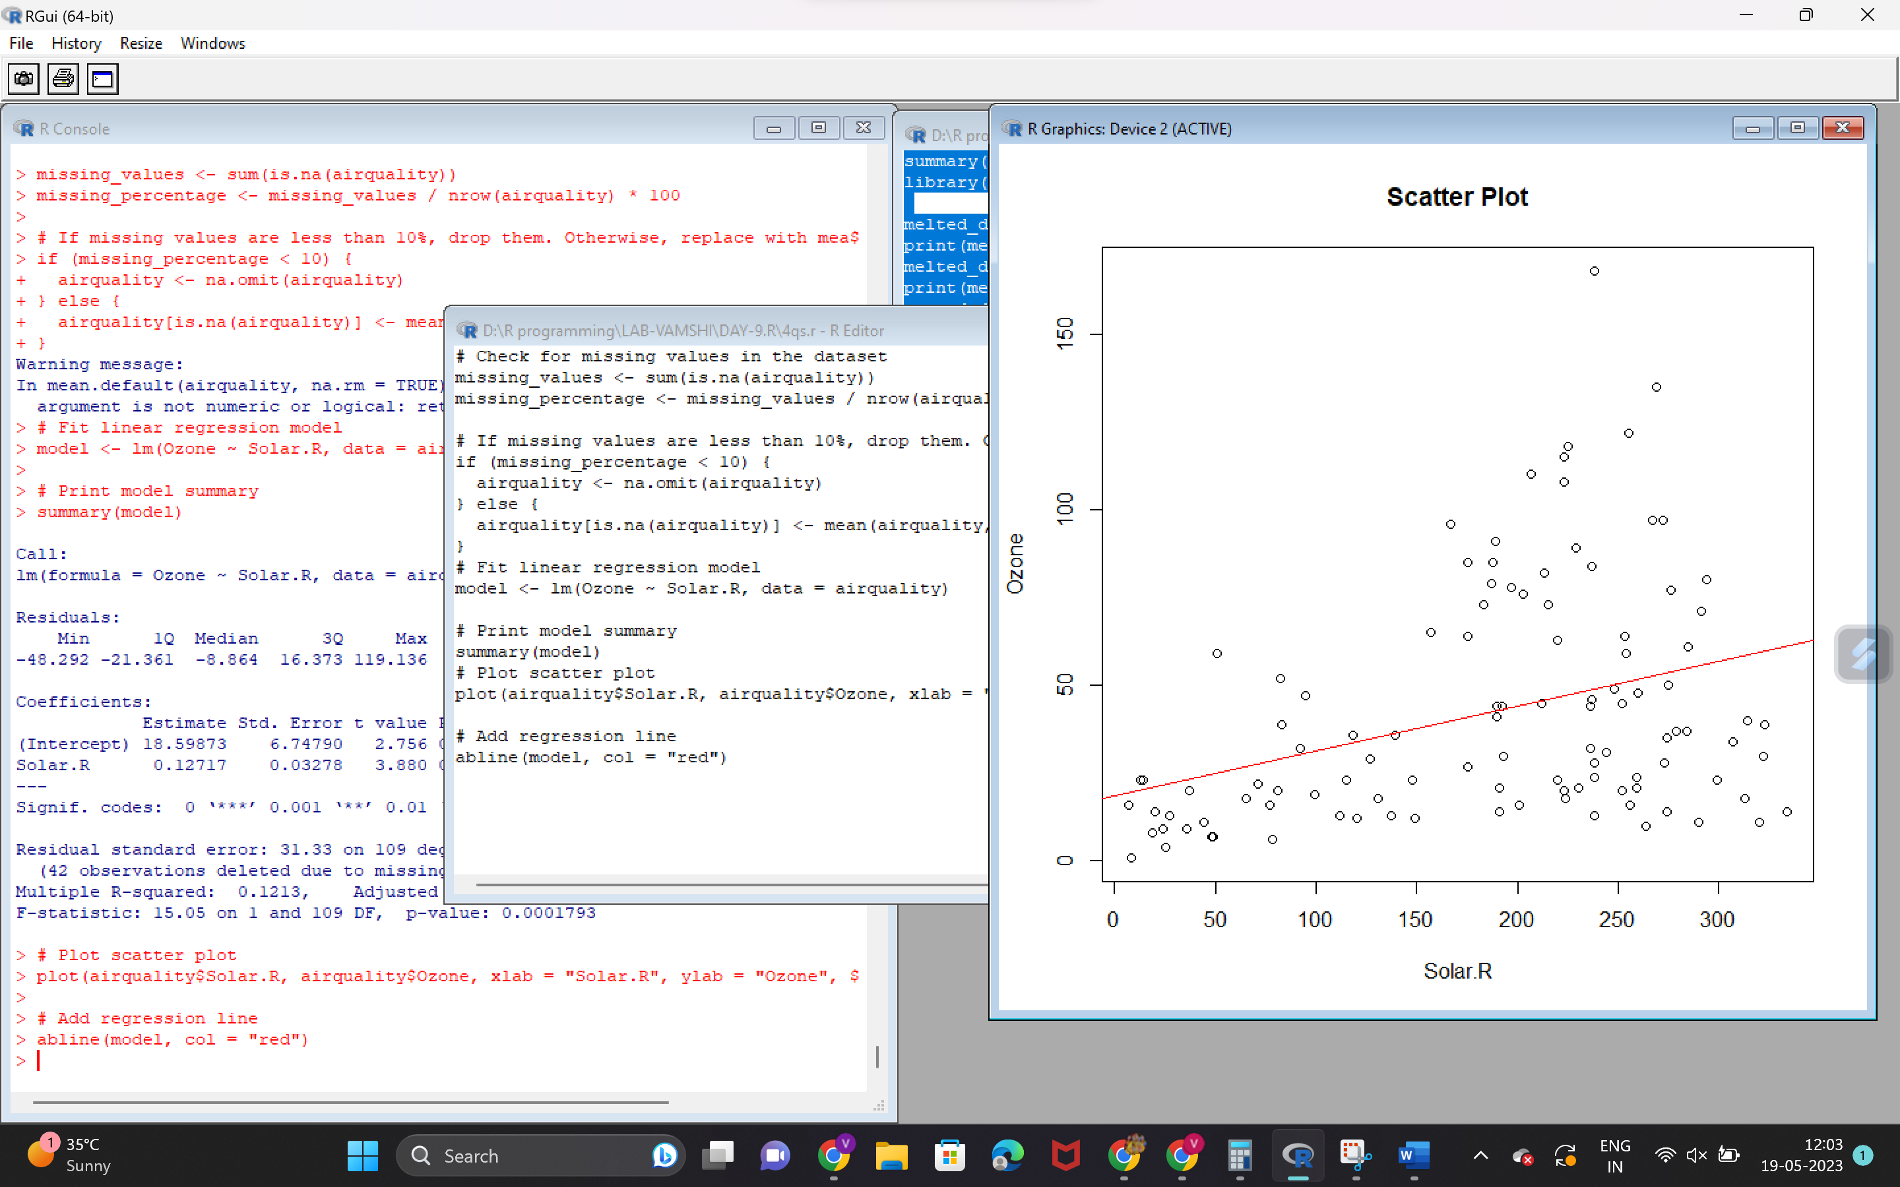

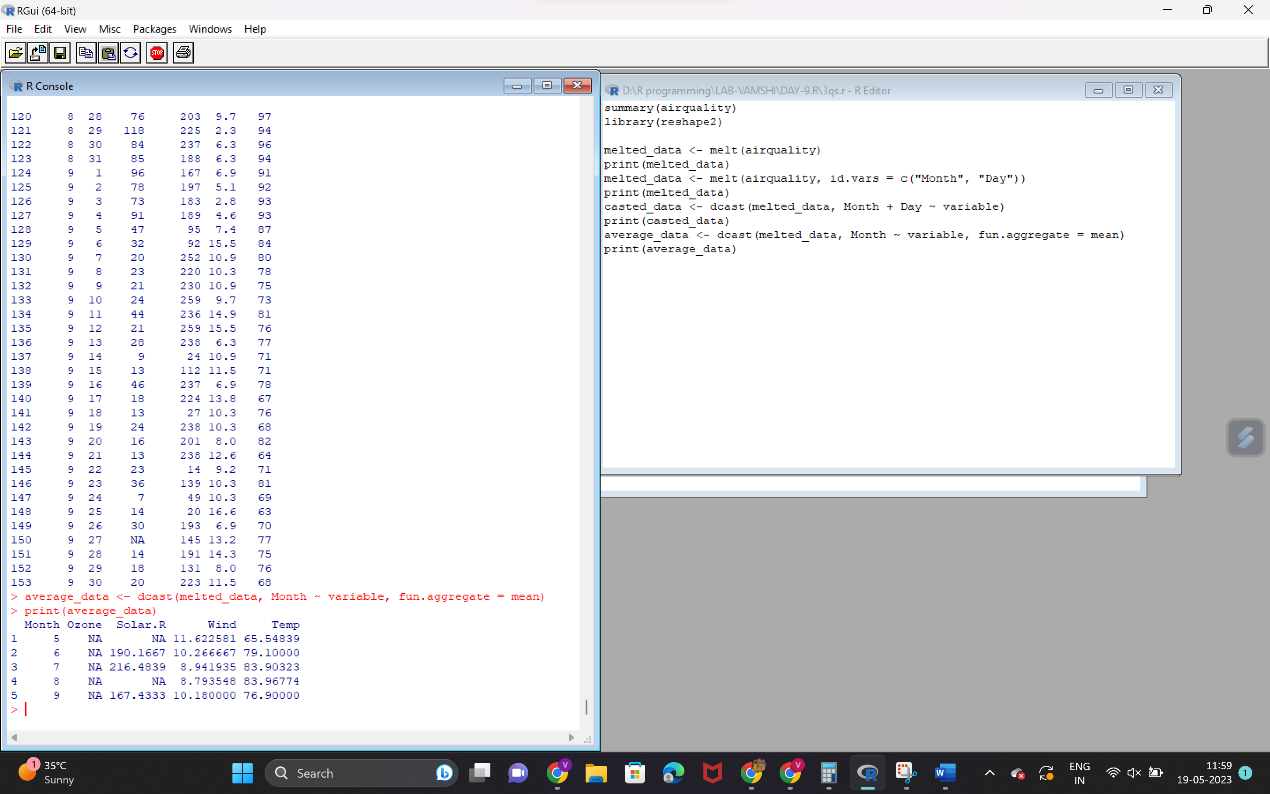

**SET2**

**CODE1**

factorial <- function(n) {

result <- 1

for (i in 1:n) {

result <- result * i

}

return(result)

}

set.seed(42) # Set seed for reproducibility

# Create matrix

matrix_data <- matrix(sample(1:100, 12, replace = TRUE), nrow = 3, ncol = 4, byrow = TRUE,

dimnames = list(c("x", "y", "z"), c("uno", "dos", "tres", "cuatro")))

# Scale matrix by 10

scaled_matrix <- matrix_data * 10

print(scaled_matrix)

column_uno <- matrix_data[, "uno"]

print(column_uno)

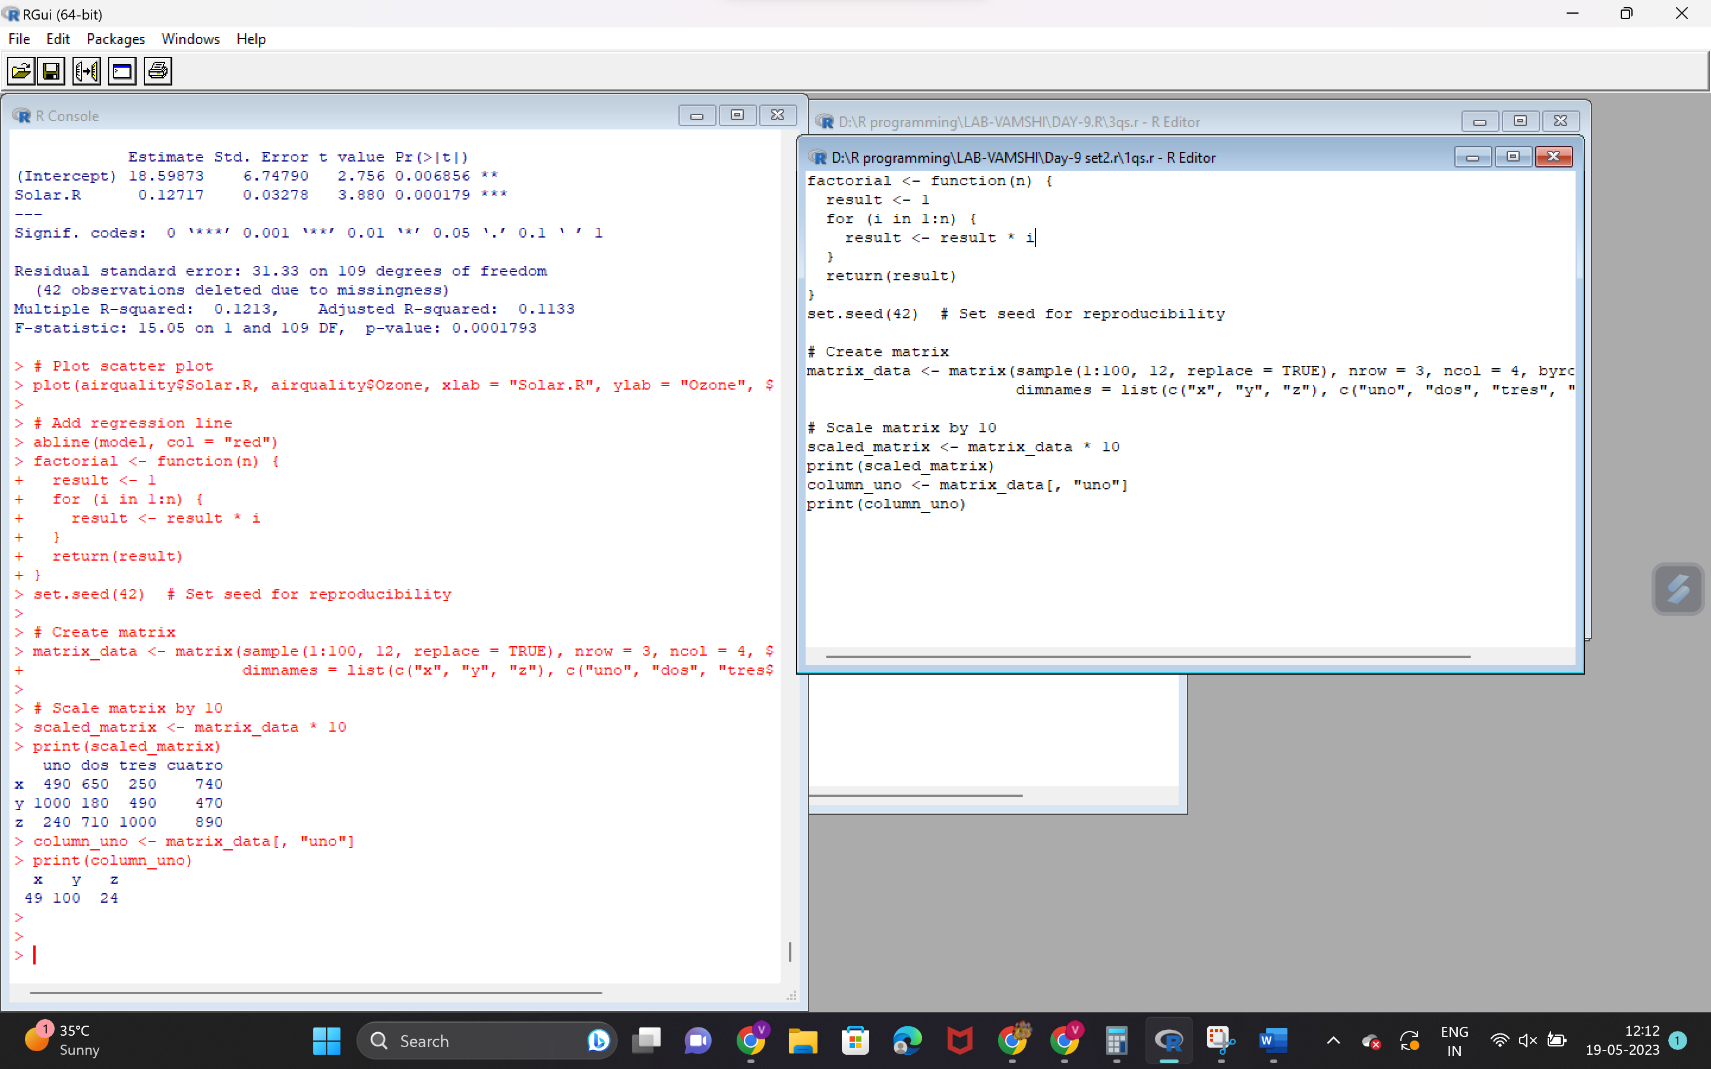

CODE2

factorial <- function(n) {

result <- 1

for (i in 1:n) {

result <- result * i

}

return(result)

}

set.seed(42) # Set seed for reproducibility

# Create matrix

matrix_data <- matrix(sample(1:100, 12, replace = TRUE), nrow = 3, ncol = 4, byrow = TRUE,

dimnames = list(c("x", "y", "z"), c("uno", "dos", "tres", "cuatro")))

# Scale matrix by 10

scaled_matrix <- matrix_data * 10

print(scaled_matrix)

column_uno <- matrix_data[, "uno"]

print(column_uno)

