**DAY-4B**

5-CODE

library(tidyverse)

data(mtcars)

summary(mtcars)

str(mtcars)

logit_model <- glm(am ~ hp + wt + cyl, data = mtcars, family = binomial(link = "logit"))

summary(logit_model)

OUTPUT:

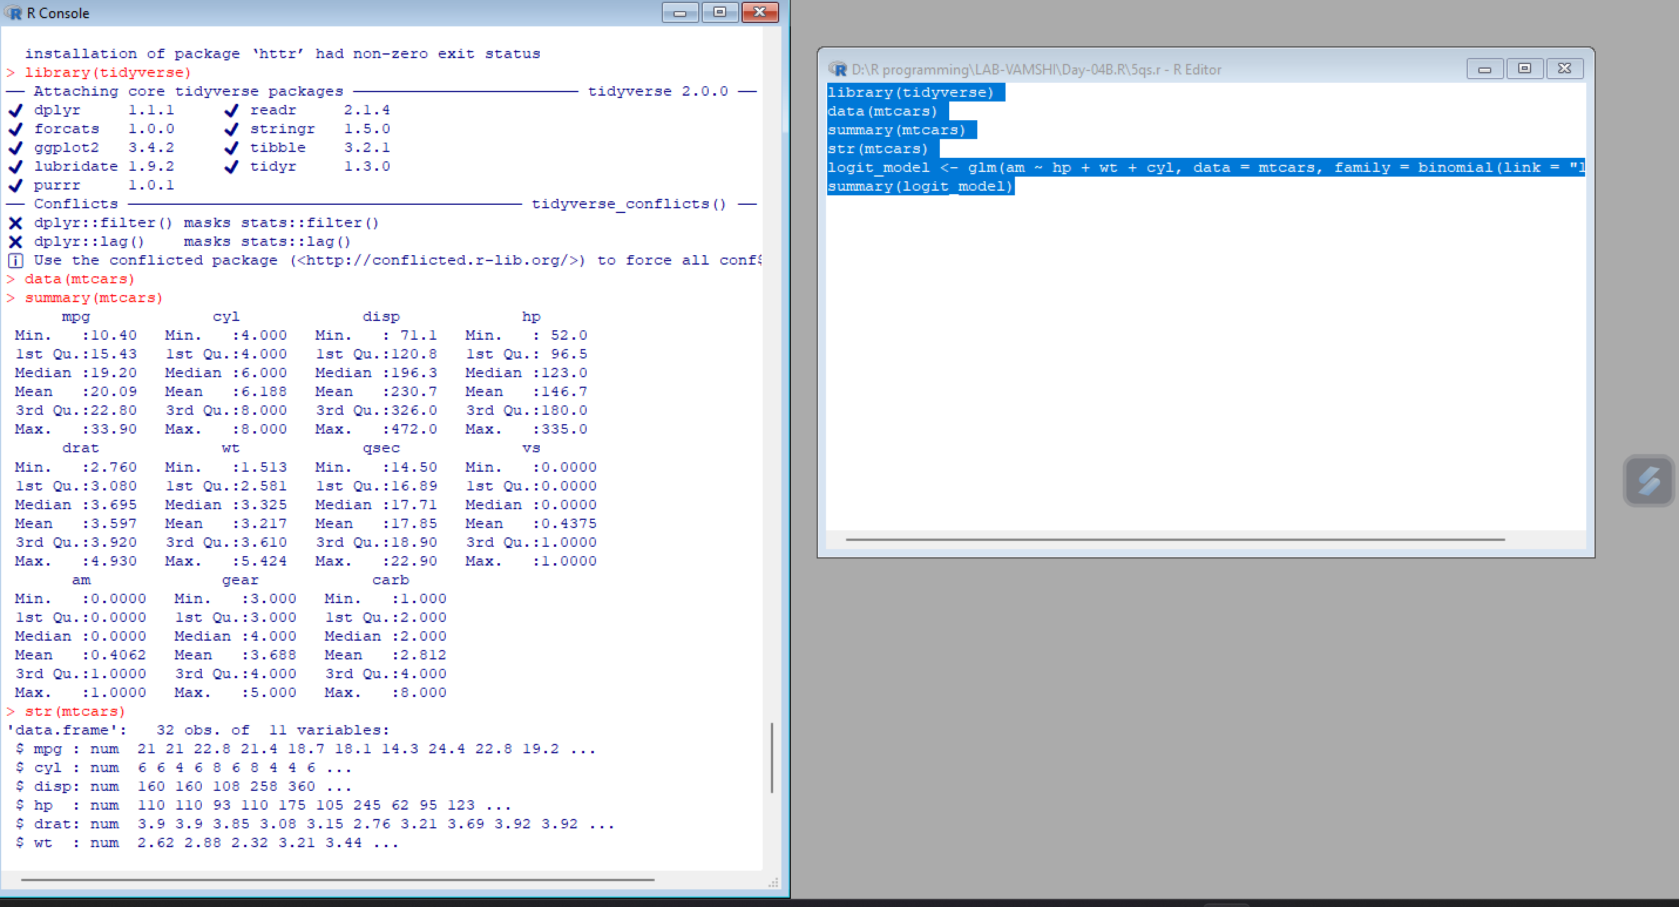

6-code

# Load the dataset

data(warpbreaks)

# Fit a Poisson regression model

model <- glm(breaks ~ wool + tension, data = warpbreaks, family = poisson)

# Print the summary of the model

summary(model)

OUTPUT

