**Day-03:**

1.code:

#a

value<-c(12,7,3,4.2,8,2,54,-21,8,-5)

average<-mean(value)

average

#b

values <- c(12, 7, 3, 4.2, 18, 2, 54, -21, 8, -5)

trimmed_mean <- mean(values, trim = 0.6)

print(trimmed_mean)

#c

values <- c(12, 7, 3, 4.2, 18, 2, 54, -21, 8, -5, NA)

mean_values <- mean(values, na.rm = TRUE)

print(mean_values)

output:

> average

[1] 7.22

> print(trimmed_mean)

[1] 5.6

> print(mean_values)

[1] 8.22

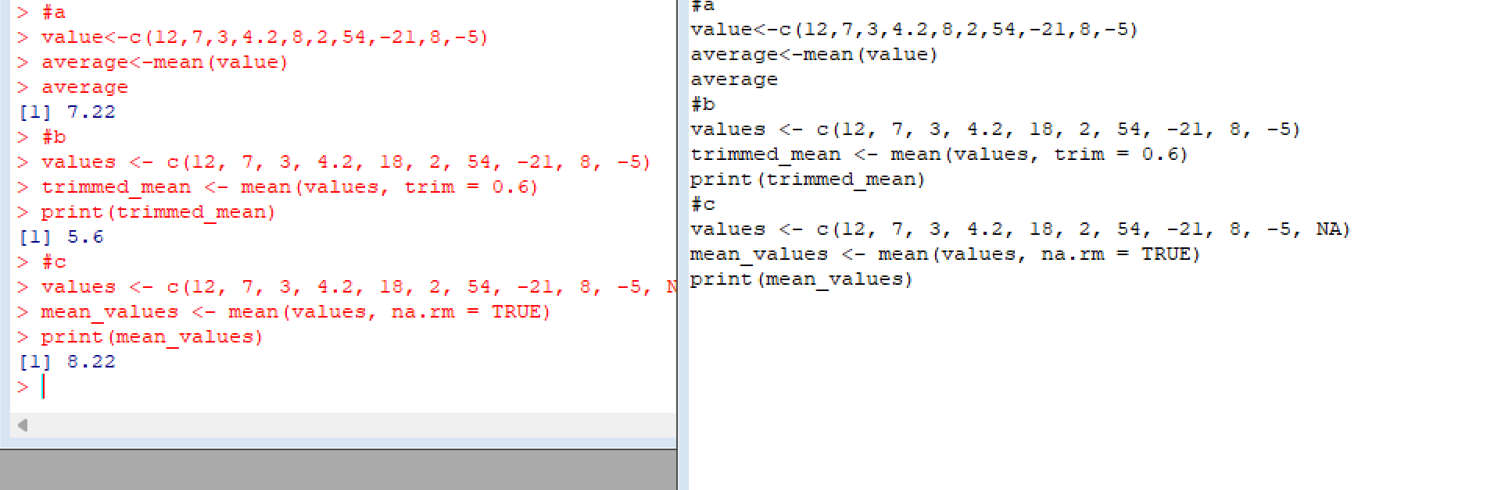

2.CODE

values <- c(12, 7, 3, 4.2, 18, 2, 54, -21, 8, -5) # create a vector of values

median_values <- median(values) # compute the median using the median() function

print(median_values) # print the median

OUTPUT:

[1] 5.6

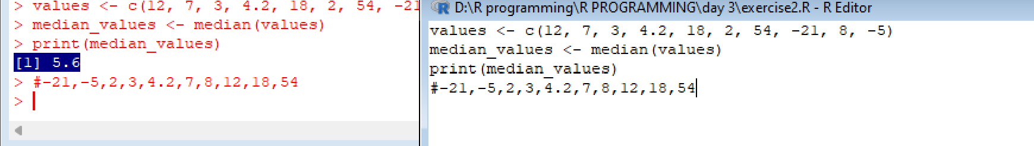

3.CODE

calculate_mode <- function(x) {

freq <- table(x)

max_freq <- max(freq)

mode <- names(freq)[freq == max_freq]

return(mode)

}

numeric_data <- c(2,1,2,3,1,2,3,4,1,5,5,3,2,3)

mode_numeric <- calculate_mode(numeric_data)

cat("Mode of numeric dataset:", mode_numeric, "\n")

character_data <- c("o","it","the","it","it")

mode_character <- calculate_mode(character_data)

cat("Mode of character dataset:", mode_character, "\n")

OUTPUT:

Mode of numeric dataset: 2 3

>Mode of character dataset: it

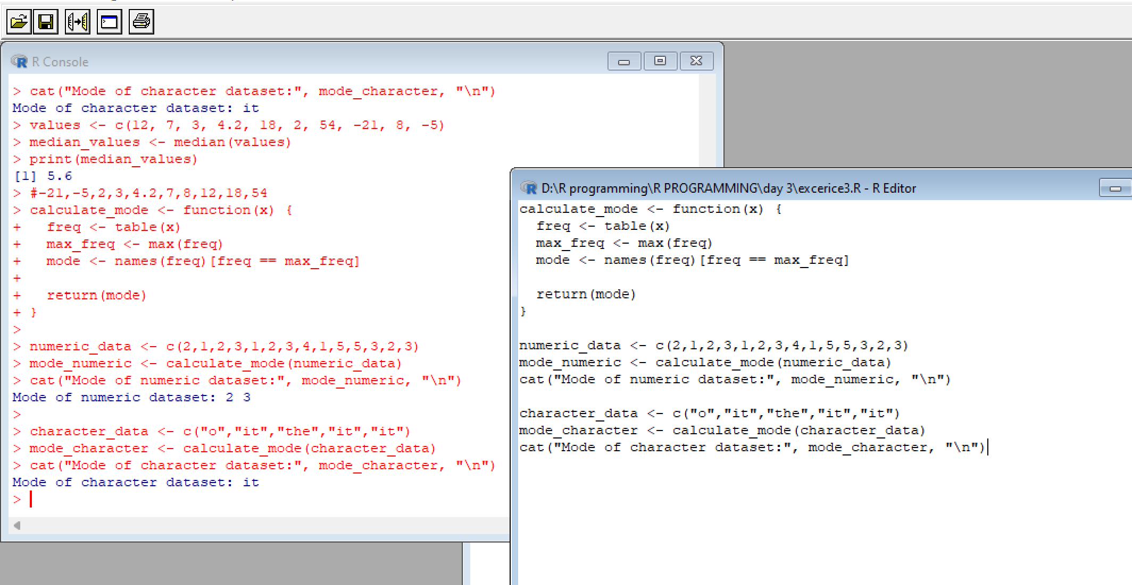

4.CODE

mpg <- read.csv("https://vincentarelbundock.github.io/Rdatasets/csv/ggplot2/mpg.csv")

head(mpg)

max_city_mpg_row <- which.max(mpg$cty)

max_city_mpg_car <- paste(mpg$manufacturer[max_city_mpg_row], mpg$model[max_city_mpg_row])

cat("Car which gives maximum city miles per gallon:", max_city_mpg_car, "\n")

compact_cars <- subset(mpg, class %in% c("compact", "subcompact"))

min_disp_compact <- compact_cars[which.min(compact_cars$displ), "model"]

cat("Car which gives minimum displacement in compact class:", min_disp_compact, "\n")

subcompact_cars <- subset(mpg, class == "subcompact")

min_disp_subcompact <- subcompact_cars[which.min(subcompact_cars$displ), "model"]

cat("Car which gives minimum displacement in subcompact class:", min_disp_subcompact, "\n")

output:

X manufacturer model displ year cyl trans drv cty hwy fl class

1 1 audi a4 1.8 1999 4 auto(l5) f 18 29 p compact

2 2 audi a4 1.8 1999 4 manual(m5) f 21 29 p compact

3 3 audi a4 2.0 2008 4 manual(m6) f 20 31 p compact

4 4 audi a4 2.0 2008 4 auto(av) f 21 30 p compact

5 5 audi a4 2.8 1999 6 auto(l5) f 16 26 p compact

6 6 audi a4 2.8 1999 6 manual(m5) f 18 26 p compact

> maximum city miles per gallon: volkswagen new beetle

minimum displacement in compact class: civic

> minimum displacement in subcompact class: civic

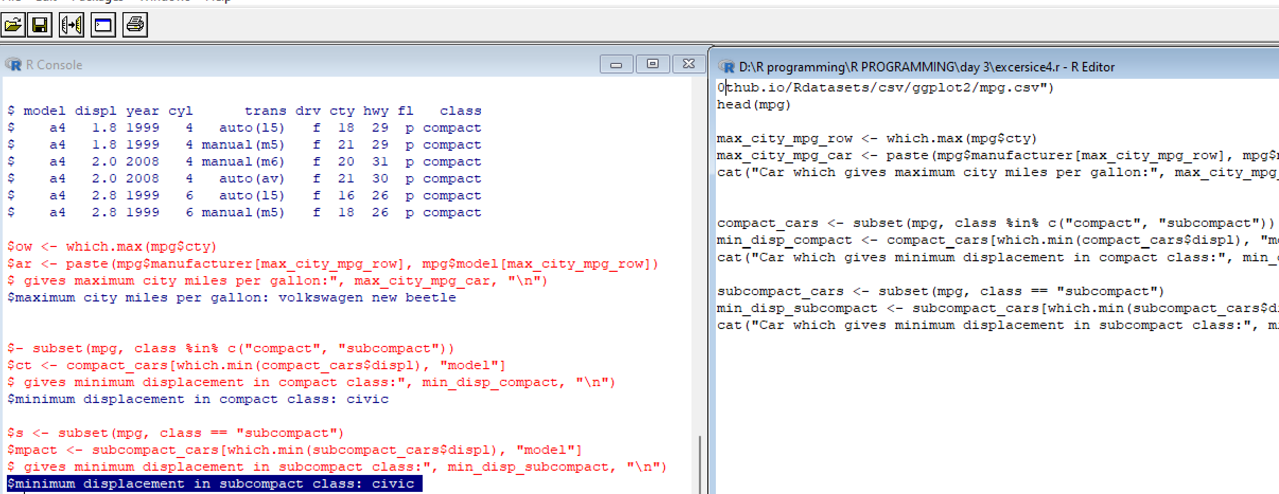

**5.code:**

sd_city_mpg <- sd(mpg$cty)

cat("Standard deviation of city miles per gallon:", sd_city_mpg, "\n")

var_hwy_mpg <- var(mpg$hwy)

cat("Variance of highway miles per gallon:", var_hwy_mpg, "\n")

output:

Standard deviation of city miles per gallon: 4.255946

iance of highway miles per gallon: 35.45778

>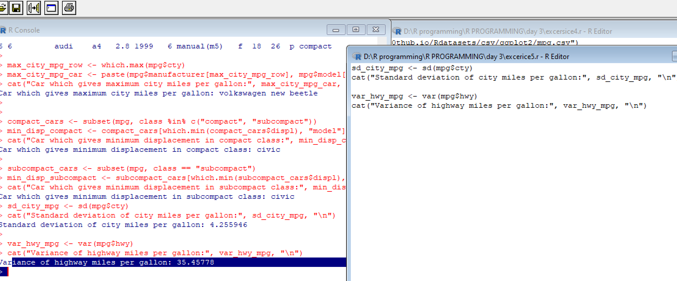

6.code

range_disp <- range(mpg$disp)

cat("Range of disp in the data set mpg:", range_disp, "\n")

quartiles_disp <- quantile(mpg$disp, probs = c(0.25, 0.5, 0.75))

cat("Quartiles of disp in the data set mpg:\n")

print(quartiles_disp)

iqr_disp <- IQR(mpg$disp)

cat("IQR of disp column in the data set mpg:", iqr_disp, "\n"

output:

Range of disp in the data set mpg: 1.6 7

>

> quartiles_disp <- quantile(mpg$disp, probs = c(0.25, 0.5, 0.75))

> cat("Quartiles of disp in the data set mpg:\n")

Quartiles of disp in the data set mpg:

> print(quartiles_disp)

25% 50% 75%

2.4 3.3 4.6

>

> iqr_disp <- IQR(mpg$disp)

> cat("IQR of disp column in the data set mpg:", iqr_disp, "\n"

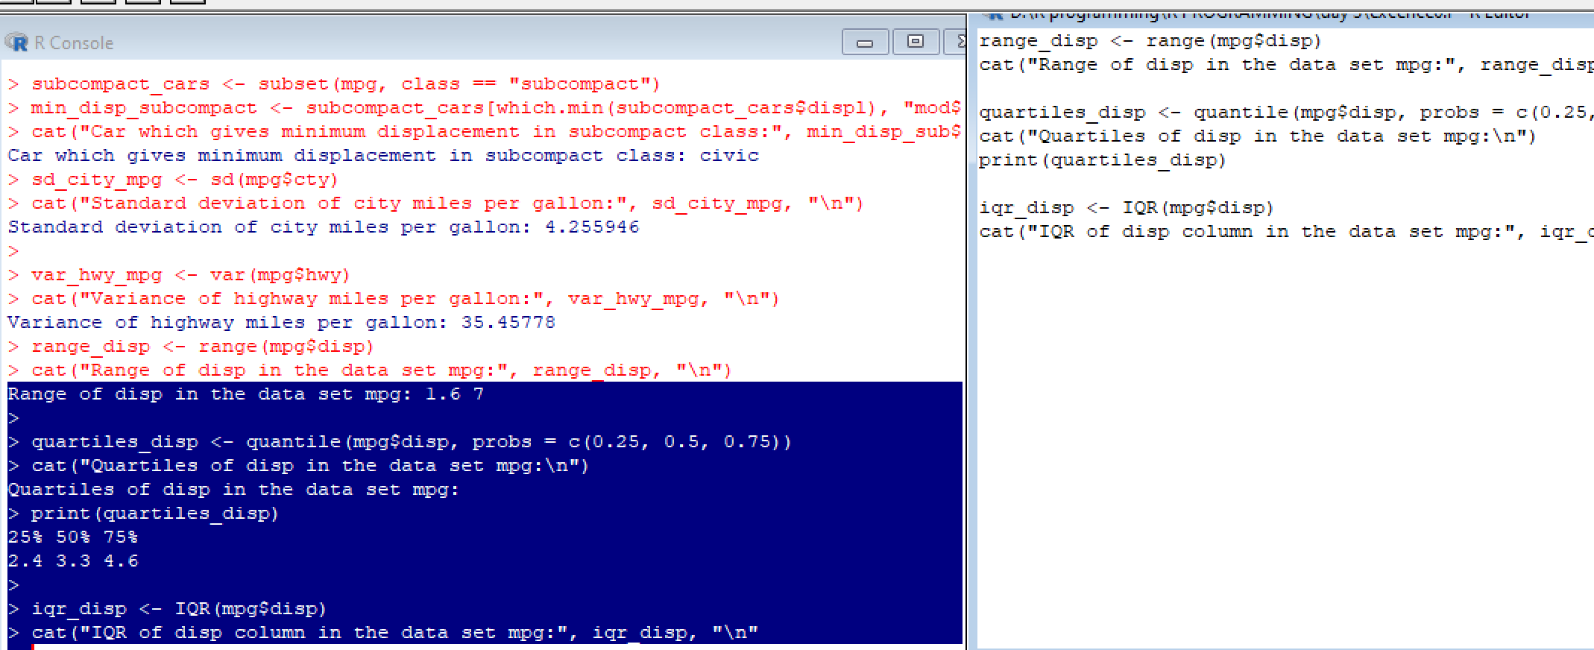

7.code;

library(e1071)

library(ggplot2)

# Calculate the skewness of city miles per gallon in the data set mpg

skew_cty <- skewness(mpg$cty)

cat("Skewness of city miles per gallon in the data set mpg:", skew_cty, "\n")

# Create a histogram of city miles per gallon in the data set mpg

qplot(mpg$cty, geom="histogram", binwidth=2, main="City Miles Per Gallon", xlab="Miles Per Gallon")

# Calculate the kurtosis of city miles per gallon in the data set mpg

kurt_cty <- kurtosis(mpg$cty)

cat("Kurtosis of city miles per gallonin in the data set mpg:", kurt_cty, "\n")

output:

+Skewness of city miles per gallon in the data set mpg: 0.7863773

>r gallon in the data set mpg: 1.430539

