**1.Two 8 bit addition program:**

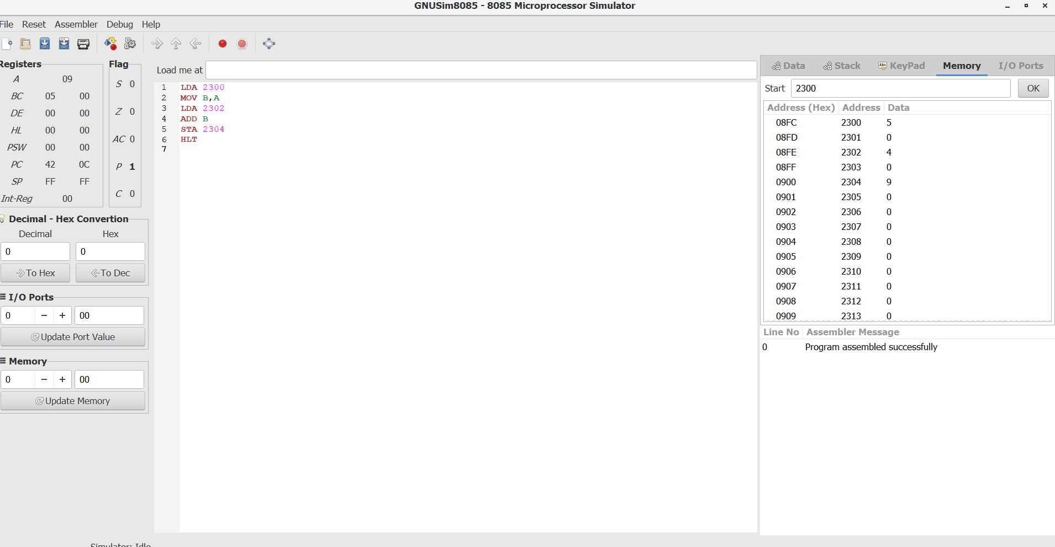

**2.Subtraction of two 8 bit numbers:**

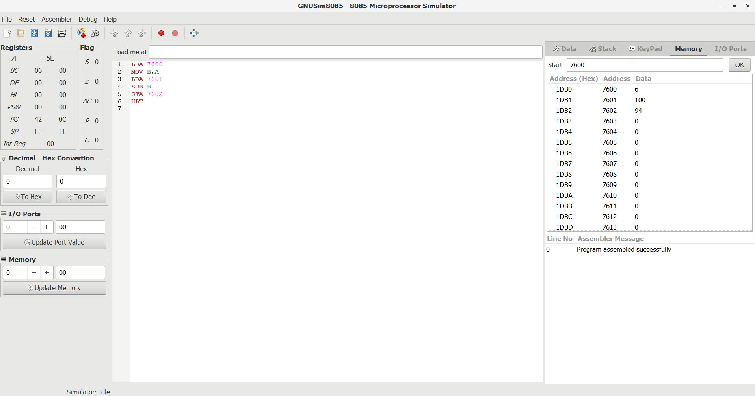

**3.Multiplication of two 8 bit numbers:**

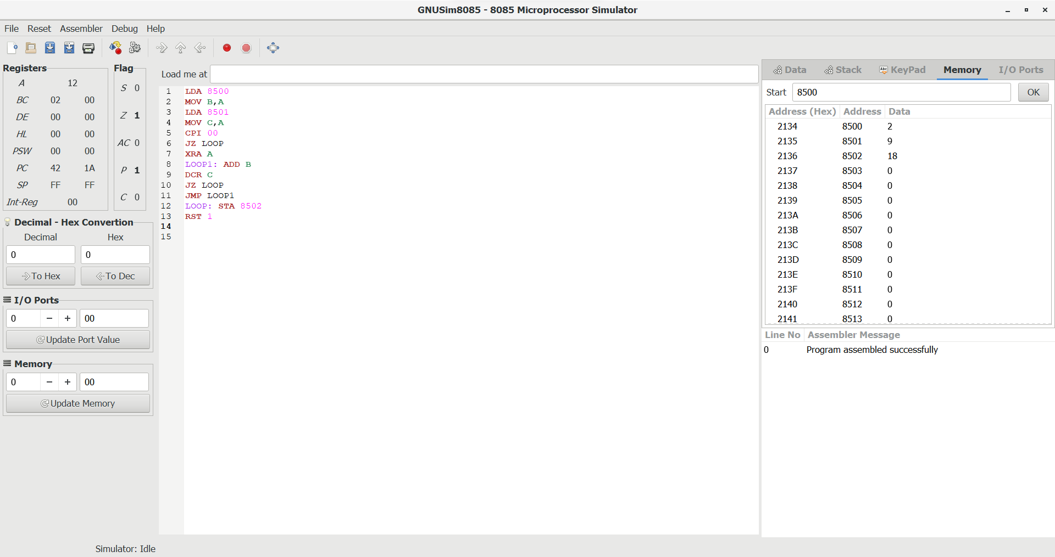

**4.Division of two 8 bit numbers**

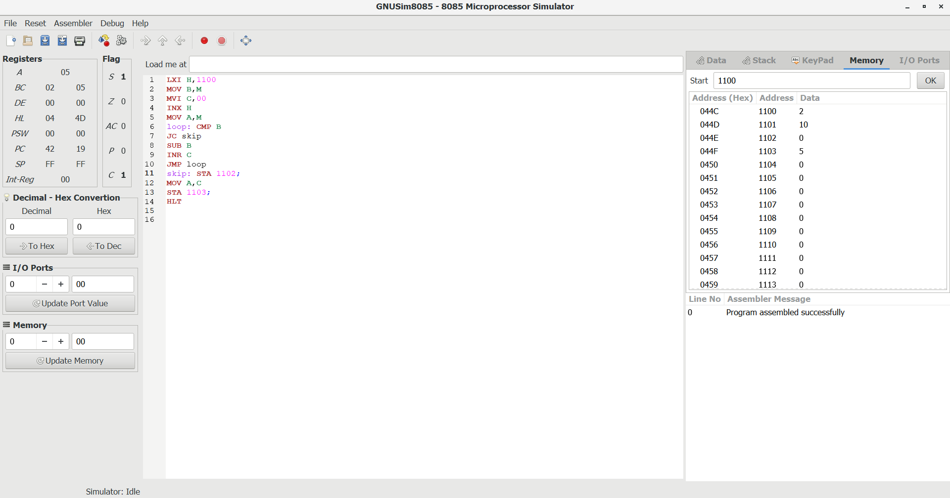

**Addition of two 16 bit numbers:**

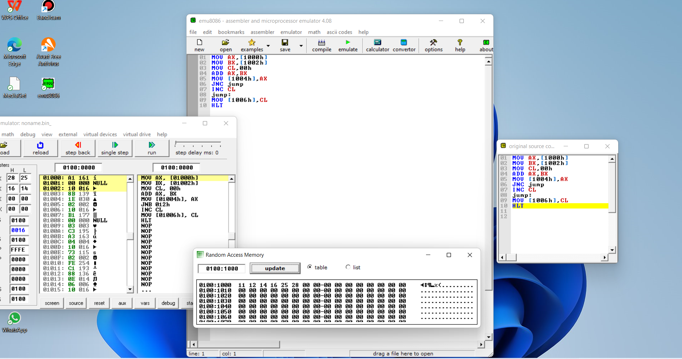

**6.Subtraction of two 16 bit numbers:**

