**Data Structure Lab**

Megha Patel 20124107

**1. Write a program in C to sort elements in lexicographical order.**

#include <stdio.h>

#include <string.h>

int main() {

char str[5][50], temp[50];

int n;

printf("how many string do u want to enter");

scanf("%d",&n);

printf("Enter words: ");

for (int i = 0; i <= n; ++i) {

fgets(str[i], sizeof(str[i]), stdin);

}

for (int i = 0; i <= n; ++i) {

for (int j = i + 1; j <= n; ++j) {

if (strcmp(str[i], str[j]) > 0) {

strcpy(temp, str[i]);

strcpy(str[i], str[j]);

strcpy(str[j], temp);

}

}

}

printf("\nIn the lexicographical order: \n");

for (int i = 0; i <= n; ++i) {

fputs(str[i], stdout);

}

return 0;

}

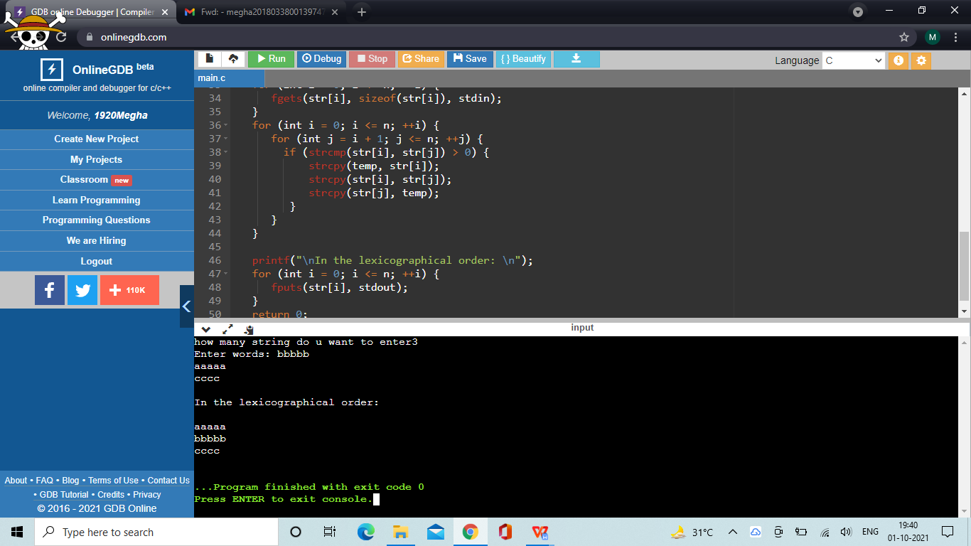

1. **Write a C program to copy one string into another string using pointers.**

#include <stdio.h>

int main()

{

char text1[30];

char text2[30]="";

int i;

printf("Enter any string: ");

scanf("%s",text1);

printf("Second string = %s\n", text2);

for(i=0; text1[i]!='\0'; i++)

{

text2[i] = text1[i];

}

text2[i] = '\0';

printf("Second string after copied fron 1st string =\t %s\n", text2);

return 0;

}

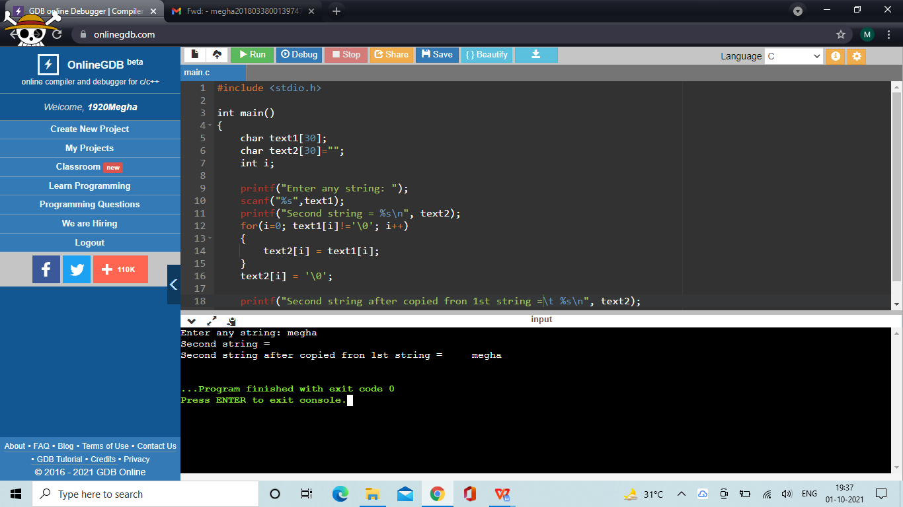

1. **Write a program in C to print all permutations of a given string using pointers.**

#include <stdio.h>

#include <string.h>

void swap(char *x, char *y)

{

char temp;

temp = *x;

*x = *y;

*y = temp;

}

void permute(char *a, int l, int r)

{

int i;

if (l == r)

printf("%s\n", a);

else

{

for (i = l; i <= r; i++)

{

swap((a+l), (a+i));

permute(a, l+1, r);

swap((a+l), (a+i)); //backtrack

}

}

}

void main()

{

char str[5];

printf("enter string for permutation\n");

scanf("%s",str);

printf("permuted string is\n");

int n = strlen(str);

permute(str, 0, n-1);

}

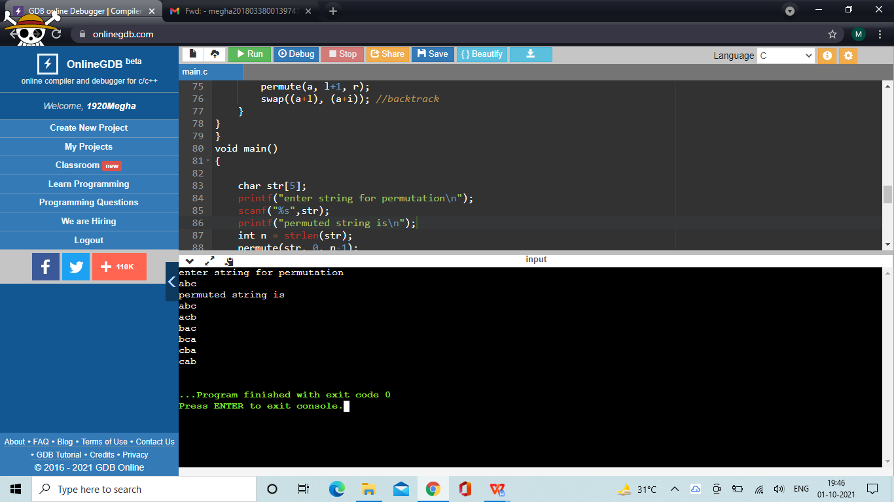

1. **Write a program in C to calculate the length of the string using a pointer.**

#include <stdio.h>

void main()

{

char str1[25],*ch;

int l;

printf("Input a string to calculate its length : \n");

scanf("%s",str1);

int ctr = 0;

ch=str1;

while (*ch != '\0')

{

ctr++;

ch++;

}

printf(" The length of the string is %d ", ctr);

printf("\n\n");

}

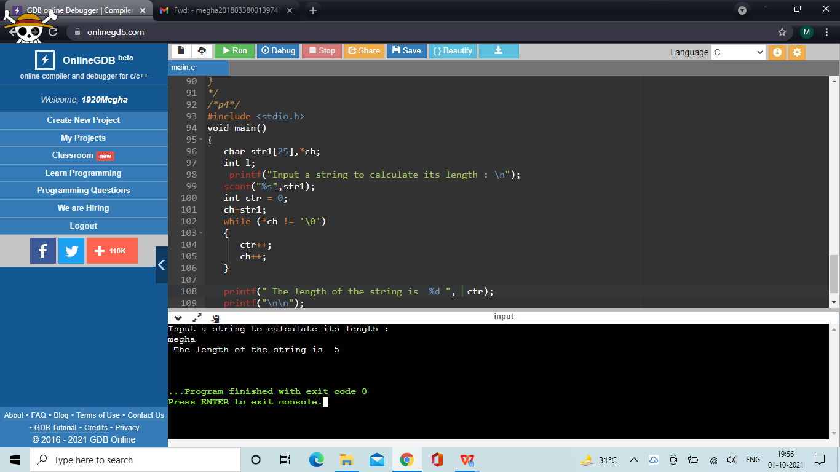

1. **Write a program in C to copy string without using strcpy() function by creating own function which uses pointers.**

#include <stdio.h>

int main()

{

char s1[20], s2[100]="......", i;

printf("enter a string to copy\n");

scanf("%s",s1);

printf("string s2 before getting copied : %s\n", s2);

for (i = 0; s1[i] != '\0'; ++i) {

s2[i] = s1[i];

}

s2[i] = '\0';

printf("String s2 after getting copied: %s", s2);

return 0;

}

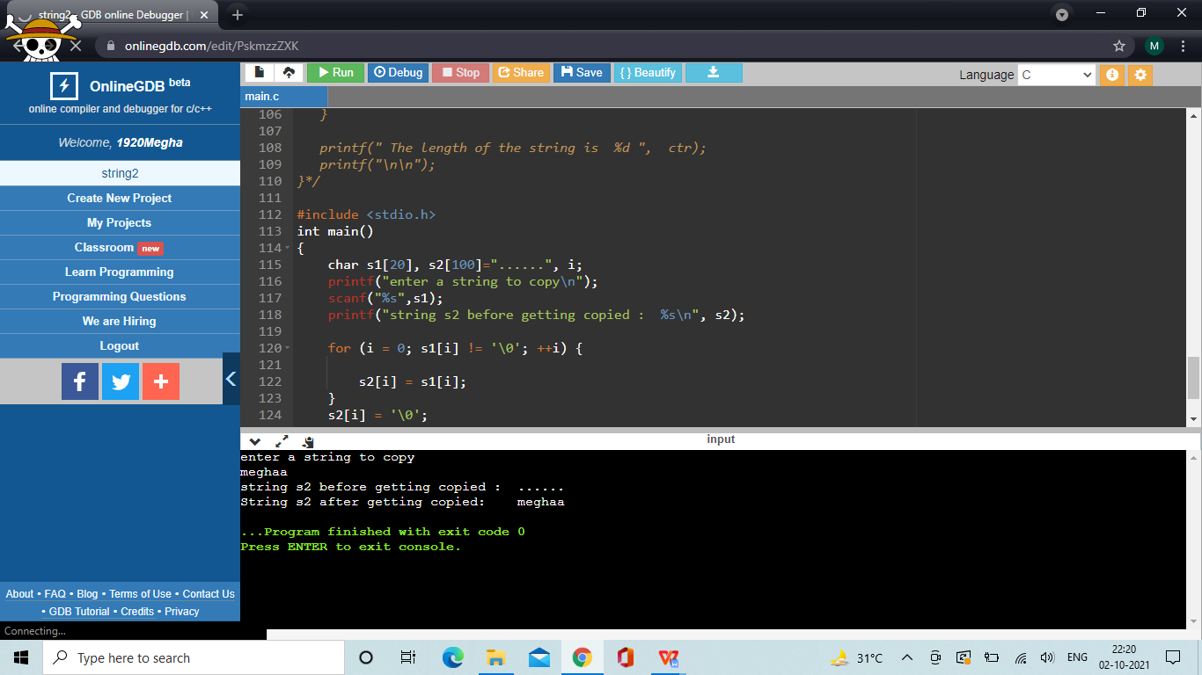

1. **Write a program in C to compare string without using strcmp() function by creating own function which uses pointers**

void compareStrings(char* s1, char* s2)

{

int i = 0;

while(s1[i]!='\0'&&s1[2]!='\0')

{

if(s1[i]==s2[i])

{

i++;

}

else

{

printf("missmatch occur at location %d",i+1);

break;

}

}

if(i==strlen(s1)){

printf("both string are same");}

}

int main(void)

{

char s1[20], s2[100], i;

printf("enter 2 string t compare \n");

scanf("%s \n %s",s1,s2);

compareStrings(s1, s2);

return 0;

}

