Day -1 test

B. Vishnu Vardhan babu

192110216

1. Check Whether a Given Number is Even or Odd

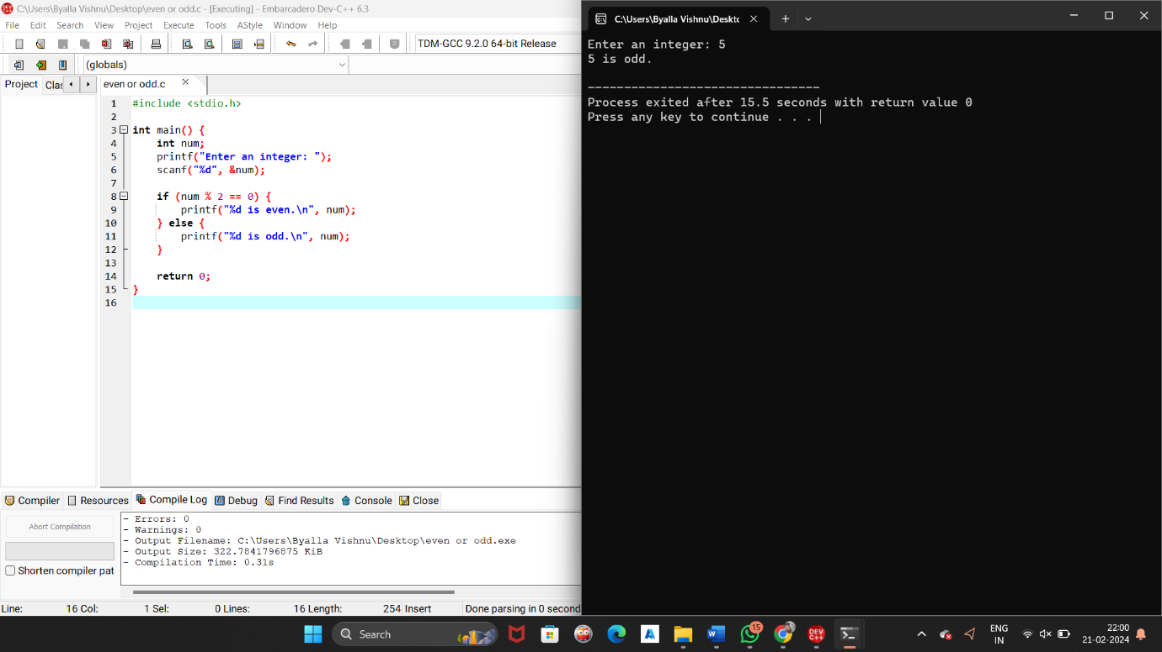

1. Find the Sum of Even and Odd Numbers

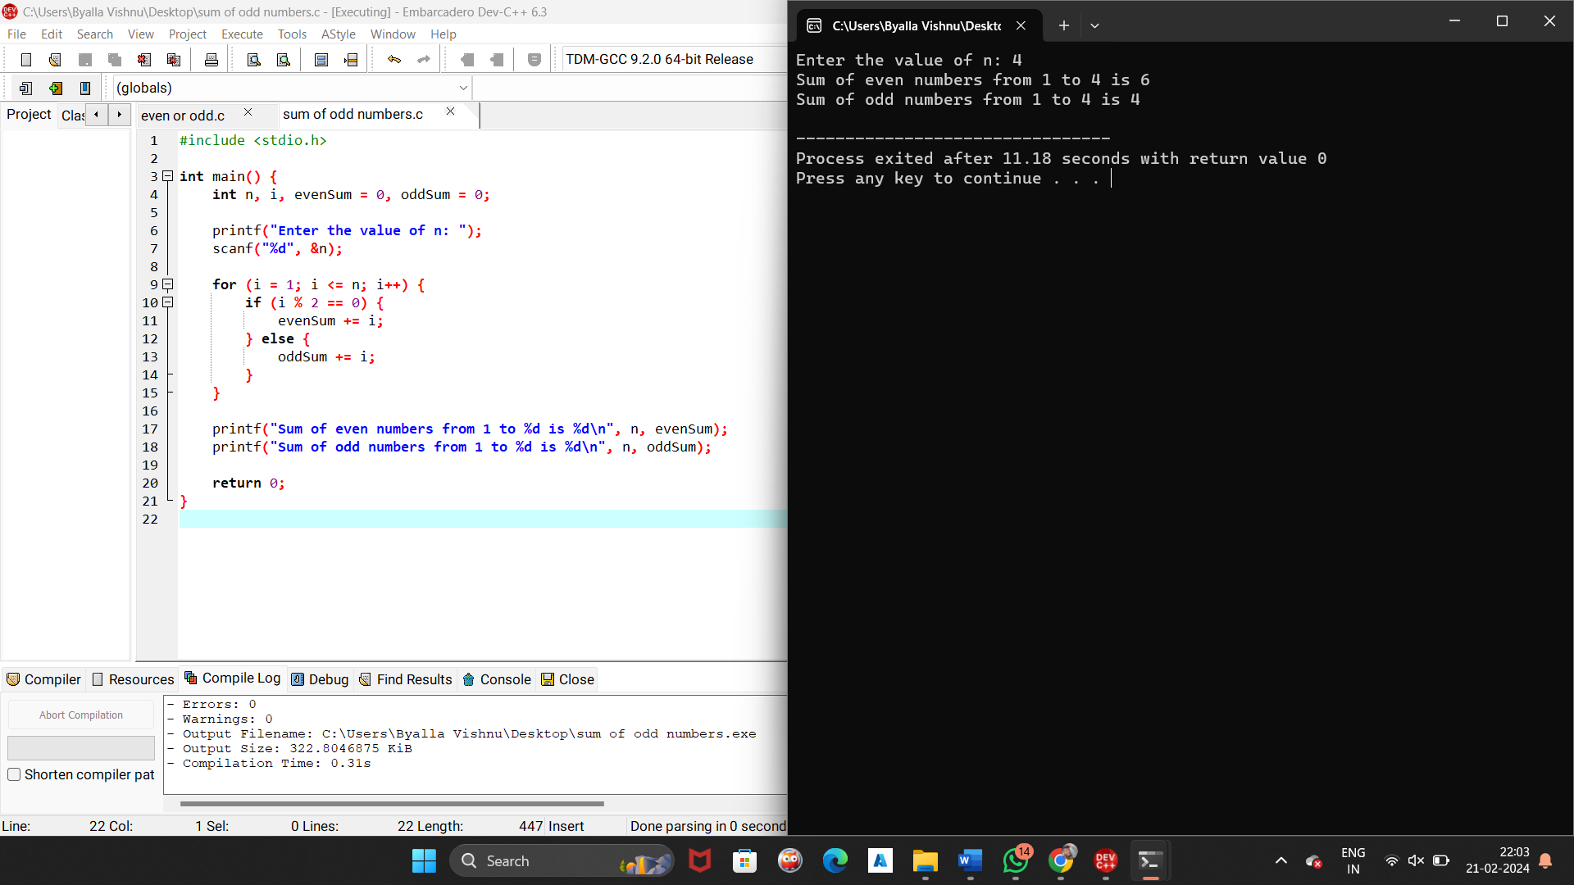

1. Check Whether a Number is Positive or Negative

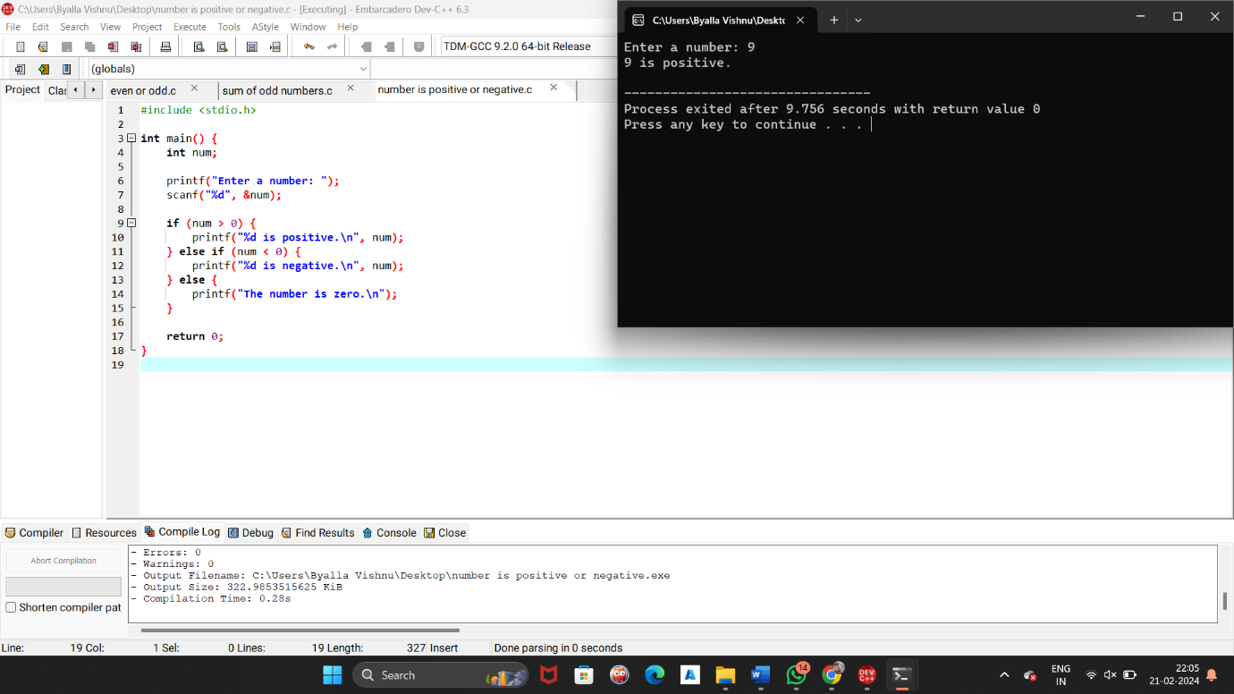

1. Find the Largest Number Among Three Numbers.

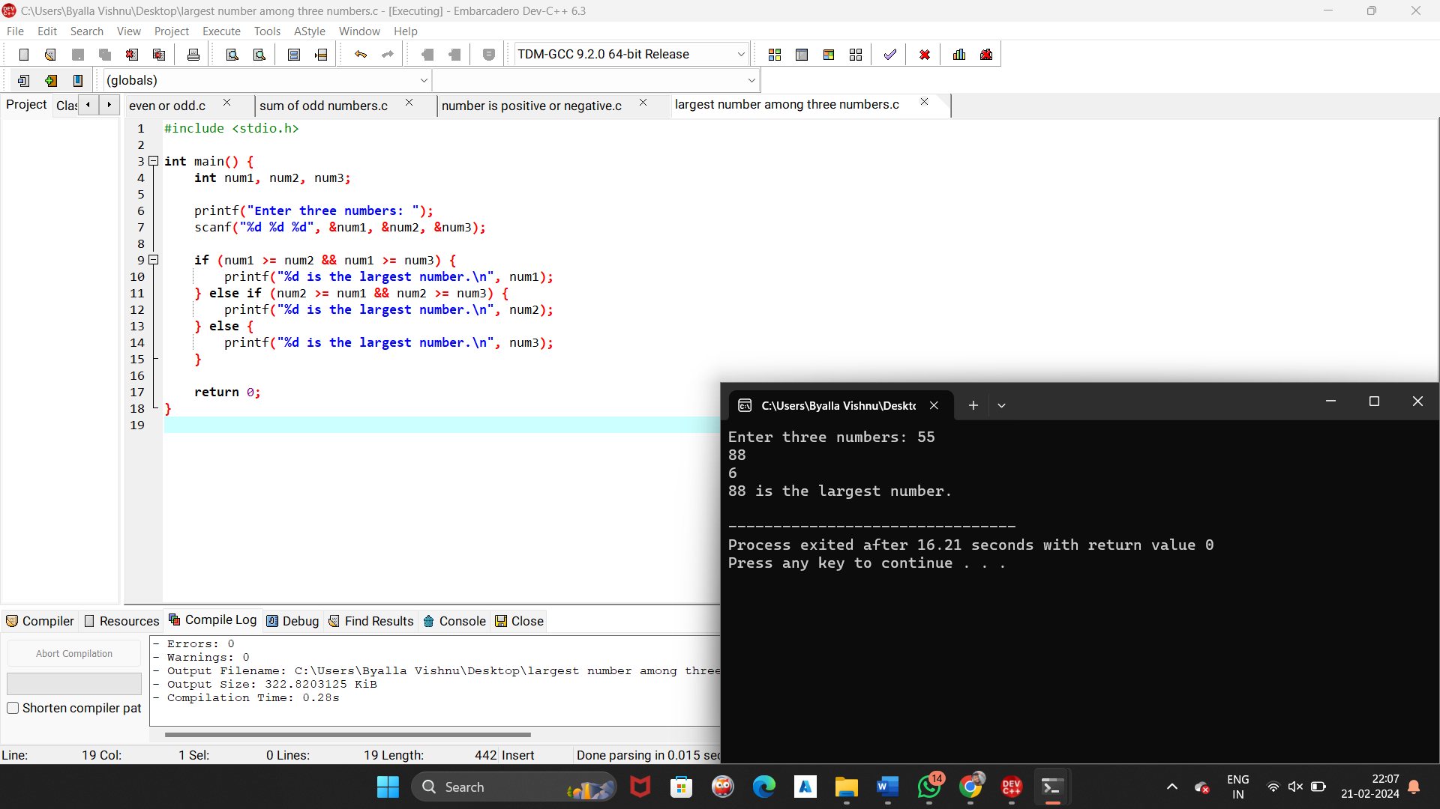

1. Swap Two Numbers

