Experiment-12

nikto -h [www.zoro.com](http://www.zoro.com) -Tuning x

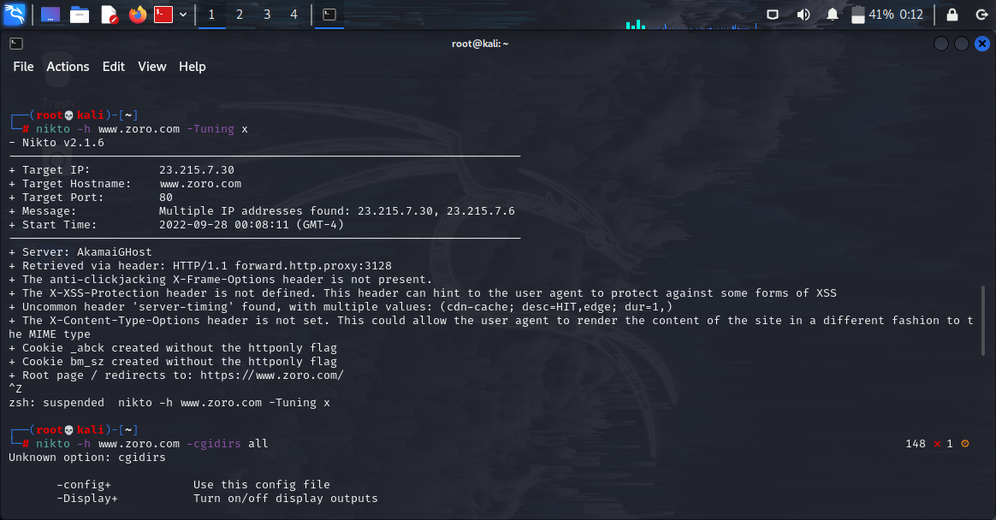

nikto -h [www.certifiedhacker.com](http://www.certifiedhacker.com) -cgidirs all

